TOWN OF GREENBURGH
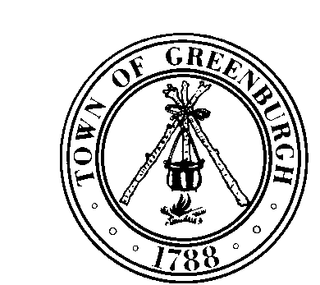

177 Hillside Avenue, Greenburgh, New York 10607
www.greenburghny.com

JOB ANNOUNCEMENT

Real Property Appraiser
Job Group: CSEA(Group 9) Annual Salary: $84,000 - $101,000

The Assessor’s Department at the Town of Greenburgh is recruiting for a Real Property Appraiser. Working under the direct supervision of the Town Assessor, this position is responsible for obtaining and reporting factual and relevant data to support real property valuations related to the assessment of real property for the purposes of taxation.

The successful candidate must have a working knowledge of modern principles and practices of real property appraisal for tax purposes including legal terminology used in deeds, liens, property descriptions, and tax records. Candidate must be able to demonstrate ability to make accurate appraisals of real property.

Examples of Work (Illustrative Only):
- Evaluates all types of real estate, review appraisals with local officials, makes preliminary reviews and analyzes appraisal reports from outside appraiser.
- Conducts assigned fields inspections of real property for appraisal and reappraisal field notes.
- Reviews deeds and other property records to extract applicable information for the preparation of detailed, factual and analytic reports of the basis for real property valuation estimates.
- Reports discrepancies in records of building location, topography, condition, bulk heading, street conditions, and improvements.
- Confers with taxpayers and assessors to explain factors used in determining valuation.

Minimum acceptable training and experience: (In accordance with Codes, Rules and Regulations of the State of New York, Title 20, Part 8188, Subpart 8188-5.3): Either (a) graduation from high school or possession of a high school equivalency diploma and three (3) years of satisfactory full time paid experience in an occupation involving the valuation of real property. Examples of occupations are appraiser, valuation data manager, real property appraisal aide or the like, two (2) years of which must have been in a fill-time paid position requiring the use of independent judgement in the appraisal of real estate, including the preparation of original written detailed reports. OR (b) graduation from an accredited two or four year college with a major in a related field and a minimum of twelve (12) credit hours in real property appraisal courses and one (1) year of satisfactory full-time paid experience as described in (a). Experience also requires the use of independent judgement in the appraisal of real estate, including the preparation of original written detailed reports.

Substitution: Please review the local job description for applicable substitution for some of the minimum acceptable training and experience listed above.

The Town of Greenburgh offers a comprehensive benefits package including medical, dental, vision, deferred compensation, paid leave and NYS retirement plan.

Submit cover letter and resume to emccarthy@greenburghny.com and indicate Real Property Appraiser in the subject line of your email.

The Town of Greenburgh is an Equal Opportunity Employer promoting the equal opportunity of employment, compensation and other terms and condition of employment without discrimination because of age, race, creed, color, national origin, sex, disability, marital status, sexual orientation or any other protected status.

