PLAYER ENTRY FORM-Captain’s Name First

Name______________________________ Email_______________ Shirt Size ______

Name______________________________Email________________ Shirt Size ______

Name______________________________Email________________ Shirt Size ______

Name______________________________Email________________ Shirt Size ______

**SEAN J. MORAN SCHOLARSHIP FUND**

***Individual & Corporate Sponsor***

**Title Sponsorship $2500**-Includes tournament banner, golf cart signage as well as a foursome and lunch.

**Golf Cart Sponsor $1000-** Name and logo on entire fleet of golf carts

**Golf Ball Sponsor $750-** Name/Logo on a sleeve of golf balls for every golfer-SOLD Reading Coop Bank

**Driving Range Sponsor $300-**Signage with name and logo at driving range for the entire day of the event.

**Clubhouse Lunch Sponsor $300-** Signage with name and logo in clubhouse for lunch and awards ceremony.

**Tee Sponsor $100-**Signage with name and logo on tee box.

**10th ANNUAL SEAN J. MORAN MEMORIAL GOLF TOURNAMENT**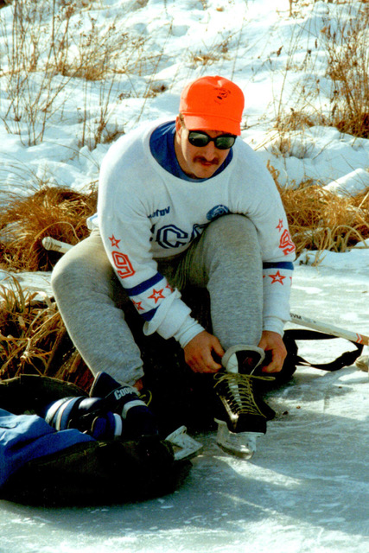

**Monday August 1, 2022**

**Windham Country Club**

**1 Country Club Road**

**Windham, NH**

[**www.windhamcc.com**](http://www.windhamcc.com)

**Scramble Format**

**Shotgun Start 7:30 AM**

The Sean J Moran Scholarship Fund is proud to sponsor the tenth annual Sean J Moran Memorial Golf Tournament. The tournament is named in honor of Sean J. Moran, coach of the Pinkerton Academy and Norwich University athlete.

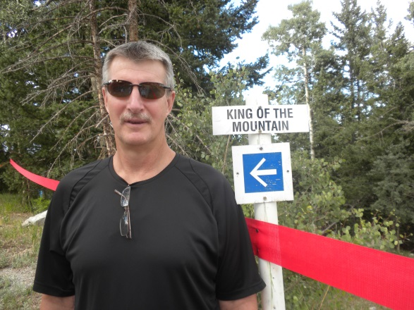

The entry fee will be $150.00 per player which includes: large and small raffle tickets, mulligan, putting string, lunch, coffee/donuts and goodie bag with gift.

There will be lots of raffle prizes, and each player will receive a memento of the occasion.

Cut-off date for all transactions will be **Monday July 25, 2022.** Scoring instructions will be furnished to you upon check in. If you desire further information, please contact:

*Jeffery Katz 603-434-0592* [*jeffwkatz@comcast.net*](mailto:jeffwkatz@comcast.net)

*Or*

*Barry Chisholm 781-583-8898* [*bchisholm@americanalarm.com*](mailto:bchisholm@americanalarm.com)

*Webpage* [www.sjmmemorialscholarshipfund.org](http://www.sjmmemorialscholarshipfund.org)

OUR MISSION

To provide financial assistance to a worthy student from Pinkerton Academy and Norwich University that exemplifies the heart, passion, and determination that Sean J. Moran showed on and off the ice or grid iron. Sean was a fearless competitor in sport and life. Those of us who played alongside Sean cherished him and those that played against Sean respected him. In sport and in life Sean excelled in everything he did because of his dedication to friends and family. Our intention, therefore, is to select students that show that same passion for family, friends, and sport.

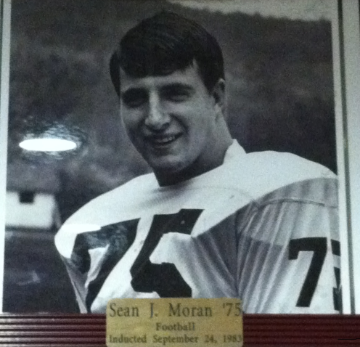

You can help us even more when you make a purchase on Amazon by visiting [smile.amazon.com](http://smile.amazon.com) and select the **Sean J Fund** as your charity of choice.

SJM Committee and volunteers

Make checks payable to: SJM Scholarship Fund or PayPal on our Website is available! C/O Jeff Katz 8 Judith Lane Derry, NH 03038 or C/O Barry Chisholm 5 Raven Terr. Londonderry, NH 03053

We are a 501C3 Organization

Circle Payment: M/C, Visa, Discover or Check

Card Number __________________________

Expiration Date ________________________

CVC Code _____________________________

Signature _____________________________

Entry Fee $150.00 Per player __________

Lunch and Awards Only $25 __________

Sponsorship __________

TOTAL $ __________

Thank you very much for your support

Jeff Katz and Barry Chisholm

Golf Committee Chairpersons