**Amy’s Driving School**

**Program Completion CHECKLIST:**

* You have attended 30 Hours of Classroom Instruction and pass the Final Written Exam with a score of 75% or higher
* Your Grade Verification Form must be completed and on file with Amy’s Driving School
* You have completed the required In-Vehicle training and must pass an in-vehicle evaluation

-Three Oaks Package: Six Drives and Six Observations

-Cary Algonquin and Northwest Hwy Package: Eight Drives +

* You have a $0.00 account balance
* Your Permit Number, Issue Date and FAC CM is on file with Amy’s Driving School
* Once ALL requirements are met, we will submit the Student’s Completion Report to the Secretary of State (Please Note S.O.S. processing can take up to 15-20 Business Days)
* Before making an appointment with the DMV double check with S.O.S.

Ilsos.gov/deccheck/

Any Questions?

Call/ Text 847-416-0999 or

Email [AmysDrivingSchoolCary@gmail.com](mailto:AmysDrivingSchoolCary@gmail.com)

**Had a Great Experience? Please Scan and Leave a Review**

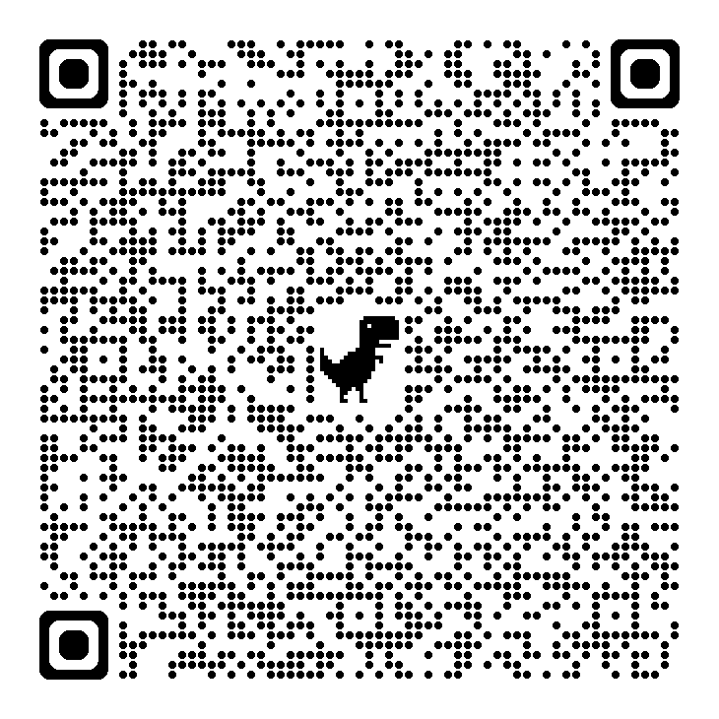**Google Reviews, Yelp, Facebook, Etc.**