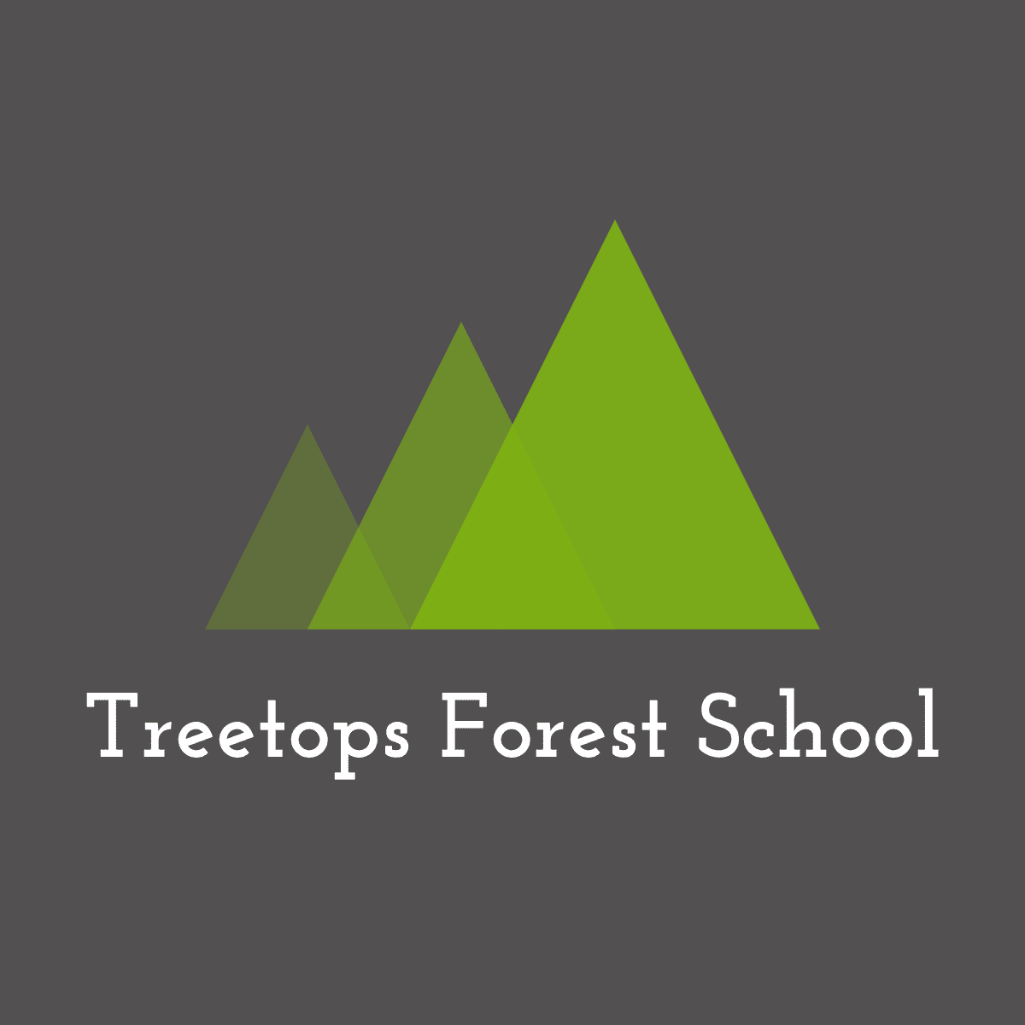 Disclaimer

Some of the activities at Forest School have an element of risk, these include free-play, den building, rope swings, tool use, camp-fire cooking, fire lighting, tree climbing, digging, low ropes, however these are not the only activities with an element of risk at Forest School. Risks can be minimised, but they cannot be eliminated altogether. Children, young people, and adults will suffer the occasional bumps, cuts and bruises which are a part of everyday life. We will teach children how to use tools safely and keep safe around fires, we will recommend the use of gloves where needed and have a suggested kit-list to be provided by the parents, but we cannot be held responsible for any injuries that occur at Forest School.

Detailed risk assessments have been carried out and procedures put in place to reduce risks and these are updated annually.

Covid19

During the pandemic, our holiday clubs are running in bubbles. We are continuously updating our policies to ensure that we follow the Government guidelines. Children are asked to wash their hands at key points of the day, on entering base camp, before eating and before going home. Soap and hand gel is available throughout the session.

Hand washing facilities are available, and parents and children are expected to use these on entering base camp during Little Shoots, birthday parties and Additional Needs sessions. Parents are reminded to keep a safe distance of at least 1m away from other families. Kit is cleaned regularly during and after the session.

We are not responsible for anyone testing positive for Covid19 after a Forest School session.

Updated 20th March 2021