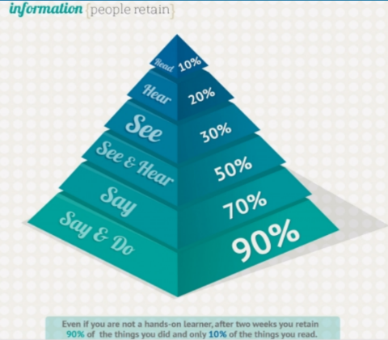
What is my learning style?
General Facts:
- The tactile-kinesthetic learner must DO things for them to have the best chance at learning
- The tactile-kinesthetic learner remembers best the things they experience
- Kinesthetic learning involves use of the whole body, rather than just hands-on
- Retaining information from written materials or by listening is not as easy as the methods listed above
Even if you are not a hands-on learner, after two weeks
you retain 90% of the things you did and only 10% of the
things you read
Learning Strengths of the Tactile-Kinesthetic Learner:
- Remembers what they DO: what they experience with their hands or bodies (movement and touch)
- Enjoys using tools or lessons which involve active or practical participation
- Can remember how to do things after they’ve done them once (motor memory)
- Have strong motor coordination
Learning Strategies for the Tactile-Kinesthetic Learner:
- Pace or walk around while reciting to yourself, or using flashcards and notes to improve memorization
- Using a whole-to-part approach when reading a short story or chapter in a book. This means you should first scan the pictures, then read the headings, then read the first and last paragraphs and try to get a feel for the book
- If you need to fidget, try doing so in a way which will not disturb others or endanger yourself or others. Possible options could include jiggling your legs or feet, try hand or finger exercises, or handling a ball similar to a koosh or tennis ball
- Studying may not be done most effectively sitting at a desk. Instead, try lying on your stomach or back, or sitting in a comfortable lounge chair or on cushions, a yoga ball, etc.
- Color Grounding: a technique in which colored construction paper is used to cover or decorate the desk in your favorite color which will help you focus
- Frequent breaks while studying, but be sure to settle back down to work quickly. A reasonable schedule would be 15-25 minutes of studying and a 3-5 minute break time

Teaching Strategies for the Tactile-Kinesthetic Learner:
- Allow students to take breaks during lessons and move around
- Encouraging tactile-kinesthetic learners to write down their own notes
- Encourage students to stand or move while reciting information or learning new material
- Incorporation of multimedia resources (computer, video camera, photo camera, etc) in to programs (either teacher or student presentations)
- Providing many tactile-kinesthetic activities in the class
Major Traits of the Tactile-Kinesthetic Learner:
- Remembers what they DO very well—getting physically involved in whatever is being learned
- Enjoys acting out a situation relevant to the study topic
- Enjoys making and creating; having opportunities to build and physically handle learning materials
- Will take notes to keep busy but will not often use them
- Enjoys using computers
- Has trouble staying still or in one place for a long time
- Tends to want to fiddle with small objects while listening or working
Activity Suggestions for the Tactile-Kinesthetic Learner:
Tactile Activities:
Modeling Scrapbooks Coloring Books Artistic Creations Dioramas
Needlework Posters Task Cards Whiteboard Activities
Sandpaper/Felt Letters Games Calculators Puzzles Collections

Kinesthetic Activities:
Demonstrations Dance Products Body Games
Field Trips Dress as Characters Role Play & Interviews Charades Pantomimes Plays Projects Walking & Reading

