Kinesthetic Learning Research: Print
Kuczala, Mike. Training in Motion: How to Use Movement to Create Engaging and Effective Learning. AMACOM, 2015. Print.
The Gist: “So why does more movement lead to more learning? The simple answer is that movement helps us refocus our ‘fidgeting’ brains by increasing oxygen and blood flow to the brain. The complex answer is that movement changes our brain chemistry so that we’re more alert, positive, and accepting of learning” (page 36).
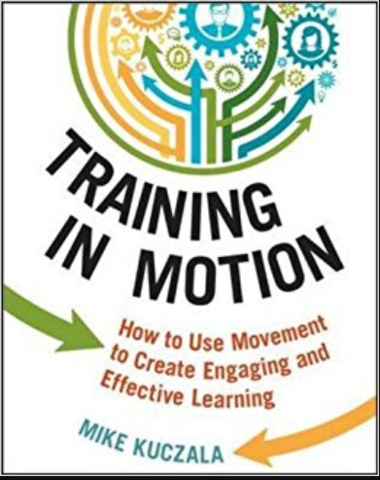
Cites a study in the Journal of Abnormal Child Psychology: “Students in exercise groups showed greater improvements in attention and mood than their sedentary counterparts” (page 24).
“Based on the brain/body connection, learning doesn’t happen from the neck up, it happens from the feet up” (page 35).
Eight Ways Movement Enhances the Training Process: (pages 37-42)
- Movement Creates Pathways for Implicit Learning
- Movement Refocuses Attention and Provides a Break From Learning
- Movement Creates Motivation to Learn
- Movement Improves the Learning State
- Movement Differentiates Training (Instruction)
- Movement Engages the Senses
- Movement Reduces Stress
- Movement Enhances Episodic Learning and Memory
Four Purposes of Movement in Training (pages 45-48)
- Renergize the brain and body
- Team Building
- Review and Retention
- Effective Training
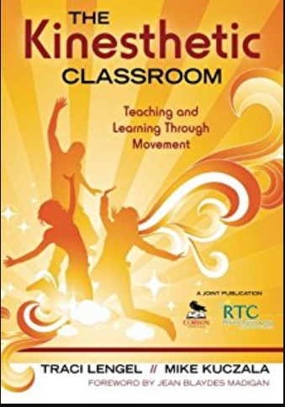
Lengel, Traci & Kuczala, Mike. The Kinesthetic Classroom: Teaching and Learning Through Movement. Thousand Oaks, CA: Corwin, 2009. Print.
- “Movement improves communication, builds relationships, and strengthens critical thinking skills” (page 46)
- “Every successful business relies on collaborative and cooperative teams. One of the benefits of movement-oriented activities is that certain key baseline emotional needs are met through participation. If this need is not met, the part of the brain involved in higher level critical thinking skills strategies shuts down and team dynamics suffer” (page 46).

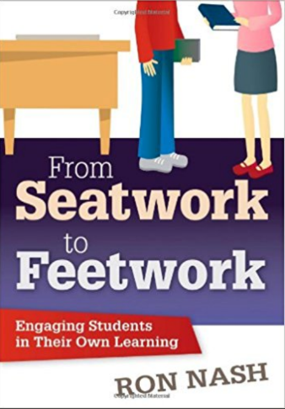
Nash, Ron. From Seatwork to Feetwork. Thousand Oaks, CA: Corwin, 2012. Print.

- According to Prensky (2010), “What today’s kids do have a short attention span for are our old ways of learning” (2).
- Hannaford (2005) “Movement is not only essential for nerve net development and learning, but also for adequate heart and lung development to support brain function” (158)
- Ratey (2008) “Exercise provides an unparalleled stimulus, creating an environment in which the brain is ready, willing, and able to learn” (10)
- James (2007). “As more and more students are diagnosed with ADHD, the tendency of schools consumed with improving end of year test performance to increase the amount of seatwork is actually ‘boosting symptoms’ of ADHD” (93)
- Jensen (2005) affirms that movement and learning are connected: “Evidence from imaging sources, anatomical studies, and clinical data shows that moderate exercise enhances cognitive processing” 67)

Shoecraft, Stacey. Teaching Through Movement. 2015. Print.
- “Evidence proves referrals in schools decline when there is regular movement in the classroom. Exercise automatically releases a chemical in the brain called serotonin” (page 19).
- “A short term result is the ability to focus for the next 2-3 hours, as well as improving long term memory” (19).

