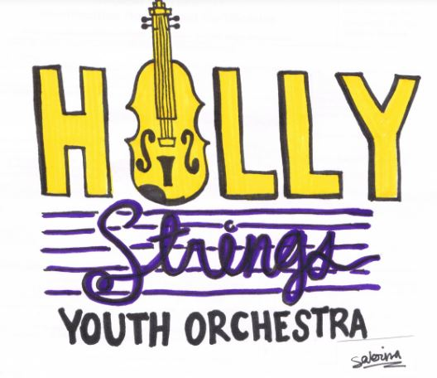

2019 HSYO Fall Calendar

Sunday, September 8: First Day of Fall Session!

Sunday, September 15: Audition Music Distributed (Vibratos)

Sunday, September 22: Auditions will take place during regular rehearsal time (Vibratos)

Sunday, September 29: Solo and Advanced Ensemble Performances Announced/Seating Announced (Vibratos)

Sunday, October 6: "A Bit of History"

Sunday, October 13: "Pizzicato Races"

Sunday, October 20: "A Day In The Life Of A World Famous Composer"

Saturday, October 26: HSYO Performance at Holly Fest: 12:45 - 1:05p.m.
Arrive at Holly Springs Cultural Center at 11:45 a.m.

Sunday, October 27: "It's A Birthday!"

Sunday, November 3: "Can You Conduct?"

Sunday, November 10: "Terminology Game"

Sunday, November 17: "Spectacular Scales"

Sunday, November 24: "Concert Rehearsal" - Regular rehearsal times for all groups

Saturday, November 30: HSYO trip to see the North Carolina Symphony perform "Cirque de Noel"
3:00 p.m. at the Meymandi Concert Hall in Raleigh

Sunday, December 1: *Thanksgiving Weekend Rehearsals are optional but encouraged. Happy Thanksgiving!

Saturday, December 7: *Optional community performance at Ms. Erin's House in Sunset Ridge:
Donuts, hot cocoa, and eggnog served; may stay for Christmas Caroling and fellowship!

Sunday, December 8: Full HSYO Concert Rehearsal: 3:00 p.m. for entire HSYO
*Ice cream social to follow

Saturday, December 14: HSYO Winter Concert 1:00 p.m. at the Holly Springs Cultural Center
HSYO must arrive at 12:00 p.m. in concert attire, with instrument and music

