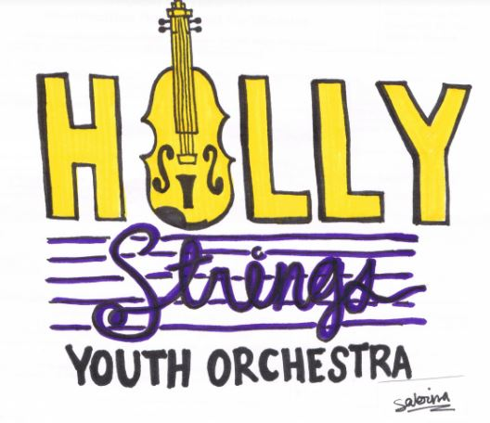

2022 HSYO Spring Calendar

Sunday, January 23: First Day of Spring Session! (delayed one week for weather)

Sunday, January 30: All Music Distributed to Ensembles

Sunday, February 6: Regular Rehearsal for all Groups/Seating assigned

Sunday, February 13: "Valentine's Day Treat"

Sunday, February 20: Regular Rehearsal for all Groups

Sunday, February 27: "Pizzicato Day"

Sunday, March 6: Regular Rehearsal for all Groups

Sunday, March 13: *Daylight Savings Time Ends* - Regular Rehearsal for all Groups

Sunday, March 20: "Saint Patrick's Day Surprise"

Sunday, March 27: Regular Rehearsal for all Groups

Sunday, April 3: "Celebrating Spring Birthdays!"

Sunday, April 10: Regular Rehearsal for all Groups

Sunday, April 17: "Let's Switch"

Sunday, April 24: Regular Rehearsal for all Groups

Sunday, May 1: Last Regular Rehearsal for all Groups

Sunday, May 8: Full HSYO Concert Rehearsal: 3:00 p.m. for entire HSYO
*Ice cream social to follow

Sunday, May 15: HSYO Spring Concert 4:00 p.m. at the Holly Springs Cultural Center
HSYO must arrive at 3:00 p.m. in concert attire, with instrument and music

