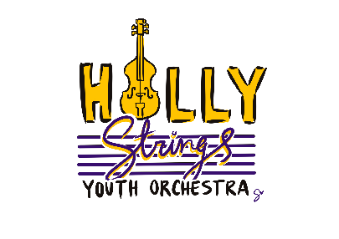

**2025 SPRING ADVANCED ENSEMBLE AUDITION DIRECTIONS**

**(CRESCENDOS ADVANCED AND VIBRATOS ADVANCED)**

1. ONE 2 OCTAVE SCALE OF YOUR CHOICE
2. 1-2 MINUTES OF A SOLO PIECE OF YOUR CHOICE
3. AUDITION EXCERPT FOR YOUR INSTRUMENT AND ENSEBMLE PROVIDED BY MS. ANNA (we are a bit delayed in getting this up on the website, please bear with us!)

AUDITIONS WILL BE HELD IN-PERSON WITH MS. ANNA ON SUNDAY, JANUARY 19TH

2:00 P.M. – VIBRATOS ADVANCED AUDITIONS

3:00 P.M. – CRESCENDOS ADVANCED AUDITIONS