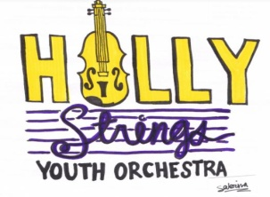

The HSYO is taking a field trip to see the North Carolina Symphony!

What: North Carolina Symphony Concert "Cirque De Noel"!
Date: Saturday, November 30th at 3:00 p.m.
Location: Meymandi Concert Hall, Woolner Stage, 2 E South Street, Raleigh, NC 27601.
*Transportation will not be provided by the HSYO; please arrange transportation for your child.
Tickets for HSYO youth have been paid for, thanks to generous community contributors!
Tickets for family members are available at a discounted rate of $35.00 each. This rate applies to both children and adults. The HSYO has a group of reserved seats, located center-rear orchestra, rows AA, BB, CC.
If you wish to purchase tickets to the concert for family or friends, please fill out the order form below and attach your cash or check payment. Checks should be made out to the Holly Strings Youth Orchestra.
Deadline to order tickets is Sunday, November 3rd!
For more information about the NC Symphony, the "Cirque de Noel" Concert on November 30, or to view the seating chart, please visit ncsymphony.org
_________________________________________________________________________________________________
ORDER FORM

Name: ____________________________________________________________________________________

HSYO Participant Name: _____________________________________________________________________

Number of Tickets (Not including HSYO musician) : ______ X $35.00/each = Total: ___________

Payment method (attached): ______ CASH _____ CHECK

