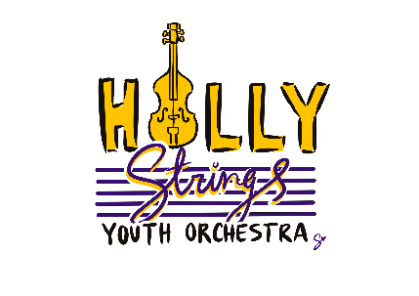

**RESOURCES FOR INSTRUMENT RENTAL OR PURCHASE**

**Stringed Instrument Rentals:**

Violin and Fiddle Shop: <https://www.sgmcviolins.com/>

Triangle Strings: <https://trianglestrings.com/>

Music and Arts: <https://www.musicarts.com/rentals>

Azure Violins: <https://azureviolins.com/>

**For purchase:**

Shar Music: <https://www.sharmusic.com/collections/instruments>

Johnson String Instrument: <https://www.johnsonstring.com/rental/>

Amazon.com (please ask our instructors for guidance in purchasing an instrument from Amazon).