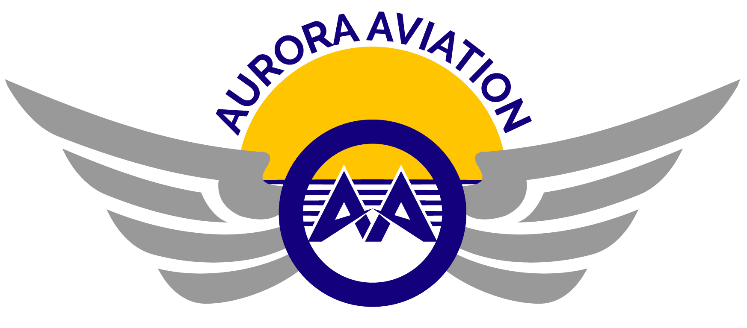

704 North King Street, Wilmington, DE 19801 (402) 498-4142

CERTIFICATE
OF
TRAINING
This certifies that on May 12, 2021,
Chuck Yeager
has successfully completed training for
CE-500 RECURRENT,
GROUND AND FLIGHT
INSTRUMENT PROFICIENCY CHECK
BIENNIAL FLIGHT REVIEW
in a CE-500.
I certify that Chuck Yeager, Commercial Pilot certificate #1234 has successfully completed the biennial flight review required by FAR 61.56(a) and instrument proficiency check of FAR 61.57(d) in a CE-500, on May 12, 2021.
Signed:

