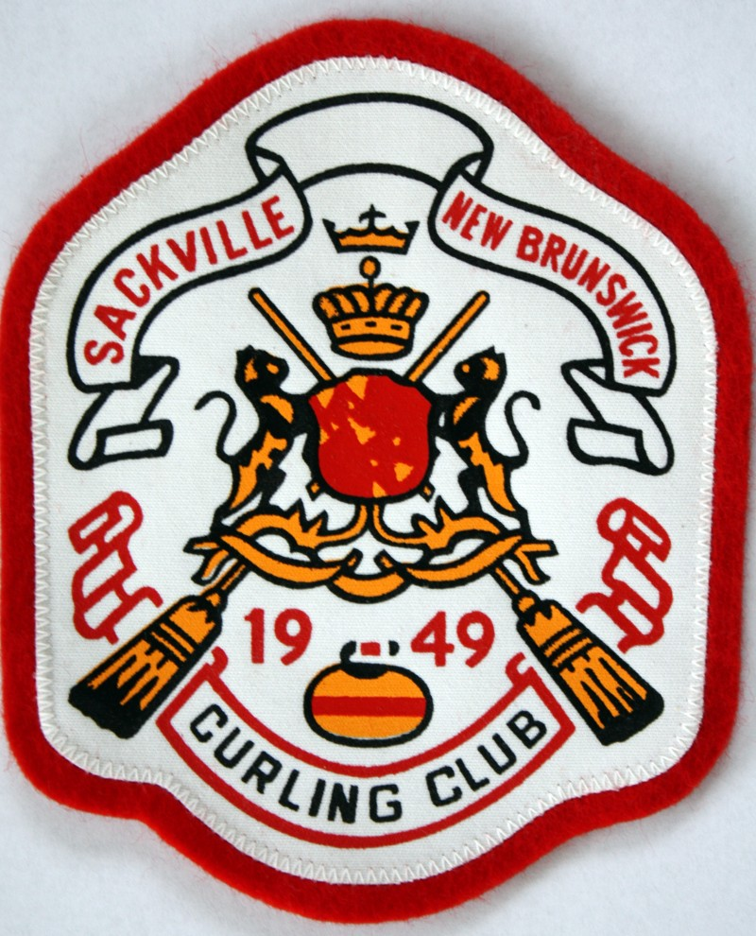
Sackville Curling Club

Release of Liability, Waiver of Claims & Indemnity Agreement

(To be signed by participants of the age of majority and over.)

WARNING! By signing this document, you will waive certain legal rights, including the right to sue. Please read carefully.

- This is a binding legal agreement; therefore, clarify any questions or concerns before signing. As a participant in the activities, programs, services of Curling Canada, New Brunswick Curling Association and the Sackville Curling Club, collectively or independently and the sport of curling (collectively the “Activities”, the undersigned acknowledges and agrees to the following terms.

Disclaimer
- Curling Canada, the New Brunswick Curling Association and the Sackville Curling Club, their respective directors, officers, committee members, members, employees, coaches, volunteers, officials, participants, agents, sponsors, owners/operators of the facility, and representatives (the “Organization”) are not responsible for any injury, property damage, expense, loss of income, damage or loss of any kind suffered by me during, or as a result of, the Activities, caused in any manner whatsoever including, but not limited to, the negligence of the Organization.

I have read and agree to be bound by paragraphs 1 and 2.

Description, Acknowledgement of Risks and Helmet Recommendation
- I understand and acknowledge that the Activities have foreseeable and unforeseeable inherent risks, hazards and dangers that no amount of care, caution or expertise can eliminate, including without limitation, the potential for serious bodily injury, permanent disability, paralysis and loss of life. The sport of curling is played on a sheet of ice, which is slippery, hard and dangerous.

- I understand and acknowledge that a pertinent risk to participating in the sport of curling is the risk of suffering serious head injury should I fall, trip, or stumble onto the ground or ice. It is highly recommended that I wear a helmet at all times when participating in the sport of curling.

- I am participating voluntarily in the activities. events and programs of the Organization. In consideration of my participation, I hereby acknowledge that I am aware of the risks, dangers and hazards associated with or related to the Activities. The risks, dangers and hazards include, but are not limited to, injuries from:
- Executing strenuous and demanding physical techniques in curling;
- Dry-land training including weights, running and massage;
- Strenuous cardiovascular workouts;
- Exerting and stretching various muscle groups;
- Being struck by a broom, brush or curling stone;
- The failure to properly use any piece of equipment or from the mechanical failure of any piece of equipment;
- Physical contact with other participants, spectators, equipment and vehicles;
- Running or sliding on the ice surface;
- Falling while delivering the curling stone, skipping or sweeping;
- Falling because of slippery ice, or uneven or irregular surfaces;
- Spinal cord injuries which may render me permanently paralyzed;
- Stepping onto the ice surface from the walkway or onto the walkway from the ice surface;
- Stepping over dividers that divide one sheet of ice from the next;
- Weather conditions which may result in hypothermia.
- Travel to and from competitive events and associated non-competitive events, which are an integral part of the organization’s activities.

Terms
- In consideration of the Organization allowing me to participate in the Activities, I agree:
- That my physical condition is appropriate to participate in the Activities;
- To comply with the rules and regulations for participation in the Activities;
- That if I observe an unusual significant hazard or risk, I will remove myself from participation and bring such to the attention of an Organization representative immediately;
- That the Organization does not undertake to provide health, accident, disability, hospitalization, personal property or other insurance for me in the Activities and I affirm that I have ascertained appropriate insurance to protect myself.

Release of Liability
- In consideration of the Organization allowing me to participate, I agree:
  - The sole responsibility for my safety remains with me;
  - To ASSUME all risks arising out of, associated with or related to my participation;
  - To WAIVE any and all claims that I may have now or in the future against the Organization;
  - To freely ACCEPT AND FULLY ASSUME all such risks and possibility of personal injury, death,
property damage, expense and related loss, including loss of income, resulting from my participation
in the activities, events and programs of the Organization; and

- To FOREVER RELEASE the Organization from any and all liability for any and all claims, demands, actions, damages (including direct, indirect, special and/or consequential), losses, actions, judgements, and costs (including legal fees) (collectively, the “Claims”) which I may have or may in the future, that might arise out of, result from, or relate to my participation in the Activities, even though such Claims may have been caused by any manner whatsoever, including but not limited to, the negligence, gross negligence, negligent rescue, omissions, carelessness, breach of contract and/or breach of any statutory duty of care of the Organizations.

I have read and agree to be bound by paragraphs 3 and 7.

General
- I expressly agree that this Agreement is intended to be as broad and inclusive as is permitted by the law and that if any of its provisions are held to be invalid, the balance shall, notwithstanding, continue in full legal force and effect.

Acknowledgement
- I acknowledge that I have read this agreement and understand it, that I have executed this agreement voluntarily, and that this Agreement is to be binding upon myself, my heirs, spouse, children, parents, guardians, next of kin, executors, administrators and legal or personal representatives.

_____________________________________________ ___________________________
Name of Participant Date

_____________________________________________ ___________________________
Signature of Participant Witness

