

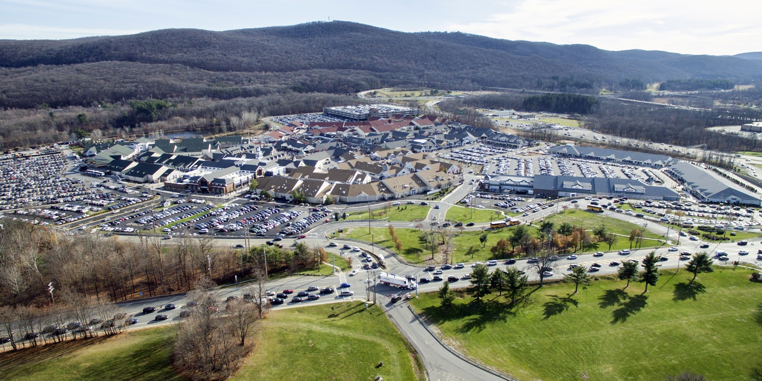

**WOODBURY POLICE DEPARTMENT’S**

**ANNUAL REPORT**

**2024**

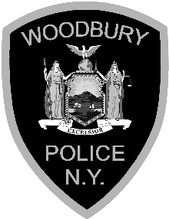

**MESSAGE FROM THE CHIEF**

I am proud to provide this report showing the activity of the Town of Woodbury Police Department for the year 2024. The men and women of the Town of Woodbury Police Department are dedicated to serve and protect our community and the entire public.

In 2024, the Town of Woodbury Police Department answered 12,621 calls for service and issued 6177 traffic citations. Officers also made 620 arrests. As part of The Department’s commitment to public service, we performed 12,898 security checks of local businesses, neighborhoods, and vacant houses as well as 1,104 calls for Operation Concern.

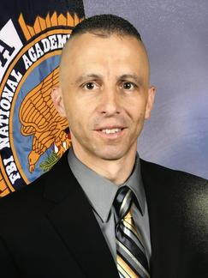The Town of Woodbury Police Department continued to train its Officers and remain vigilant in being ever present to better serve its community and address the ever-expanding influx of international tourism and new growth in the Town. In 2024, the Town has renewed interest in commercial and residential building and growth in our community. The Department worked to continue to provide our excellent attention to detail in how we strive to administer our services. We continued to provide comprehensive training opportunities so that we best prepared our members for the everchanging community we serve. Sergeant Potter graduated the prestigious FBI NA Session 291. We put members on multiple Orange County Task Forces to receive training opportunities and access to resources from our Federal Law Enforcement partners. We provided additional dispatcher training in order to accommodate the increased demand on our telephone systems. We focused our traffic enforcement on critical issues concerning our roadways and how we could safely enforce the rules and regulations. We relied upon our specialized units to get this done efficiently. Those operating on the Town’s busy highways, our exchanges are some of the busiest in the county, were able to travel safely thanks to our traffic/commercial vehicle units who proactively patrolled our most congested roadways in order to diminish our growing rate of motor vehicle accidents.

It is my pleasure to serve as the Chief of Police for the Town of Woodbury Police Department and I am honored to work with men and women who are truly dedicated to serve the public. Thank you for letting me provide you with this report.

Respectfully submitted,

Kevin J. Watson

Chief of Police

***MISSION STATEMENT***



The principle mission of the Town of Woodbury Police Department is to enforce all laws and ordinances in a fair and impartial manner by preserving the constitutional rights of all persons to live in peace by reducing fear in the community through the prevention of crime, protection against criminal attack, loss or damage to property, and by preserving order in public places.

It is essential that all members of the department remember that in the execution of their duties that they act not for themselves but for the good of the community. They will respect and protect the rights of individuals and perform all police services with honesty, zeal, courage, discretion, fidelity and sound judgment without prejudice.

The department will at all times work in cooperation with other law enforcement agencies, community agencies, groups, or departments to promote confidence, understanding, trust and competence from the public to achieve our police objectives.

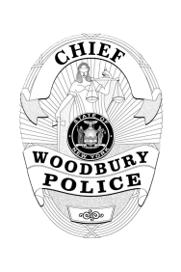TOWN OF WOODBURY POLICE DEPARTMENT – 2024 ANNUAL REPORT

**STAFFING TABLE**

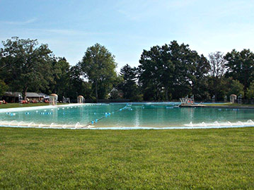

**Chief of Police**

**Lieutenant**

**Administrative Sergeant**

**A Shift**

**1 Sergeant**

**B Shift**

**1 Sergeant**

**C Shift**

**2 Sergeants**

**2 Detective /**

**Investigator**

**6 Patrol Officers**

**6 Patrol Officers**

**5 Patrol Officers**

**2 Dispatchers**

**1 Dispatcher**

**1 Dispatcher**

**The optimal staffing levels for the Town of Woodbury PD are illustrated above.**

**Ideally, there are 4 full-time Sergeants, 2 full-time Detectives, and 17 full-time/13 part-time Police Officers. At the conclusion of the year 2024, the Department was operating with 4 full-time Sergeants, a full-time and part-time Detective, 15 full-time and 3 part-time Patrol Police Officers and 8 School Resource Officers.**

TOWN OF WOODBURY POLICE DEPARTMENT – 2024 ANNUAL REPORT

**PERSONNEL**

Chief of Police

|  |
| --- |
| Kevin J. Watson |

Lieutenant

|  |
| --- |
| Kevin Phillips |

Sergeants

|  |  |
| --- | --- |
| Christopher Caruso | Eric Hardin |
| Christopher Correa | Kristen Potter |
|  |  |

Detective

|  |
| --- |
| Steven Roman  Scott Danielson |

Police Officers (Full Time)

|  |  |  |
| --- | --- | --- |
| Aaron Roberts | Jon Hurtado | James Tremper |
| Michael Farahvashi | Nicholas Schust | Ryan Sinclair |
| Lawrence Coe | Dominick Gonzalez | Kevin Ambrose |
| Jorge Medina  Michael Ambrose | Raymondhan Maeang  Ryan Finn | Kevin Wood  Anthony Feliciano |

Police Officers (Part Time)

|  |  |
| --- | --- |
| Cecil Hunter  Javier Quintero | Carlos Castro |

Dispatchers and Administrative Staff

|  |  |  |
| --- | --- | --- |
| Susan Anderson | Greg Hoffman | Michael Gironda |
| Jacklyn Vidal | Jessica Spall | Jen Wassmer |
| Daniel Bennet | John Seymour | Michael Ganz |
|  |  |  |

TOWN OF WOODBURY POLICE DEPARTMENT – 2024 ANNUAL REPORT

**TOWN OFFICIALS**

TOWN SUPERVISOR

|  |
| --- |
| Kathryn Luciani |

Deputy supervisor

|  |
| --- |
| Teresa Luongo |

councilmen

|  |
| --- |
| Sandra Capriglione |
| Kelly Rinaldi |
| Brandon Calore |

town clerk

|  |
| --- |
| Nicole Young |

Town Justices

|  |
| --- |
| David Hasin |
| Bruce Schonberg |

TOWN OF WOODBURY POLICE DEPARTMENT – 2024 ANNUAL REPORT

**DEPARTMENT PROGRAMS**

Operation Concern

Operation Concern allows residents of the Town of Woodbury to register their loved ones or place themselves on a call list. This list is in place in order to ensure that its participants are called daily. Therefore, if a participant is not reached after various attempts, a patrol unit will be sent to ensure the health and safety of the participant. It can provide peace of mind for residents who participate in the program.

child passenger safety seat program

The Town of Woodbury Police Department has specially trained police officers who are certified Child Passenger Safety Seat Installers. By appointment, these officers will professionally install your child safety seat. During installation, these officers will provide the owner with safety tips and guidelines to ensure that your child is safe and comfortable. Your child's safety is these officers’ paramount concern

Emergency medical technician

The Town of Woodbury Police Department works closely with Woodbury Volunteer Ambulance Core in order to provide excellent emergency medical care for our residents. The majority of our officers are certified NYS Emergency Medical Technicians. Few local police departments have an EMT program due to the rigorous training necessary to become and maintain an officer's certification. Enabling our police officers, who typically are the first responders to all medical calls, to be familiar and equipped with all medical supplies needed to save lives greatly increases our ability to assist residents in times of medical distress. Our EMT's carry supplies such as oxygen, defibrillators, Narcan, splints, bandages. All of which have been used by our officers to save many lives.

PRESCRIPTION & UNWANTED DRUG DISPOSAL

The Town of Woodbury Police Department would like to remind residents that there is a prescription drug turn in box located in the police department lobby. Unused prescription drugs can be damaging to the environment and alluring and dangerous to children and young people if not disposed of properly. Any resident can turn in any accumulated, unwanted, unused or expired pre, no questions asked. All of the prescription drugs that are turned in will be disposed of properly and safely.

TOWN OF WOODBURY POLICE DEPARTMENT – 2024 ANNUAL REPORT

**DEPARTMENT PROGRAMS**

VACANT HOUSE CHECKS

This program allows residents to submit a form in order to have a Town of Woodbury Patrol Unit monitor the condition of their home for a requested range of dates to ensure that it remains in its present condition as they vacation or leave their home vacant for any other means.

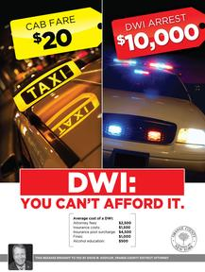

Orange County STOP DWI

Orange County STOP DWI Program is a grant that provides funding for directed DWI patrol and checkpoints. Town of Woodbury Police Department is an active participant in this program. All of the police officers of the Woodbury Police Department have received extensive training in DWI detection and enforcement. This department routinely enforces, on a daily basis, the DWI laws through directed patrols.

GUN LOCK PROGRAM

 The Town of Woodbury, in conjunction with Project Child Safe, will be distributing free gun locking devices to Town of Woodbury residents. Project Child Safe is a program whose purpose is to promote safe firearms handling and storage practices among all firearms owners, through the distribution of safety messages and gun locking devices all over the United States. This program is being funded by a US Department of Justice Grant.

aNIMAL CONTROL

The Town of Woodbury employs one full time Animal Control Officer (ACO) who continually patrols the town and picks up stray dogs. They are dispatched through the Woodbury Police Department. The Animal Control Officer also maintains the town's Dog Shelter where strays are housed until their legal owners can be located. Every effort is made to find a good home for all dogs when their owners cannot be found.

TOWN OF WOODBURY POLICE DEPARTMENT – 2024 ANNUAL REPORT

**DEPARTMENT PROGRAMS**

RAPE AGGRESSION DEFENSE PROGRAM

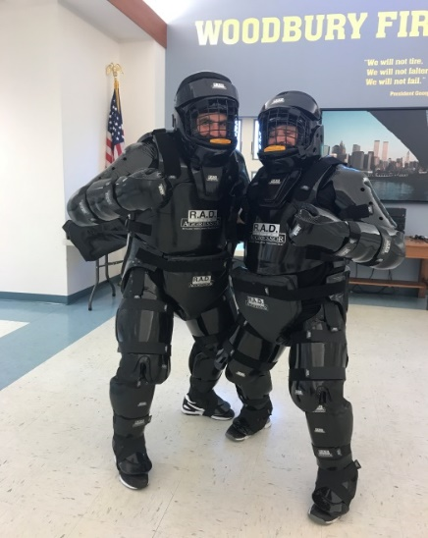

Rape Aggression Defense (R.A.D.) is an international program that trains citizens in self-defense in case they ever become victim to an attack. The R.A.D. Systems of Self Defense offers programs for women, children, men and seniors. These offerings provide a truly holistic approach to self-defense education, supporting the necessity of continuous learning in order to provide realistic options for each population as they go through life. Each of these programs includes educational components comprised of lecture, discussion, physical resistive strategies. All of which are facilitated by certified R.A.D. Instructors. The Town of Woodbury Police Department currently has four R.A.D. instructors.

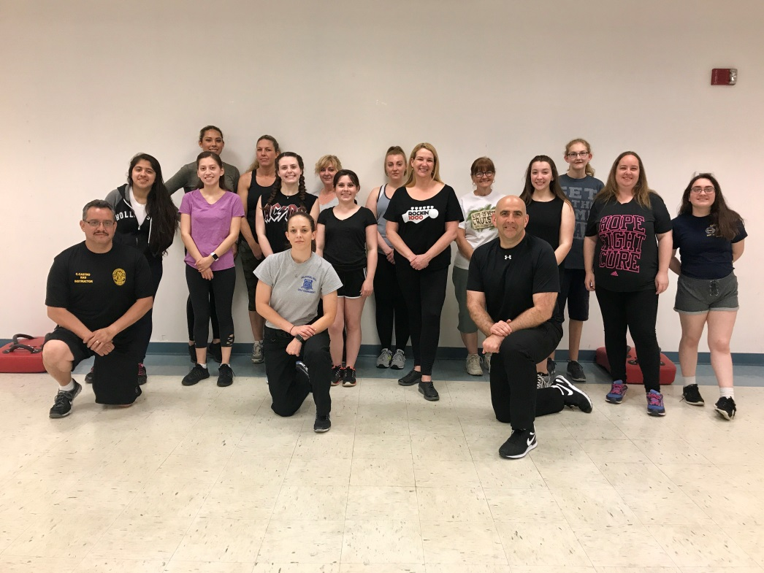

TOWN OF WOODBURY POLICE DEPARTMENT – 2024 ANNUAL REPORT

**SPECIALIZED UNITS**

TACTICAL RESPONSE UNIT (T.R.U.)

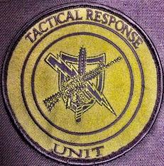

The Tactical Response Unit was started in January of 2000. The Unit is comprised of members from the Town Police Departments of Woodbury, Chester, Warwick, Tuxedo and the Villages of Goshen, Harriman, Greenwood Lake and Monroe. Recognizing that the presence and availability of a trained, skilled and established Unit has been shown to substantially reduce the risk of injury or loss of life to citizens, police officers and suspects; and recognizing that a well-managed Unit response to critical incidents usually results in the successful resolution of critical incidents. It is the intent of the participating agencies to provide a Tactical Response Unit as a resource for the resolution of critical incidents and search warrant/raid service. The mission of the Unit is to support the departments and other requesting law enforcement agencies with a tactical resolution to such incidents.

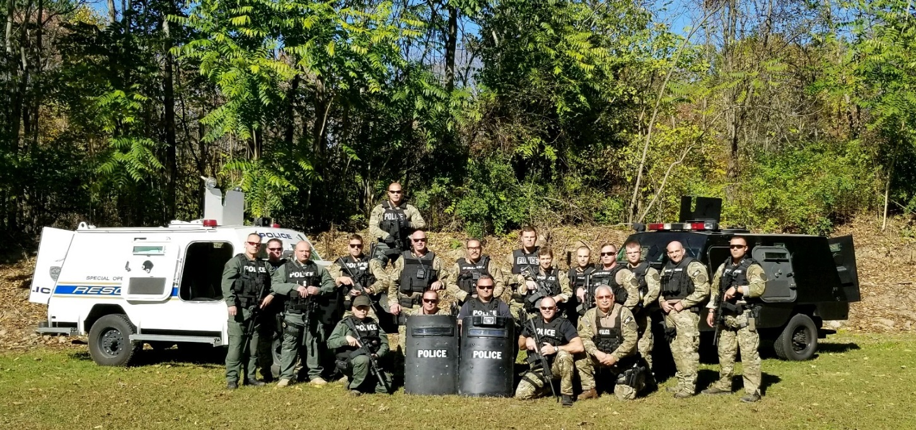

TOWN OF WOODBURY POLICE DEPARTMENT – 2024 ANNUAL REPORT

**SPECIALIZED UNITS**

COMMERCIAL VEHICLE ENFORCEMENT UNIT

The

The Town of Woodbury Police Department has several officers that are trained in Commercial Vehicle Enforcement. Primarily, this unit's objective is to protect motorists and pedestrians who utilize our very busy highways and local routes.. This unit secondary mission is to reduce commercial and passenger motor vehicle accidents through the enforcement of Motor Carrier Safety regulations alongside NYS Vehicle and Traffic Law infractions. These efforts ensure safe travel for residents and visitors in addition to safeguarding the state highways from unnecessary damage by securing compliance with laws regulating the weight of commercial vehicles and to ensure equitable payment of commercial vehicle registration fees through enforcement of said laws.

TOWN OF WOODBURY POLICE DEPARTMENT – 2024 ANNUAL REPORT

**SPECIALIZED UNITS**

Off Road uNIT

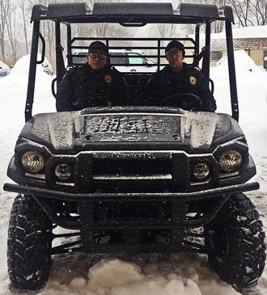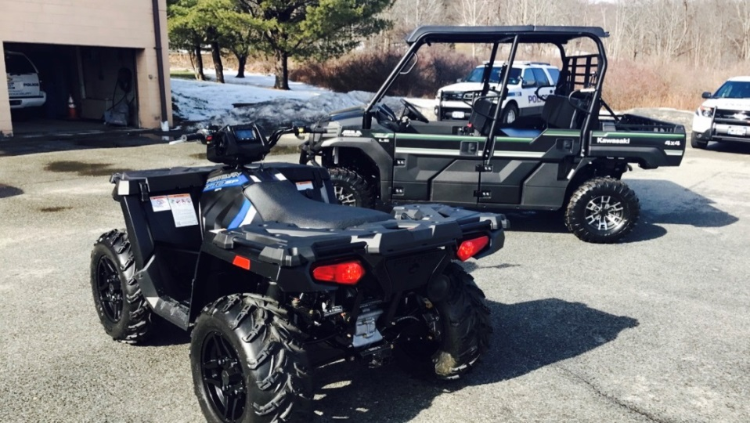

The members of the unit have completed training in the operations of the various vehicles they employ.  The unit is responsible to patrol the hillsides and the mountains that encompass the Town of Woodbury.  The lands that surround the Town are rugged, steep and not easily accessible to the normal patrol vehicle. Our mission is to patrol these hillsides and conduct any criminal investigation that we may encounter and provide enforcement within this rugged terrain.  
  
In addition, the ORU works during any special details or events which require police presence in areas where the normal patrol vehicle cannot access such as patrolling the Woodbury Commons Mall, any of the many Monroe-Woodbury Central School District functions, parades etc.

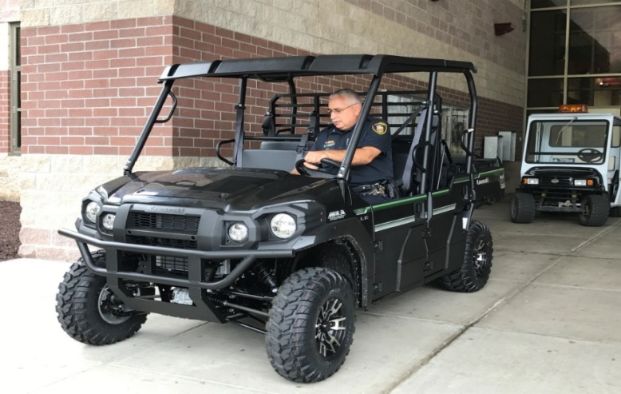

TOWN OF WOODBURY POLICE DEPARTMENT – 2024 ANNUAL REPORT

**SPECIALIZED UNITS**

Motorcycle unit

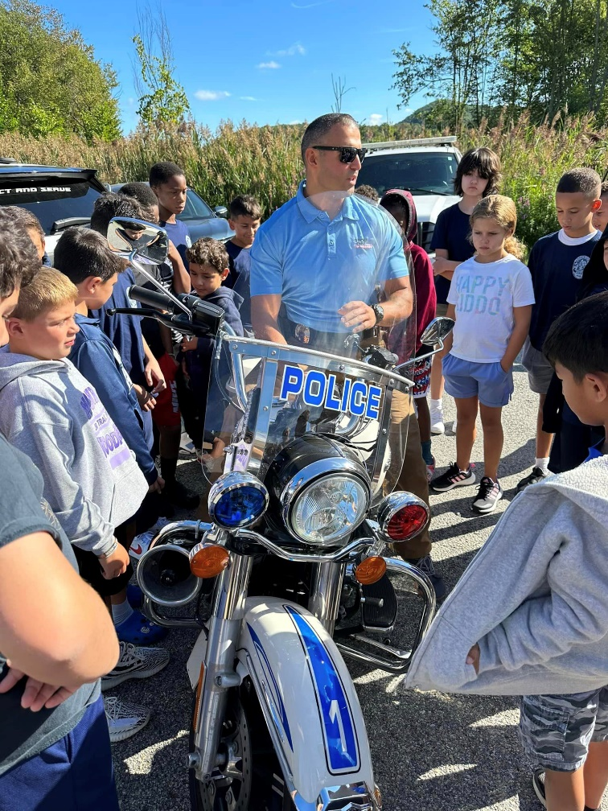

The Woodbury Police Department Police Motorcycle unit has been in service since 2003. The unit currently utilizes the Harley Davidson Road King Police package motorcycle. This unit is currently staffed with several officers. The maneuverability of the police motorcycle offers advantages not provided by larger more traditional police vehicles. One example is maneuvering through congested traffic. The Woodbury Police Department utilizes this motorcycle for traffic law enforcement, patrol, and special events such as parades, funerals, dignitary visits, and motorcycle bike runs. It is also proactive policing as the motor unit has high police visibility in the neighborhoods. It also creates police involvement and interaction with the youths in the community. Police motorcycles are often called motors, and employ unique characteristics with both high and low speed maneuverability required of the police motorcyclist. It creates a need for specialized training. Officers are required to train in low speed maneuvering, high speed control, braking, curve negotiation, defensive driving, and law enforcement techniques.

TOWN OF WOODBURY POLICE DEPARTMENT – 2024 ANNUAL REPORT

**SPECIALIZED UNITS**

K-9 unit

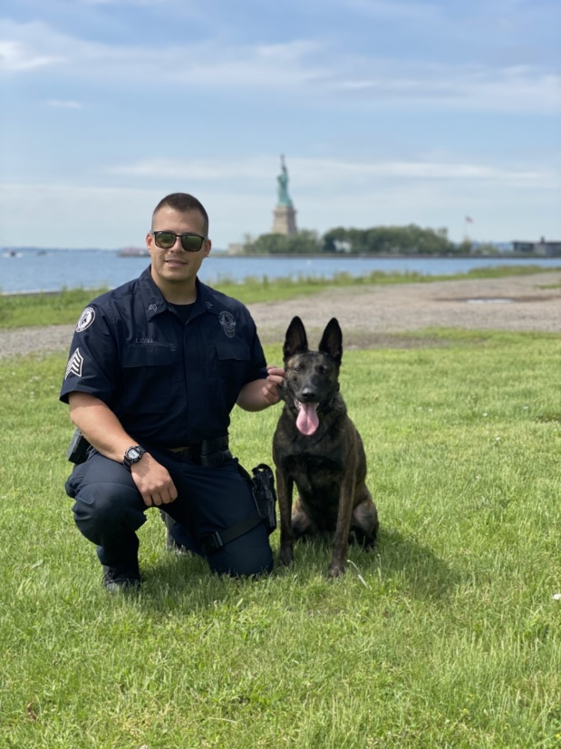

K-9 Officers' respond to assist field and detective operations within the Town, seven days a week, 24 hours a day. K-9 teams also assist with emergency calls for service including "officer needs help", "assistance" or "back-up" calls where they may assist in the search of outstanding felony suspects, misdemeanor suspects who are armed, lost and missing persons, evidence collection or explosives odor detection.

TOWN OF WOODBURY POLICE DEPARTMENT – 2024 ANNUAL REPORT

**APPOINTMENTS**

**PO Javier Quintero: 09/19/2024**

The Town of Woodbury Police Department would like to welcome their newest member to the rank and file. Police Officer Javier Quintero (Not Pictured) who were sworn into the department during the year of 2024. Their hiring fills some of the vacant positions at the department and we are looking forward to getting them on patrol. Congratulations gentlemen and we wish you nothing but success. Thank you to the Town Board for your dedication and support throughout the hiring process.

TOWN OF WOODBURY POLICE DEPARTMENT – 2024 ANNUAL REPORT

**EVENTS**

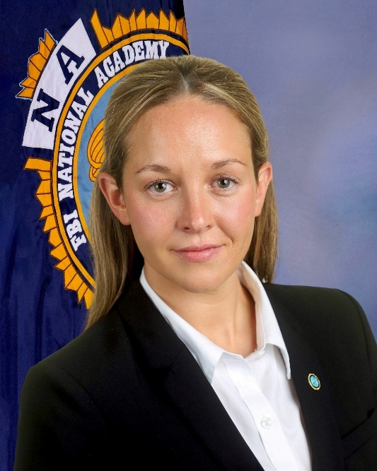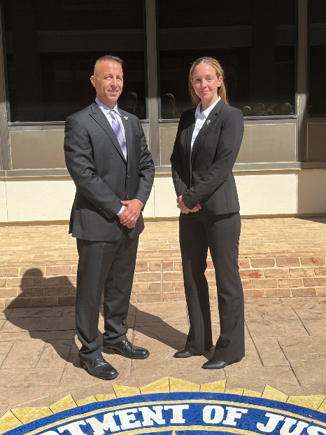

The Woodbury Police Department is proud to announce that on September 12, 2024, Sergeant Kristen Potter has become the third Woodbury Police Officer to graduate from the prestigious FBI National Academy in Quantico, Virginia. Following in the footsteps of Retired Lieutenant Arthur Abbott and Chief Kevin Watson, who both previously completed this rigorous program, Sergeant Potter's achievement underscores the department's commitment to professional development and excellence in law enforcement.

Sergeant Potter’s National Academy class consisted of men and women from 47 American states, 7 military organizations, 7 federal civilian organizations, and 26 nations around the world.

During her time at the National Academy, Sergeant Potter engaged in advanced leadership training and participated in various courses aimed at enhancing her skills in law enforcement management and operations. The program is highly selective, with only a small percentage of applicants being accepted, underscoring the significance of this achievement. The National Academy, which runs four sessions per year, is known as one of the most prestigious law enforcement executive trainings in the world where very few executives are accepted.

Sergeant Potter's graduation not only reflects her dedication and commitment to professional development but also enhances our department's capabilities in serving and protecting our community. We are proud to have such a dedicated officer among our ranks and look forward to her continued contributions to our team.

Please join us in congratulating Sergeant Kristen Potter on this remarkable accomplishment!