**What the new House bill to expand Social Security could mean for you**

“We have a deficit in Social Security, and it’s a pretty simple program: It brings in money through payroll taxes, and then it pays out benefits,” Munnell says. “So you have the choice, raising taxes to pay promised benefits or reducing promised benefits to come down to the level of current taxes. What this bill does, it says, ‘Let’s keep the benefits that we have on the book. Let’s enhance them a little. Let’s raise the money to pay for them.'”

<https://www.bankrate.com/retirement/new-social-security-bill/>

**The 7 steps to obtaining a mortgage for your dream home**

Deciding to buy a house is one of the most rewarding things you'll ever do. After all, there's nothing like being able to sit back and relax in your very own living space.

* **Get your financial and personal information in order.**
* **Find a realtor with whom you feel comfortable.**
* **Get pre-qualified, and then pre-approved, for a mortgage loan.**

https://www.delawareonline.com/story/sponsor-story/artisans-bank/2019/01/22/7-steps-obtaining-mortgage-your-dream-home/2585261002/?mvt=i&mvn=c5c5ce96fe674f3ba24bf536048cc685&mvp=NA-GANNLOCASITEMANA-11238693&mvl=Size-2x3+%5BDigital+Front+Redesign+Tile%5D

<https://www.delawareonline.com/story/sponsor-story/artisans-bank/2019/01/22/7-steps-obtaining-mortgage-your-dream-home/2585261002/?mvt=i&mvn=c5c5ce96fe674f3ba24bf536048cc685&mvp=NA-GANNLOCASITEMANA-11238693&mvl=Size-2x3+%5BDigital+Front+Redesign+Tile%5D>

**90 Ideas in 90 Minutes – 2019**

<https://www.delawarebusinesstimes.com/90in90-2019/>

[**https://www.delawarebusinesstimes.com/90in90-2019/**](https://www.delawarebusinesstimes.com/90in90-2019/)

<https://www.stereogum.com/2025750/firefly-2019-lineup/news/>

**In MARCH…………….. Open House**

**Sunday, MARCH 10, 2019**

***Save the Date***

**In FEBRUARY……FEBRUARY 10, 2019 (12-3)**

**72 Black Oak Dr, Felton…………..$270,000**

**202 Lake Cove Lane, Felton …….$325,000**

**1643 S. State St., Dover………….$205,000**

**40 Shull Dr, Newark……………….$270,000**

**10321 Greentop Rd, Lincoln……..$298,000**

My Open Houses

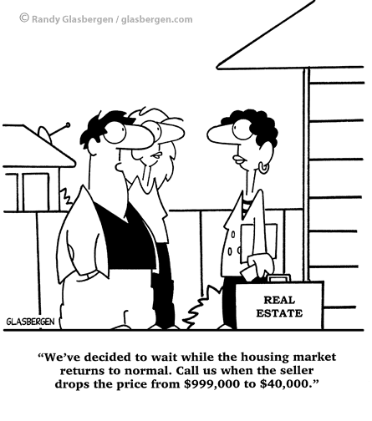

FIRST CLASS PROPERTIES

FEBRUARY AT A GLANCE

First Class Properties 1641 East Lebanon Road, Dover, DE 19901 302-677-0770

|  |
| --- |
|  |

**2019 HOME DESIGN TRENDS: 10 THAT ARE HOT AND 10 THAT ARE DEFINITELY NOT!**

* Nautical motifs - Seashells, sailor’s rope and (especially) anchors, should be cast away.
* Edison light bulbs - This design shines for a while but it’s burned out now.
* Tufted headboards - They were once “glam” but now design “spam.”
* Tuscan kitchens - They were everywhere in the early 2000’s, but it’s time to say Arrivederci!
* Damask - Once hot for wallpaper and curtains, but it now looks extremely dated.
* Matching window valances - It’s no longer cool to have curtains, valances and furniture that matches.
* Mason jar mania - Put a lid on it and bring on the hand-crafted vases instead.
* Wicker furniture - It’s so 80’s and 90’s. Time for a bright sofa instead.
* Hollywood mirror lights - The popularity of these bright lights have dimmed.
* Vertical blinds - RIP to this annoying relic. Invest is

**https://brick.com/2019-home-design-trends-10-are-hot-and-10-are-definitely-not**

**Help Wanted: The Skills Employers are Looking For**

Companies have fewer people on staff, and they are doing more things. They expect the individuals they hire to meet challenges. When they encounter a problem on a line, are they going to shut the line down, or are they going to go a step further and ask, ‘Why did this happen, and what can I do to fix it?’”

<https://www.delawarebusinesstimes.com/stuff-help-wanted/>



**Rib-Eye Steak and Crispy Smashed Potatoes for Two**

Looking for a special dinner for two? First, pan-sear one big steak to share. Then, while the steak rests, use the tasty beef fat left in the skillet to sear smashed paprika-spiced potatoes to crispy, golden perfection.

<https://www.epicurious.com/recipes/food/views/rib-eye-steak-and-crispy-smashed-potatoes-for-two>