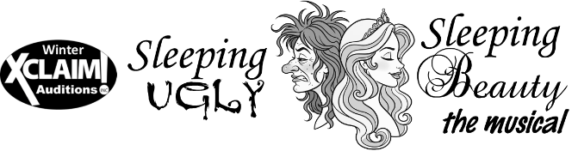
This special presentation includes two different twists on the same folktale!
Sleeping Ugly: In this short non-musical tale, a fairy places a beautiful but nasty princess and a plain but sweet maid under a sleeping spell, leaving the young prince to make a difficult and surprising decision about whom to awaken!
Sleeping Beauty: In this short musical, the evil Maleficent curses the baby princess. To thwart the curse, three good fairies hide in the forest and raise the princess as a peasant maiden. She meets a man (who is secretly the prince) in the forest but is taken to the castle on her sixteenth birthday to claim her birthright. Always ahead, Maleficent completes the curse, leaving the princess in a deep sleep. The prince must fight Maleficent’s henchmen, enchantments and finally the evil fairy to break the spell with true love’s kiss.
- AUDITIONS: Ages 4-Adults eligible. Choose one audition slot:
Saturday, December 13 3:00p-4:00p OR
Monday, December 15 5:00p-6:00p OR
Wednesday, December 17 5:00p-6:00p
502 College Street, Bowling Green, KY 42101
- AUDITION FORMAT: Interviewed by director (parents encouraged to attend), sing audition song cut(s), perform audition sides and movement/dance exercises as instructed by the director.
- CASTING: The director may multi-cast some roles or cast understudies for some but reserves the right to single cast. 2025 Fall Academy students get extra consideration, but casting is based on BEHAVIOR, LACK OF CONFLICTS, & ability to best perform audition material. Race is not a factor in any casting decisions. Gender is not a factor for casting most roles.
- FIRST MEETING & READ-THRU:
Sunday, December. 28 at 4:00p-6:00p. Parents at 6:00pm.
- REHEARSAL PERIOD: December 29 – February 11
Rehearsals depend on role (usually 3-4 days per week). Audition form has rehearsal times on each day of the week. Actors are not called to all rehearsals.
- REHEARSAL CONFLICTS affect casting. You can only perform the roles for which you can rehearse. If cast, the director accepted conflicts on your audition form, but later conflicts will NOT be accepted and WILL result in re-casting your role. NO conflicts allowed beginning 2 weeks before the show.
- PERFORMANCES: February 12-22 Thursdays, Fridays & Saturdays at 7:00pm and Sundays at 3:00pm at the Xclaim! Center.
- BACKSTAGE & TECHNICAL POSITIONS: Parties interested in stage management, costumes, make-up, lighting, or sound should attend an audition.
- EXPECTATIONS, FEES & EXPENSES: Cast members must contribute the following to our production:
$175 Activity Fee (due at 1st rehearsal) plus Assistance with costumes
Personal undergarments/dressing, footwear and make-up
A minimum of 6 volunteer hours for production needs
Strike will occur following the final performance on Sunday, February 22.
All cast members MUST stay to strike. Cast party after until 7:00p.
- CONTACT INFO: www.xclaiminc.com or email: info@xclaiminc.com

CHARACTERS
SLEEPING UGLY
Narrators are the storytellers and have the most lines in the script.
Sleeping Ugly is a beautiful princess with a mean and nasty attitude.
Plain Jane is a simple maiden who isn’t very pretty but is kind and sweet.
Fairy is old but wise with a sassy streak.
Prince is the youngest of his family and lacks confidence.

SLEEPING BEAUTY
King and Queen require actors who can convey parents’ anguish at sending their baby girl away. King has one vocal solo. Also cast in Chorus.
Visiting King is a loyal friend requiring a comedic actor who equally shows supportiveness and excitement. One vocal solo, also cast in Chorus.
Prince requires commitment and focus. He is warm & likable with a strong sense of self. Also needs strong timing and physical presence for the battle with Maleficent. Vocal range: C5 – G5
Young Prince is featured at the beginning, where he meets the baby princess. This smaller actor will also be cast in the Chorus.
Princess/Briar Rose requires a strong actor/singer. She is free-spirited, strong willed but mostly happy and respectful of her elders. Mostly, she is a dreamer who follows her heart. Vocal range: B4 – D6
Three Good Fairies range from practical to peacemaking to impulsive. They are completely devoted to the protecting the princess and fighting for good. Vocal range: A4 – D6
Maleficent requires a serious actor/singer with intense focus, physical control and ability to dominate a scene and carry a song. Surrounded by failure through comedy, she maintains formality and grace with superior intelligence, evil scheming, and relentless use of magic. Vocal range: A4 – D6
Chorus Singer/dancers make five choral groups: Animals, Fairy Magic, Henchmen (some have short lines), Royal Guards (have a couple of lines) and Loyal Subjects (the people in the kingdom). Most cast members will play more than one group. Vocal range: B4 – E6

See the Audition Song & Sides to prepare for your audition!
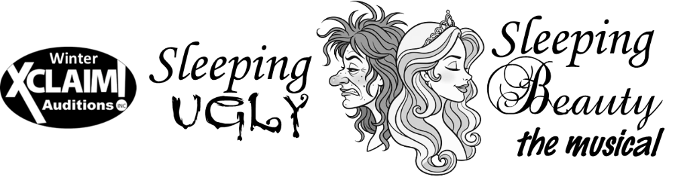
ALL auditioners sing the cut from “Once Upon a Dream”
Audition cut is from the middle of the song through the end.
AND I KNOW IT’S TRUE,
THAT VISIONS ARE
SELDOM WHAT THEY SEEM,
BUT IF I KNOW YOU,
I KNOW WHAT YOU’LL DO:
YOU’LL LOVE ME AT ONCE,
THE WAY YOU DID ONCE
UPON A DREAM.

ALL auditioners perform the following characters’ short lines.
Special attention should be given to creating different voices and physicality.

QUEEN: Can you believe it, dear? The whole kingdom has gathered to meet our baby girl, Aurora – named after the beautiful dawn!

KING: This is a wonderful day! Here is our friend the King – he has come from a afar! Ah, my friend, good to see you. And this must be the young Prince!

VISITING KING: Well, if it isn’t my loyal and dear friend the King! And his beautiful wife, the dear Queen!

ROYAL GUARD: And now to present the first gifts, their most honored and exalted Excellencies . . . The Three Fairies!

MALIFICENT: Aaaarrrrgggghhhh!!!! It’s incredible! I’ve been after the Princess for sixteen years. Sixteen years and not a trace of her! Are you sure you’ve searched everywhere?

HENCHMEN: Yes, Your Disgrace, we’ve searched mountains and forests and every cradle for the last sixteen years! Every cradle!

Choose one or two of the following sides to perform.
The director may or may not request you perform additional sides.

FAIRY 1: Each of us, the child may bless
With a single gift, no more, no less. (waves her wand)
My gift is beauty, sweet and fair
With ruby lips and flowing hair!

FAIRY 2: Each of us, the child may bless
With a single gift, no more, no less. (waves her wand)
Sweet melody is what I bring…
A voice as sweet as larks in spring!

MALIFICENT: Look around the room, Your Highnesses. Everyone you love is here. In fact, the whole kingdom was invited. But it appears that my invitation was lost in the mail. But I have a gift for the princess! A curse on the Princess Aurora! (exits laughing, in a blaze of glory)

FAIRY 3: (waving her wand)
If this curse shall come to pass,
Fear not for our little lass.
You’ll have no cause to wail or weep;
She will not die, just fall asleep. (thinks hard to end the spell)
All that she’ll need is true love’s kiss!

BRIAR ROSE: Why do they treat me like a child? My three aunts. They never want to answer my questions or have me meet anyone at all! . . . But I’ve fooled them, because I have met someone! . . . A prince . . . who’s tall and handsome and nice and we walk together, and talk together, and dance and dance and dance! And then . . . And then I wake up. Yes, I’m afraid it’s only in my dreams. But they say if you dream something often enough, it’s bound to come true. And I’ve dreamed it so many times.

PRINCE: I’m sorry, I didn’t mean to frighten you. But I’m not a stranger. We’ve met before . . . you said it yourself – once upon a dream. And since we’re such old friends . . . may I have this dance? (after a dance, she quickly starts to run away) But when will I see you again? (she replies “Tonight”) Where? (she tells you where and runs away) Goodbye! Did you hear that everyone? Tonight it is!

