**Lillian was killed in a Naples Community Hospital by a doctor who did a procedure she did not need, all she really needed was an MRI.**

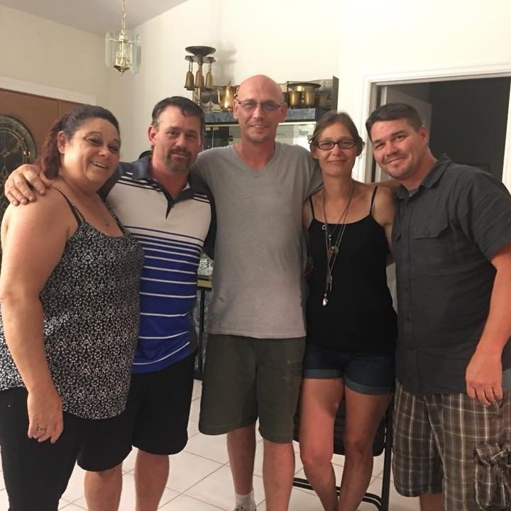

Lillian was a mother of five children Ruth, Tom, Harry, Belinda, and Billy. She had 18 grandchildren, nine great grandchildren and fostered many more children. She was an amazing woman, full of life, never passed a day without a kind word and a smile even when she worked three jobs to get by.

IT WAS HER TIME TO ENJOY LIFE, she finally had the freedom to spend time with her children, grandchildren, family and friends. These were her happiest moments, ours too. My brothers took very good care of her, made sure she had a few extra dollars in her pocket, a safe car to drive, a home in their homes where her feet could be up and her hands free of chores. A time in her life the things she never had time for could begin.

A mother is one of the Three closests bonds in life, Parent, siblings,children

IT WAS SO BRUTALLY AND SENSLESSLY TAKEN AWAY FROM HER!

Our mother learned she had a very small aneurism in her brain, it only measured 1mm in size, “the size of a sharp pencil point”. She had it for many years, it had not really grown much over those years. She had the same doctor throughout. He would do a simple MRI every few years to see if it had grown.

Lillian had Medicare and Medicaid, her insurance was changed and so her doctors were changed. The new doctor chose to do a procedure he should have never done. (the Florida medical examiner confirmed it was still only a 1mm at her death.) and it can not be coiled until it is at least a 7mm giving him no reason to go in. It was the doctors responsibility to first do no harm, an MRI has 0 risk of causing death!

According to her records reveiewed by the Florida Medical examinor He put a tube through her groin into her brain and pushed 42 pieces of plaque in, this causing her 42 strokes and a massive seizure. At this point our mother was brain dead, the doctor left the hospital not explaining to us what happened or if she had a chance at life. We kept asking him to come talk to us but he would not, we were told he was going on vacation and it was already schedualed. The only thing they would tell us is she only had 1% brain activity and we needed to let her go.

We let her go 15 days later. IT changed us! she suffered in a way so awful not one of us in that room will ever be able to get it out of our heads. MY MOTHER Lillian Gerber suffocated for 15 minutes, and we could do nothing but watch our mother die. I am sorry for that shocking moment, but the reality is, this is our reality and only we can make it stop. I understand accidents happen, but to do the things that are being done to us I cannot accept.

The doctor made a mistake and killed my mother, I can accept that, but what I cannot accept is a doctor who would take an oath to do no harm and do harm and not even accept responsibility so much as to go on vacation while we watch our mother die. Then send us the bill and wrote on her death certificate she died of natural causes …That I cannot ever accept.

I cannot accept that of five women in a room two of them on their loved one’s white boards in their hospital room it read:

NOT MARRIED OVER 25 and Florida Statute

**This shows awareness and intent.**

To say that because my mother did not support us financially that she had no value. That justice for her is unattainable because her youngest child was 45 and she was divorced. To create a law that says we don’t have a right to hold a man accountable for killing her or have equal access to the law is simply detestable.

She was as alive as any other person ever was, her life was taken by another person’s hands and whether by accident or purposeful intent she deserved justice. A correct system would allow spouse and or children regardless of age to access the court of law and let a judge and jury decide innocent or guilty and allow an open door to settle out of court and if it is settled out of court you know it’s because the preponderance of evidence proved it was true. it’s called due process.

It is their benefit to settle out of court instead of facing criminal charges or losing their license not ours, there is no dollar value to compensate for human life, it was designed to protect them not us. The whole state of Florida does not have enough money to pay for my mother’s life. I am angry that this doctor took my mom’s life, and he does not even have to have the beside manor to give us the news, why? He already knew we could not hold him accountable.

Thank you for giving my mother’s story a moment of your time.

She was a precious gift in our lives, our whole family misses her beautiful smile, her kind funny heart, and her company.

For the past three years since my mother’s death June 6, 2018, I have been to Tallahassee capital three years in a row speaking to every representative and senator in the state of Florida. **Not one of them can say that they do not know what the free kill law is and what it means for the people.** So, no more excuses should be accepted from them.

To my understanding as for our side we have most the representatives and perhaps most of the senators that I would be proud to name, AARP and the Florida Justice Association.

Some representatives and senators who won’t let it be heard and don’t want it changed**, they however have big corporations, Lobbyist, doctors club, and insurance companies backing them telling them not to let it be heard.** Danny Burgess is the chair and refuses to allow it to be heard. Kathleen Passidomo and Jim Boyd also do not want it heard.

Why? Because we are the problem they say, all we want to do is sue! Why should they have to pay for us being sad. Bob Rommel said to me “Come on Belinda you don’t need your parents after 25.” And then insulted me with a statement like we just want to sue. I can’t sue I’m past my statute of limitations, I don’t want it to happen to anyone else. I did not make the method to get justice from a doctor or a hospital killing your family one of financial responsibility, you did!

You and the big corporations, insurance companies, lobbies, hospitals, doctors, and big pharma did that to protect themselves and then our representatives and senators allowed them write into law taking away our option to take their license or hold them accountable in any way to again protect yourselves, no matter how heinous the crime.

One senator we spoke with was on our side and it was said to him **“To do this they must have sold their souls.” His response was “we all did!”** I don’t have a problem telling what I saw and heard every time I am there, I am appalled that we are doing this to each other for money’s sake. Instead of the sensible, moral, ethical, responsible thing to do and let a court of law do its job and stop making yourselves immune to any act of human rights violations you can write down with a pencil.

At this point I believe anyone keeping it in place is just as guilty as the one committing the crime, representatives, and senators alike. May God forgive you I don’t know if I can!

Belinda Soseray Warren

Daughter of Lillian Eileen Gerber …I love you mom!

May 100,000 people line the hallways of the Florida senate and make them hear us one at a time. Statute 768.21(8) HB 6011 & 6039 SB 560 & 262

