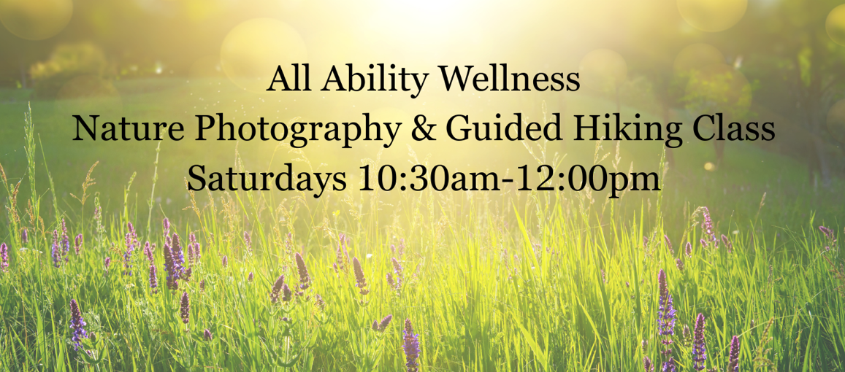
Explore the beauty of Long Island’s parks, preserves, forests, and beaches while learning how to capture it all through your lens. This fun, supportive, and immersive small-group experience blends nature photography, gentle hiking, mindfulness, and forest bathing to help you slow down, connect, and truly see the world around you. Each session takes place at a different scenic location and includes:

Photography Instruction: Learn basic photography techniques using your cell phone or personal camera, with access to a variety of professional cell phone camera lenses, including:
- Telephoto Zoom Lens – capture distant subjects
- Fisheye Lens – create unique circular effects
- Macro Lens – photograph flowers, insects, and small details
- Wide-Angle Lens – showcase sweeping landscapes

Guided Hiking & Outdoor Skills: Learn essential hiking techniques, including:
- Trail awareness & navigation basics
- Pacing, rhythm & movement in nature
- Simple stretching, hydration & outdoor tips

Mindfulness in Nature: Incorporating mindfulness techniques, this class will help you connect deeply with your surroundings, enhancing both your hiking and photography experience.
- Slow down and reconnect with nature through:
- Guided breathing and grounding exercises
- Gentle Forest bathing practices to reduce stress and increase presence

Program Details
- Each class meets at a different park (location details provided upon registration)
Commit to at least three sessions to build skills and confidence
Small group rate: $125 per 90-min class (plus park fees, if applicable)
Photos taken during class can be shared in a private Facebook group
Open to all abilities—no prior photography or hiking experience needed!
- Pre-registration is required. Sign up today to secure your spot and start capturing the beauty of nature like never before! 🌿
- Open to people of all abilities - no prior photographic knowledge or experience is needed.
- Registration is required before attending classes. Location details and directions will be provided only to registered participants.

Please ensure your registration is confirmed before attending. Thank you!
*Park locations may change—please check the All Ability Wellness website for updates.
Registration link is available at www.allabilitywellness.com

Spring Schedule
*Park locations may change—please check the All Ability Wellness website for updates.
Dogs are welcome upon request. Please contact us for additional information.
April 18 – Avalon Park (Shep Jones Rd. entrance in St. James)
Gardens, streams & woodland paths • Perfect intro to nature photography
🐕 Dogs: Yes
April 25 – Gardiner County Park (Bay Shore)
Open meadows & bay views • Sky, water & sunset photography
🐕 Dogs: Yes
May 2 – Caleb Smith State Park (Smithtown)
River trails & wildlife • Quiet Forest + bird photography
🚫 Dogs: No
May 9 – Robert Moses (Lighthouse Area)
Beach, dunes & boardwalks • Minimalist coastal beauty
🚫 Dogs: No
May 16 – Sunken Meadow State Park (Kings Park)
Bluffs, beach & marsh • Expansive coastal views
🚫 Dogs: No
May 30 – Bayard Cutting Arboretum (Great River)
Gardens & riverfront • Calm, scenic & meditative
🚫 Dogs: No
June 6 – West Hills County Park (Huntington)
Forest trails & hills • Deep nature immersion
🐕 Dogs: Yes
June 13 – Connetquot River Preserve (Oakdale)
Protected woodland & streams • Peaceful, wildlife-rich
🚫 Dogs: No
June 20 – Manorville Hills County Park
Pine barrens & sandy trails • Unique LI ecosystem
🐕 Dogs: Yes
June 27 – Belmont Lake State Park (West Babylon)
Lake reflections & easy paths • Great for beginners
🐕 Dogs: Yes
Come breathe, explore, and capture the beauty around you—one step and one photo at a time.

www.allabilitywellness.com
Laura@allabilitywellness.com
631-708-7770

