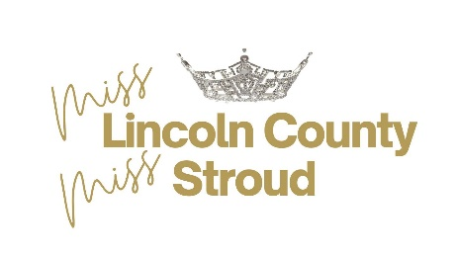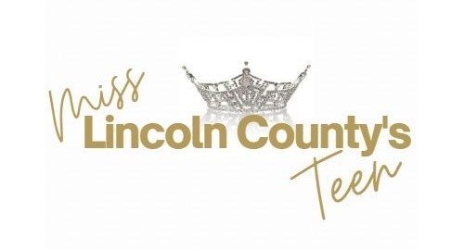

We are so glad that you are going to compete for the title of

Miss Lincoln County/Miss Stroud or Miss Lincoln County’s Teen!

**June 16, 2025 – Entries Now Being Accepted**

**July 1, 2025 – Prince & Princess Pageant Applications Due**

**July 13, 2025- 5:00 pm – Miss and Teen Applications Due**

**July 20, 2025 – People’s Choice Voting Will Begin. Photos will be posted on our website and social media. Votes are $1 each to be paid on Venmo @MissLincolnCountyOK. Voters should send “as a friend” and be sure to put in your name!**

**July 21 – August 1 – RAISE $30 FOR THE American Heart Association through SPOTFUND.**

**July 27, 2025 – Prince & Princess Pageant Prague Middle School Auditorium**

**August 1, 2025 – Online People’s Choice Voting will end at 6:00 pm.**

**In person voting for People’s Choice will continue until intermission.**

**August 2, 2025 – COMPETITION DAY! Stroud Performing Arts Center**

**Schedule with times will be sent out once all entries are received.**

**Schedule will be like this:**

**Jr Pageant Contestants**

**Rehearsal for Opening//Competition/Crowning Segments**

**Talent Rehearsals coinciding with Interviews (don’t worry, I’ve got the schedule all worked out so you aren’t rushed getting ready!) – Schedules will be emailed once the entry deadline has passed.**

**Interviews end at 4:00 at which time everyone will leave the auditorium.**

**Once you are finished with your talent rehearsal and interview, you are welcome to leave to go explore Stroud! We will have a list of sponsoring restaurants in the area for your reference. If you go into any restaurants/stores, PLEASE tell them that you are with the competition and THANK YOU FOR YOUR SUPPORT!**

**4:15 – Auditorium Closed**

**6:00 – Auditorium Doors Open**

**6:30 – Showtime!**

**NO SMOKING/VAPING OR FOOD INSIDE OF THE AUDITORIUM OR DRESSING ROOMS!**

We are livestreaming the competition on EventLive.com. Videos of the competition will be available for afterwards for $20 which will be on a flashdrive that will be sent to you. Stacey will send info after the competition with info.

Attire:

**Opening Number TEEN -**Anything **ORANGE, RED OR PINK COCKTAIL ATTIRE – NO JEANS. MISS – ANYTHING BLUE, PURPLE OR GREEN COCKTAIL ATTIRE – NO JEANS. WOULD PREFER NEON COLORS!!!**

**ON STAGE CONVERSATION**: Wear your opening number outfit.

**Health & Fitness – All active/fitness wear must be ordered from REBEL ATHLETIC. USE CODE: MAOOKGB. Anything red from the Miss America line. NO EXCEPTIONS TO WEARING ANYTHING BUT THE REBEL ATHLETIC BRAND FITNESS APPAREL. WHITE tennis shoes.**

**BRING YOUR OWN MIRRORS, EXTENSION CORDS and CLOTHES RACK**

**STEPS TO ENTER:**

1. **Preferred that you first fill out an Request for Application Form found on www.MissLincolnCountyOK.com**
2. **REGISTER ON MISSAMERICA.ORG. PAY $49.99. SELECT Miss Lincoln County. You will digitally sign the Miss America Delegate Contract and upload documents directly to this document.**
3. **Director will email you the following: MLC application form link, link to set up Spotfund account and Miss Lincoln County contracts.**
4. **Download documents from** [**www.misslincolncountyok.com/contestantforms**](http://www.misslincolncountyok.com/contestantforms)
5. **Upload completed documents to jotform and pay entry fee**

**BOTH TEENS AND MISS NEED TO SEND IN ENTRY FEE OF $125 to Miss Lincoln County through the link on jotform. IF YOU PAY BY PAYPAL PLEASE INCLUDE $5.00 SERVICE FEE.**

**ALL OF THE ABOVE ARE DUE BEFORE 5:00 PM ON July 13,2025.**

Please read the Lincoln County Local Contract Addendum that will be sent to you. **Please read before entering. Print out, sign and BRING WITH YOU TO CHECK IN ON DAY OF COMPETITION.**

**\*I will be meeting with the new titleholders the week after the competition as we are going to hit the ground running!!**