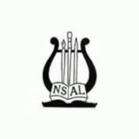
Dorothy Lincoln-Smith
Voice Competition 2023
for
Classically Trained Singers Ages 23-31
$10,000 in Awards
Sponsored by
The National Society of Arts and Letters
www.arts-nsal.org

Applications due at Chapters March.1, 2023
Chapter Winners to DLS by March 10, 2023
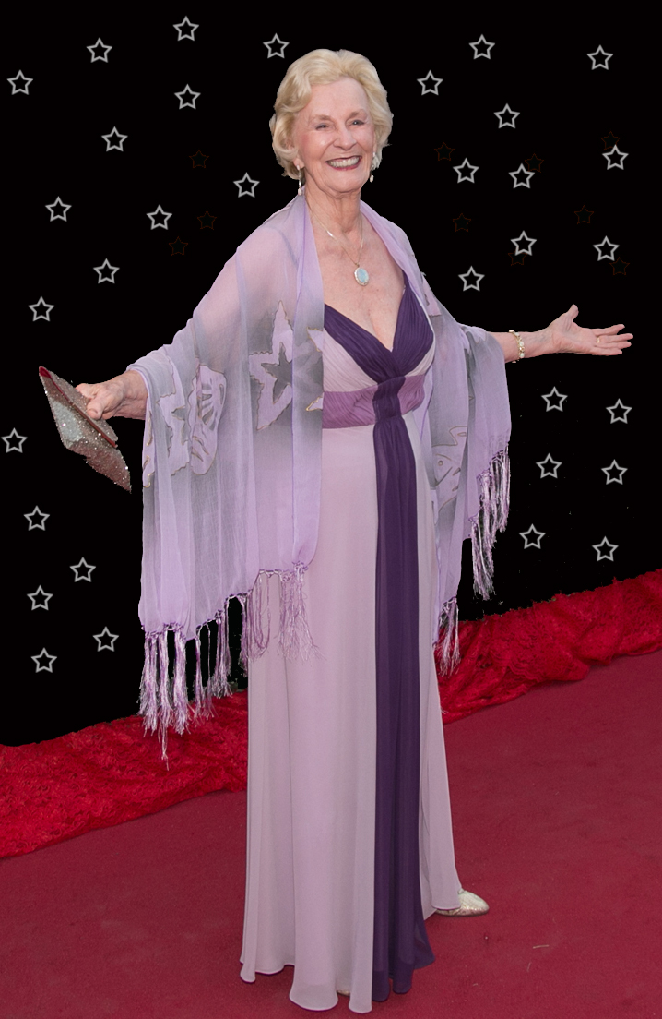

DOROTHY LINCOLN-SMITH VOICE AWARDS
Sponsored by THE NATIONAL SOCIETY OF ARTS AND LETTERS

A Classical Voice Competition with $10,000 in awards is the National Society of Arts and Letters legacy of Dorothy Lincoln-Smith commemorating two years as National President ending in 2016.

ELIGIBILITY

Applicants must be 23-31 years of age by March 1, 2023. Former applicants including recipients of the Winston Voice Scholarship are encouraged to enter. First place winners of the DLS Competition may not
enter again. Each NSAL Chapter may submit two candidates.

APPLICATION
Chapters may choose:
1. COMPETITION BY VIDEO - must include ONE current high-quality video of the applicant performing ALL the required repertoire, not to exceed 12 minutes.
a) Selections are not to be edited except for accompaniment interludes and introductions which may be cut in the interest of time.
b) The audio may not be enhanced, and the singer should be clearly visible.

2. LIVE COMPETITION --Two finalists will then prepare and send a video as instructed above for National Competition. Applicants please check with Chapter Chairs to determine live or video competitions.

The repertoire must include:
a) Two opera arias, or one opera and one operetta aria
b) One art song, or one oratorio aria
3. Three languages represented, one being English.
4. Repertoire selections must be by different composers, demonstrating contrasting styles.
5. Dramatic interpretation encouraged.
6. Repertoire to be sung from memory except the oratorio selection. Each singer must submit only one video which includes all required repertoire. The
video may be a compilation but without enhancement

PROCEDURE FOR SUBMITTING APPLICATION

Upload completed video to YouTube, identifying yourself by name only. List only song titles and composers in the Description.
- Complete Application Form. Be clear about your commitment to a vocal arts career. Include a short biography especially noting young artist programs, study abroad, etc. Listing future appearances/engagements is encouraged.
- Apply to any one NSAL Chapter, via email, provide the link (URL) to your YouTube video and attach the completed application form. Chapter application deadline: March 1, 2023.
- Chapter Chairs send the videos and applications of not more than two chapter winners by email to Classical Voice Chair: Dorothy Lincoln-Smith.

NATIONAL ADJUDICATION
- Applicants will be judged for musicality, vocal quality, interpretation, diction, presentation, and ability to demonstrate exceptional talent and promise of future success.
- Qualified national judges will select singer(s) to receive awards(s), with award amounts determined by the Committee. Judge and Committee decisions are final.
- Award funds will be given directly to winners when announcements are made. Maximum awarded to an applicant is $5,000.
- A winner may have the opportunity to perform at the NSAL National Meeting in May, 2023.

NATIONAL CLASSICAL VOICE SCHOLARSHIP CHAIR
Dorothy Lincoln-Smith dlincolnsmith@cox.net
CO-CHAIR: Thomas Jones, thoswjones44@gmail.com

Notice to all Applicants:
By participating in the Dorothy Lincoln-Smith Voice Awards you consent to your name, image, and likeness being listed on NSAL website and other materials including for advertising, fundraising, and promotional purposes, without payment or additional compensation unless prohibited by law.

CHAPTER DLS CLASSICAL VOICE CHAIRS

ALABAMA: BIRMINGHAM CHAPTER les.fillmer@earthlink.net
Les Fillmer 205-608-3093
1511 Meadows Dr. Birmingham, AL 35235

ARIZONA: GREATER ARIZONA CHAPTER chauan@cox.net
Catherine Hauan 480-767-8182
10797 N. 105th Way Scottsdale, AZ 85259

ARKANSAS: LITTLE ROCK CHAPTER slhhsinger@yahoo.com
Sherry Henderson 501-352-0339
5116 Cantrell Road, Little Rock, AR 72207

DISTRICT OF COLUMBIA, MARYLAND, and NORTHERN VIRGINIA:
WASHINGTON, D.C. CHAPTER
Seth Arenstein sethygee@gmail.com
10913 Thanlet Ln. Reston, VA 20190 571 236 2896

FLORIDA: FLORIDA EAST COAST CHAPTER
Judi Asselta judiasselta@gmail.com
7170 Promenade Drive #701, Boca Raton, FL 561-756-5412

HAWAII: HAWAII CHAPTER
Carolyn A. Berry Wilson momcab@aol.com
Carrie Hedden, assistant berryexecassist@gmail.com
980 lkena Circle, Honolulu, H196821 808-373-2980

ILLINOIS: CENTRAL ILLINOIS CHAPTER
Sarah Francys Wigley swjohn@illinois.edu
600 N. Neil St. #871 Champaign, IL 61824 612-483-0472

ILLINOIS: METROPOLITAN CHICAGO CHAPTER: tlac31@comcast.net
Judy Park 847-710-7127
3135 Shagbark Lane, Long Grove, IL 60047

INDIANA: BLOOMINGTON CHAPTER
Mary Alice Cox maryalicecoxdvm@gmail.com
4885 N. Bruce Lane, Unionville, IN 47468 812-320-2109

KENTUCKY: KENTUCKY CHAPTER
Sarah Moore seomoore@yahoo.com
5500 Spirit Ridge Lane, Lexington, KY 40515 859-338-1490

MISSOURI: ST. LOUIS CHAPTER lindajbseibert63@gmail.com
Linda Seibert 314-498-9297
8735 Delmar Blvd. #1E, St. Louis, MO 63124

NEW JERSEY, DELAWARE and NEW ENGLAND: NEW JERSEY CHAPTER
Judy Martorelli smartorielly@verizon.net
52 Kahdena Road, Morristown, NJ 07960 973-267-0952

NEW YORK: GREATER NEW YORK CHAPTER smontage@gmail.com
Sam McKelton 704-281-2763
243 Halsey St. 5A, Newark, NJ 07102

OHIO and WEST VIRGINIA: OHIO RIVER VALLEY CHAPTER
Jayne Whitlow jaynewv@hotmail.com
1206 55th St. Vienna, WV 26105 304-483-1525

PENNSYLVANIA: PITTSBURGH CHAPTER
Rikke Foulke rikke@paintingsconservator.com
1100 Itin St., Pittsburgh, PA 15212 412-321-0779

ABOUT DOROTHY LINCOLN-SMITH

Dorothy Lincoln-Smith was a leading solo vocal artist in concert venues throughout Europe, Asia, Australia, and the U.S., with the Roger Wagner Chorale, the Los Angeles Master Chorale, Bach & Madrigal Society (now Phoenix Chorale), and the Phoenix Boys Choir under the direction of the late Harvey K. Smith. Performing the role of Constanza in Mozart's Abduction from the Seraglio with the (now) Arizona Opera was a special favorite as well as Olympia’s “Doll Song” from Offenbach’s Tales of Hoffman.

She has been a member of NSAL since 1971 having completed a term as National President in 2016 and as Chair of the Board of Trustees. Dorothy serves on the Boards of the Scottsdale Museum of Contemporary Art, (honored in 2017 for longtime service) the Phoenix Boys Choir, (honor in 2023, for PBC 75th Anniversary), and the Metropolitan National Opera Council-AZ. She received the Arizona Governor’s Arts Award in 2020.

Dr. Lincoln-Smith earned a Bachelor of Music from Cornell College, Iowa, and in 2018 she received the Distinguished Achievement Award for service to the college, participation in community affairs, and distinguished achievement in her fields of endeavor. She received the Master of Music and Doctorate at Arizona State University in 1973 and is a retired Professor of Voice and as soloist at First Church of Christ Scientist, Phoenix.

Unique achievements include Advanced Certification in Scuba Diving; Dorothy has completed 914 dives with the goal of reaching 1000.

