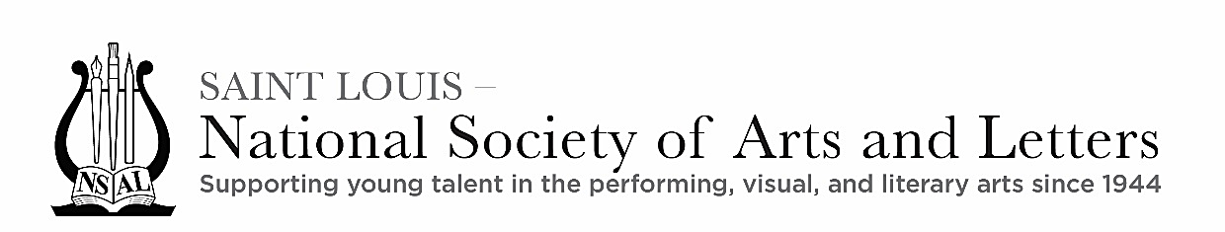
Artist Support Fund Application
The National Society of Arts and Letters, Saint Louis Chapter

The National Society of Arts and Letters was founded in 1944 to encourage young people to pursue careers in the fine and performing arts. More information may be found on the National website, https://arts-nsalnatl.org/

The Saint Louis Chapter of NSAL offers grants from the Artist Support Fund to emerging artists between the ages of 20 and 30. The purpose of the fund is to help the artist advance their career through specialized training in their artistic field. Eligible fields are art, drama, dance, literature (creative writing), music, or musical theater. The maximum grant for one year is $2,500, and individuals may be awarded a lesser amount at the discretion of the Artist Support Committee. Award recipients may reapply once for a second grant after one year. Grants are not to be used for college or university tuition.

Grants will be evaluated based on the applicant’s proven commitment to their artistic field, level of accomplishment attained, and the justification provided for the request. The Saint Louis Chapter reserves the right to determine the amount of the grant and to approve or deny the request. There is no application deadline; applications will be evaluated as they are received.

Please save the application to your computer, complete all items, save it, and submit it as an email attachment with all required supplemental materials (see below).

This document will expand as you type the answers below.

Date of Application (month/day/year):

Applicant’s Full Legal Name:

Professional Name (if different):

Date of Birth:

Street Address, City, State, and Zip Code:

Telephone with Area Code:

Email Address:

Amount of Funding Requested:

Detailed description of how funds will be used to advance your artistic career:

If funding will be used for a career-specific opportunity or training program, provide a complete description including location and web link for sponsoring organization, if applicable:

Proposed dates when funding will be applied:

This application must be accompanied by the following materials.

1. A résumé including educational background; previous training in the artistic discipline; details of professional performances, exhibitions, or publications of your work; awards received; and career plans. Attach this to the email as a pdf file.

2. Two letters of recommendation from professionals in your artistic field who are familiar with your artistic ability. These letters must be submitted with the application and attached as pdf files.

3. A sample of your artistic performance, submitted in the formats specified below.

Art: In the space below, provide details of an exhibition in which your work has been shown, including the name of the venue, the location, and the dates of the exhibition. Attach up to 5 jpg files of your works in this show. (The total size of the attachments should not exceed 10 MB.)
Dance, Drama, Music, or Musical Theater: In the space below, provide details of a recent performance, including the name of the event, the location, the sponsoring organization, and the dates. Include a YouTube link to a video of your performance (in the show cited if available; if not, another sample of your performance is acceptable).
Literature: In the space below, provide details of a work that has been published. Attach a copy of the publication, as a pdf file.

Description of Sample Performance:

Send this completed application and all attachments by email to the Artist Support Chair at sandibrook@aol.com. You should receive an acknowledgment within ten days of submitting your application.

