**BE WHITE OR NATIVE - NEVER BLACK**

Claim your White or Native American heritage. NEVER claim to be "Black or African-American" because "*Tim, I don't look at myself as the first 'BLACK' president, because the word "BLACK" has no standing at law*." - Fmr Pres. Obama to Tom Joyner on 10/16/2012

"*Do an SF-181 to Change Their Status to White and American Indian*."

This entire video by Chief:Naya-Shaabu:Eil is excellent and *SHOWS* the legal definitions.

LINK: https://youtu.be/f9atlE9iHqc

Watch this Phil Donahue episode with Dr. Frances Cress-Welsing beginning at 18:00 - 18:48.

The video is cued to the place where Dr. Cress-Welsing states to "*claim your whiteness*".

She's referring to the form SF-181.

LINK: https://youtu.be/iquXlgRGX7I?t=18m

Federal government form SF-181

LINK: https://www.opm.gov/Forms/pdf_fill/sf181.pdf

This is the opposite of teaching hate. This literally shows ***how*** the government has legally created a 'classification' that has "***NO STANDING AT LAW***". This is how the government is able to arrest and/or kill *SO MANY* "Melanin-dominant" people who have been erroneously taught to claim being legally "Black or African American" *AND* are getting away without being charged.

"In law" people who have been programmed to believe they are "Black or African American" have ***no rights***. When enough "Melanin-dominant" people correct their status, then the private police & prisons-for-profit will be legally required to change how 'officers' are trained and the

repercussions of false arrest, assault & battery, false imprisonment, murder will be harsh for them.

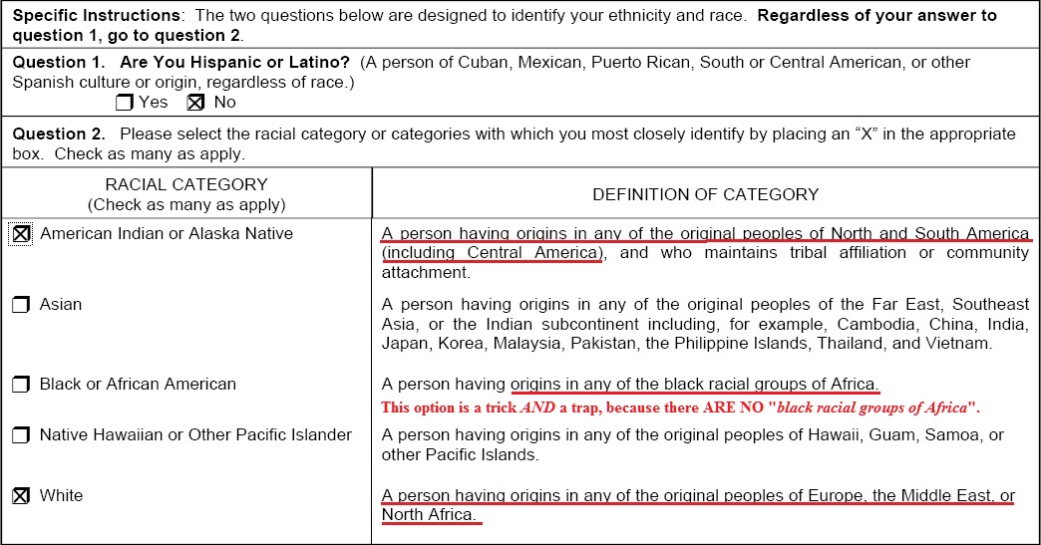This is the portion we fill at the bottom of the form SF-181: