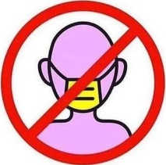
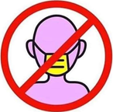
NOTICE
IF YOU HAVE FLU SYMPTOMS: DO NOT ENTER
(Please go home, get rest, and come back when healthy.)

California Penal Codes 2052, 182, and 185 prohibit this establishment from the unlicensed practice of medicine (such as taking temperatures), or any act injurious to public health. ***Requiring face coverings of any kind is prescribing a medical device or other equipment that may cause injury to private or public people.

Cal. OSHA Regulation § 5144 requires a medical physician to provide written approval that an employee is physically fit to restrict his/her breathing, as oxygen levels below 19.5% may cause permanent brain damage.

WE ARE A PRIVATE BUSINESS (NOT A GOVERNMENT AGENCY); THEREFORE, POSSESS THE RIGHT TO DO BUSINESS:

Article I, Declaration of Rights, Section 16 of the “California State Constitution, 1849” AND . . .
Article I, Section 10, Clause 1 of the “Constitution for the united States of America”, aka: “Contract Clause” state: “No bill of attainder, ex post facto law, or law impairing the obligation of contracts, shall ever be passed.”
Article IV, Section 2 states “The Citizens of each State shall be entitled to all Privileges and Immunities of Citizens in the several States.” (You have the right to medical privacy further protected by the ADA and HIPAA.)
Article VI, Paragraph 2 “Constitution for the united States of America” is referred to as the Supremacy Clause. It establishes the federal constitution, and federal law generally, take precedence over state laws & constitutions.
Amendment I guarantees that “Congress shall make no law respecting an establishment of religion, or prohibiting the free exercise thereof; ... or the right of the people peaceably to assemble, ....”
Amendment IV “The right of the people to be secure in their persons, houses, papers, and effects, against unreasonable searches and seizures, shall not be violated, and no Warrants shall issue, but upon probable cause, supported by Oath or affirmation, and particularly describing the place to be searched, and the persons or things to be seized.”
16 Corpus Juris Secundum; Constitutional Law § 3 [Right of self-government.] states: The people of the state have the sole and exclusive right to govern themselves as a free, sovereign and independent state.

Pursuant to the unannotated Title 28 U.S. Code - Judiciary and Judicial Procedure § 607. Practice of law prohibited states: “An officer or employee of the Administrative Office shall not engage directly or indirectly in the practice of law in any court of the United States”. Pursuant to (June 25, 1948, ch. 646, 62 Stat. 915.)

ANY agency that trespasses upon these rights shall be charged under: 18 U.S. Code §§ 241, 242, 245, and 2381 (Conspiracy to deprive federally protected liberties under “color of law” by treason).

DOMESTIC TERRORISM - Section 802 of the USA Patriot Act (Public Law No. 107-52)
[re-codified under Title 18 U.S. Code § 2331 domestic terrorism] expanded the definition of terrorism to cover "domestic", as opposed to international, terrorism. A person engages in domestic terrorism if they do an act "dangerous to human life" that is a violation of the criminal laws of a state or the United States, if the act appears to be intended to:
(i) intimidate or coerce a civilian population;
(ii) influence the policy of a government by intimidation or coercion;

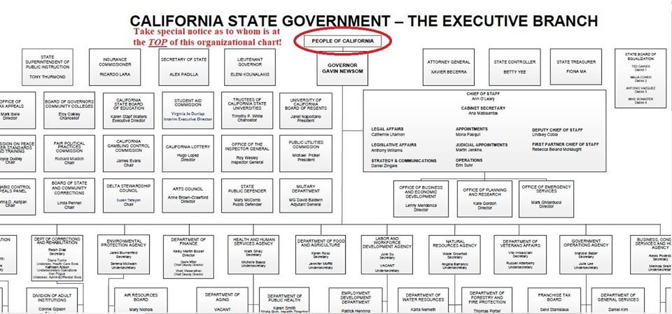
"A 'Statute’ is not a Law,” (Flournoy v. First Nat. Bank of Shreveport, 197 La. 1067, 3 So.2d 244, 248).
A “ ‘Code’ is not a Law,” (In Re Self v Rhay Wn 2d 261), in point of fact in Law, A concurrent or ‘joint resolution’ of legislature is not “Law,” (Koenig v. Flynn, 258 N.Y. 292, 179 N. E. 705, 707; Ward v State, 176 Okl. 368, 56 P.2d 136, 137; State ex rel. Todd v. Yelle, 7 Wash.2d 443, 110 P.2d 162, 165).
All codes, regulations, rules, statutes, and etcetera are for government authorities only, not Live Souls living in accord with God’s Laws and Laws of God’s Nature.
“All codes, rules, and regulations are unconstitutional and lacking due process of Law. All laws, rules and practices which are repugnant to the Constitution are null and void" [Marbury v. Madison, 5th US (2 Cranch) 137, 180].
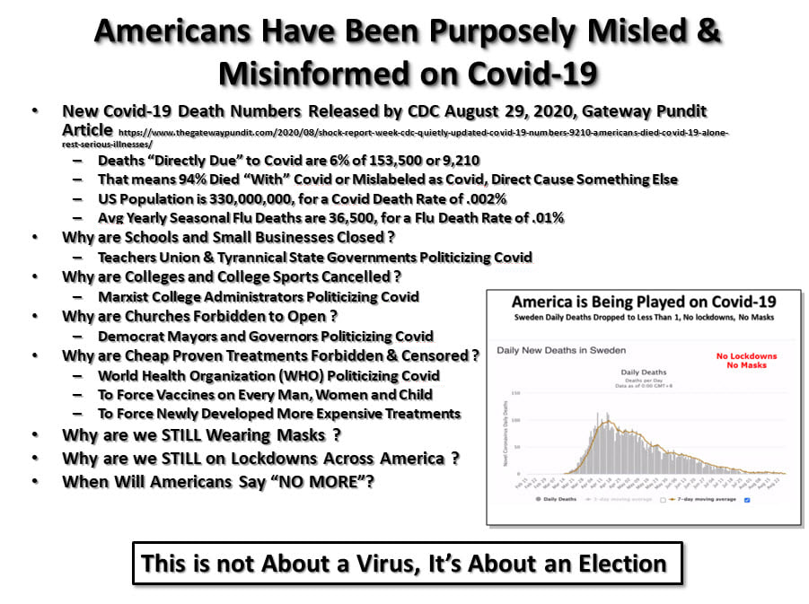

This is not about a virus. It IS about getting your voluntary consent to be governed by evil people.

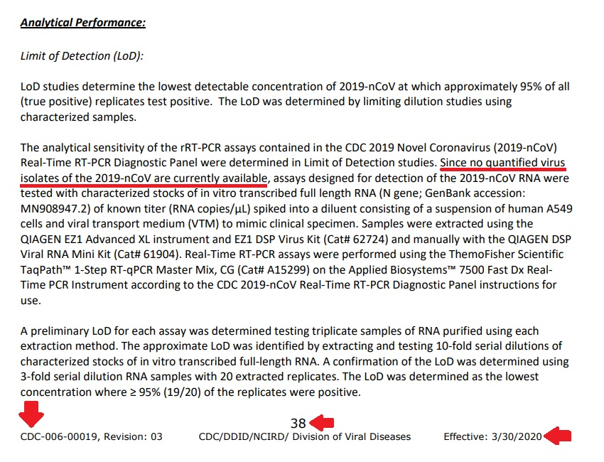

https://attogene.com/wp-content/uploads/2020/03/CDC-RT-PCR-eval-nCoV-IFU2-WP.pdf?fbclid=IwAR2GIjzGqRZgvOHDeDW-lNaMTBNaoIiJ1NgIBmlfR24ZAgIeOCPOL2afeaQ
- 03/15/2020 page 35, second to last paragraph, second sentence.

https://les-crises.fr/wp.../uploads/2020/04/CDC-tests.pdf
- 03/30/2020 page 38, second to last paragraph, second sentence.

https://www.fda.gov/media/134922/download
- on 06/12/2020 Revision 3 and 07/13/2020 Revision 5 page 39 - last paragraph, second sentence.

If the virus has not been isolated, then ... a test or vaccine cannot be created. THINK about that.
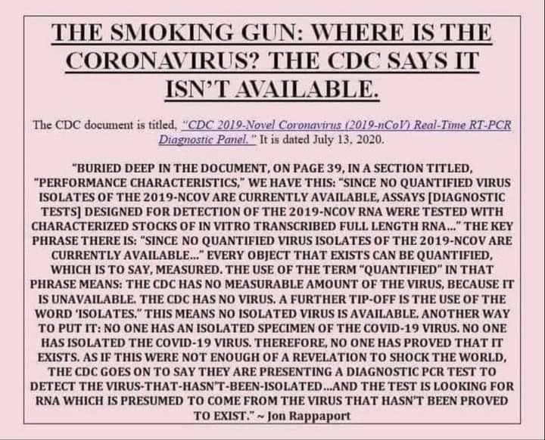

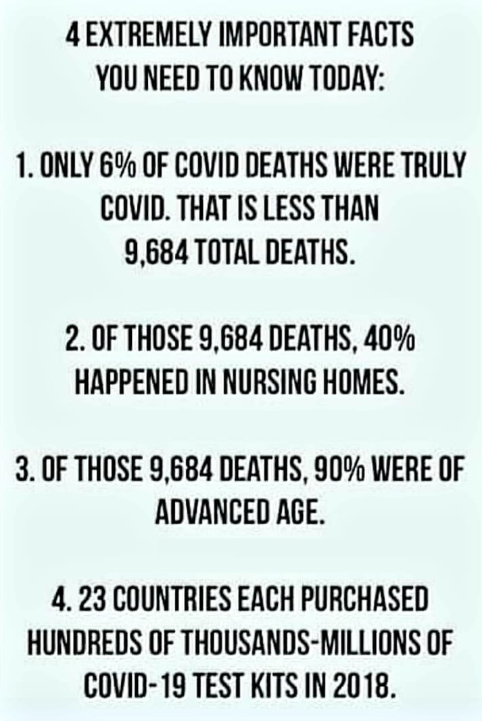

https://wits.worldbank.org/trade/comtrade/en/country/ALL/year/2018/tradeflow/Exports/partner/WLD/nomen/h5/product/300215 – “COVID-19 test kits” was changed to “Medical test kits” once the fraud became public.

2021 will be the year of cancer spikes in otherwise healthy people who covered their faces “religiously”:

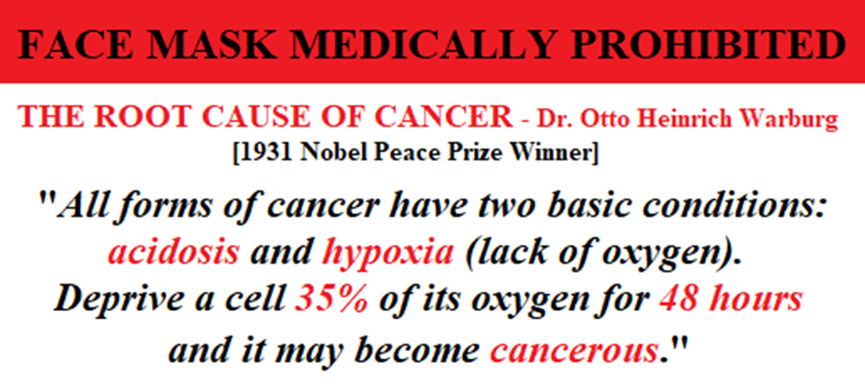

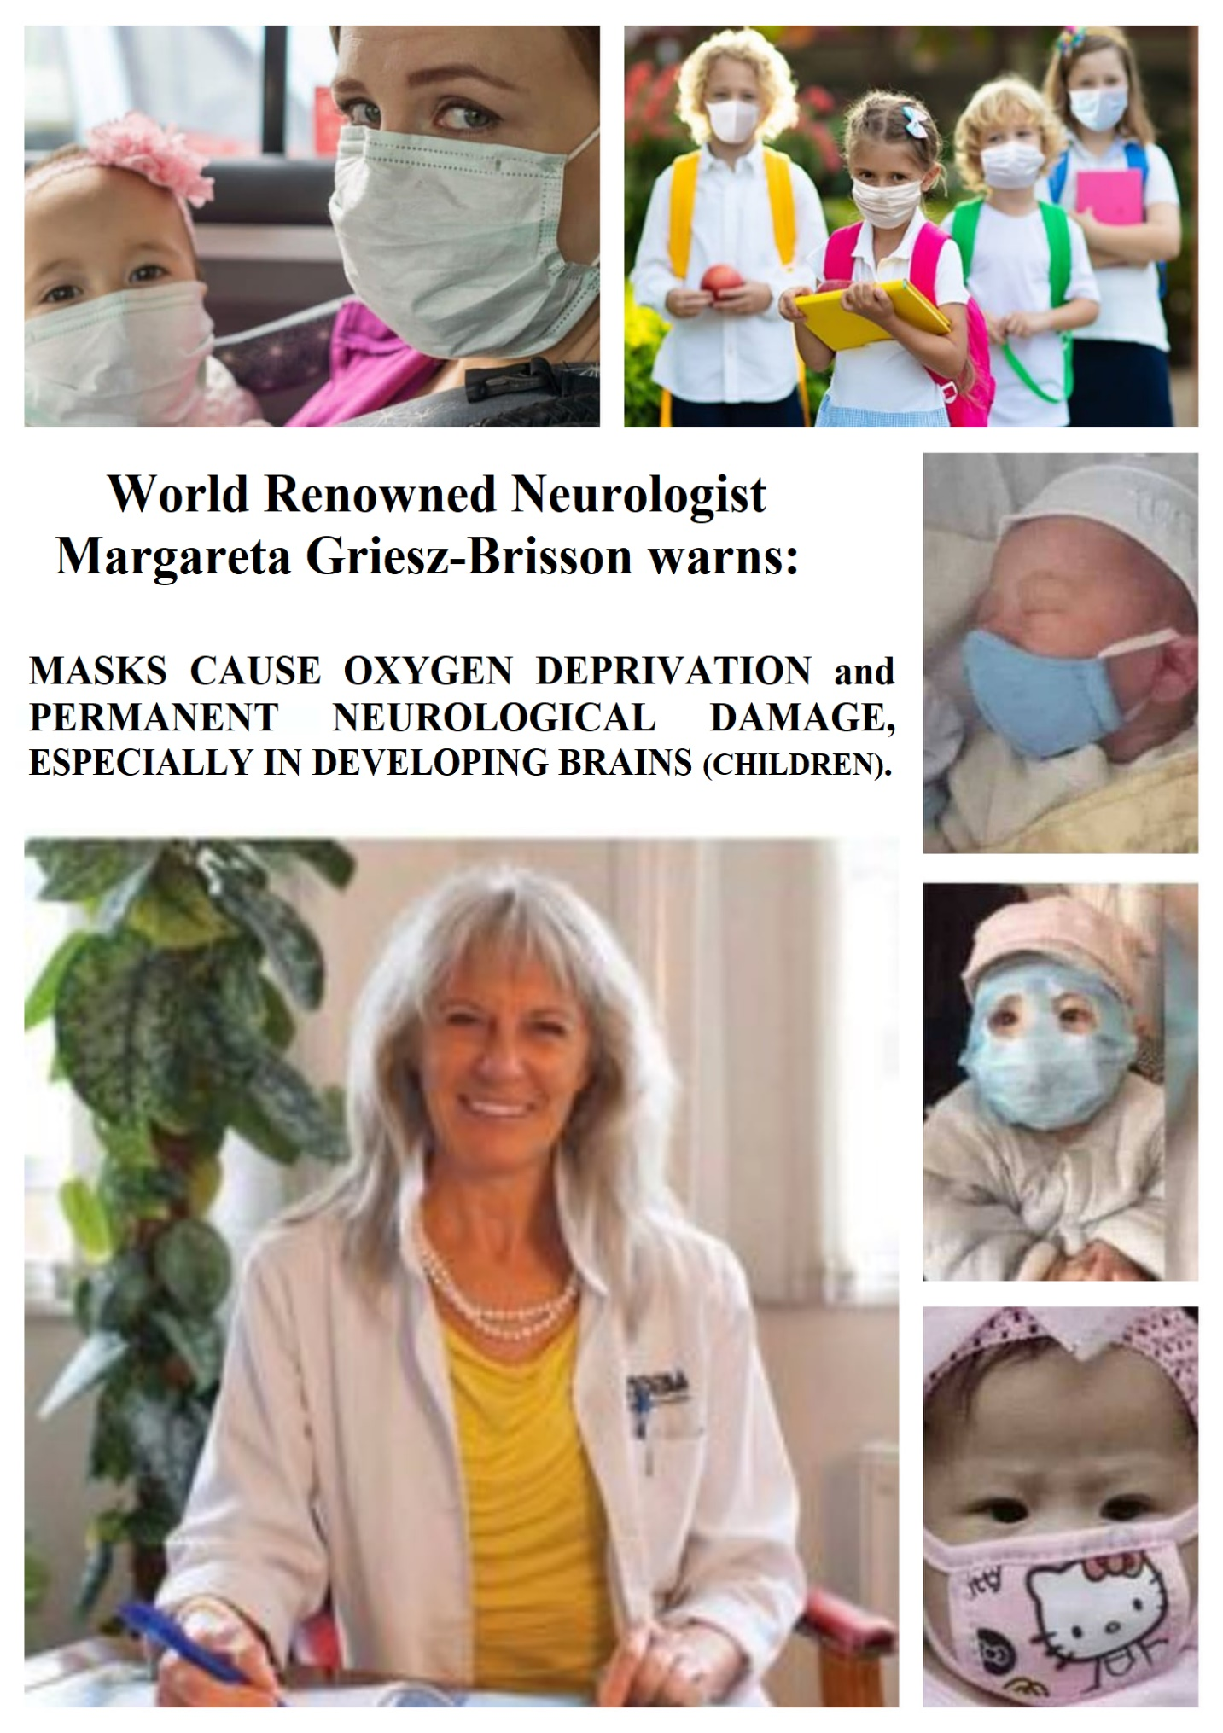

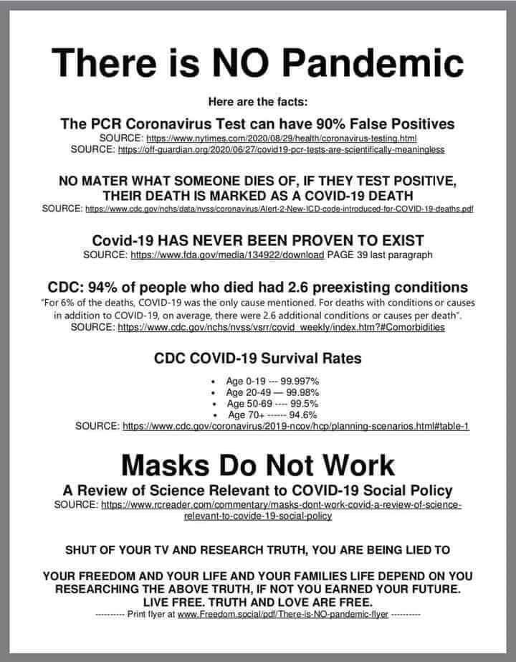

“FDA authorized” is not the same as “FDA approved”. There are no “FDA approved” tests

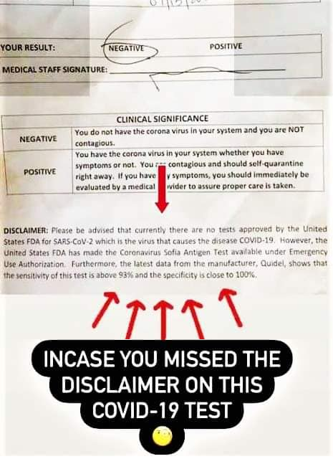

https://www.cdc.gov/coronavirus/2019-ncov/hcp/planning-scenarios.html

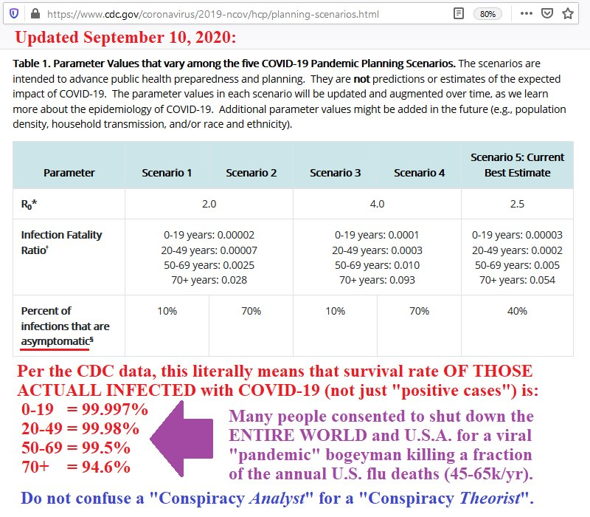
https://www.cdc.gov/nchs/nvss/vsrr/covid_weekly/index.htm#Comorbidities
