

Client money protection for landlords and tenants

This is to certify that

JACKSON O'ROURKE ESTATE AGENTS LTD is a member of Client Money Protect

Client Mon

e

y

P

r

o

t

ect

L

t

d is an Int

r

oducer Appoin

t

ed

R

ep

r

e

s

entati

v

e

o

f HFIS pl

c

who a

r

e authori

s

ed and

r

egula

t

ed

b

y the

F

inancial

C

onduct

A

uthor i

t

y

.

R

egis

t

e

r

ed in England 8564332.

V

A

T N

o

. : 893 9729 49.

Membership no: CMP004992 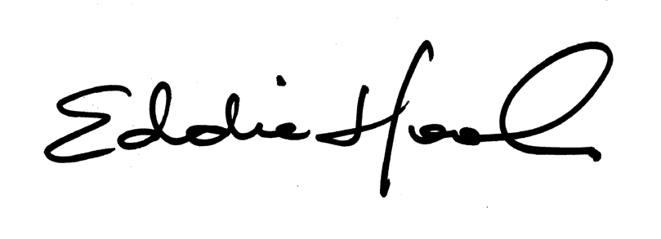Date of issue: 19/06/2025

**Eddie Hooker**

Expiry date: 18/06/2026 Client Money Protect