
REPORT FILE
(SESSION: 2026-27)

INFORMATICS PRACTICES (065)



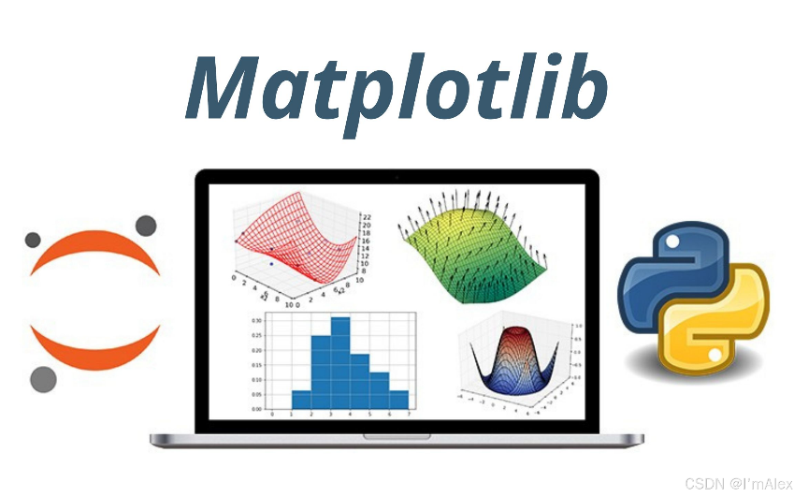


Submitted By: Submitted To:

(Student’s Name)
XII - A/B/C/D Teacher’s Name
(Board Roll No.)

Index

S.No. | Programs | Date | T. Sign
1 | SQL Queries – Q1
2 | SQL Queries – Q2
3 | SQL Queries – Q3
4 | SQL Queries – Q4
5 | SQL Queries – Q5
6 | Pandas Programs Q1
7 | Pandas Programs Q2
8 | Pandas Programs Q3
9 | Pandas Programs Q4
10 | Pandas Programs Q5
11 | Pandas Programs Q6
12 | Pandas Programs Q7
13 | Pandas Programs Q8
14 | Pandas Programs Q9
15 | Pandas Programs Q10
16 | Pandas Programs Q11
17 | Pandas Programs Q12
18 | Pandas Programs Q13
19 | Pandas Programs Q14
20 | Pandas Programs Q15
21 | Matplotlib Programs Q1
22 | Matplotlib Programs Q2
23 | Matplotlib Programs Q3
24 | Matplotlib Programs Q4

Questions

Q1. Write MySQL statements for the following:
i. To create a database named School.
ii. To create a table Exam as follows:

RegNo | Name | Subject | Marks
1 | Sanya | CS | 100
2 | Sanchay | IP | 95
3 | Vishesh | CS | 63
4 | Sneha | IP | 58
5 | Akshita | IP | 90

iii. Insert a new record in the table having following values: [6,'Khushi','CS',85]
iv. To change the value “IP” to “Informatics Practices” in the subject column.
v. To remove the records of those students whose marks are less than 65 .

Q2. Write the output produced by the following SQL commands:
- Select round(123.2345,2) , round(342,9234,-1) ;
- Select length(‘Board Exams 2023-24’);
- Select year(“2024/03/17”) as YEAR, Month(“2024/03/17”) as Month_No, monthname(“1999/11/01”) as Month_NAme, day(“1999/11/01”) as Date;
- Select concat(Left(“India”, 3), right(“Informatics Practices”,4)) As JoinedWord;
- Select mid(“Informatics”, 3,4) , Substr(“Practices”, 3);

Q3. Write SQL commands for the following on the basis of the given table SPORTS:

StudentNo | Class | Name | Game | Grade1 | SUPW | Grade2
10 | 7 | Sameer | Cricket | B | Photography | A
11 | 8 | Sujit | Tennis | A | Gardening | C
12 | 7 | Kamal | Swimming | B | Photography | B
13 | 7 | Veena | Tennis | C | Cooking | A
14 | 9 | Archana | Basketball | A | Literature | A
15 | 10 | Arpit | Cricket | A | Gardening | C

(i) Display the details of students who are in grade 7.
(ii) Display the names of students who are getting grade ‘C’ in either GAME or SUPW.
(iii) Display the different games offered in school
(iv) Display all records of SPORTS table.
(v) Modify the Game of Sujit from Tennis to Basketball.

Q4. Give the output of the following SQL commands with respect to table STUDENT

ID | Name | Stipend | Stream | Avgmark | Grade | Class
A1 | Karan | 400.00 | Medical | 78.5 | B | 12B
B1 | Divakar | 300.00 | Commerce | 89.2 | A | 12A
C1 | Divya | 350.00 | Humanities | 68.6 | C | 12C
D5 | Arun | 500.00 | Medical | 73.1 | B | 12B
E2 | Sahiba | 400.00 | Commerce | 90.6 | A | 12A

(i) Select min(Avgmark) from student where Avgmark <75;
(ii) Select Sum(Stipend) from Student where Grade = ‘B’ ;
(iii) Select avg(Stipend) from student where class= ‘12A’;
(iv) Select count(Distinct(stream)) from student;
(v) Select max(Name) from student;

Q5. Write suitable SQL queries for the following:
i. To calculate the exponent for 3 raised to the power of 4.
ii. To display current date and time.
iii. To round off the value -34.4567 to 2 decimal places.
iv. To display the remainder after dividing 10.5 by 3.
v. To display the length of the string ‘FIFA World Cup’.

PANDAS PROGRAMS
6. Create a program to create pandas series from a dictionary of values and a ndarray.

7. Write a program to create a Series object using a dictionary that stores the number
of students in each section of class 12 in your class.

8. Write Python program to Create a DataFrame with the help of dictionary, which
contains the information about Marks of five students of five subjects. Write commands to create dictionary also. Dictionary Contains:

Name | Maths | Science | SSt | HINDI | Total
Aditya | 55 | 76 | 69 | 79 | 279
Saloni | 77 | 88 | 55 | 66 | 286
Muskan | 98 | 87 | 90 | 93 | 368
Tamanna | 90 | 99 | 96 | 91 | 376

9. Create a Data Frame Quarterly sales where each row contains the item category, item name, and expenditure. Group the rows by the category and print the total expenditure per category.

10. Write python code to create a data frame from a 2D dictionary, Sales which stores
the quarter-wise sales as inner dictionary for two years, as shown below :
Sales = {‘yr1’ : {‘q1’ : 34000, ‘q2’ : 56000, ‘q3’: 85000},
‘yr2’ : {‘q1’ : 44000, ‘q2’ : 66000, ‘q3’: 55000}}

11. Write a program to create a series object from an ndarray that stores characters from ‘a’ to ‘g’.

12. Create a data frame for examination result and display row labels, column labels data types of each column and the dimensions.

13. Filter out rows based on different criteria such as duplicate rows.

14. Write a program to Import and export data between dataframe and CSV file.

15. Create a series object Vowel to store all vowels individually. Its index should be 1,2,3,4,5. Convert it into dataframe and display.

16. Create a series object population to store the population of five different metro cities and display the population that are more than 30 Lacs.

17. Consider the following Series S
0 0.430271
1 0.617328
2 0.265421
3 0.836113
What will be returned by the following statements?
a) S*100
b) S>0
c) S1=pd.Series(S)
d) S3=pd.Series(S1)+3

18. Consider the given DataFrame ‘Genre’:
Type Code
0 Fiction F
1 Non Fiction NF
2 Drama D
3 Poetry P

Write suitable Python statements for the following:
i. Add a column called Num_Copies with the following data:
[300,290,450,760].
ii. Add a new genre of type ‘Folk Tale' having code as “FT” and 600 number of copies.
iii. Rename the column ‘Code’ to ‘Book_Code’.

19. Create the series object S with values as ‘COMFORTABLE’ and index ranging from S1 to S11 and perform the following operations:
- Display first four elements.
- Display last 3 elements
- Change the index as W1 to W11.
20. Create a dataframe ‘Student’ from two series - Name and Grade, Name and marks of five students.
- Display the first three records from the student dataframe.
- Display the last two records from the student dataframe.

MATPLOTLIB PROGRAMS

21. Write a program to display a horizontal bar chart of the number of students in a class.
Class: 1= I, II, III, IV, V, VI, VII, VIII, IX, X, XI and XII.
Strengths: 40, 43, 33, 41,50, 49, 47, 50, 42, 44, 46,39

22. Write a program to analyze the performance of the students subject wise on the school result data using matplotlib library.

Name | Maths | Science | SSt | HINDI | Total
Aditya | 55 | 76 | 69 | 79 | 279
Saloni | 77 | 88 | 55 | 66 | 286
Muskan | 98 | 87 | 90 | 93 | 368
Tamanna | 90 | 99 | 96 | 91 | 376

23. Write a program to visualize a weather report for three consecutive weeks through Line Plot using ‘Weather.csv’ .

Week1 | Week2 | Week3
36 | 37 | 36
38 | 39 | 40
42 | 41 | 40
40 | 41 | 42
39 | 40 | 41
35 | 34 | 33
40 | 38 | 39

24. Given below are the sugar levels for men and women in a city. Compare the sugar levels amongst them through a histogram.
Men: [112,85,149,82,129]
Women: [67,77,76,150,100]

