SCHOOL NAME
SCHOOL ADDRESS
SCHOOL LOGO

Practical file 2026-27
Artificial intelligence (417)

Submitted to: Submitted to: -

Teacher’s Name Student Name
Class – X
Roll no

Certificate

This is to certify that Student Name of Class X – (Section) has completed his/her practical file of the subject Artificial Intelligence under the guidance of Artificial Intelligence Teacher (Teacher’s Name) during the year 2026-27 This project is submitted as part of the complete fulfillment of the syllabus prescribed by the CBSE Board.
The work done by the student is original and has been carried out with sincerity and dedication.

Internal Examiner External Examiner

Principal’s Signature

Acknowledgement

I express my sincere gratitude to the Almighty for His blessings and guidance throughout the completion of this project.
I am deeply thankful to our respected Principal, (Principal’s Name), and my Artificial Intelligence teacher, (Teacher’s Name), for their invaluable guidance, encouragement, and support. Their motivation and constructive suggestions helped me complete this file successfully.
This project, prepared as per the CBSE curriculum, has enhanced my knowledge and understanding of Artificial Intelligence and its practical applications.
I would also like to thank my parents for their constant encouragement and unwavering support. Finally, I extend my gratitude to everyone who contributed directly or indirectly to the successful completion of this project.
Thank you all for making this learning journey meaningful and enriching.

Index
Sno | Objective | Date | T. Sign
1 | Write a program to calculate mean, median, mode using numpy. If the list is follows:  [80,100,50,25,65,72,91,101,207,250,132,631,44,77,88]
2 | Write a program to display a line chart from (3,6) to (14,15).
3 | Read the CSV file saved in your system and display the top two records, bottom two records. Also display its information.
4 | Write a program to read an image and display in grey color using Python.
5 | Write a program to create a pie chart using following data:  Labels : English, Hindi, Science  Marks : 50, 25, 25
6 | Write a program to display a scatter chart for the following points:  (1,2) , (3,7), (5,4) , (7,9) , (9,6)
7 | Write a program to add two elements of lists.  L1 = [2,4,6,8]  L2 = [1,7,2,4]
8 | Write a program to input a string and display it in reverse order.
9 | Write a program to input a string and display the count of consonants and vowels in the string.
10 | Write a program to input three sides of a triangle and display whether the triangle can be formed with the inputs or not. If the triangle can be formed if the triangle can be scalene, isosceles and equilateral.
11 | Write a program to input a number whether it is palindrome or not.
12 | Write a program to input a number whether it is prime or not.
13 | Write a program to input two numbers and swap both the numbers using the third number.
14 | Using Numpy package,  - Create a 4 X 2 array with random integers.  - Create a 3 X 3 array with all zeros.
15 | Write a menu driven program to display sum and product of three numbers as per user’s choice.

PROJECT QUESTIONS
1 | Using the Palmer Penguins dataset in Orange Data Mining, develop and evaluate an AI model that applies statistical analysis and machine learning techniques to predict the species of a penguin based on features such as bill length, bill depth, flipper length, and body mass.
2 | Using Orange Data Mining, design and develop a computer vision-based AI system that analyzes underwater images to identify and classify coral reefs as healthy or bleached, enabling the early detection of coral bleaching for marine ecosystem monitoring and conservation.
3 | Develop an AI-based Natural Language Processing (NLP) model using Orange Data Mining to classify book excerpts into Children's Literature or Adult Literature based on their textual content.

PROgram 1
Write a program to calculate mean, median, mode using numpy. If the list is follows:
[80,100,50,25,65,72,91,101,207,250,132,631,44,77,88]

CODE

import numpy as np
from statistics import mode

# Creating the list
numbers=[80,100,50,25,65,72,91,101,207,250,132,631,44,77,88]

# Mean
mean_value = np.mean(numbers)

# Median
median_value = np.median(numbers)

# Mode
mode_value = mode(numbers)

# Displaying results
print("Mean =", mean_value)
print("Median =", median_value)
print("Mode =", mode_value)

OUTPUT
Mean = 134.2
Median = 88.0
Mode = 80

PROgram 2
Write a program to display a line chart from (3,6) to (14,15).

CODE

import matplotlib.pyplot as plt
# X-axis values
x = [3, 14]
# Y-axis values
y = [6, 15]
# Plotting line chart
plt.plot(x, y)
# Displaying chart
plt.show()

OUTPUT
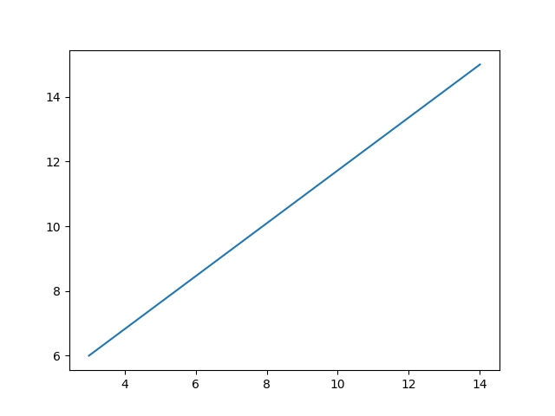
PROgram 3
Read the CSV file saved in your system and display the top two records, bottom two records. Also display its information.
CODE
import pandas as pd
# Reading the CSV file
df = pd.read_csv("STUDENT.csv")
# Display top 2 records
print("Top Two Records")
print(df.head(2))
# Display bottom 2 records
print("\nBottom Two Records")
print(df.tail(2))
print("\nInformation of CSV File")
df.info()
OUTPUT
Top Two Records
RNo Name Marks
0 1 Aman 85
1 2 Riya 90
Bottom Two Records
RNo Name Marks
8 9 Vikas 91
9 10 Anjali 73
Information of CSV File
<class 'pandas.core.frame.DataFrame'>
RangeIndex: 10 entries, 0 to 9
Data columns (total 3 columns)
PROgram 4
Write a program to read an image and display in grey color using Python.
CODE
import cv2

# Read the image
img = cv2.imread("image.png")
# Resize image
img = cv2.resize(img, (500, 400))
# Convert image into grey color
gray = cv2.cvtColor(img, cv2.COLOR_BGR2GRAY)
# Display the grey image
cv2.imshow("Grey Image", gray)
# Wait until a key is pressed
cv2.waitKey(0)
# Close all windows
cv2.destroyAllWindows()
OUTPUT
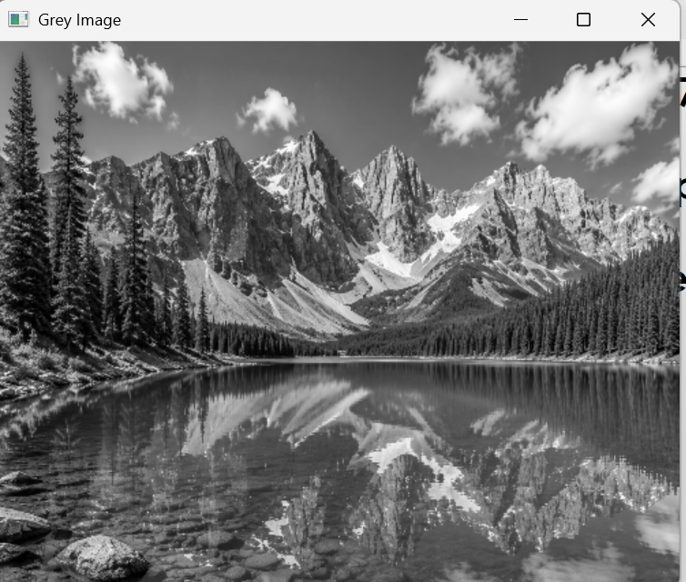
PROgram 5

Write a program to create a pie chart using following data:
Labels : English, Hindi, Science
Marks : 50, 25, 25

CODE

import matplotlib.pyplot as plt

# Data
labels = ["English", "Hindi", "Science"]
marks = [50, 25, 25]

# Create pie chart
plt.pie(marks, labels=labels)

# Display chart
plt.show()

OUTPUT

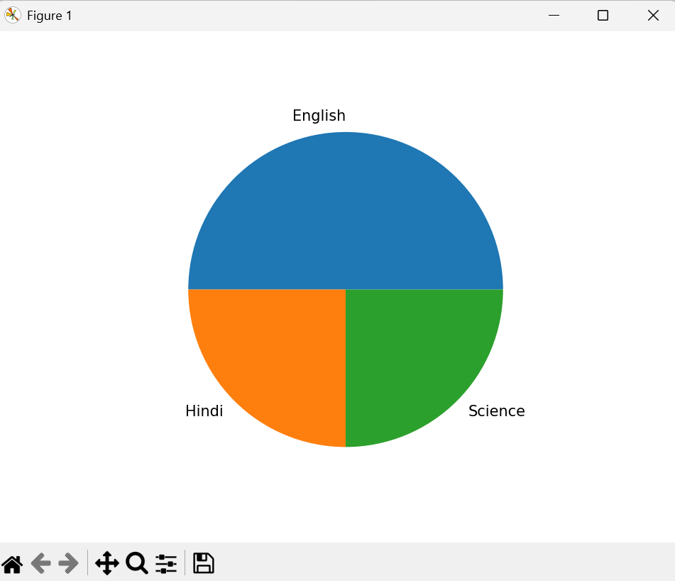

PROgram 6

Write a program to display a scatter chart for the following points:
(1,2) , (3,7), (5,4) , (7,9) , (9,6)

CODE

import matplotlib.pyplot as plt

# X-axis values
x = [1, 3, 5, 7, 9]

# Y-axis values
y = [2, 7, 4, 9, 6]

# Create scatter chart
plt.scatter(x, y)

# Display chart
plt.show()

OUTPUT
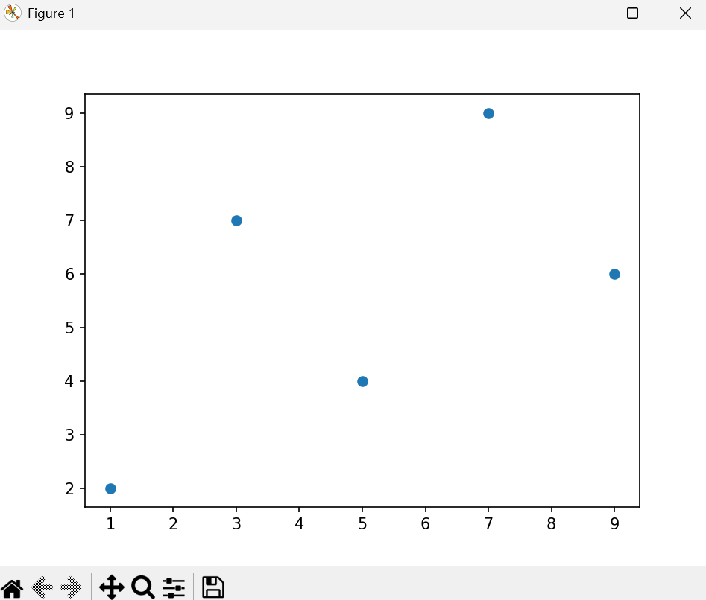
PROgram 7
Write a program to concatenate two elements of lists.
L1 = [2,4,6,8]
L2 = [1,7,2,4]
CODE

# Creating lists
L1 = [2,4,6,8]
L2 = [1,7,2,4]

# Concatenating lists
result = L1 + L2

# Display result
print("Concatenated List =", result)

OUTPUT

Concatenated List = [2, 4, 6, 8, 1, 7, 2, 4]

PROgram 8

Write a program to input a string and display it in reverse order.

CODE

# Input string
text = input("Enter a string: ")

OUTPUT

# Display string in reverse order
print("Reversed String =", text[::-1])

Enter a string: Good Morning
Reversed String = gninroM dooG

PROgram 9
Write a program to input a string and display the count of consonants and vowels in the string.
CODE
# Input string
text = input("Enter a string: ")

# Initialize counters
vowels = 0
consonants = 0

# Check each character
for ch in text.lower():
if ch.isalpha():
if ch in "aeiou":
vowels += 1
else:
consonants += 1

# Display result
print("Number of Vowels =", vowels)
print("Number of Consonants =", consonants)
OUTPUT
Enter a string: Hello, How are you ?
Number of Vowels = 7
Number of Consonants = 7
PROgram 10
Write a program to input three sides of a triangle and display whether the triangle can be formed with the inputs or not. If the triangle can be formed if the triangle can be scalene, isosceles and equilateral.
CODE
# Input sides of triangle
a = int(input("Enter first side: "))
b = int(input("Enter second side: "))
c = int(input("Enter third side: "))
# Check whether triangle can be formed
if (a + b > c) and (a + c > b) and (b + c > a):
print("Triangle can be formed")
# Check type of triangle
if a == b == c:
print("It is an Equilateral Triangle")
elif a == b or b == c or a == c:
print("It is an Isosceles Triangle")
else:
print("It is a Scalene Triangle")
else:
print("Triangle cannot be formed")
OUTPUT
Enter first side: 5
Enter second side: 5
Enter third side: 5
Triangle can be formed
It is an Equilateral Triangle
PROgram 11
Write a program to input a number whether it is palindrome or not.
CODE
# Input number
num = input("Enter a number: ")

# Reverse the number
rev = num[::-1]
# Check palindrome
if num == rev:
print("Palindrome Number")
else:
print("Not a Palindrome Number")

OUTPUT

Enter a number: 252
Palindrome Number

Enter a number: 234
Not a Palindrome Number

PROgram 12
Write a program to input a number whether it is prime or not.
CODE
# Input number
num = int(input("Enter a number: "))
# Assume number is prime
prime = True
# Check prime number
if num <= 1:
prime = False
else:
for i in range(2, num):
if num % i == 0:
prime = False
break
# Display result
if prime:
print("Prime Number")
else:
print("Not a Prime Number")
OUTPUT
Enter a number: 77
Not a Prime Number
Enter a number: 5
Prime Number

PROgram 13
Write a program to input two numbers and swap both the numbers using the third number.
CODE
# Input two numbers
a = int(input("Enter first number: "))
b = int(input("Enter second number: "))
# Display numbers before swapping
print("Before Swapping")
print("a =", a)
print("b =", b)
# Swapping using third variable
temp = a
a = b
b = temp
# Display numbers after swapping
print("After Swapping")
print("a =", a)
print("b =", b)
OUTPUT
Enter first number: 56
Enter second number: 12
Before Swapping
a = 56
b = 12
After Swapping
a = 12
b = 56

PROgram 14
Using Numpy package,
a. Create a 4 X 2 array with random integers.
b. Create a 3 X 3 array with all zeros.
CODE
import numpy as np
# a. Create a 4 X 2 array with random integers
arr1 = np.random.randint(1, 100, (4, 2))
print("4 X 2 Random Integer Array")
print(arr1)
# b. Create a 3 X 3 array with all zeros
arr2 = np.zeros((3, 3), dtype=int)
print("\n3 X 3 Zero Array")
print(arr2)
OUTPUT
4 X 2 Random Integer Array
[[99 38]
[34 33]
[86 45]
[89 18]]
3 X 3 Zero Array
[[0 0 0]
[0 0 0]
[0 0 0]]

PROgram 15
Write a menu driven program to display sum and product of three numbers as per user’s choice.
CODE
while True:
# Display menu
print("\nMENU")
print("1. Sum")
print("2. Product")
print("3. Exit")
# User choice
choice = int(input("Enter your choice: "))
if choice == 3:
print("Program Ended")
break
# Input numbers
a = int(input("Enter first number: "))
b = int(input("Enter second number: "))
c = int(input("Enter third number: "))

# Perform operation
if choice == 1:
print("Sum =", a + b + c)

elif choice == 2:
print("Product =", a * b * c)
# Exit condition
else:
print("Invalid Choice")
OUTPUT
MENU
1. Sum
2. Product
3. Exit
Enter your choice: 1
Enter first number: 11
Enter second number: 7
Enter third number: 2
Sum = 20

MENU
1. Sum
2. Product
3. Exit
Enter your choice: 3
Program Ended

Project 1
Using the Palmer Penguins dataset in Orange Data Mining, develop and evaluate an AI model that applies statistical analysis and machine learning techniques to predict the species of a penguin based on features such as bill length, bill depth, flipper length, and body mass.
Step 1 : Open Orange Data mining software. Click on New File.
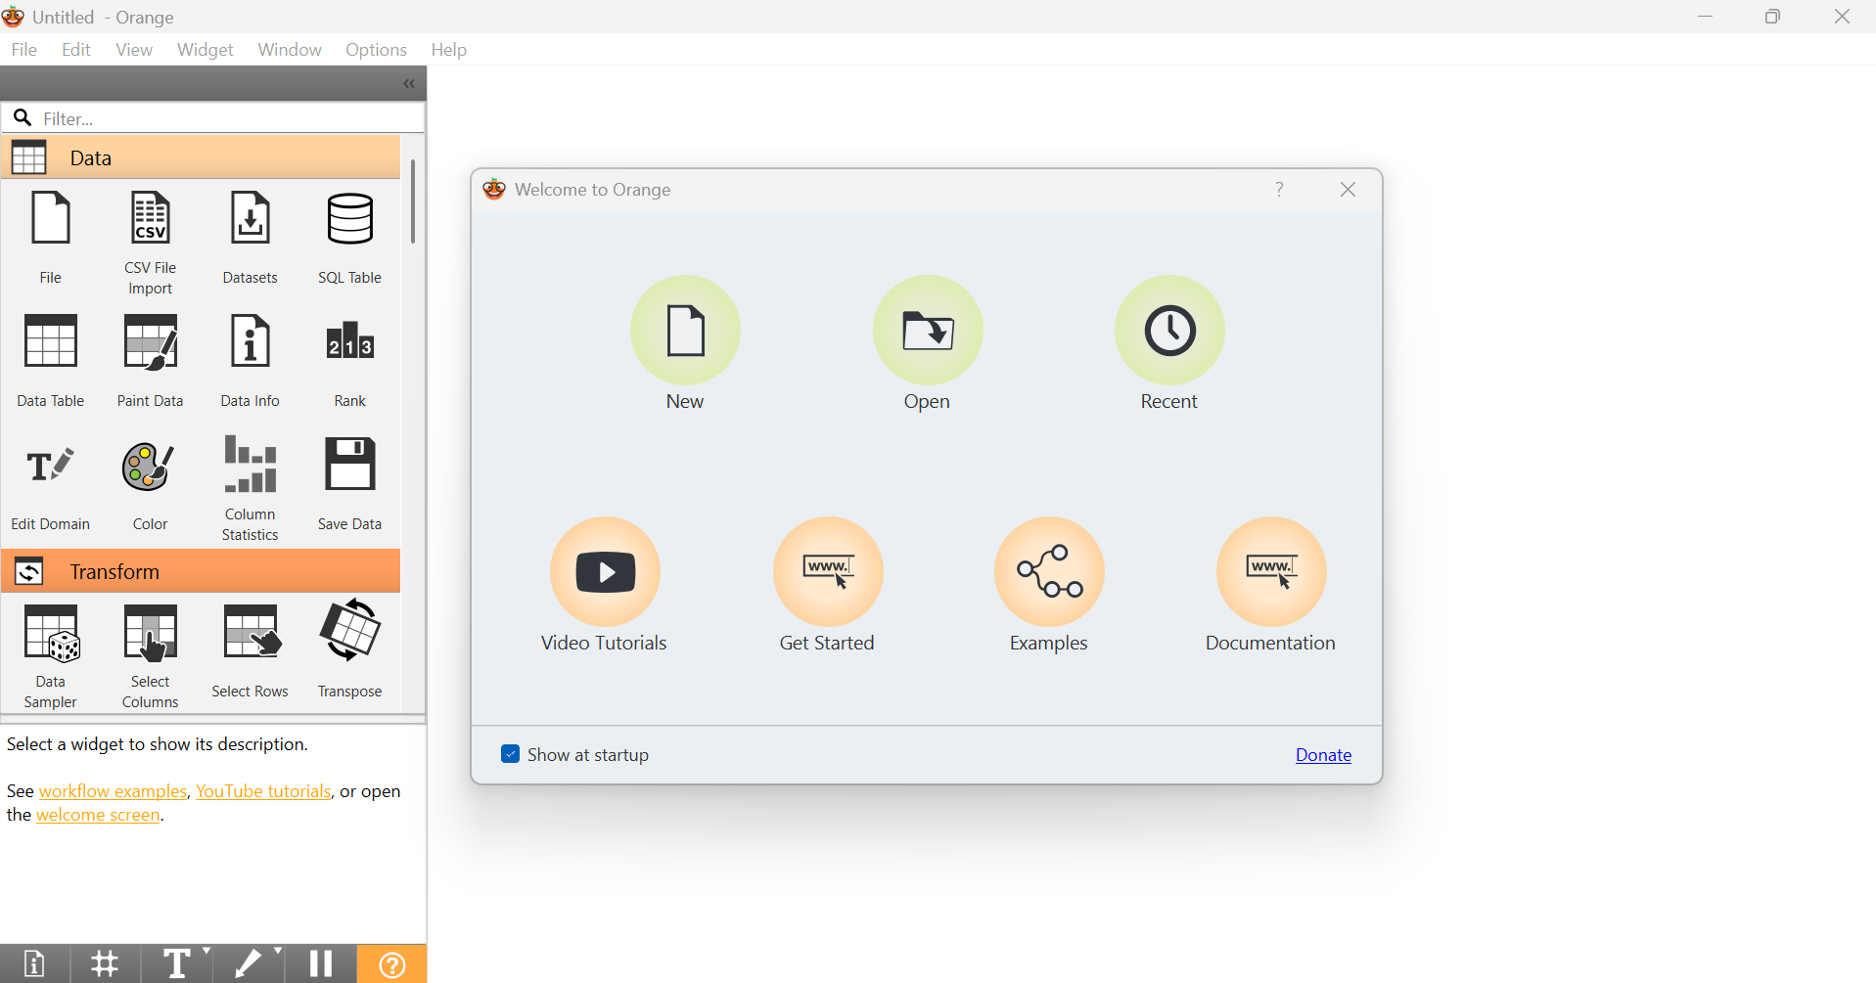
Step 2 : Click on File widget. Than double click on it to upload the dataset.
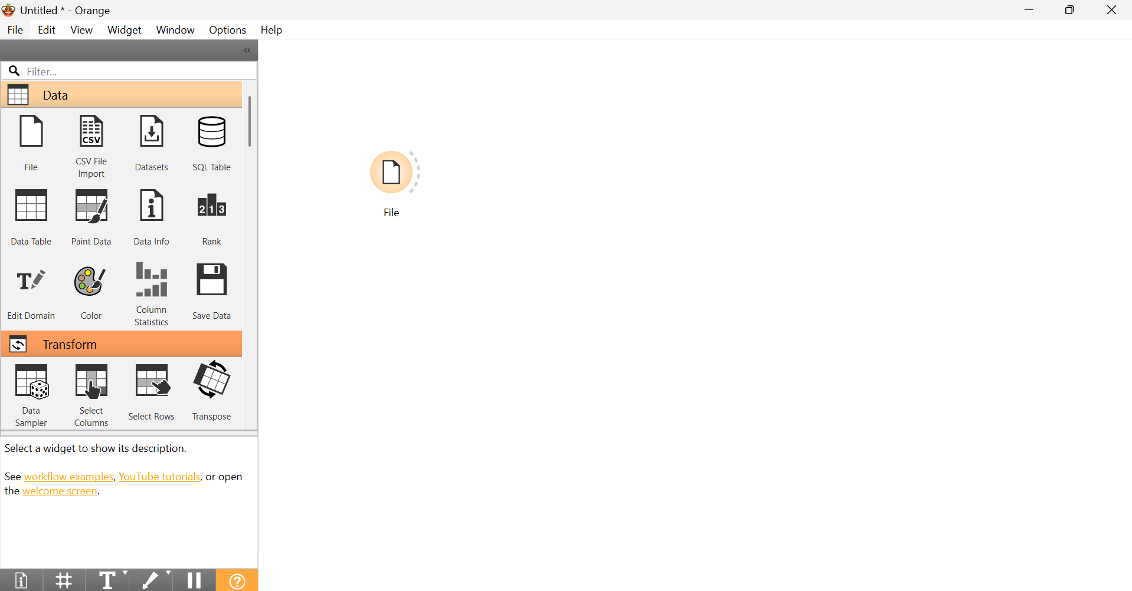
Step 3 : Upload training dataset from the Penguins-Palmer folder. 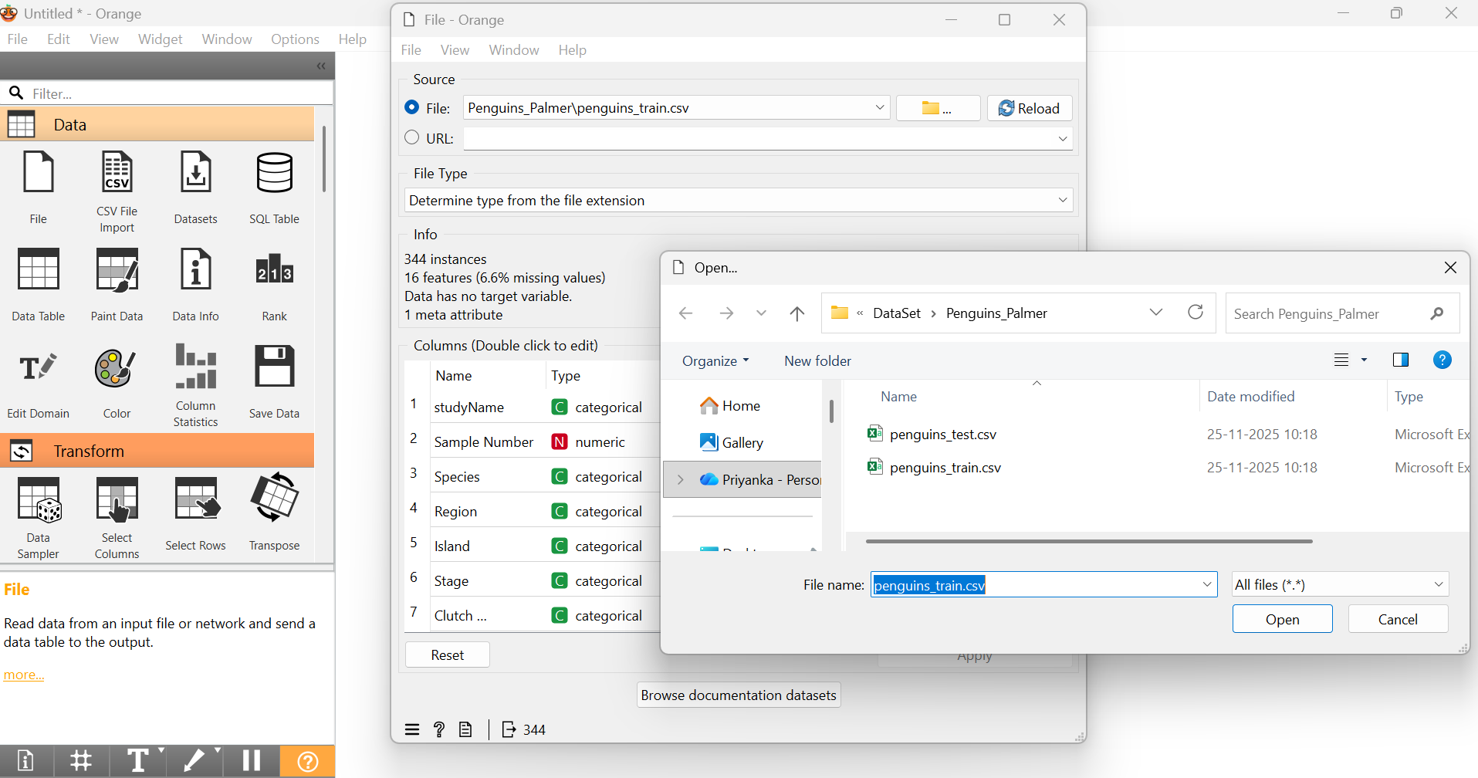
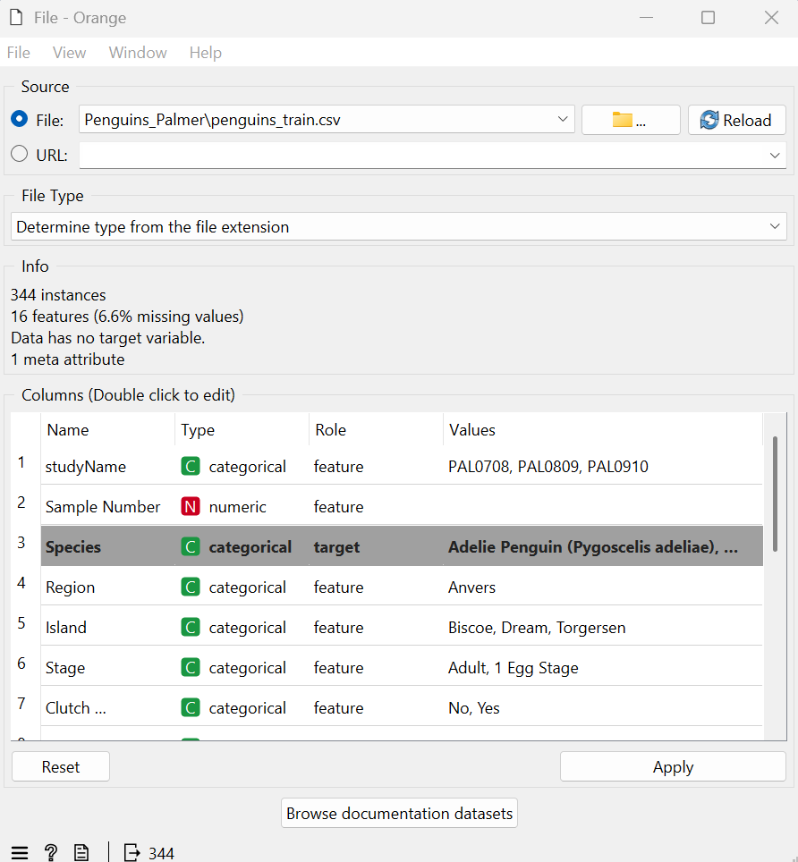
Step 4 : Change Role of Species to Target.

Step 5 : Drag Data table widget and connect output of File widget to input of data Table widget.
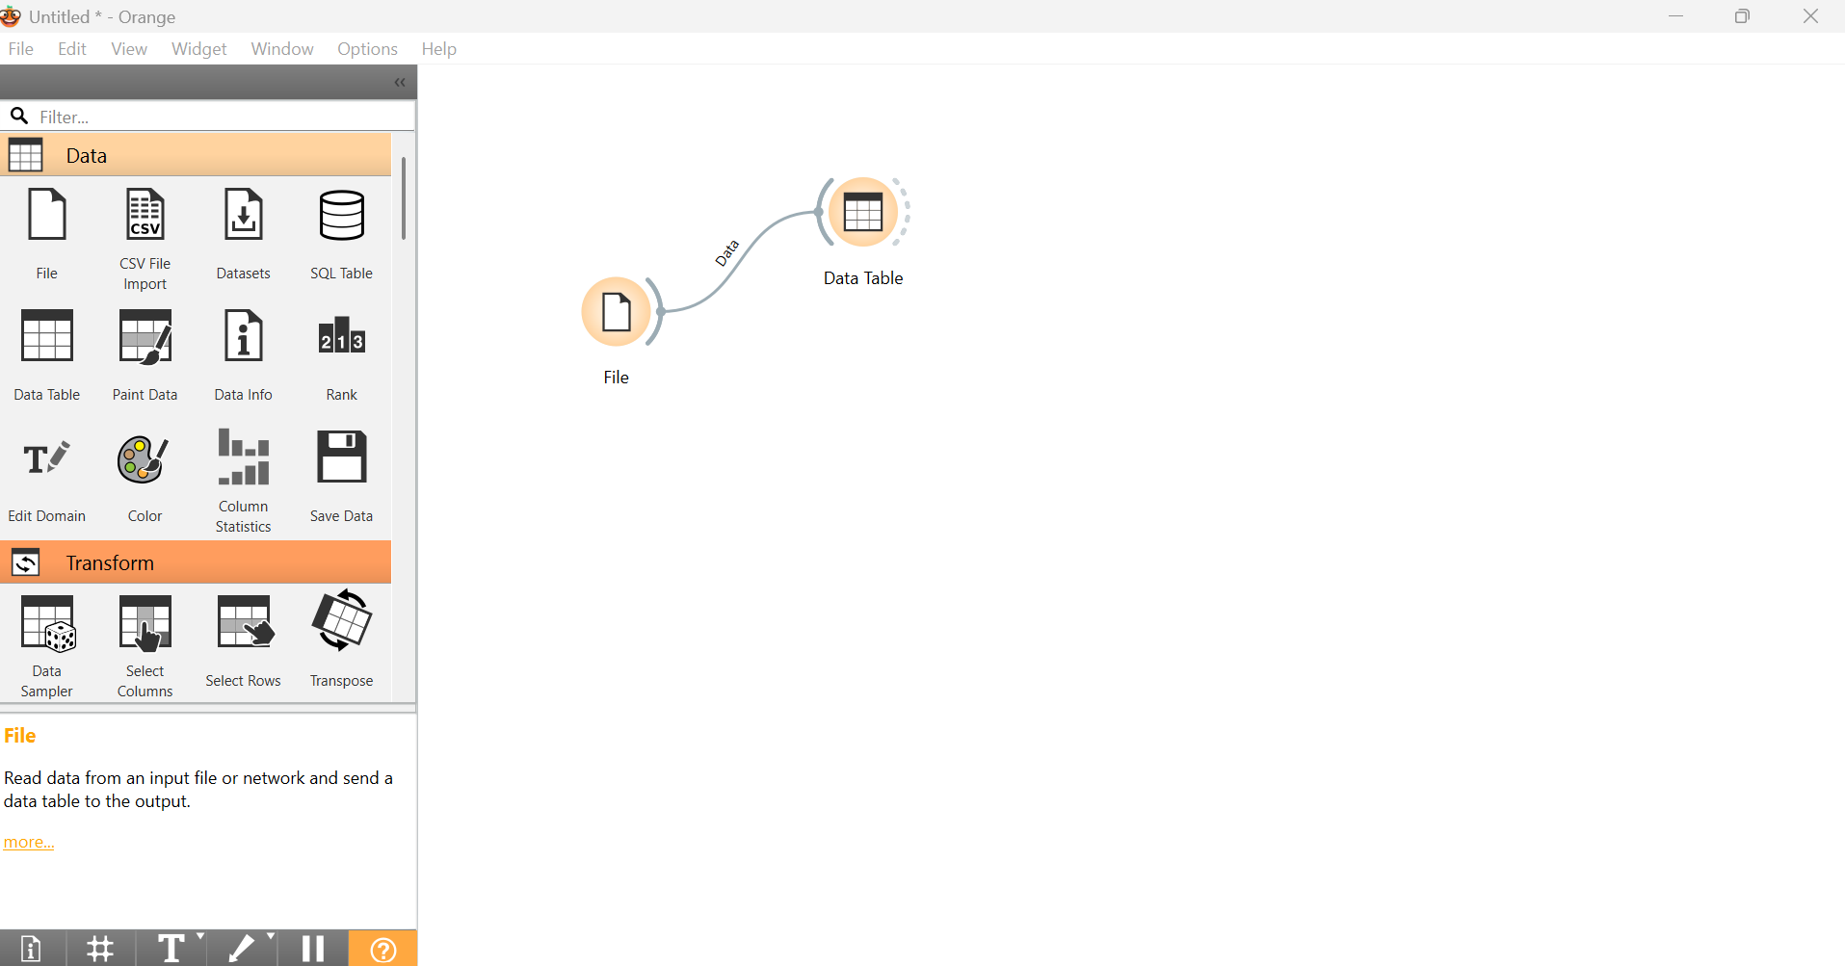
Step 6 : Double click on Data Table widget and can scroll all three categories of penguins with 344 records
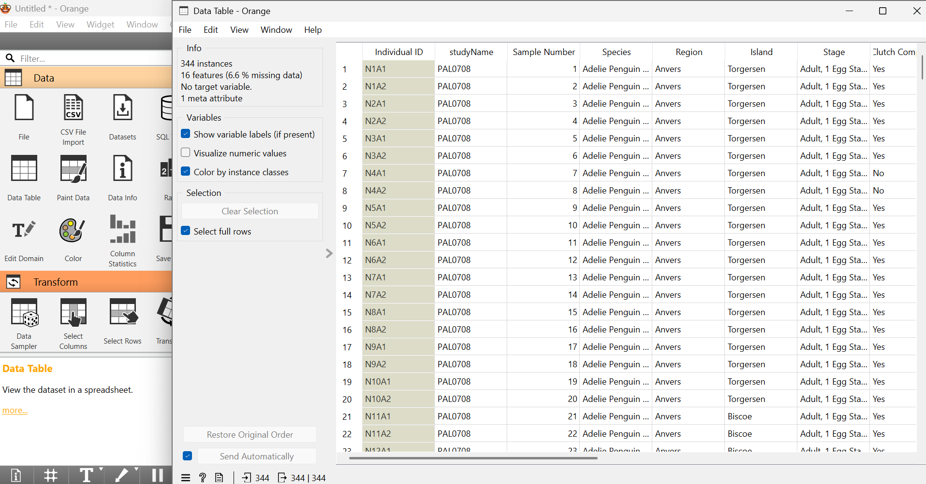
Step 7 : Drag Impute widget inside Transform menu to fill missing values. Connect the output of File widget to input of Impute widget.
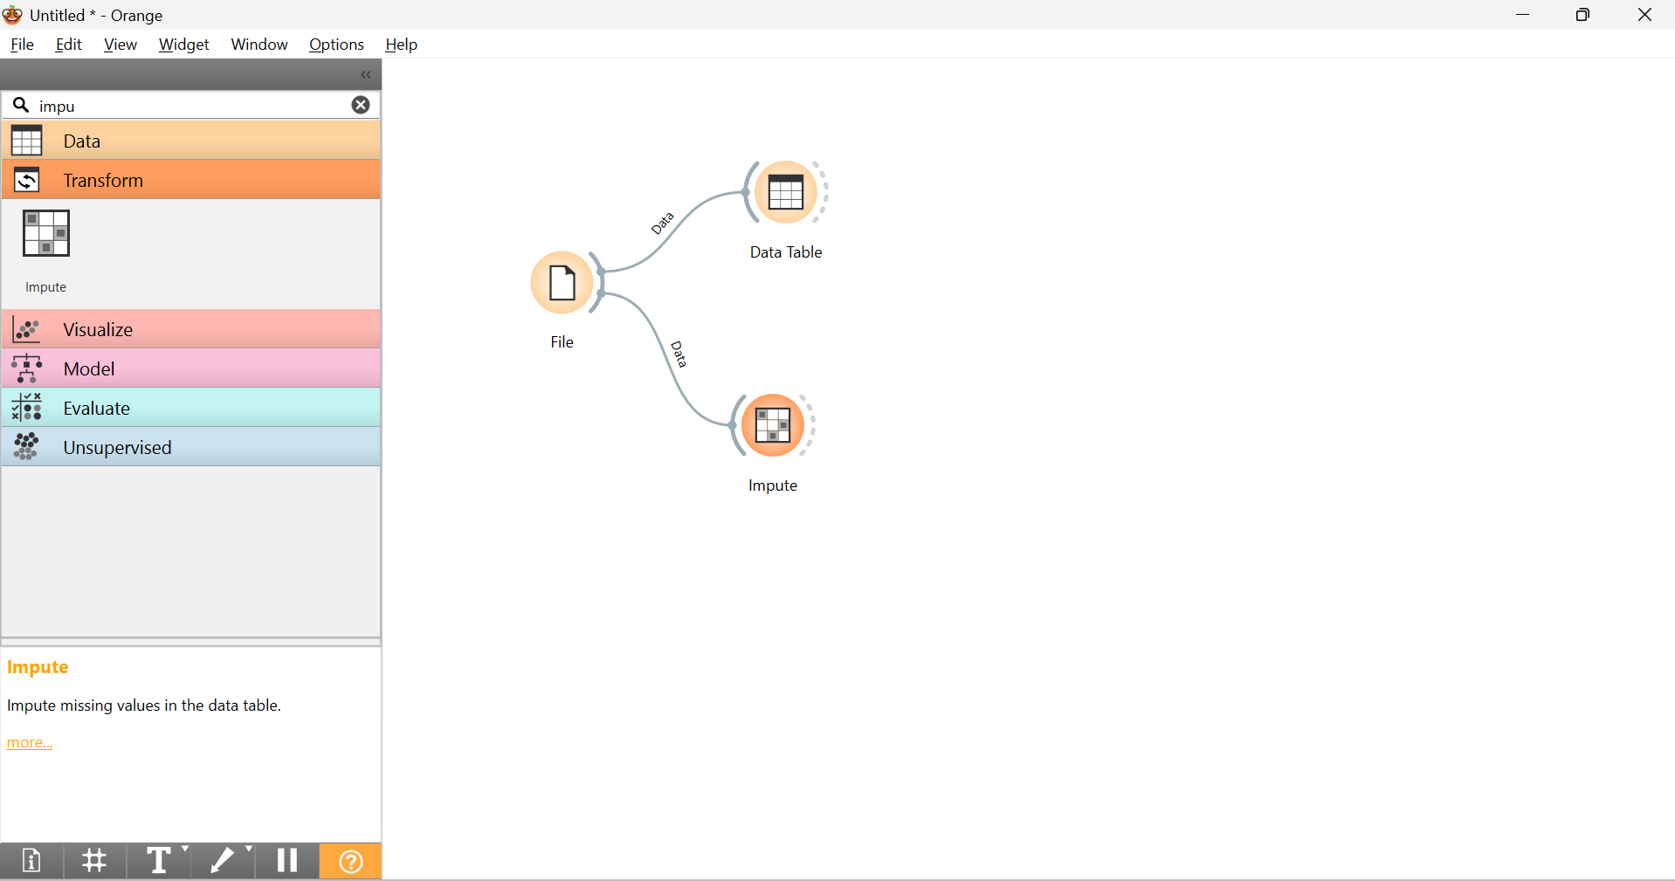
Step 8 : Connect Column Statistics widget to the output of Impute Widget.
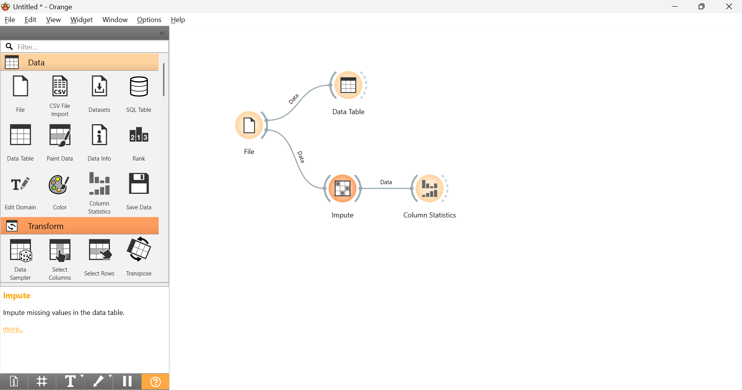
Step 9 : Click on Column Statistics widget.

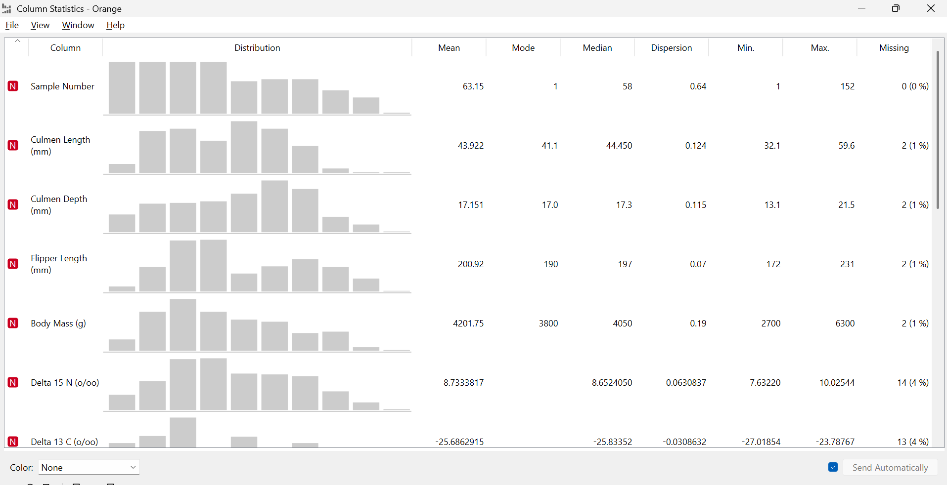

Step 10 : Drag Select columns widget to connect to the output of Impute widget.
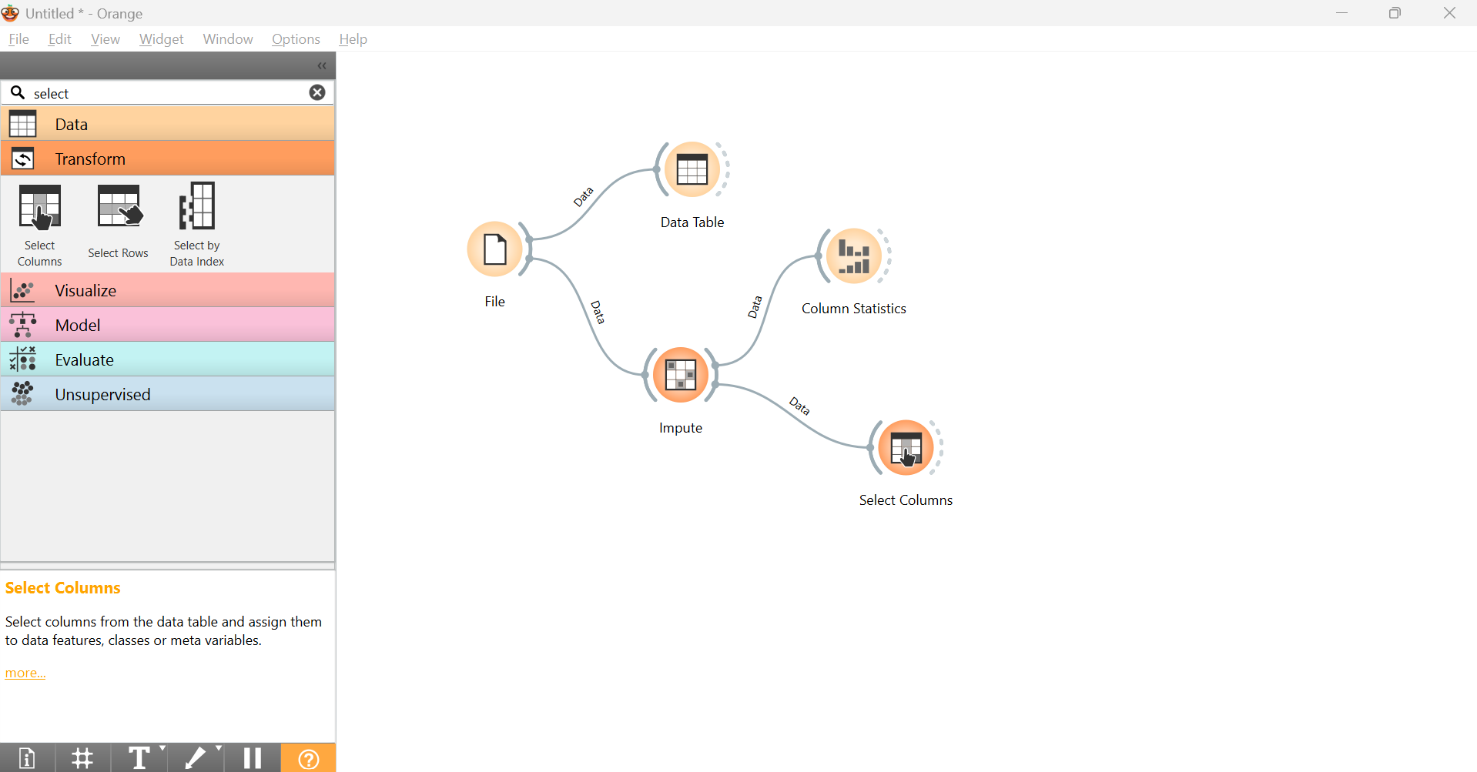
Step 11 : Double click and set Species to Target , if not already done.
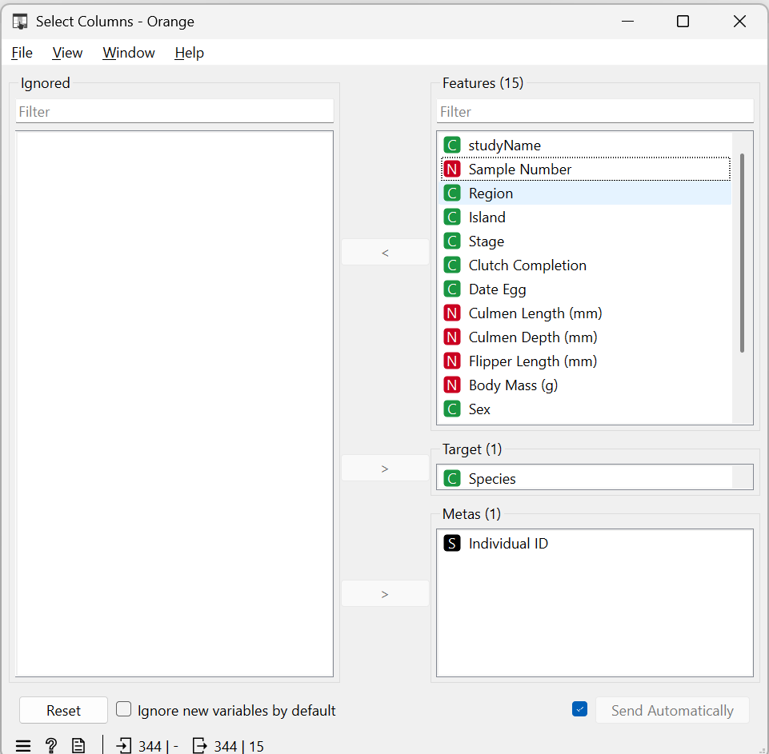

Step 11 : Connect Data Sampler widget to split training and testing data
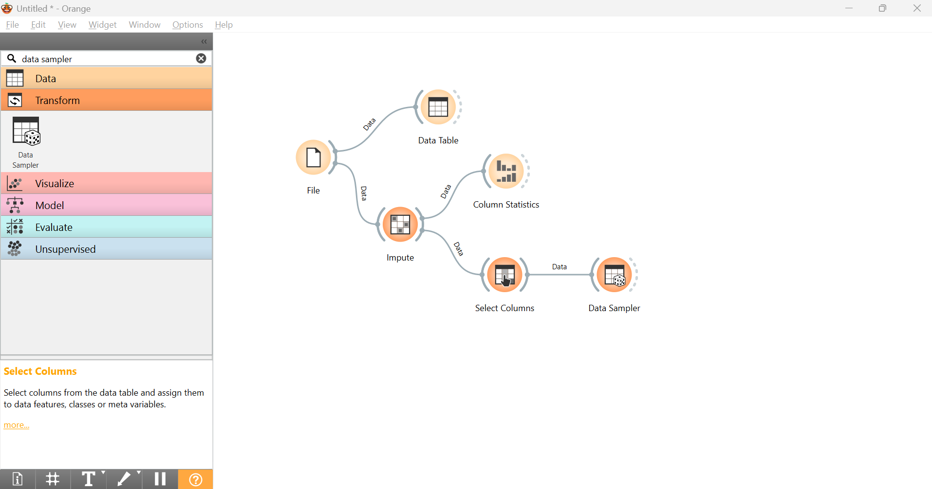
Step 12: Click on DataSampler to change fixed proportion to 80%
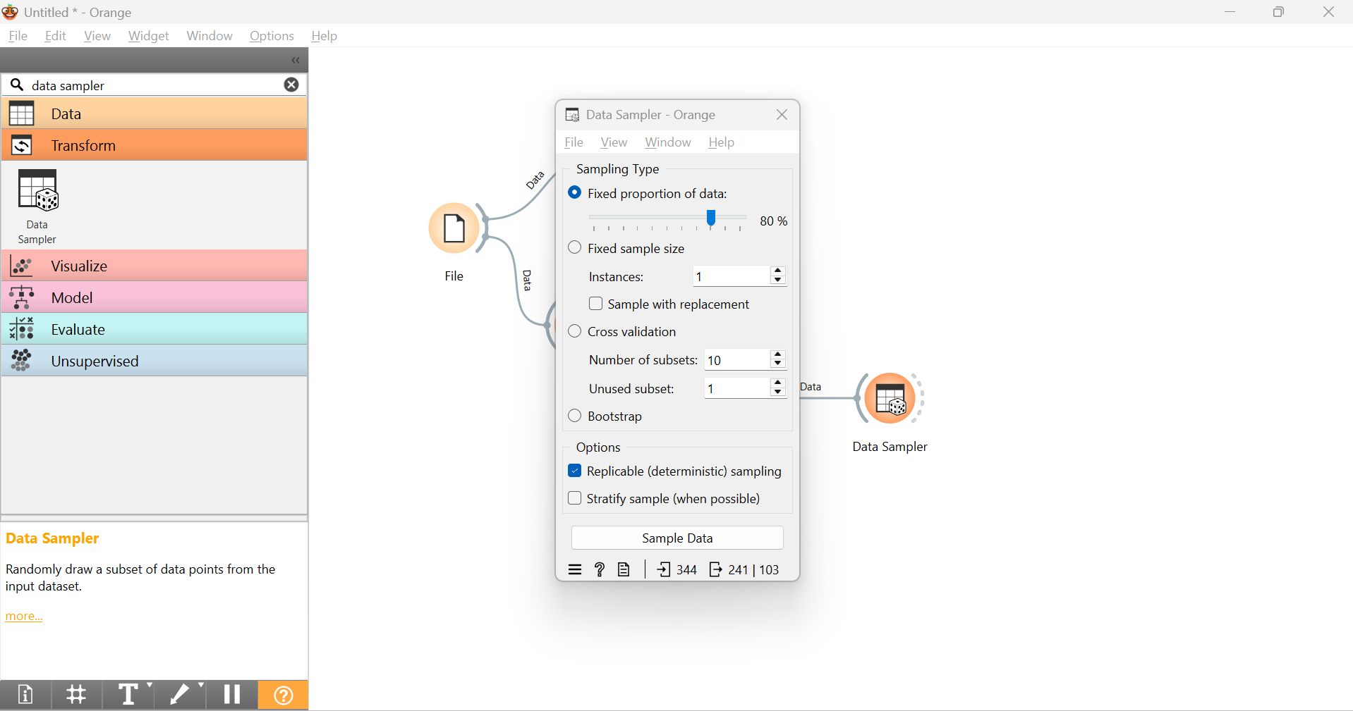
Step 13: Connect remaining data with data for second Data Info after clicking on its link.
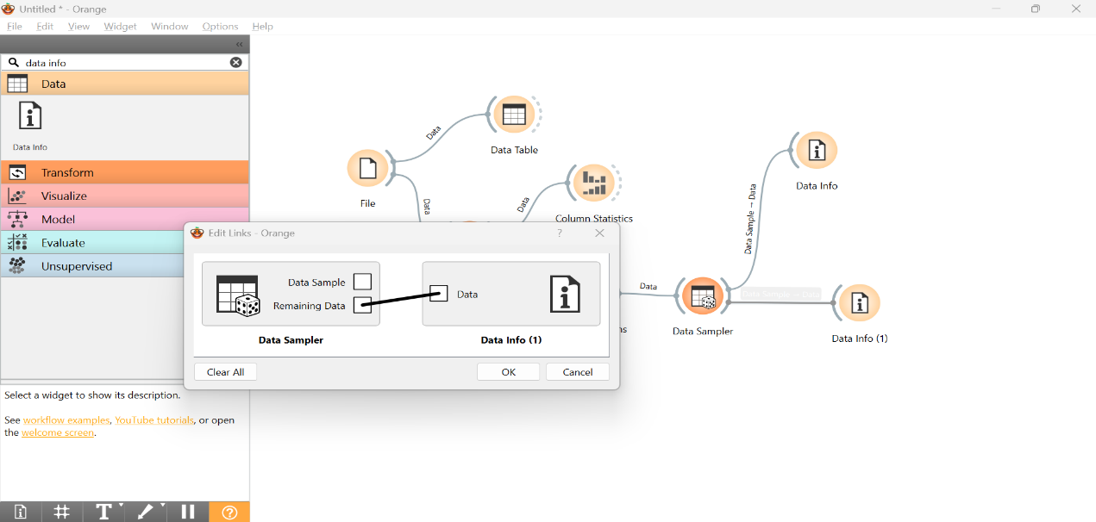

Step 14 : Drag Test and Score widget and connect twice to the output of Data Sampler widget. Click on any one link and connect remaining data with test data.
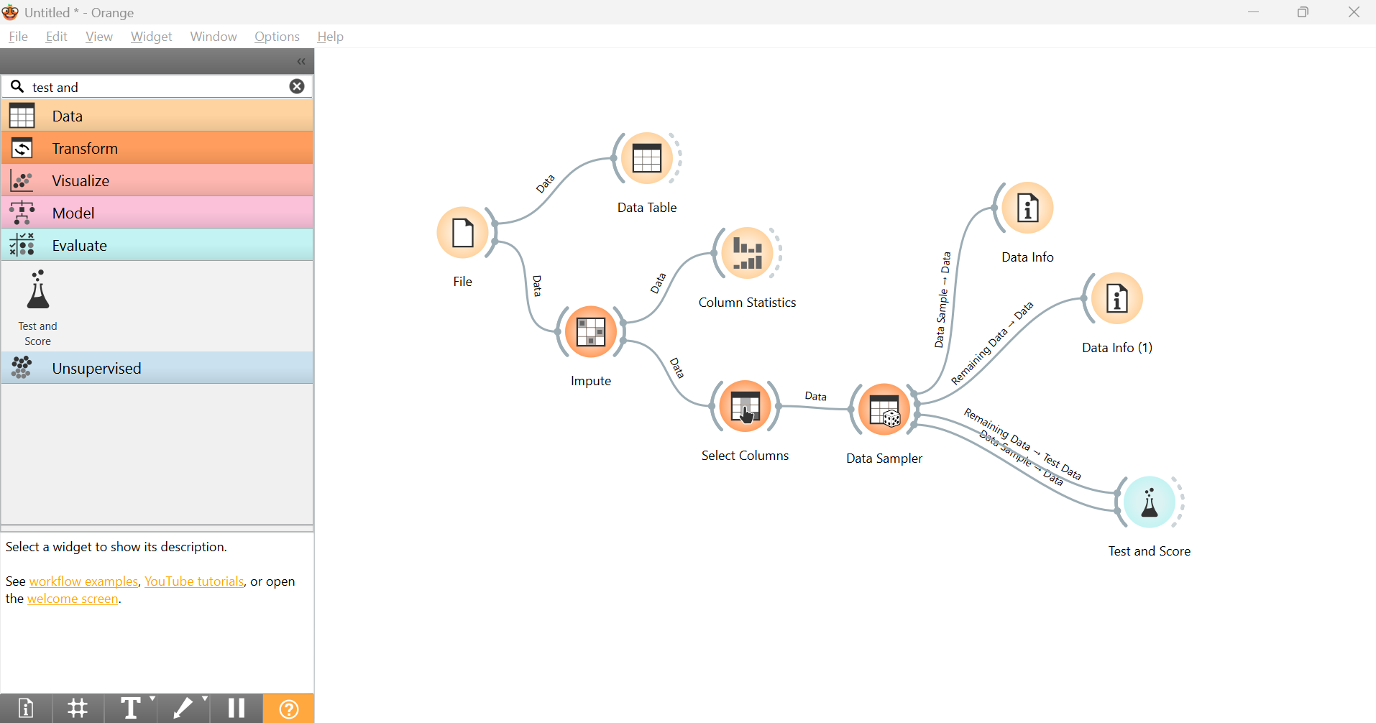
Step 15 : Train with Random Forest and KNN model by connecting both with test and score widget.

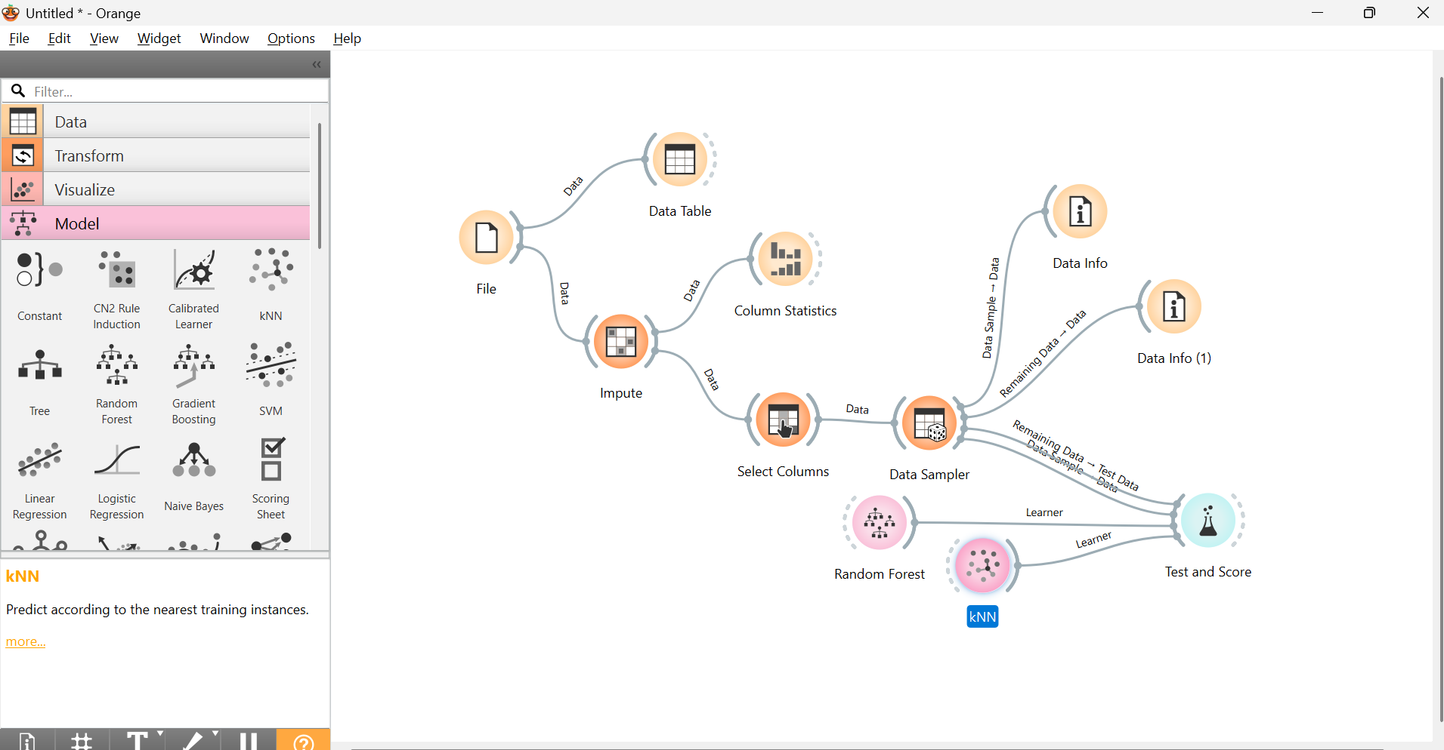

Step 16 : Double click on Test and Score widget and compare the values of AUC, CA, F1, Precision, Recall, MCC

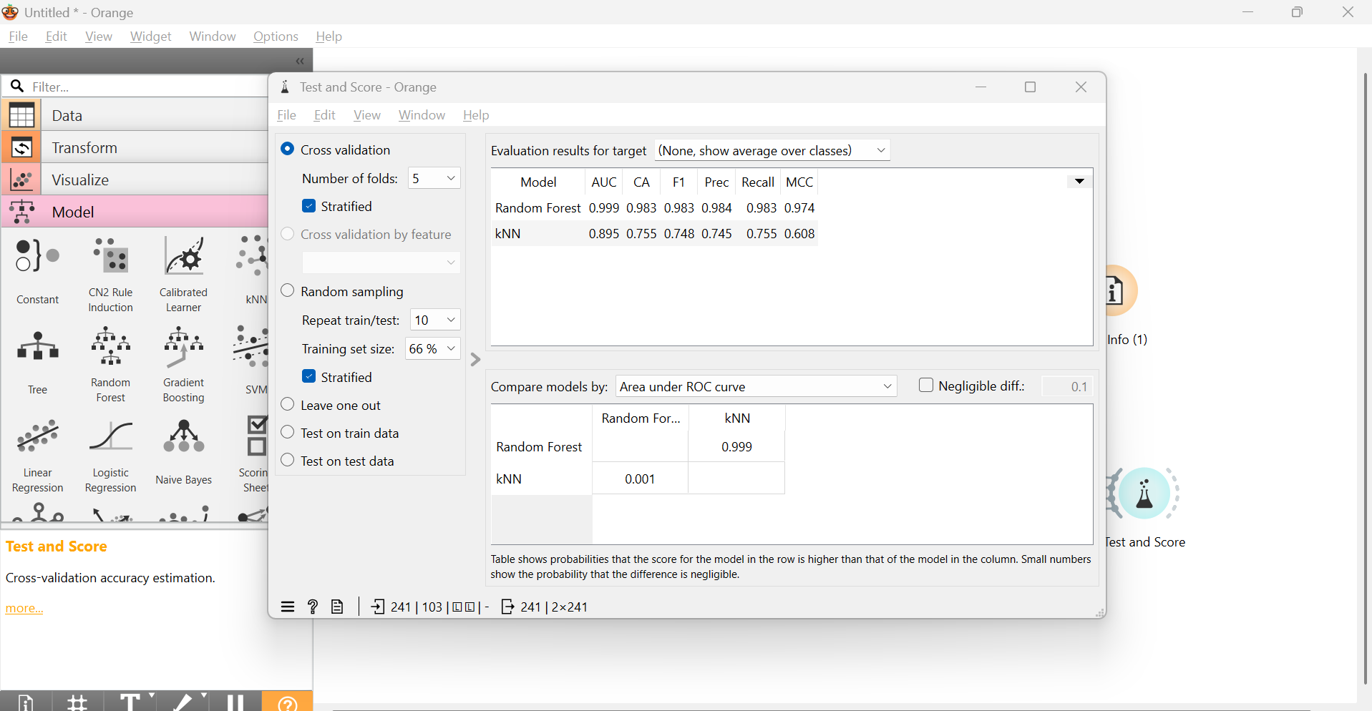

Step 17 : Add File widget for testing data. Check species column should be target.
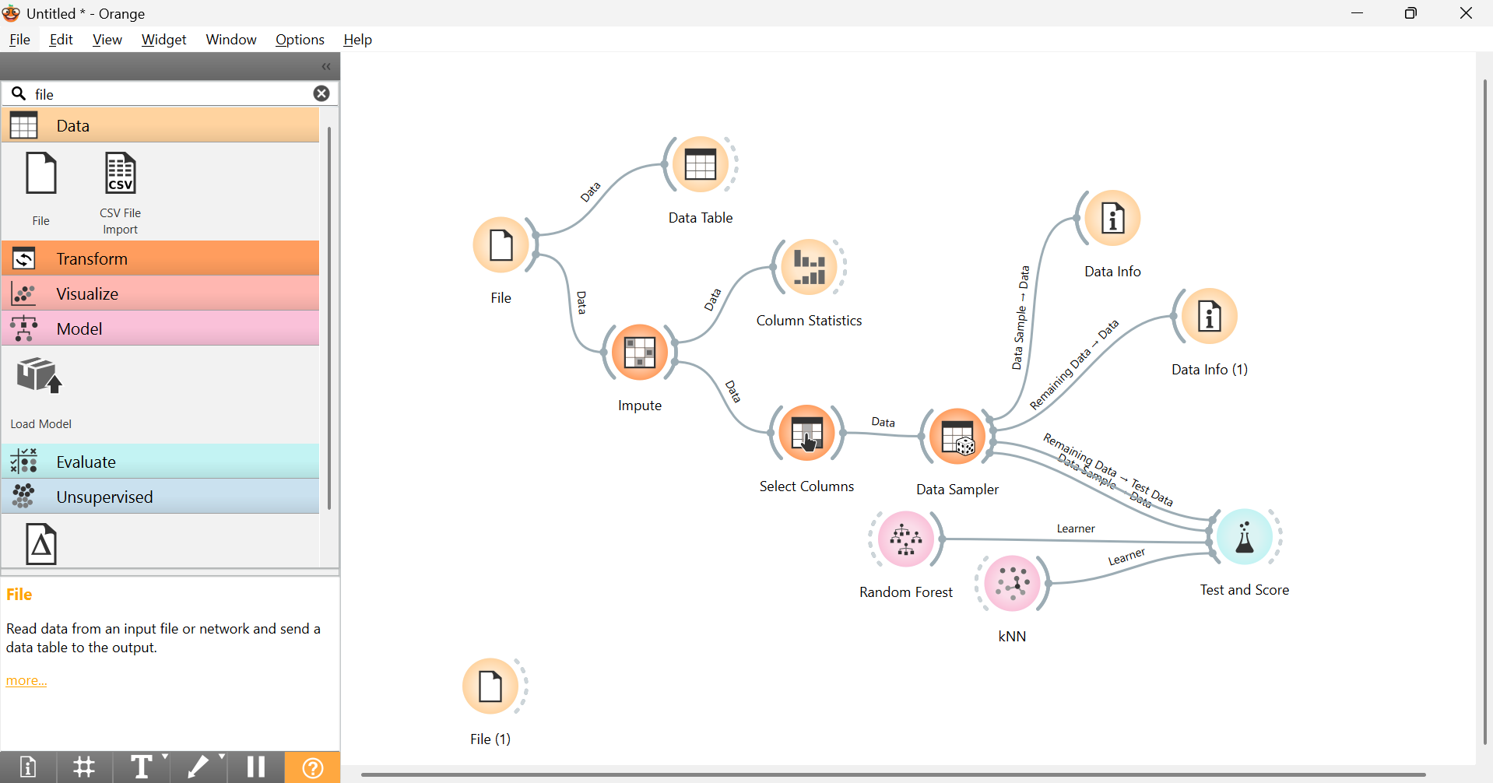

Step 18: Connect the output of second file widget with Impute widget for missing values. Than connect with the Predictions widget. Also, connect any one or most appropriate model with Predictions Widget.
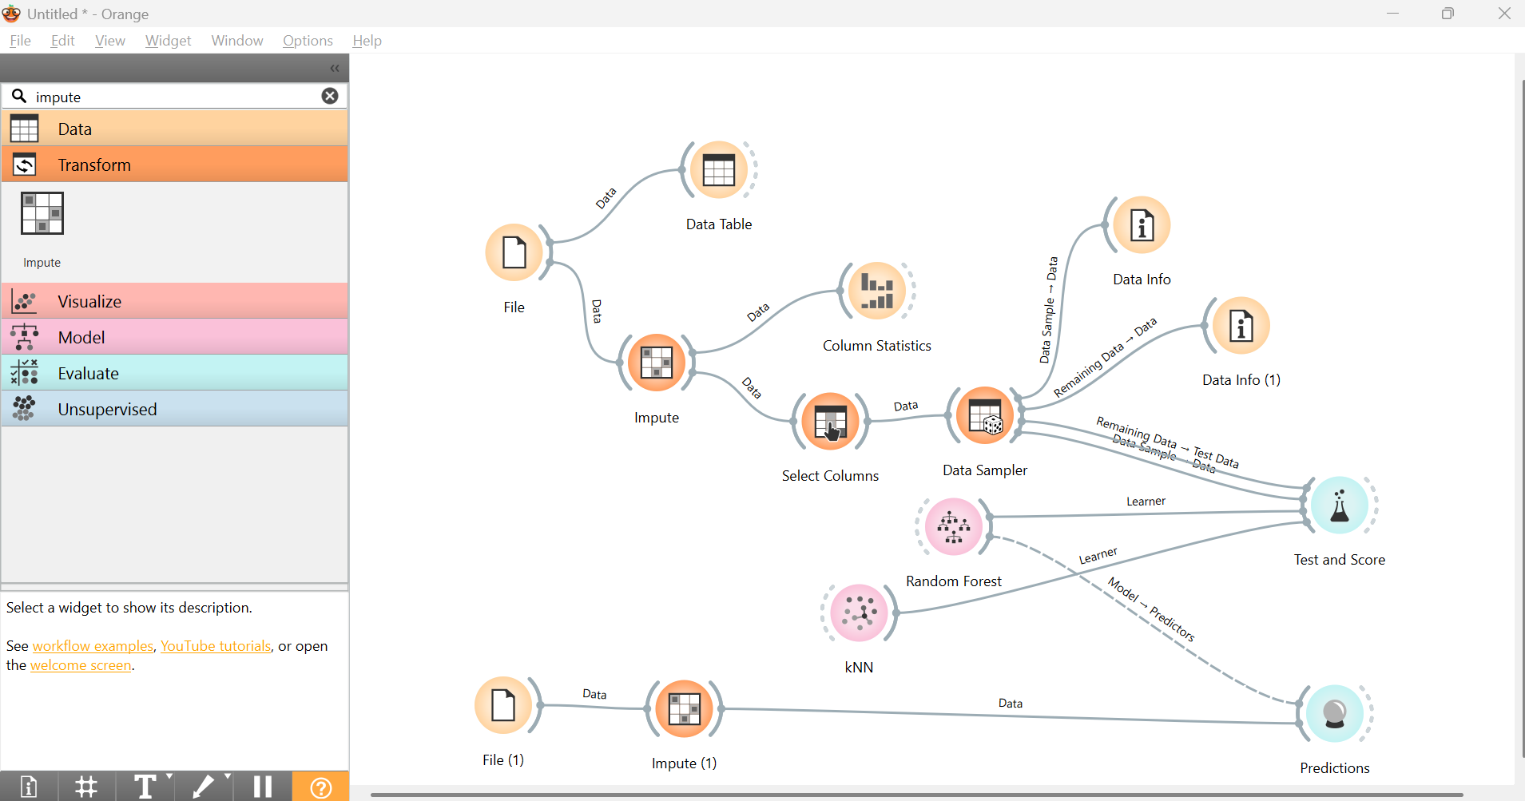

Step 19: Check the values of Prediction widget by double clicking on it.

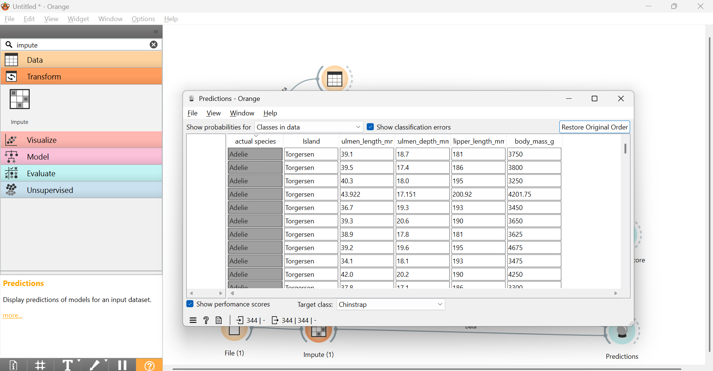

Project 2
Using Orange Data Mining, design and develop a computer vision-based AI system that analyzes underwater images to identify and classify coral reefs as healthy or bleached, enabling the early detection of coral bleaching for marine ecosystem monitoring and conservation.
Step 1: Click on Options -> Add On -> Image Analytics . Restart Orange for the changes to take effect.
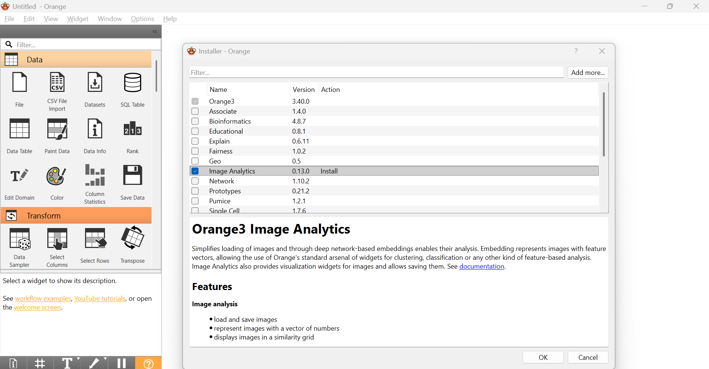
Step 2: Click on Import Images widget under Image Analytics menu
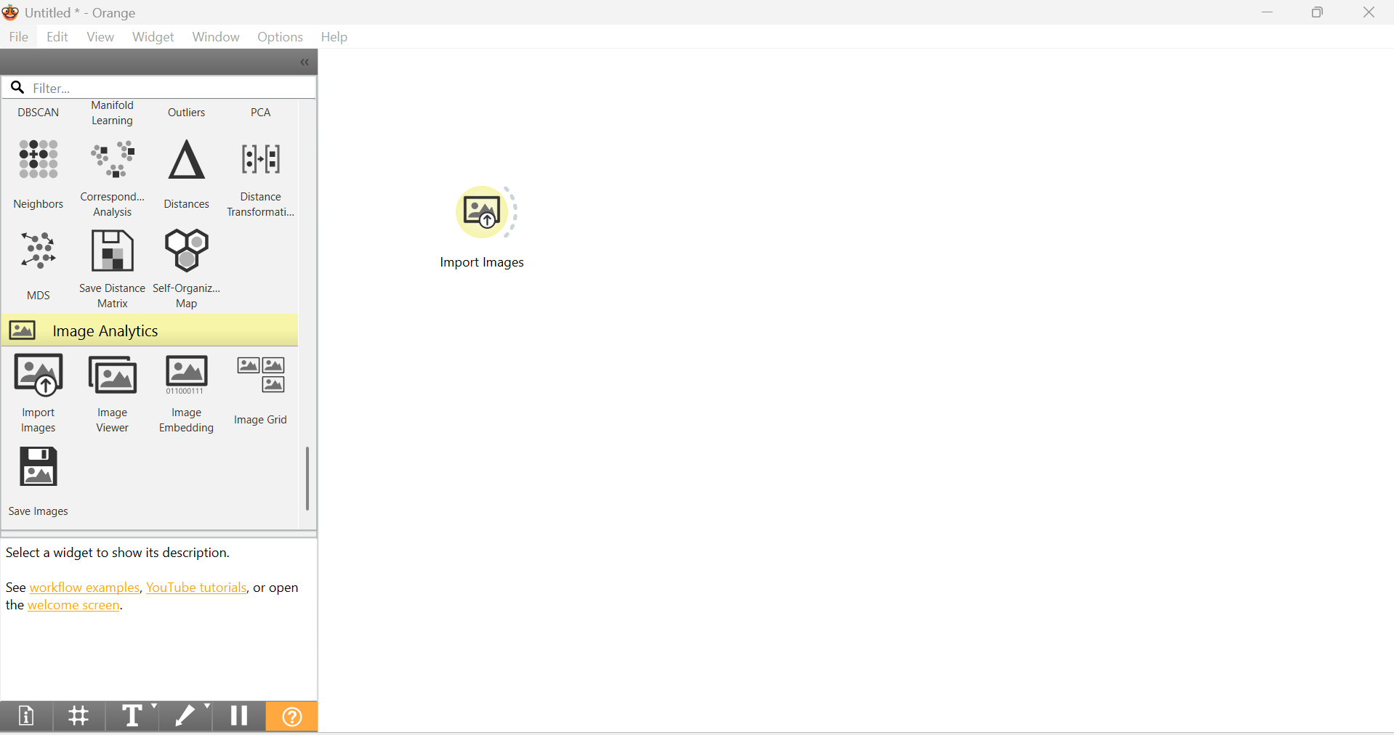
Step 3: Click on Import images widget to upload Train dataset folder which has both bleached and unbleached images of coral.
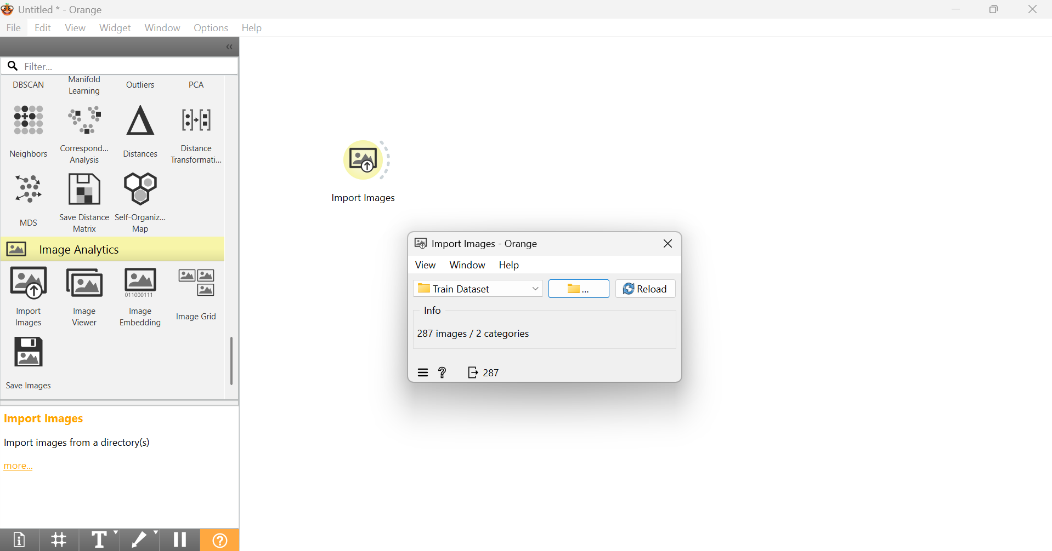
Step 4: Connect Image Viewer widget to the output of Import images.
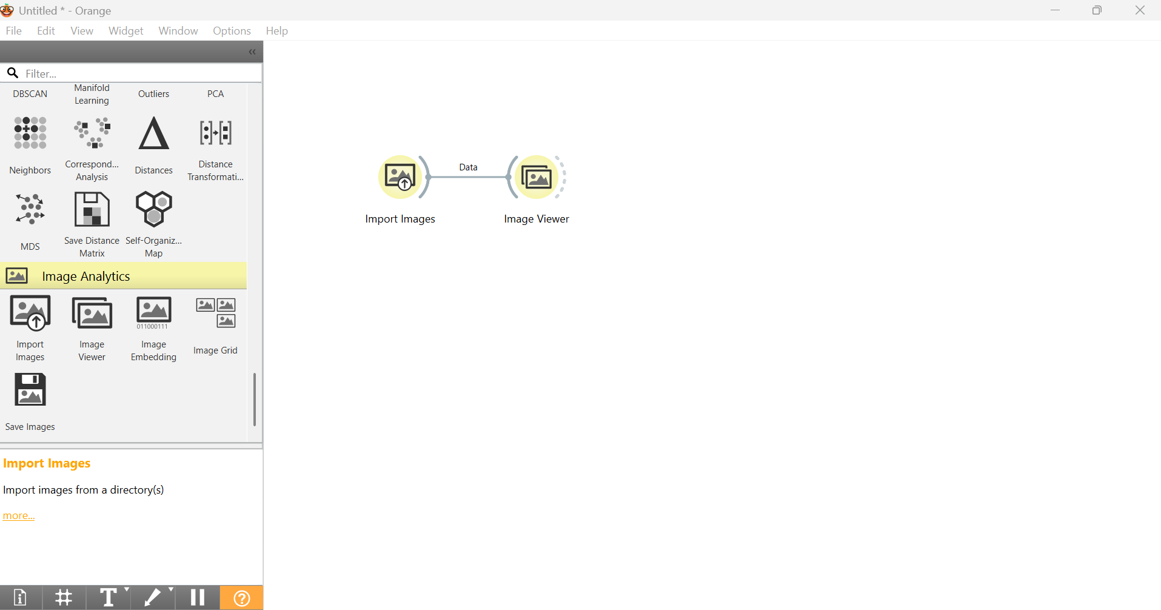

Step 5: Connect Image Embeddings widget to the output of Import Images widget to convert images in 0 and 1.
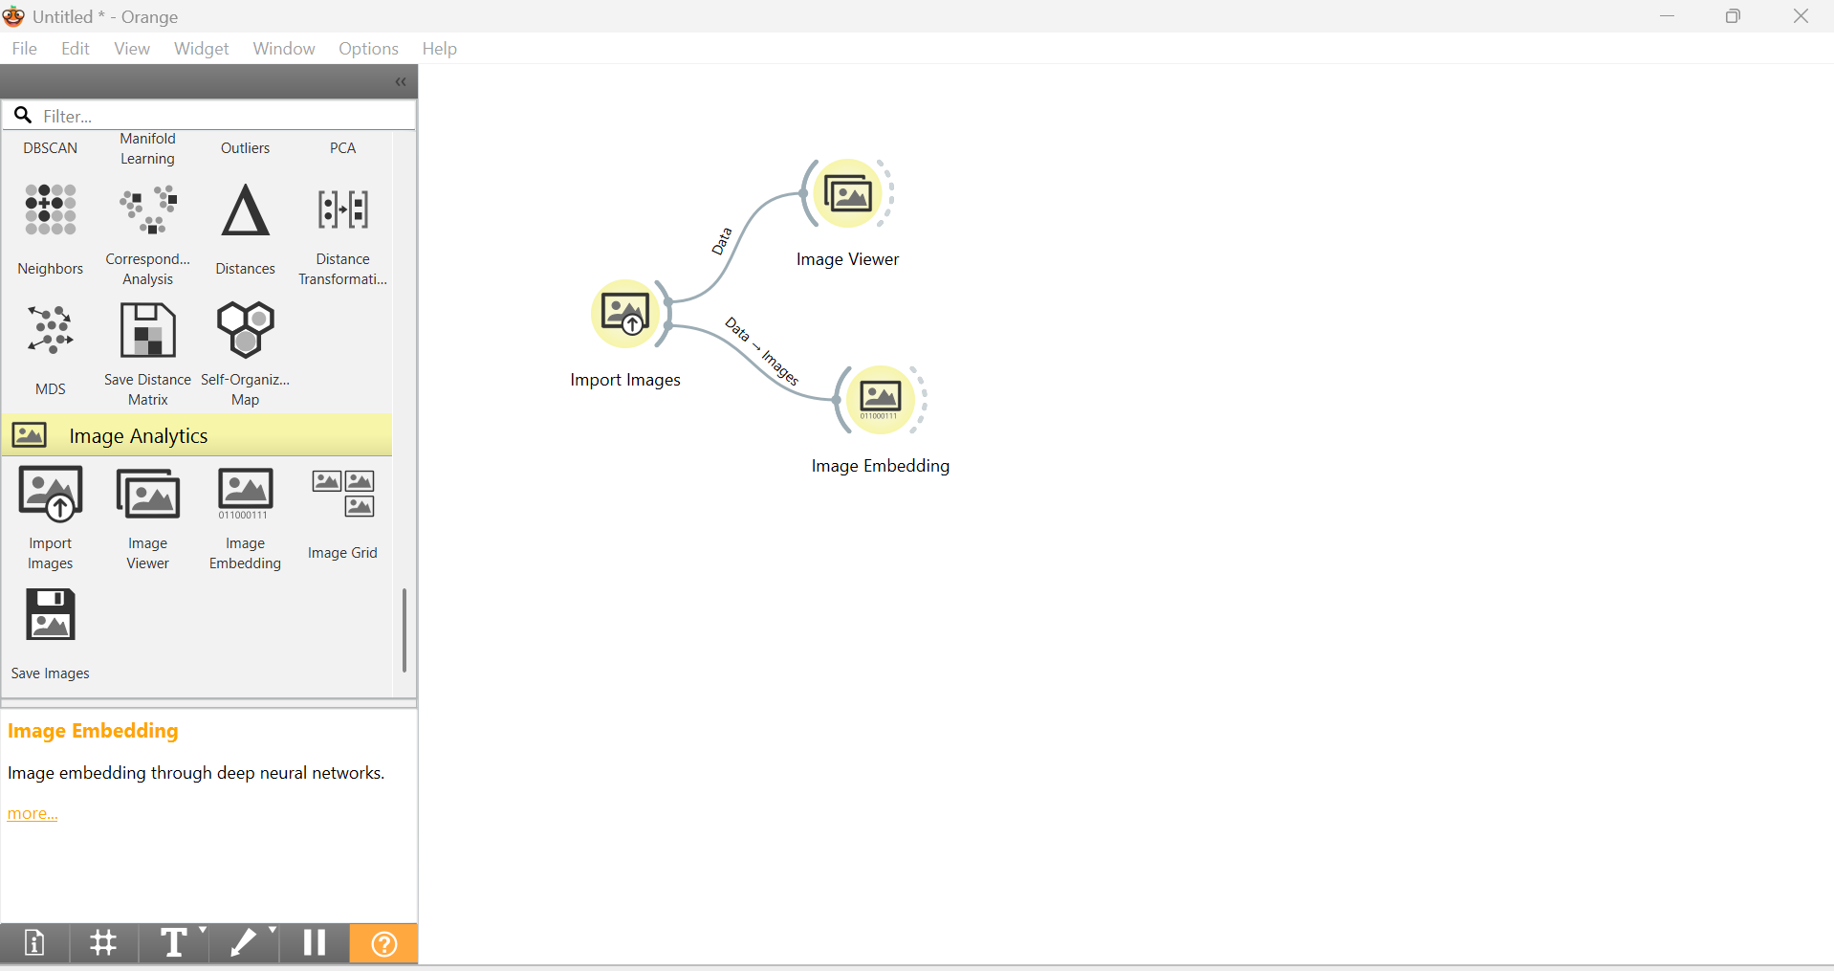
Step 6: Connect Data Table widget to the output of Image Embedding and click to check the data instances
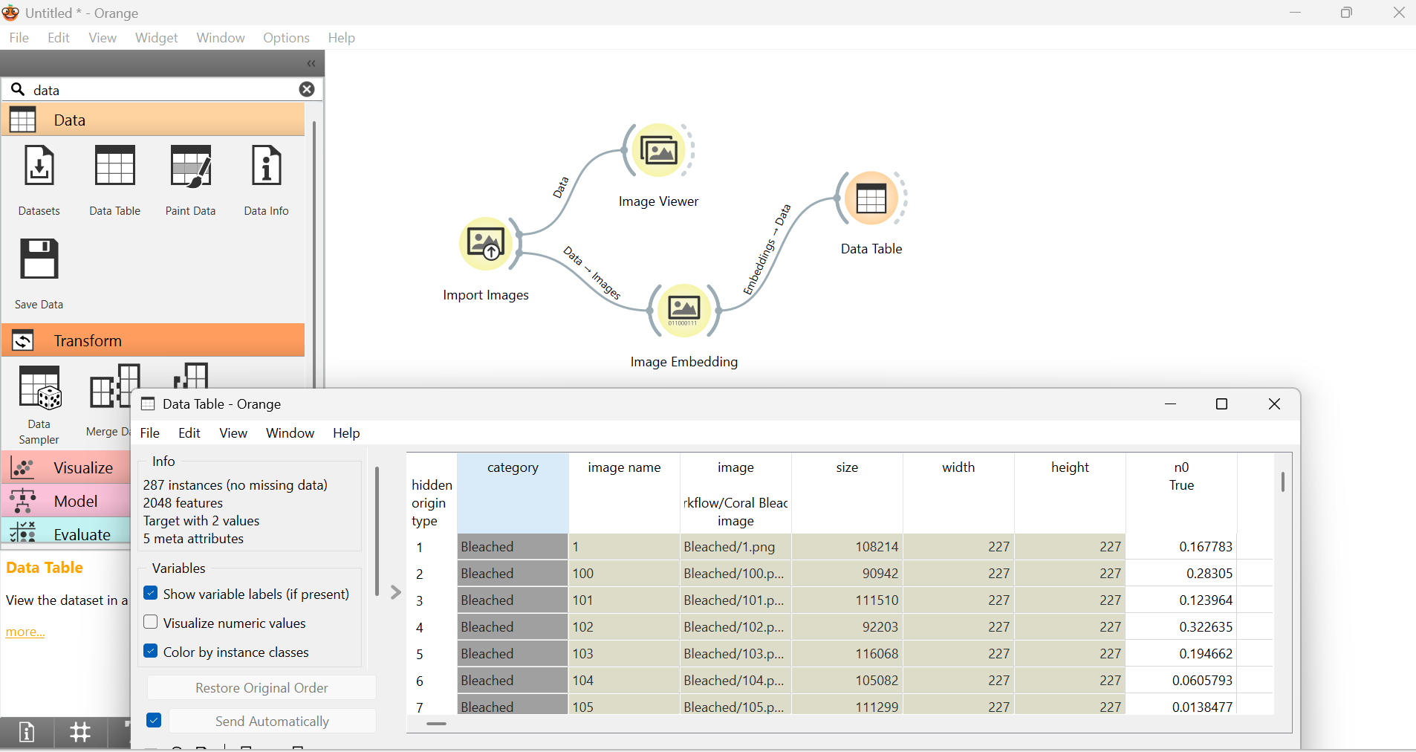

Step 7: Add Test and Score widget to the output of Image Embedding and algorithms like Logistic Regression, SVM and random Forest.
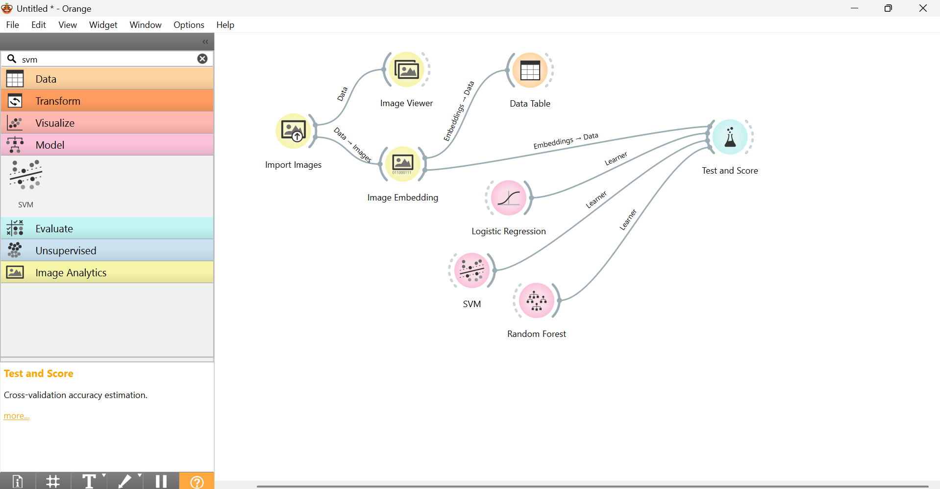
Step 8: Open Test and Score widget to compare the values of AUC, CA, F1 Score, Precision, Recall and MCC
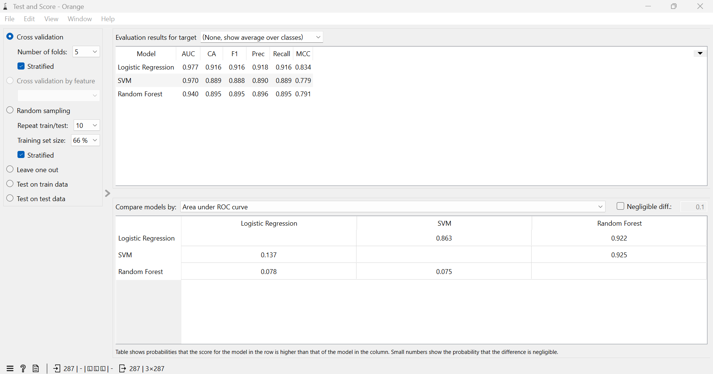

Step 9: Add Confusion Matrix to the output of Test and Score and double click to view the Actual and Predicted values.
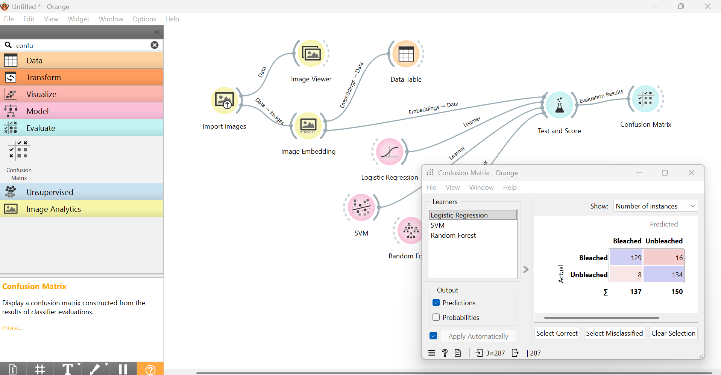
Step 10: Again add Import Images widget and upload Test Dataset.
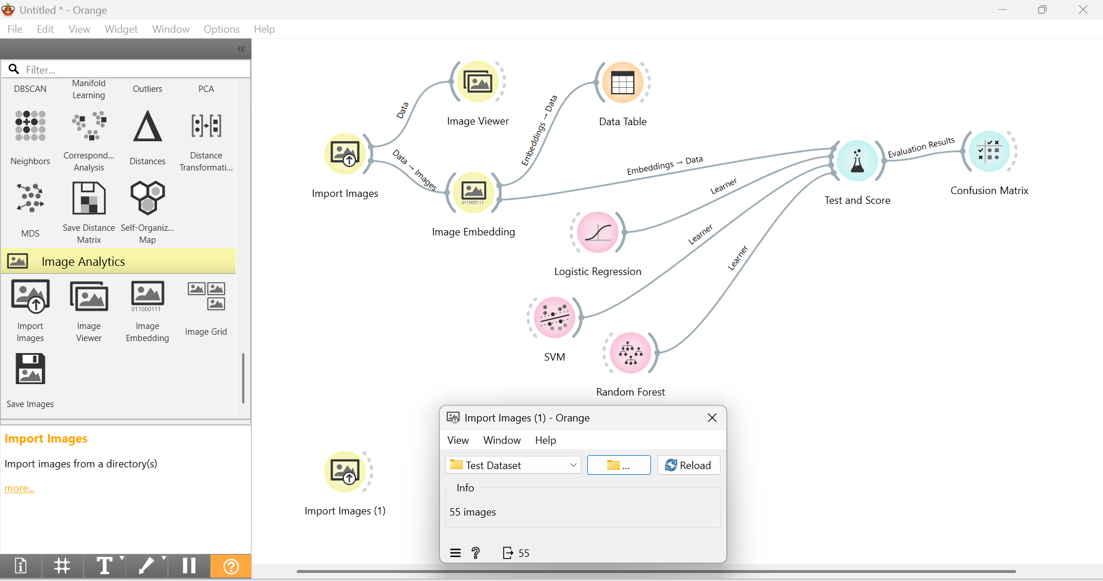

Step 11: Add Image viewer to view the images of Test dataset.
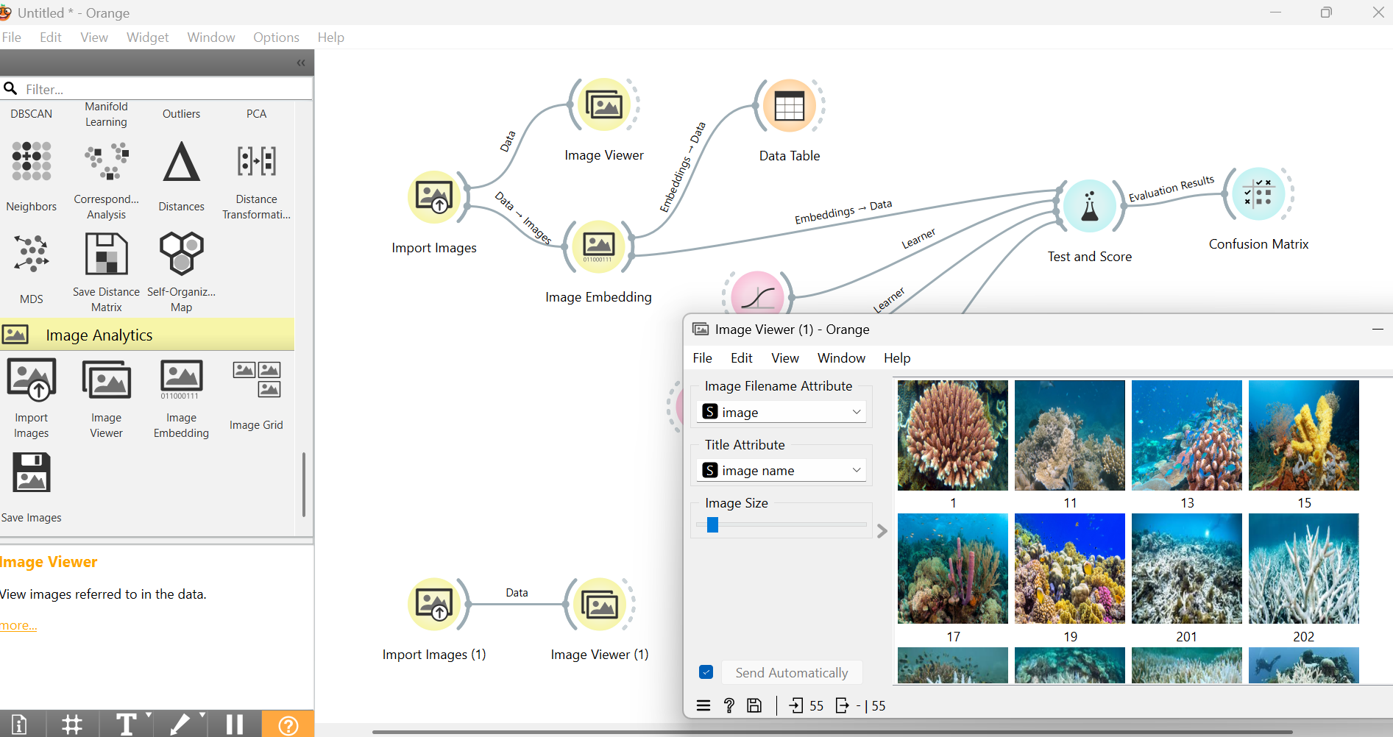

Step 12: Add Image Embedding widget to convert images in 0 and 1
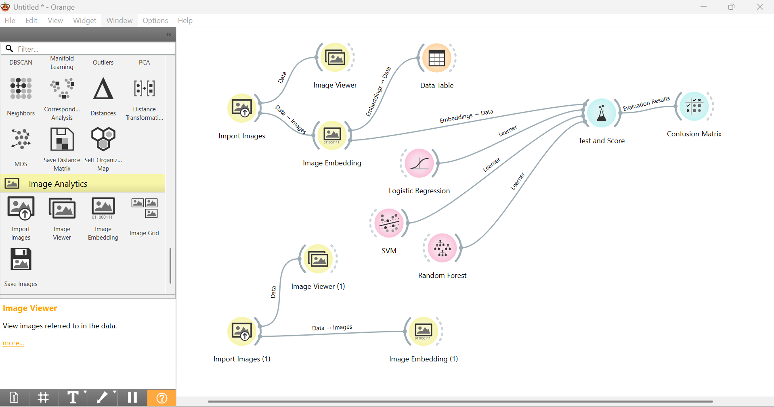

Step 13: Connect initial Inage Embedding to the newly added Random Forest widget.
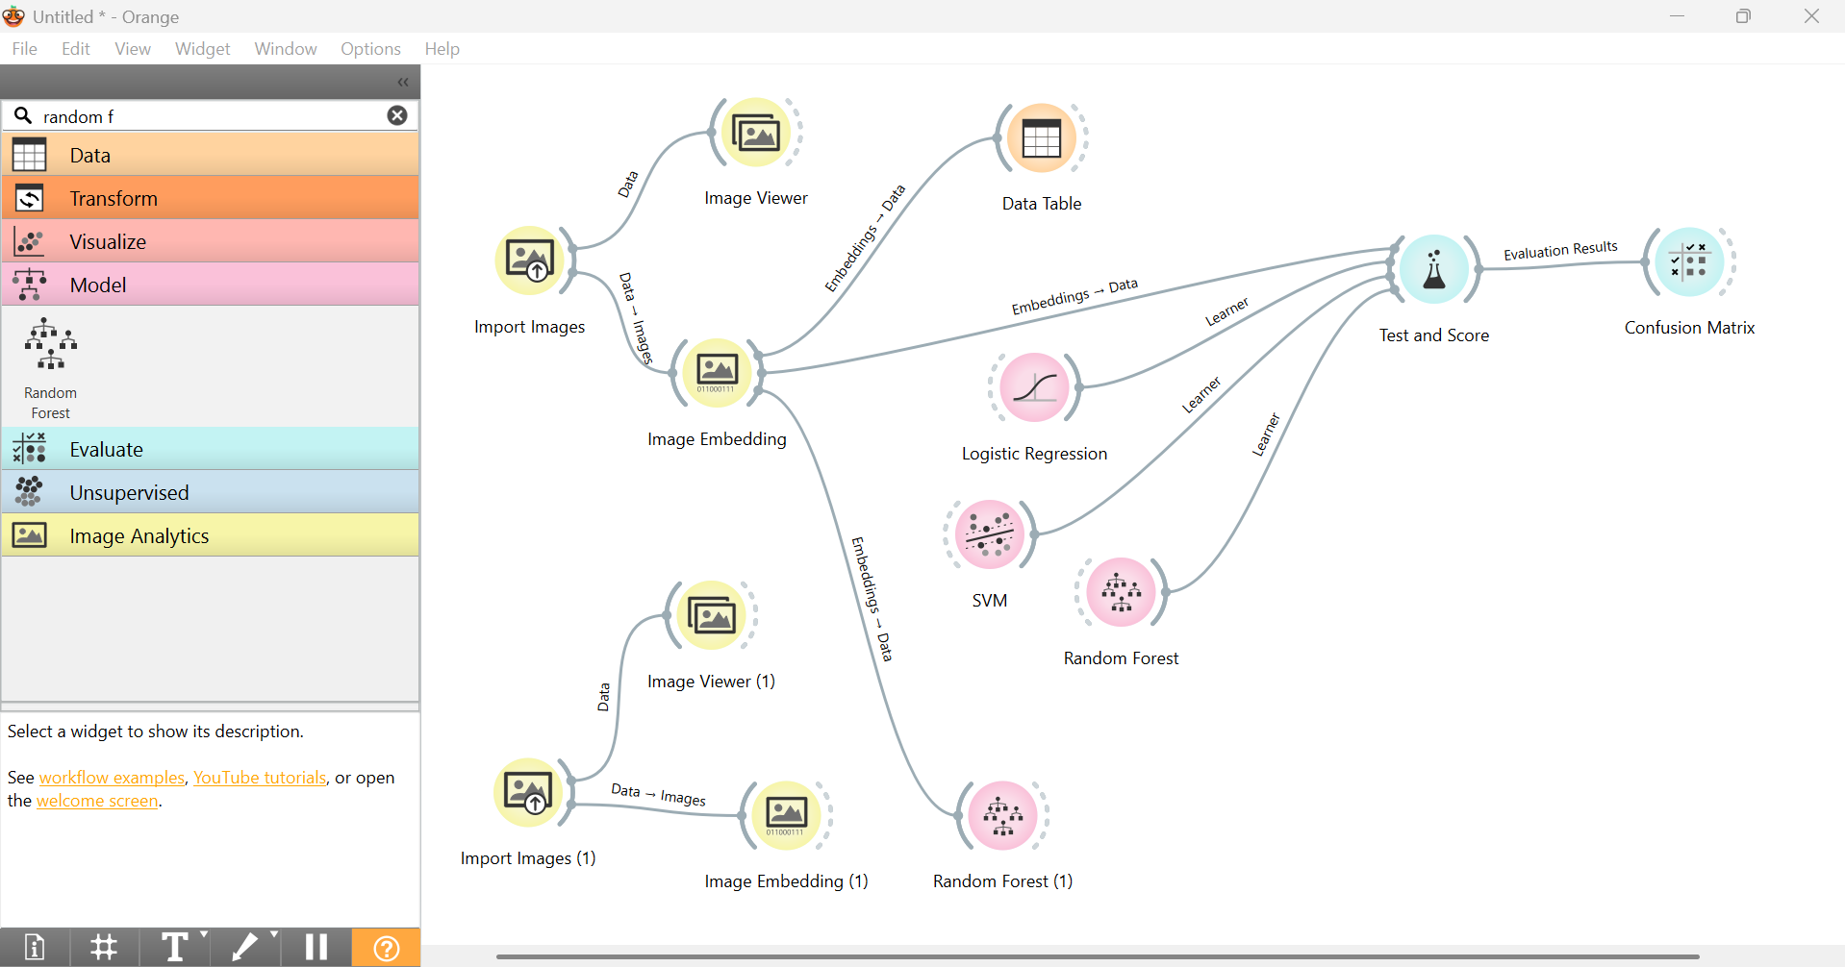

Step 14: Add Predictions widget to the output of Image Embedding widget for Testing data.
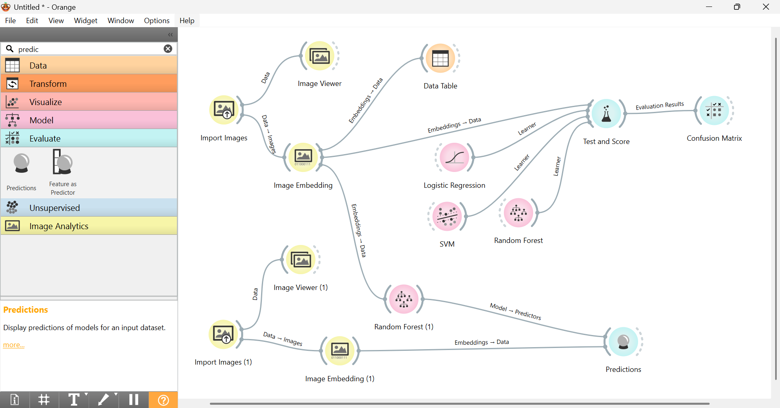

Step 15: Double click on predictions widget to check the Testing Data image is Bleached or Unbleached.

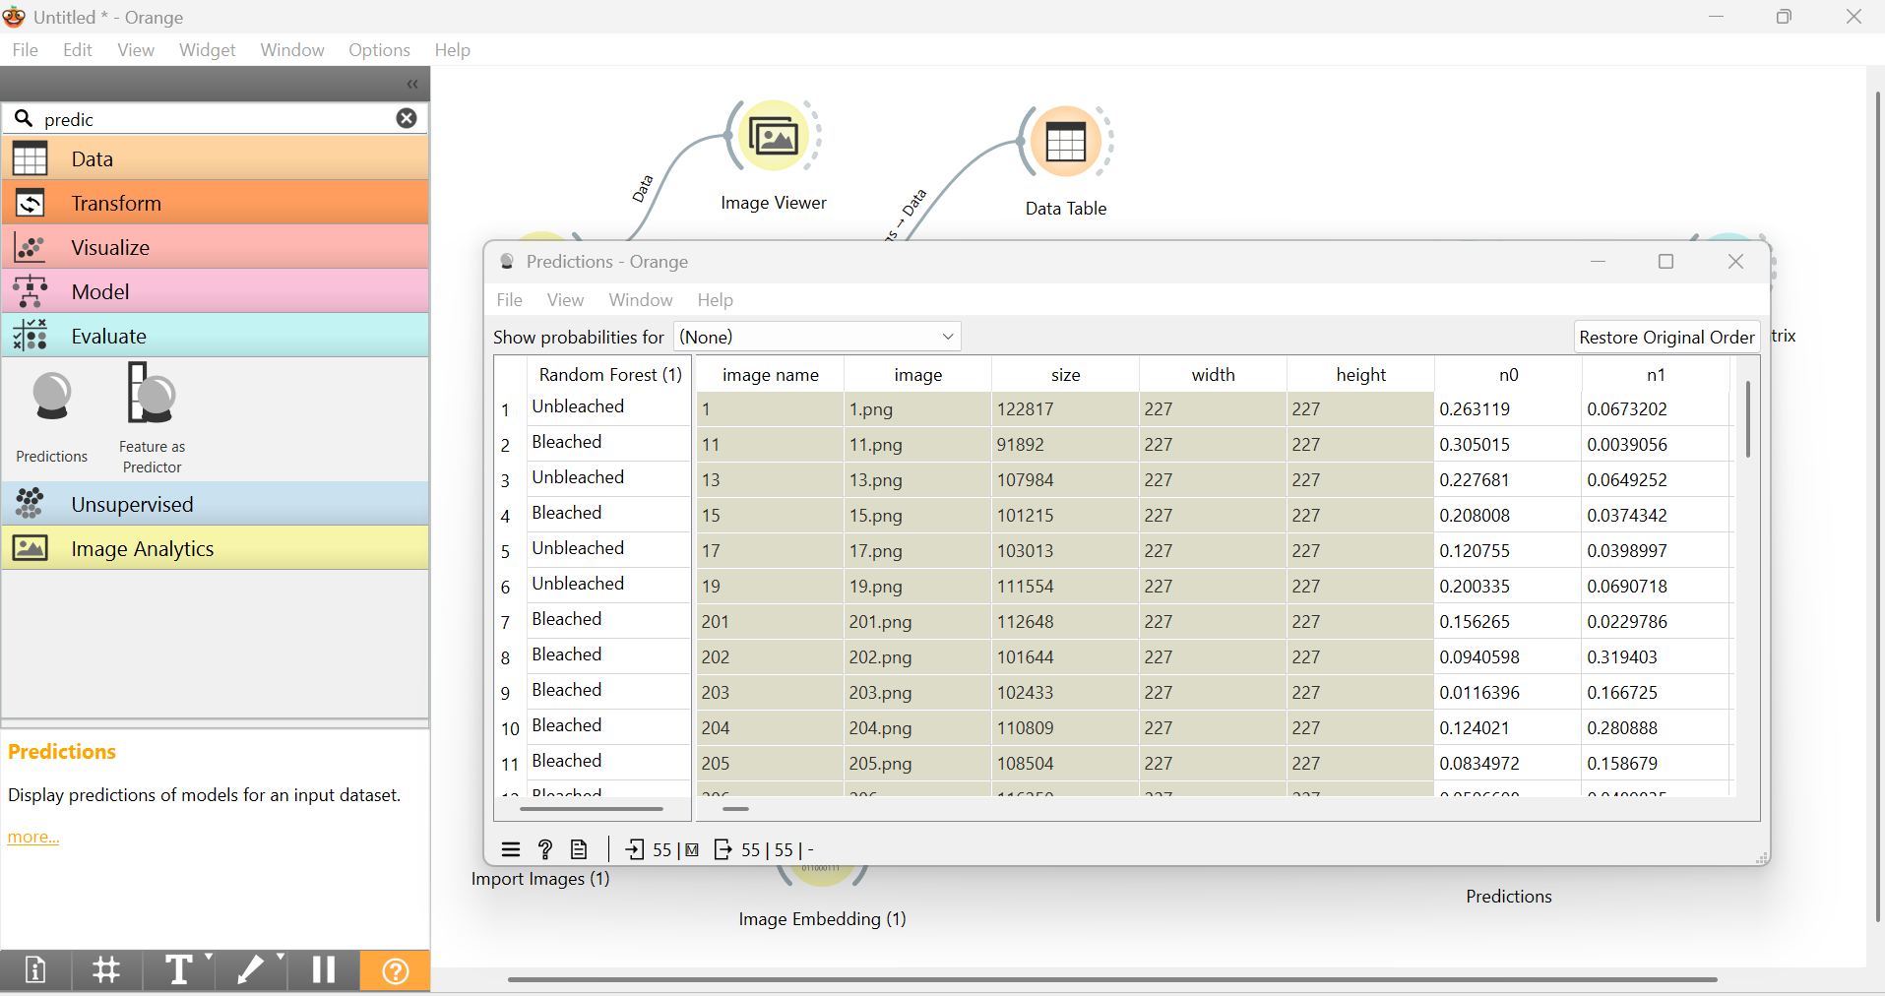

Project 3
Develop an AI-based Natural Language Processing (NLP) model using Orange Data Mining to classify book excerpts into Children's Literature or Adult Literature based on their textual content.
Step 1: Click on Options -> Add On -> Text . Restart Orange for the changes to take effect.
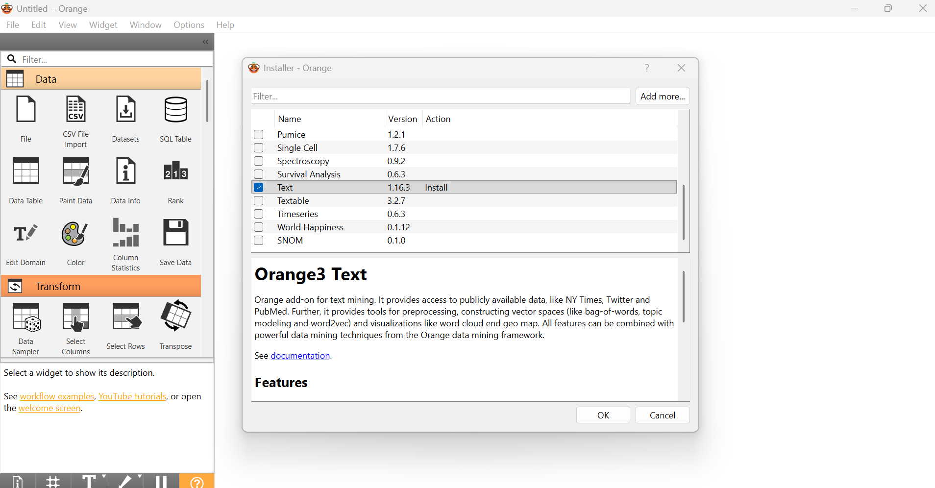
Step 2: Add corpus widget and from inbuilt datasets select book excerpts.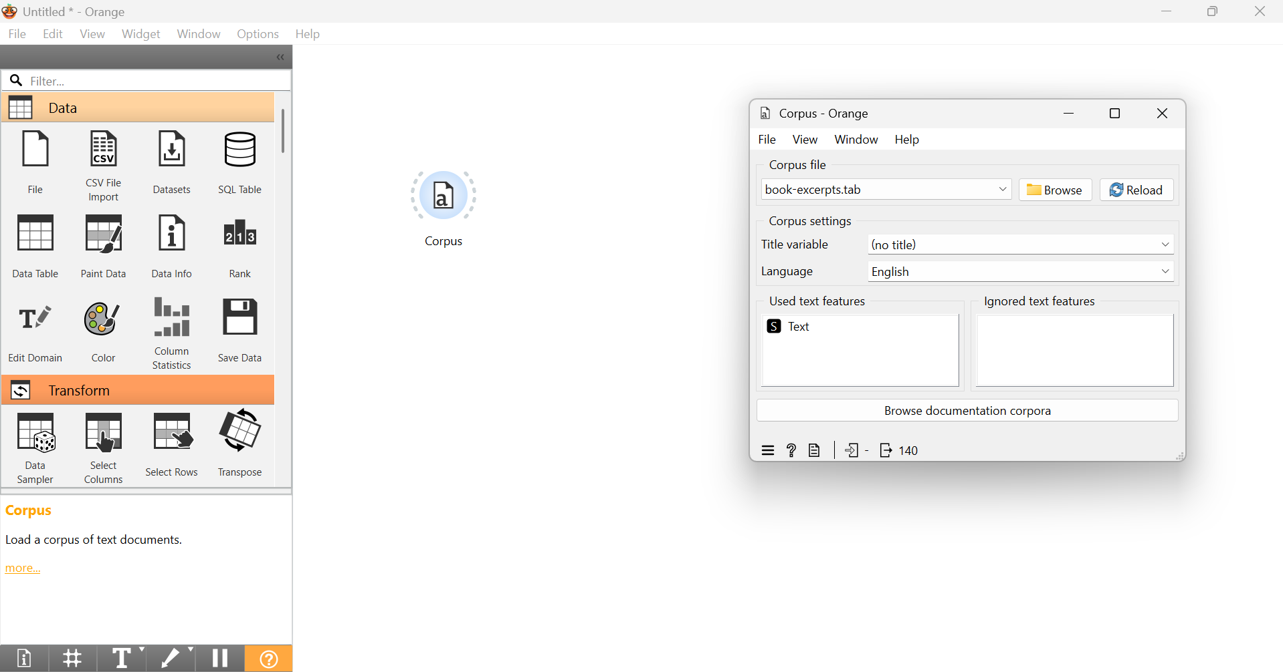

Step 3: Connect Data table with the output of corpus widget to view the dataset.
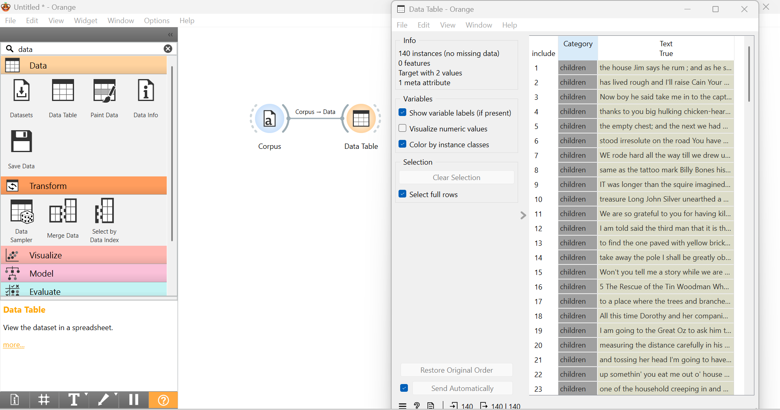
Step 4: Add Preprocess Text with the output of Corpus to clean and transform raw text into a structured format.
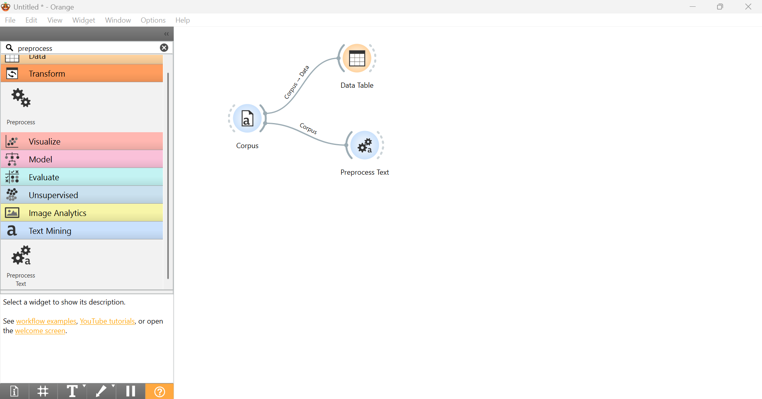
Step 5: Add Bag of Words widget to convert text documents into numerical data.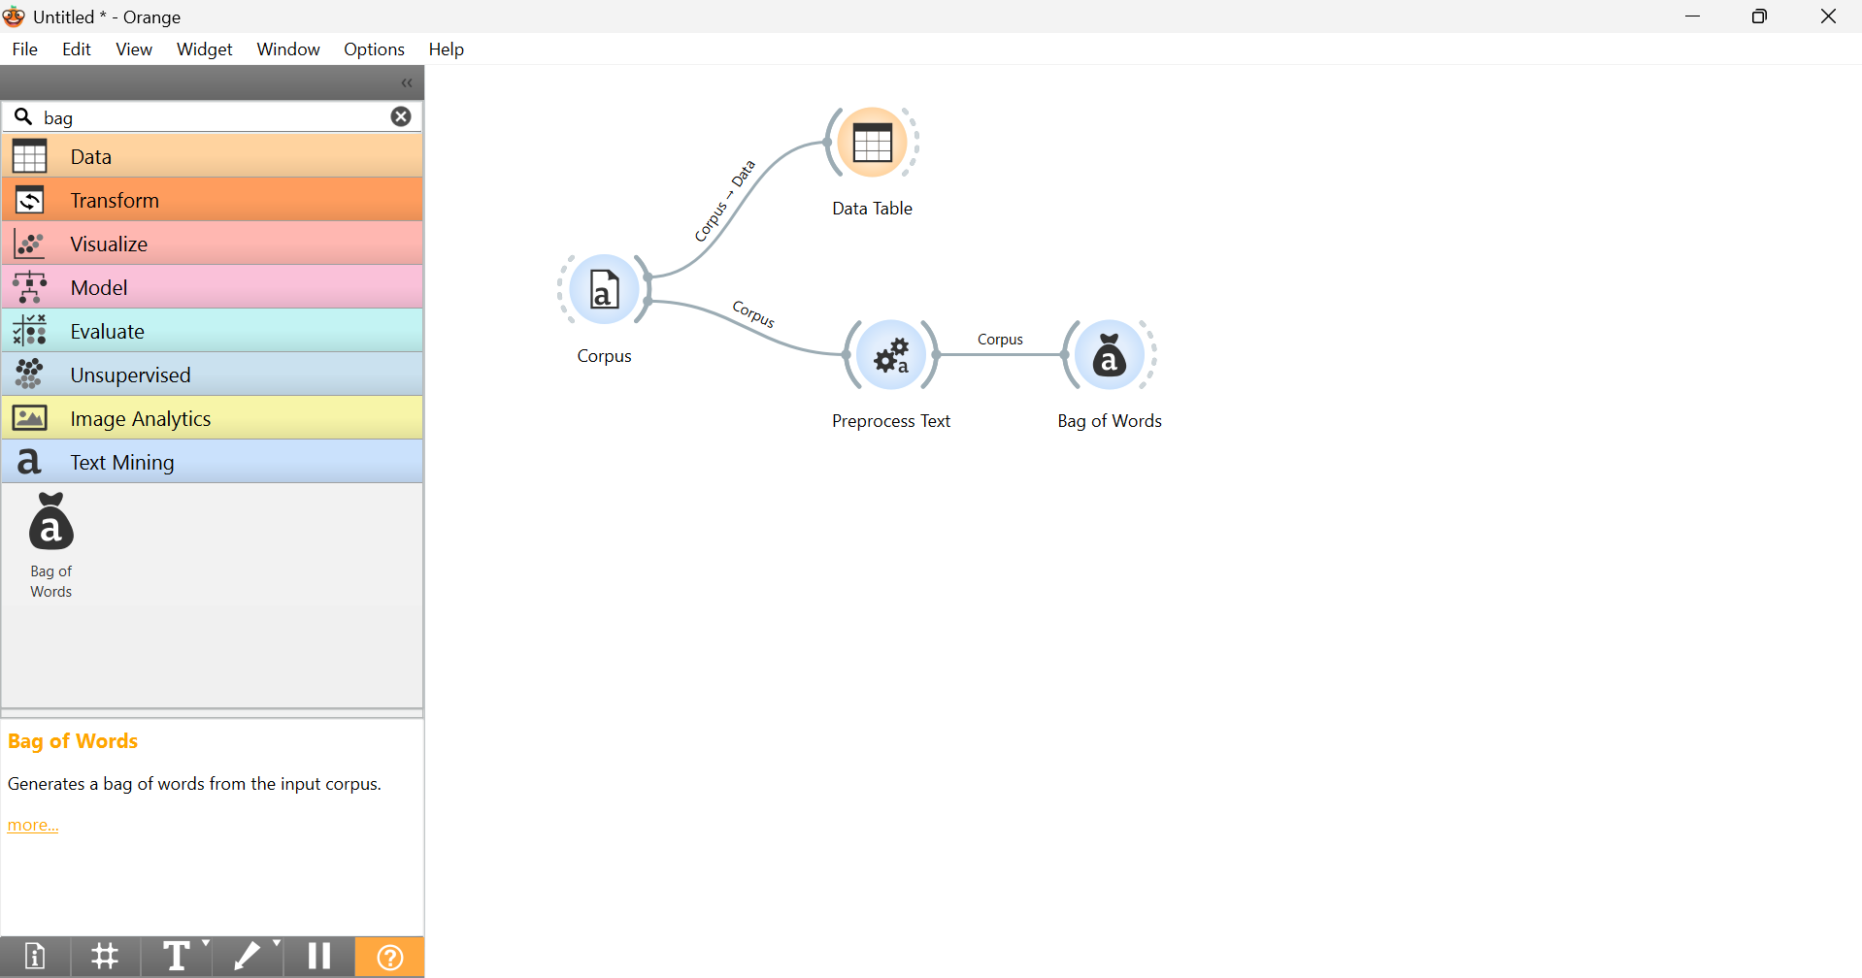
Step 6: Connect Data Sampler widget to randomly divide the dataset into training and testing machine learning models.
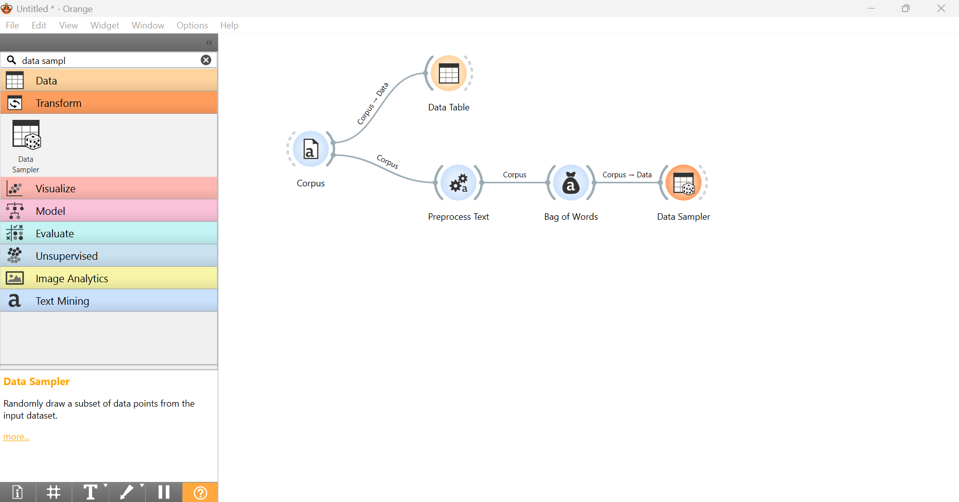

Step 7: Connect Test and Score with the output of Data Sampler. Train it with Naïve Bayes algorithm.
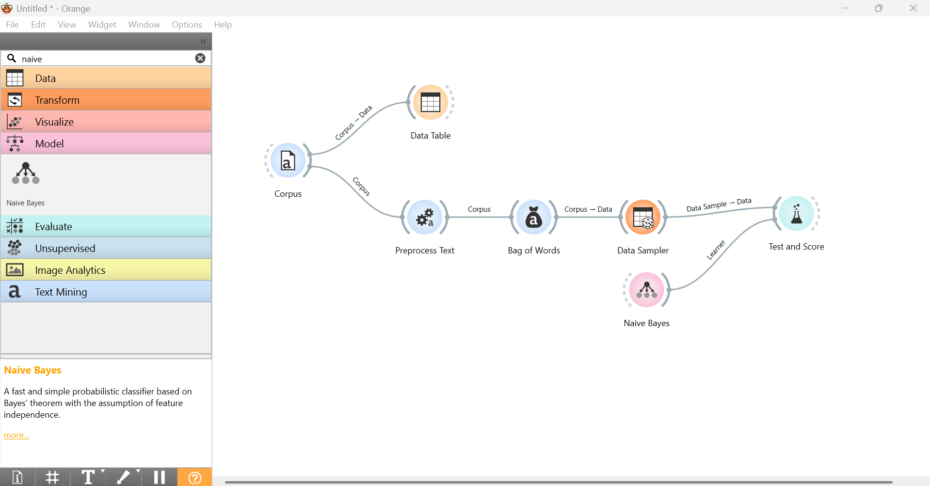

Step 8: Train your model with more algorithms like Logistic Regression , Random Forest
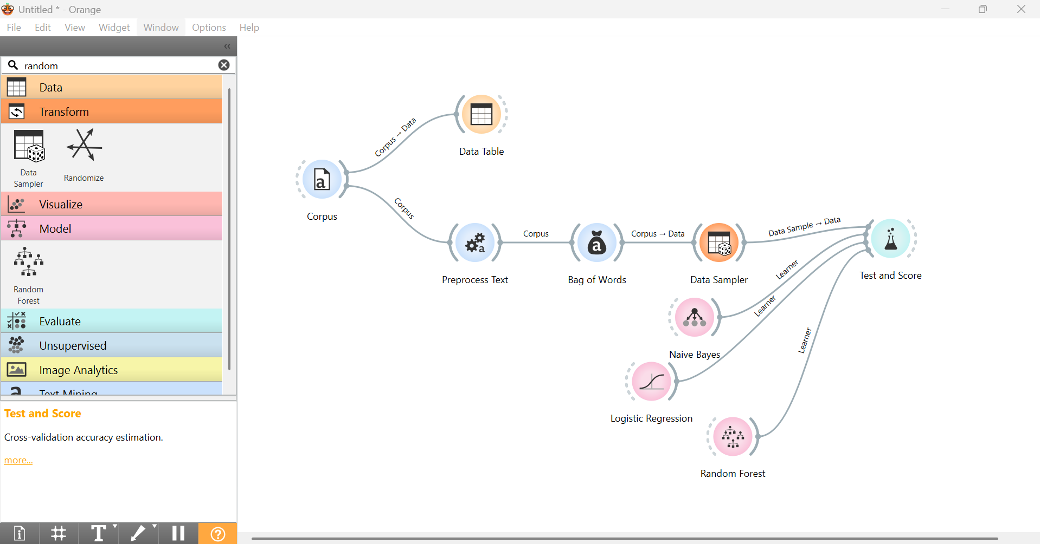

Step 9: Compare the values of AUC, CA, F1, Precision, Recall and MCC.
