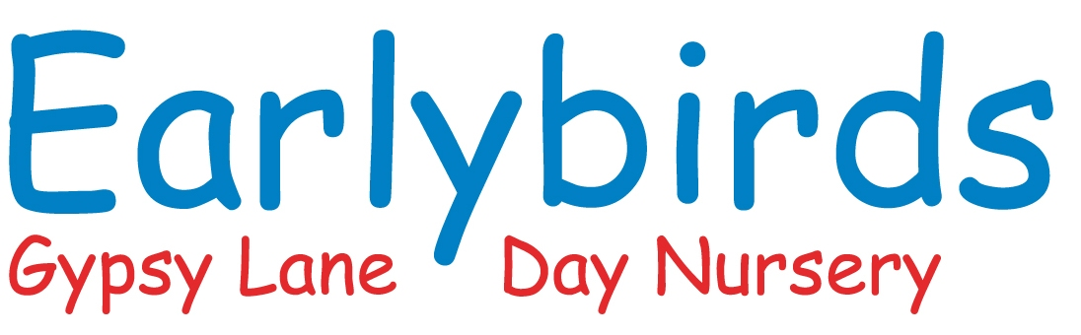

Day | Breakfast | Morning Snack | Lunch + Dessert | Vegetarian Alternative | Afternoon Snack | Tea + Dessert | Allergen Notes
1 | Porridge with smashed banana, Milk & Water | Apple wedges  Milk & Water | Chicken & vegetable casserole with mashed potato.  stewed pear | Lentil & veg casserole | Rice cakes  Milk & Water | Wholemeal sandwiches with egg mayo or Cheese  Yoghurt | Milk, gluten, egg
2 | Cereal with Milk & Water | Cucumber Sticks  Milk & Water | Spaghetti Bolognese.  Carrot & Sultana pudding | Lentil Bolognese | Pear slices Milk & Water | Stir-fry chicken noodles  Fruit | Gluten, milk
3 | Toast fingers  Milk & Water | Breadsticks  Milk & Water | Mild chicken curry with rice.  Peaches & yoghurt | Chickpea & veg curry | Cheese Sticks, Milk & Water | Tuna pasta Bake.  banana | Egg, milk, gluten, Fish
4 | Porridge  Milk & Water | Orange Segments  Milk & Water | Quorn stew with root vegetables; Apple oaty crumble & custard | Quorn & vegetable stew | Breadsticks & hummus  Milk & Water | Wholemeal Sandwiches with cheese & cucumber.  fruit salad | Milk, gluten
5 | Wholegrain cereal  Milk & Water | Banana Sticks  Milk & Water | Fish pie with peas & sweetcorn; rice pudding | Veggie pie | Apple Slices  Milk & Water | Bagels and Chicken with veg sticks  fruit | Fish, milk, gluten
6 | Toast  Milk & Water | Apple slices  Milk & Water | Meatballs with tomato sauce & pasta.  Carrot Muffins | Veggie meatballs | Pepper sticks  Milk & Water | Jacket potato with beans.  Jelly | Milk, gluten
7 | Porridge with grated apple  Milk & Water | Bread Sticks  Milk & Water | Cottage pie with peas; semolina pudding | Lentil cottage pie | Cucumber sticks  Milk & Water | Tuna sandwiches; Banana Sticks | Milk, gluten, fish
8 | Wholegrain cereal  Milk & Water | Rice Cakes  Milk & Water | Chicken & veg risotto.  stewed apple | Vegetable risotto | Rice cakes  Milk & Water | Veg Soup & wholemeal Bread fruit yoghurt | Milk, gluten
9 | Toast fingers Milk & Water | Banana Sticks  Milk & Water | Mild fish curry with rice and Veg  Bread & Butter pudding | Veggie mince shepherd’s pie | Oat biscuit Milk & Water | Pasta with tomato sauce.  fruit salad | Milk, egg, gluten
10 | Cereal  Milk & Water | Apple wedges  Milk & Water | Chicken & Veg past a bake  Banana & Oat Muffins | Veggie Pasta Bake | Breadsticks & Hummus  Milk & Water | Wholemeal sandwiches with cheese & tomato; yoghurt | Milk, gluten
11 | Porridge & Smashed Banana  Milk & Water | Cucumber sticks | Roast chicken, potatoes, carrots, Yorkshire Pudding & gravy;  fruit crumble | Nut roast | Cracker with Spread.  Milk & Water | Beans on Toast  Banana slices | Milk, gluten
12 | Toast  Milk & Water | Orange segments  Milk & Water | Beef lasagne; with mixed Veg  Rice pudding | Vegetable lasagne | Rice cakes with cream cheese  Milk & Water | Ham Bagels;  fruit yoghurt | Milk, gluten.
13 | Wholegrain cereal with Milk & Water | Pear slices  Milk & Water | Chicken stew with dumplings; stewed apple | Quorn stew | Oat biscuit Milk & Water | Egg Mayo & Cheese Sandwiches Fruit | Milk, gluten
14 | Porridge with cinnamon & grated apple | Banana pieces  Milk & Water | Minestrone Soup  Bananas & Custard | Lentil casserole | Cheese cubes  Milk & Water | Broccoli Pasta.  fruit | Milk, gluten
15 | Toast fingers | Rice cakes  Milk & Water | Chicken & veg pie; semolina pudding | Veggie pie | Breadsticks  Milk & Water | Spaghetti on toast.  fruit | Milk, gluten
16 | Wholegrain cereal with banana | Cucumber sticks  Milk & Water | Fish fingers, mash & peas; Health Fruit scones | Veggie fingers | Orange segments  Milk & Water | Chicken sandwiches; fruit | Fish, milk, gluten

✅ Key EYFS Nutritional Compliance Notes
- No added salt or sugar.
- Soft textures for under-1s (e.g. mash, chopped fruit.
- Fruit & veg at every meal.
- Iron-rich foods daily (meat, lentils, fortified cereal).
- Hydration: water available all day, milk offered at snack times.

