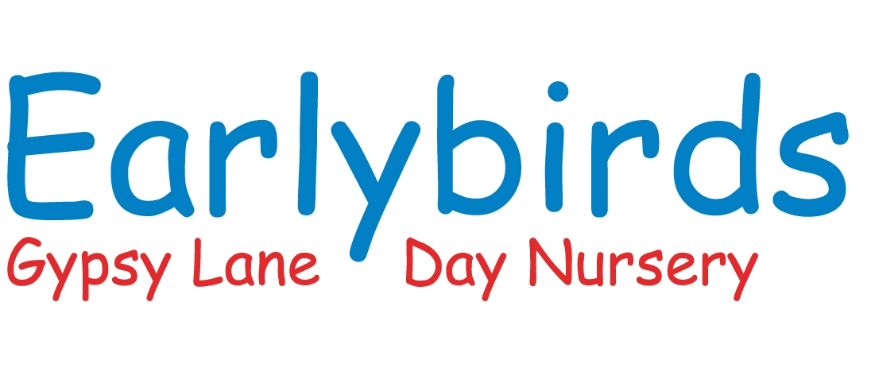


Caring for Children from
3 months to 8 years
Gypsy Lane
Elmton Road
Creswell
Worksop
Notts
S80 4HY
01909 723947

Earlybirds Day Nursery offers high quality childcare to the village of Creswell and the surrounding area. Enabling all parents to know their child is within a safe and happy learning environment.

Our ethos is based on the belief that every child deserves the best possible start in life and the support to fulfil their potential. A child’s learning in the early years has a major impact on their future. A secure, safe and happy childhood is important and when parents and carers choose a nursery they want the assurance that they will keep their child safe and support them to develop. The daily activities at Earlybirds help to develop happy, independent and creative children.

Light, airy and spacious, Earlybirds is a bright, stimulating and inviting learning environment where children thrive. Located close to junction 30 of the M1 and close to A60 with good links to Barlborough, Clowne and surrounding area. Earlybirds is part of Creswell C of E Infants and Nursery school and based on the same site as Children’s Centre.

Ages 3 months to 8 years.
Open 7.30am to 6pm Monday to Friday.
The nursery is closed for every bank holiday and for a week over the Christmas period.

Earlybirds is extremely proud to have been graded as an good provider by Ofsted in 2022.

Staff who Care
We are proud of our happy, professional team of nursery practitioners, all of whom have been chosen for their ability and commitment to care for and nurture young children.
Practitioners are appropriately qualified and experienced, and the nursery actively encourages further staff training and development. All our carers are DBS checked and are trained or are working towards NVQ Child Care level 2/3.
Nursery practitioners attend regular Paediatric First Aid, Child Protection and Food Hygiene courses. Everyone is encouraged to extend, improve and update their training and qualifications and keep up to date with developments and good practice in the Early Years Foundation Stage framework.

Our carer-to-child ratios meet the requirements of Ofsted and we ensure our staff have time to provide the attention each child needs.
0 to 2-year olds: 1 carer to 3 children
2 to 3-year olds: 1 carer to 4 children
3 to 5-year olds: 1 carer to 8 children


A Place to Grow and Develop

Children are full of amazing potential and giving them everything they need to make the most of it is something the team at Earlybirds Day Nursery takes very seriously.

Our aim is to help your child develop physically, intellectually, socially, and emotionally – helping to prepare them for their future at school and beyond. We understand that each and every child needs a happy, healthy environment for learning and playing and at Earlybirds we are dedicated to helping parents provide just that. Children at Earlybirds benefit immensely from the rich, stimulating environment and the wealth of learning opportunities that are available to them. The government's Early Years Foundation Stage (EYFS) is the framework the nursery follows to provide that assurance.
The curriculum and activities are based around the 'Every Child Matters' principles – keeping children safe and healthy, helping them enjoy and achieve, and encouraging them to make a positive contribution as they grow.
Every child who attends is an individual and is treated accordingly. The children are surrounded by their peers and dedicated practitioners to allow them to develop at their own pace.
Room organisation and age groupings ensure that all children have plenty of time to explore, play and learn, but most of all to enjoy their day. There are separate play areas and children are allocated a room in which to commence their nursery experience. Short 'settling in' sessions are offered to ensure that your child is completely happy in their new surroundings before attending a full session.

Building Partnership with Parents

We work hard to promote a happy working relationship with all children and their parents, as it is recognising that the best quality childcare is achieved through close co-operation with all the family. A successful partnership with parents is based on the exchange of information, knowledge, and expertise. When a child joins Earlybirds, they are allocated a key person who becomes their primary carer whilst at nursery, and with whom they, and their family, will build a secure relationship ensuring all feel included, secure, valued, and welcome in the nursery.

We operate flexible sessions your child attends – mornings, afternoons, all day – whatever works for you and your child. At Earlybirds we encourage parents to access their child’s learning journey through their individual log in details. We also have a closed Facebook group where we keep you up to date with news about the nursery and things that are happening, plus there are two parents’ evenings per year, where you are encouraged to contribute.
We’re always here to listen to your comments, sharing our insights and learning from yours.
Nutrition
Good nutrition is central to the healthy growth and development of all children. That's why all of our meals, from our carefully planned menus, are prepared on site by the nursery cook. Earlybird has a 5 Star rating from the Environmental Health Inspectors. All meals and snacks are included in the price of our day nursery fees.
7.30 till 9.30am Breakfast & morning snack
11.45 Dinner
2.30pm Afternoon Snack
4.30pm High Tea
Fees
Full day 8am to 6pm £37.00
Sessions 8am to 1pm or 1pm to 6pm £27.00
Full week 8am to 6pm £185.00
Early start for 7.30am £2.00
Wrap around care and holiday care for school age children up to the age of 8 also provided.
£10.00 for an after-school session
£4.50 for breakfast and early start.
Earlybirds collects children for wraparound care from Creswell C of E Infants and Nursery School on a daily basis, we also provide holiday club care for the school.

Taking it Outdoors
The philosophy of Forest Schools is to encourage and inspire children through positive outdoor experiences, creating a unique learning vehicle for interactive play, health, recreation, and personal development.
By participating in engaging, motivating, and achievable tasks and activities in a woodland environment, children learn about nature, how to handle risks and most importantly to use their own initiative in solving problems and co-operating with others. The aim is to develop, good social communication skills, independence, intrinsic motivation, empathy, positive mental attitude, and self-esteem. These, through self- awareness can be developed to reach personal potential.

Safeguarding Children
To ensure all children are protected from abuse and harm, and to promote their right to be strong, resilient and listened to Earlybirds Day Nursery is committed to responding promptly and appropriately to all incidents or concerns of abuse and to work with the Head of Pastoral care within Creswell C of E Infants and all other statutory agencies. We follow the Local Safeguarding Children’s Boards flowchart for referrals. These will be recorded in accordance with our Procedures.

Statement of Care
We are dedicated to providing high quality childcare, which
offers each individual child a safe, secure, and caring environment. We provide a comprehensive range of stimulating and purposeful opportunities and experiences that allows each child to explore and pursue their own interests and goals to promote and enhance all aspects of their individual development.
Statement of Equal Opportunity

Earlybirds Day Nursery is committed to providing equal opportunities through their activities and state that no user will be disadvantaged compared to another by virtue of class, ability, gender, marital status, race or religion.

The nursery will promote an environment in which children can develop their own individual characteristics and skills, none of which will be determined by the sex or ability of the individual.

Booking a Visit

For more information on booking a place at Earlybirds Day Nursery please contact during lockdown and times of high Covid-19 rates all our rooms can be viewed on out web site or our Instagram page earlybirds_creswell and any questions can be answer by a phone call.

Claire Senogles Nursery Manager

Jodie Kitson Deputy Manager

Tel: 01909 723947

Email: earlybirds@gmx.co.uk

