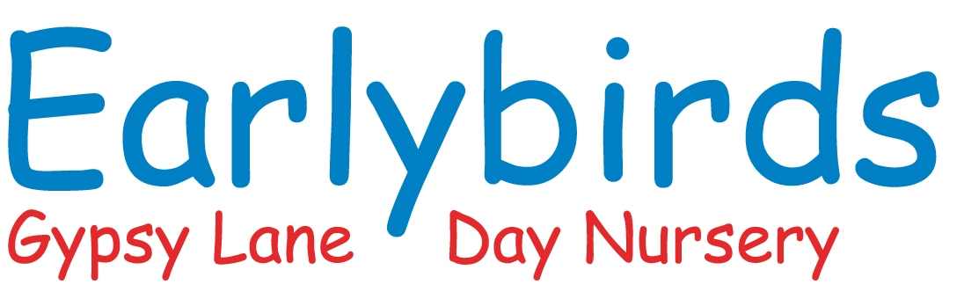

Parent contract and terms and condition
Please keep this copy and return the last page to nursery

Earlybirds Day Nursery trading As Gypsy Lane Day Nursery Ltd a limited company with company number 6231866 the principal address of which is Gypsy Lane, Elton Road, Creswell, Worksop, Notts, S80 4HY

Name of Child ________________________

PAYMENTS

- All payments will be worked out on a fixed monthly basis and will be paid in advance on the 1st week of each month by standing order.

- This means that you pay the same each month even if you are on holiday or your child is absent through illness. Any extra sessions you require for your child will be invoiced separately and paid on the day by cash or bank transfer.

- We except payment of fees by external funders including the government Tax free childcare scheme.

- We reserve the right to review our fees at any time but will give you no less than one month’s notices prior to any changes.

- In the case of fees not being paid by an agreed date we reserve the right to exclude your child and cancel the place without notices.

- Your child must be booked in for fixed days of the week, these days are not interchangeable.

- If you require your child to be booked in on any other day this is chargeable at the daily rate.

ABSENCES/SICKNESS

- Please contact the nursery to inform us if your child will not be attending giving the reason for his/her absence. Please be reminded that all absences/sickness must be paid for.

- We reserve the right to contact you requesting that your child be collected if he/she becomes unwell during the session.

- If the Child is suffering from a communicable illness, he/she should not be brought to the nursery until such time as the infection has cleared. A full copy of our infection control policy is available from the nursery website. Please also refer to the illness/communicable disease booklet supplied in the entrance hall of the nursery.

- If your child shows any of the symptoms of covid-19 we ask that your child stay at home until the are well. This will still be charged like any other illness e.g. chickenpox.

FOOD/DIETARY REQUIREMENTS

- We will work with you to provide suitable food for your Child, if they have a special dietary requirement or any allergies as diagnosed by a doctor or dietician. All reasonable care will be taken to ensure that a Child does not come into contact with certain foods with support from parents and external professionals should the need arise.

- Menus will be displayed for all parents to see on the website and on Learning Journals.

- Parents should provide sealed formula milk for bottle feeding babies.

Bringing in and storing made-up formula milk may increase the chance of a baby becoming ill and should be avoided.

PERSONAL PROPERTY

- Staff are not responsible for loss or damage to children’s personal property and all items are left at your own risk. Please label all children’s belongings as this helps with identify lost items.

- Parents of Children who are not toilet trained must provide nappies, wipes and cream if required.

CLOUSURE

- The Nursery will be closed for all major bank holidays and the closure between Christmas and the new year.

- The nursery reserves the rights to charge for closures due to unforeseen circumstance or offer alternative days.

CHANGING DAYS

- Four weeks’ notice must be given to the nursery if you wish to decrees the days you require for your child/children in the Nursery.

CONTRACTS

- We require four weeks’ notice in writing to terminate your contract for childcare. This will start from the day we receive the letter of termination.

- The Nursery reserves the right to refuse a place or terminate a contract where conditions are not being met.

- If your child is term time only your child will attend 38 weeks of the year or 39 if wanting a full school year including INSET days. This will be in line with Derbyshire/Nottinghamshire/Sheffield term dates. The dates are non-transferable and children on term time payments cannot make up and missed days during the school holidays.

- Payments for term time only will be split in to 12 equal monthly payments payable on the first week of the month every month. This includes a payment in August even though your child will not attend.

- A retainer fee will be charged for the weeks not attended on a tern time contract, this is currently £20 a week. this will be the 11/12 weeks of the school holiday that we are open dependent on if you have a 38/39 week term time contract. This excludes the weeks closure at Christmas.

- Holiday club is available for children till the summer holidays that they would move to the Juniors school.

- Holiday club is booked for the 12 weeks of the school holiday (we don’t offer individual week) in line with Derbyshire/Nottinghamshire/Sheffield term dates. These are payable on a monthly basis the first week of the month every month, any cancelation of your child’s place or reduction in days will not be back dated.

- Holiday club does not include the 5 INSET days as these vary from school to school. But can be added on if you require.

LATE COLLECTION

- Consistent late collection will be charged for. At the rate of £25 to parents this will pay for any additional operational costs that caring for a nursery child outside their normal working hours may incur.

FUNDED CHILDREN

- Funding is offered term time only for the 2, 3, and 4-year-old funding, and is a free place for your child 15 hours for 2-year funding where your child is eligible, 15 universal hours for 3 and 4-year-old funding and an additional 15 hours funding for 3 and 4-year olds who meet the eligibility criteria set out by the government.

- If you wish to take up your free nursery education, you are required to complete and sign a Parental Declaration FE1 form on a termly basis, or if your details change, detailing how and when you will take up the free sessions.

- All funding will be deducted from your invoice if you are taking additional hours/days with the nursery.

- All fees will be paid the first week of that month for that month.

- 4 week’s notices are required to move days.

- Funded children payment for children that take extra sessions within nursery will be spread over 12 equal monthly payments even if your child is only doing term time. This means there will be a payment in August although your child will not attend in this month.

- Food for funded children is invoiced every half term. This is an extra cost.

REPORTING OF NEGLECT OR ABUSE

- We have an obligation to report to the relevant authorities any suspicions we have that your Child has suffered neglect or abuse, and we may do without your consent and/or without informing you.

SECURITY

- Parents are welcome to visit the nursery, but we will not admit anyone without prior notification. It is your responsibility to ensure that we are aware of who will be collecting your Child. No Child will be allowed to leave the building with any person who has not been notified as an authorised person to collect the Child on your behalf.

COMPLAINTS, CONCERNS & COMPLIMENTS

- Please address any complaint, concern or compliments to the room leader, in the first instance, and if the matter is not resolved within a reasonable period, please refer it to the nursery manager. Please also refer to our complaints and compliments policy which shall apply to any complaints received by us.

EVENTS THAT ARE BEYOND OUR CONTROL

- If any event beyond our reasonable control (e.g. a fire, flood, strike, civil action, act of terrorism, war, pandemic etc.) occurs, for which we have business interruption insurance, we may close the nursery without liability to you and we will not charge you for the fees for the time the nursery is closed. We will keep you informed, in such an event.

- If it is, in our reasonable opinion, necessary or in the interests of the Child to do so, we may close the nursery even though our business interruption insurance will not cover us for the closure. In these circumstances, we will charge you for the time the nursery is closed. For example, we may close because of severe weather conditions, outbreak of flu, swine flu or other communicable diseases etc.

- All of the above sits alongside the nurseries policies and procedures.

Parent Contract and Terms and Condition

I,___________________________ Parent/Carer of

(Name of Child)--------------------------------------

Acknowledge that on _________________________ (date), I received a copy of the

Nursery’s Parent Contract and Terms and Conditions and that I have read
and understood them.

Parent/Carer Signature…………………………………………………………

Name………………………………………………………………………………………..

Date………………………………………………………………………………………

Please return this signed section back to nursery with your child’s entry records.

Many thanks Earlybirds.

