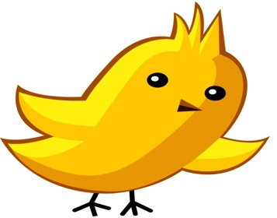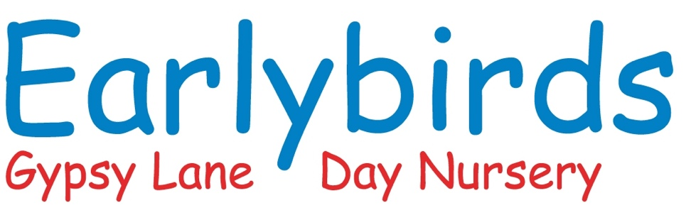

My Unique Child
This book is all about

Photo of child

“Every child is a competent learner from birth who can be resilient, capable, confident and self assured.”
Early Years Foundation Stage – A Unique Child
Parent/Carer Name__________________________

Has completed this book to help care for my child and provide for their future learning.
I understand that this book will be the start of my child’s Learning Journey and I am happy for this information to be shared with other people involved in their care and education.

Signature___________________________________________
Date______________________________________________
Signed when majority of information has been gathered and book completed

This book…….
- Celebrates your child’s learning journey so far.
- Values you as your child’s prime educator.
- Indicates the starting point for the setting and where early years practitioners can begin to make contribution to your child’s learning.
- Please fell free to add photos, especially of your child growing up.

All about
My child
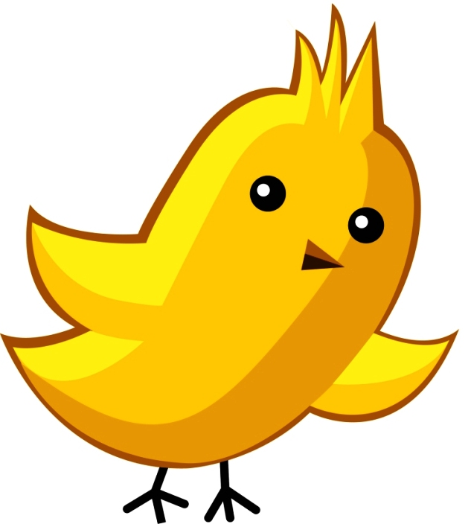

Our family
Please let us know about the important people in your child’s life.
This could include brothers and sisters, grandparents, childminder or your friends.

What is your child’s position in the family?
Is he/she first, second or third child? This could be a photo.

Please let us know about any pets, favourite toys, games or activities or interests.
There are more detailed questions later on regarding games activities and interests

Important event in your family life, including your child’s birth

Are there any important celebrations, festivals or events that you share as a family?

Medical/Health Care Plan

Does your child have any medical conditions allergies that you feel we should know about,

Any professionals involved with my child or family. Please give full names and where we could contact these people if needed.

My child’s physical development

Please let us know about your child’s physical development so far. Can they ride a bike/scooter, walk, run climb etc.

My child’s health and habits
Please let us know whether your child sleeps well generally, has a good appetite and is generally in good health.

Other things my child can do for themselves:
This may include dressing/undressing, toileting, hand washing, choosing toys to play with etc.

My child’s moods and feelings
Please let us know how your child shows their emotions such as happiness, sadness, anger, excitement, frustration, love and affection.
E.g. Cuddles? Smiles? Throws things?

Is there anything that worries your child or that they are sensitive about?
This could include things such as loud noises, bright lights, and unfamiliar people/places.

My child’s speech and language
Please let us know things like whether your child talks a lot.
Do you understand what they say?
Do you use any special words we need to know?
Do they communicate using signs?

If your child is learning English as an additional language, would you describe him/her as:
(Please circle)

New to English
Becoming familiar with English
Becoming a confident user of English
A fluent user of English?

What is/are the languages your family speak and that your child uses/understand?
E.g. Punjabi……..Polish…………..Urdu………….Farsi………….Schona……..Yoruba……………Ewe
Playing and learning

Please let us know what your child enjoys most
Playing alone, with other children or playing alongside others – this will depend on the age and stage of development of your child.

What are their favourite games or activities which keep them absorbed for a long time? (Not video or TV programmes!)

What are their favourite books, songs or rhymes?

What do they like to explore and investigate?
Do they sometimes get into “mischief”?
Have you and your child attended or are you currently attending any groups, such as parent and toddler.

My child’s behaviour
At different ages and stages all children have times when they can be difficult or get frustrated or angry because they cannot make you understand what they want. Apart from these times is there anything that worries you or we need to know about your child’s behaviour?

Are they developing an awareness of danger?
E.g. Holding hands to cross the road.

Do they understand simple rules for safety?

Is there anything else you would like

us to know about your child and or your family?

Initial Assessments 2 year olds
Name of child: ...................................................................... Key person: ...................................

Age when starting Nursery........................................ Additional needs:- Yes/No

Date of assessment: .................................. Speech & Language delay:- Yes/No

Communication and Language:
- I show interest in rhymes and playing with sound Yes/Starting to/No
- I Understand ‘who’, ‘what’, ‘where’ in simple questions
(e.g. Who’s that/can? What’s that? Where is?) Yes/Starting to/No
- I am starting to use two words together. Yes/Starting to/No

Physical Development:
- I can climb confidently Yes/Starting to/No
- I can turn pages in a book, sometimes several at once Yes/Starting to/No
- I can drink from an open cup. Yes/Starting to/No
- I can clearly communicate my need for the potty or toilet Yes/Starting to/No
- I can help with getting dressed. Yes/Starting to/No

Personal, Social and Emotional Development:
- I am interested in playing with others Yes/Starting to/No
- I can separate from main carer with support. Yes/Starting to/No
- I can express my own feelings such as sad, happy, cross. Yes/Starting to/No
- I can follow simple routines to help me do things Yes /starting to/No

Other things I can do:
- I can repeat words or phrases from familiar stories. Yes/Starting to/No
- I can recite some number names in sequence. Yes/Starting to/No
- I notice simple shapes and patterns in pictures. Yes/Starting to/No
- I am beginning to have my own friends. Yes/Starting to/No
- I enjoy playing with small-world models such as a farm, a garage,
or a train track. Yes/Starting to/No
- I experiment with, colours and marks Yes/Starting to/No
- I am beginning to give meaning to marks I make. Yes/Starting to/No
- I am beginning to make-believe by pretending. Yes/Starting to/No

The information collected on this form will help us plan for your child in their first few weeks with us; we will use these starting points as a guide to enable their future learning.

Initial Assessment 3 years +
Name of child: ................................................ Key person: ...................................

Age when starting Nursery........................................ Additional needs: Yes/No

Date of assessment: ................................................. Speech & Language Yes/NO

Communication and Language:
- I listen to stories with increasing attention Yes/Starting to/No
- I am able to follow directions Yes/Starting to/No
- I understand use of objects (“What do we use to cut things?’ Yes/Starting to/No
- I respond to simple instructions, (put away your coat). Yes/Starting to/No
- I am beginning to understand ‘why’ and ‘how’ questions. Yes/Starting to/No
- I am beginning to use more complex sentences to link thoughts (using and, because). Yes/Starting to/No
- I question why things happen and give explanations. Asks e.g. who, what, when, how. Yes/Starting to/No

Physical Development:
- I can climb up and down stairs confidently Yes/Starting to/No
- I can catch a large ball Yes/Starting to/No
- I can turn pages in a book, sometimes several at once. Yes/Starting to/No
- I can feed myself and drink from a cup without spilling Yes/Starting to/No
- I can tell you when I need to go to use the toilet or potty Yes/Starting to/No
- I can dress with help Yes/Starting to/No
- I will tell you when I am hungry or thirsty Yes/Starting to/No

Personal, Social and Emotional Development:
- I can play in a group, extending and elaborating play ideas, e.g. building up a role-play
activity with other children. Yes/Starting to/No
- I enjoy the responsibility of carrying out small tasks. Yes/Starting to/No
- I am confident in asking adults for help. Yes/Starting to/No
- I can cope with delay when needs are not immediately me Yes/Starting to/No

Other things I can do:
- I listen to and join in with stories, one-to-one and also in small groups. Yes/Starting to/No
- I recognise familiar words and signs such as own name and advertising logos Yes/Starting to/No
- I sometimes give meaning to marks as I draw and paint. Yes/Starting to/No
- I can recite numbers in order to 10. Yes/Starting to/No
- I am beginning to represent numbers using fingers, marks on paper or pictures. Yes/Starting to/No
- I show interest in shapes in the environment. Yes/Starting to/No
- I show interest in the lives of people who are familiar to me. Yes/Starting to/No
- I talk about some of the things I have seen such as plants, animals, natural and found objects. Yes/Starting to/No
- I show care and concern for living things and the environment Yes/Starting to/No
- I know how to operate simple equipment, e.g. turn on CD player and use remote control Yes/Starting to/No
- I sing a few familiar songs. Yes/Starting to/No
- I engage in imaginative role-play based on first-hand experiences. Yes/Starting to/No

Parents comments:- if you have seen your child do anything that we have not mentioned
above please tell us about it

The information collected on this form will help us plan for your child in their first few weeks with us; we will use these starting points as a guide to enable their future learning.
As always if you have any questions or concerns please speak to a member of staff.

Thank you for completing this book.
This important information will be used to continue all the learning your child has done at home whilst they are in our setting. We look forward to working with you!

