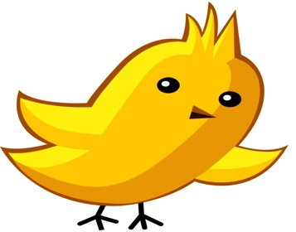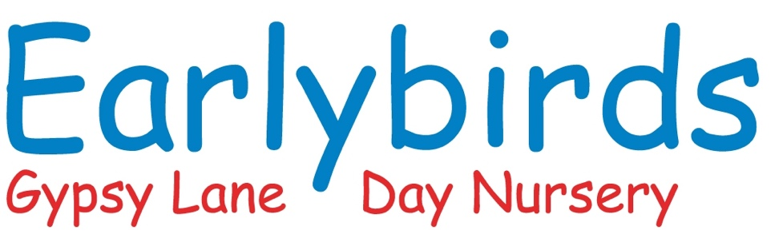

My Unique Child

This book is all about

Photo of child



*“Every child is a competent learner from birth who can be resilient, capable, confident and self-assured.”*

Early Years Foundation Stage – A Unique Child

Parent/Carer Name__________________________

Has ……………………………… completed this book to help care for my child and provide for their future learning.

I understand that this book will be the start of my child’s Learning Journey and I am happy for this information to be shared with other people involved in their care and education.

Signature___________________________________________

Date______________________________________________

Signed when majority of information has been gathered and book completed

This book…….

* Celebrates your child’s learning journey so far.
* Values you as your child’s prime educator.
* Indicates the starting point for the setting and where early years practitioners can begin to make contribution to your child’s learning.
* Please feel free to add photos, especially of your child growing up.

 All about My Child

Our family

Please let us know about the important people in your child’s life.

This could include brothers and sisters, grandparents, childminder, your friends or any other setting your child attends.

What is your child’s position in the family?

Is he/she first, second or third child? What are the names on your child’s siblings?

Please let us know about any pets, favourite toys or comforter’s you child has or uses.

Important event in your family life, including your child’s/children’s birth.

Are there any important celebrations, festivals or events that you share as a family?

Medical/Health Care Plan

Does your child have any medical conditions allergies that you feel we should know about?

Any professionals involved with my child or family. Please give full names and where we could contact these people if needed.

What is your child’s sleep routine?

What is your child’ feeding routine?

My Childs Development

My child’s physical development

Please let us know about your child’s physical development so far. Can they sit unaided pull to stand, crawl or walk at what age did your child achieve these milestones etc.?

Communication

Does your child chuckle, squeal in excitement, laugh, cry when you leave the room, babble or say a few simple words?

My child’s moods and feelings

Please let us know how your child shows their emotions such as happiness, sadness, anger, excitement, frustration, love and affection.

E.g. Cuddles? Smiles? Throws things?

If your child is learning English as an additional language, would you describe him/her as:

New to English

Becoming familiar with English

Becoming a confident user of English

A fluent user of English?

What is/are the languages your family speak and that your child uses/understand?

E.g. Punjabi……..Polish…………..Urdu………….Farsi………….Schona……..Yoruba……………Ewe

Is there anything that worries your child or that they are sensitive about?

This could include things such as loud noises, bright lights, and unfamiliar people/places.

Playing and learning

Please let us know what your child enjoys most

Playing alone, with other children or playing alongside others – this will depend on the age and stage of development of your child.

What are their favourite games or activities which keep them absorbed for a long time? (Not video or TV programmes!)

What are their favourite books, songs or rhymes?

Have you and your child attended or are you currently attending any groups, such as parent and toddler.

My child’s behaviour

At different ages and stages all children have times when they can be difficult or get frustrated or angry because they cannot make you understand what they want. Apart from these times is there anything that worries you or we need to know about your child’s behaviour?



Is there anything else you would like us to know about your child and or your family?

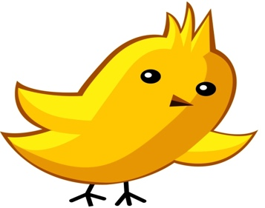

**BABY ROOM PARENT INFORMATION**

Name of child: ...................................................................... Key person: ...................................

Age when starting Nursery........................................ Additional needs: - Yes/No

Date of assessment: .................................. Speech & Language delay:- Yes/No

**Communication and Language:**

* I move my body or head when I hear noise. Yes/Starting to/No
* I will smile at you when you talk to me. Yes/Starting to/No
* I will stop what I am doing if I hear a grown up talking. Yes/Starting to/No
* I will point to things that I want. Yes/Starting to/No
* I will look at you when you say my name Yes/Starting to/No
* I understand what you mean when you wave, clap or Yes/Starting to/No

blow kisses.

**Physical Development:**

* I can move my arms and legs in different ways. Yes/Starting to/No
* I can roll over from front to back. Yes/Starting to/No
* I can reach out and touch things that are near me. Yes/Starting to/No
* I can sit up. Yes/Starting to/No
* I can walk when a grown up holds my hand Yes/Starting to/No
* I can hold my own bottle or cup. Yes/Starting to/No
* I am beginning to use a spoon. Yes/Starting to/No

**Personal, Social and Emotional Development:**

* I laugh and gurgle and use my voice to get your attention Yes/Starting to/No
* I when I am feeling upset, I like you to hold me. Yes/Starting to/No
* I am beginning to make friends with special grown-ups Yes/Starting to/No
* Ii like finding different parts of my body e.g. eyes, mouth Yes /starting to/No
* I am beginning to understand when you say yes or no. Yes /starting to/No
* I can be quiet when meeting new people. Yes /starting to/No

**Other things I can do:**

* I like to listen to singing and stories. Yes/Starting to/No
* I smile at things I like to play with. Yes/Starting to/No
* I notice simple shapes and patterns in pictures. Yes/Starting to/No
* I like to listen to you talk. Yes /starting to/No
* I can hold chunky crayons in my hand. Yes/Starting to/No
* I can point to a picture in a book when you ask me. Yes/Starting to/No
* I like banging things together Yes/Starting to/No
* I wriggle and dance when music is on. Yes/Starting to/No

|  |
| --- |
| **Parents comments**: if you have seen your child do anything that we have not mentioned  above please tell us about it. |