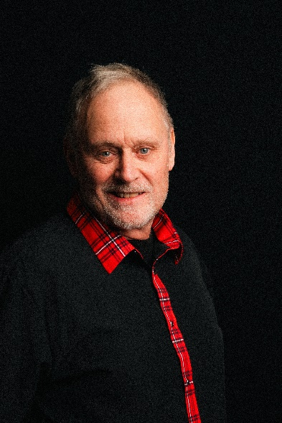

FILM & TELEVISION
From The Static SUPPORTING Angel Peavey
Twelve Hours in June SUPPORTING James Yaw
Barrett LEAD Michael Entity
Falling From The
Straight and Narrow** *** LEAD James Yaw
The Journey LEAD Chris Blackford
Needles*** LEAD Matthew Lawrence
Under The Old Oak*** LEAD Taylor Buckalew
Finch LEAD Keaton Bongiorno
Riley** SUPPORTING Michael Entity
The Good In Evil SUPPORTING Gerardo Candelario Suffer The Innocents** *** LEAD James Yaw
Artificial Intelligence SUPPORTING Nick LaRovere
Deathly Annoyed SUPPORTING Chauntelle Krook
USED SUPPORTING Khuloud Kelly Rabadi
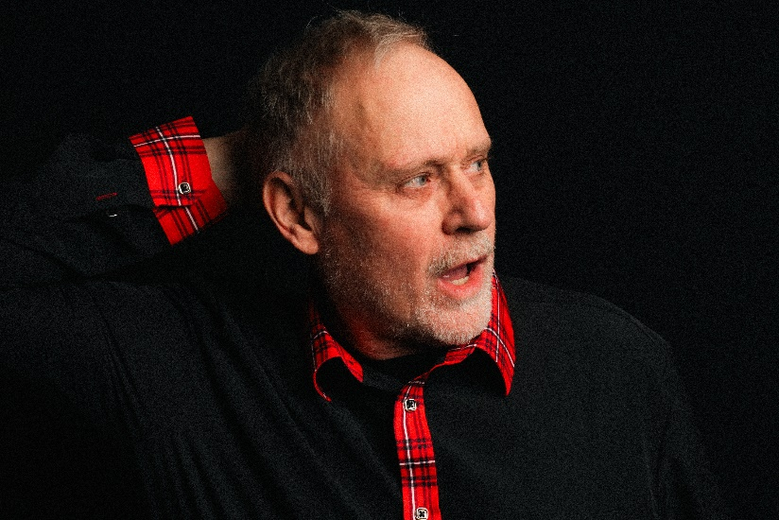
Hippie Carpool** SUPPORTING Cameron Markwart
Glass Walls** SUPPORTING Jeff Breuer
Murder Pizza** SUPPORTING Elizabeth Dowland
Justified SUPPORTING Khuloud Kelly Rabadi
Forgiven** SUPPORTING Jason Campbell
Mercy** *** LEAD** Nathen Burch
No Reception SUPPORTING Mack Harris
Loaded Monday** SUPPORTING** Beau Yotty
Exposure** SUPPORTING** Colten Reed Dietz
Controlled** SUPPORTING** Danielle Dominique
The Ferryman** LEAD** Angel Peavey

THEATER
Black Irish LEAD Jeffrey Kagan McCann
Driving Miss Daisy SUPPORTING Camilla Ross
Eurydice SUPPORTING Jon Capozzoli
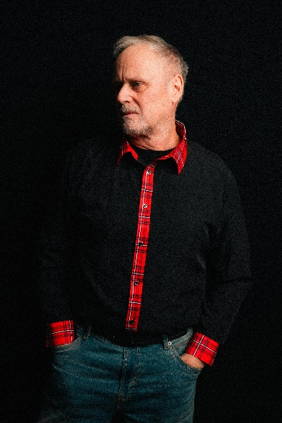
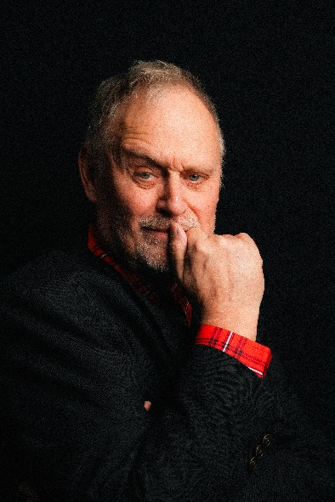
House With No Walls SUPPORTING Ashley Adelman
Permanent Collection SUPPORTING Ashley Adelman
Bee Luther Hatchee SUPPORTING Camilla Ross
Vesta SUPPORTING Breinne Reeder
Alabama Story SUPPORTING Breinne Reeder

TRAINING

Improvisation Katy Patterson
Scene Study Katy Patterson
Commercial Audition Katy Patterson
On Camera Audition Katy Patterson

MILITARY EXPERIENCE
US Army Veteran with 3 combat tours to Kyrgyzstan and Iraq
- Combat vehicle convoy / military radio operations
- Military drill and ceremony

