Reading List on alignment to Practice Planning Consistent with the Human Rights Code and UN Declaration of Human Rights

Contents
Contents 1
Law 2
Ontario Human Rights Code 2
Policy on Human Rights and Rental Housing 2
Planning and Human Rights: Legal Cases and Resources 3
Zoning Out Discrimination: Working Towards Housing Equality in Ontario 3
Planning Act 3
The Provincial Policy Statement 4
A Place to Grow: Growth Plan for the Greater Golden Horseshoe 4
United Nations 5
Ontario Provincial Planning Institute 6
Anti-Black Racism in Planning Task Force: Terms of Reference 6
Zoning for Inclusion: Human Rights and the Public Interest 7

This is an incomplete annotated reading list of key documents.

Law

Ontario Human Rights Code
Author: Ontario Human Rights Commission
Published: Consolidation Period: from January 8, 2021
Below is a clipping from the website which pulls out the protected grounds and protected social area. Clipping retrieved from (ohrc.on.ca) (also includes additional readings)
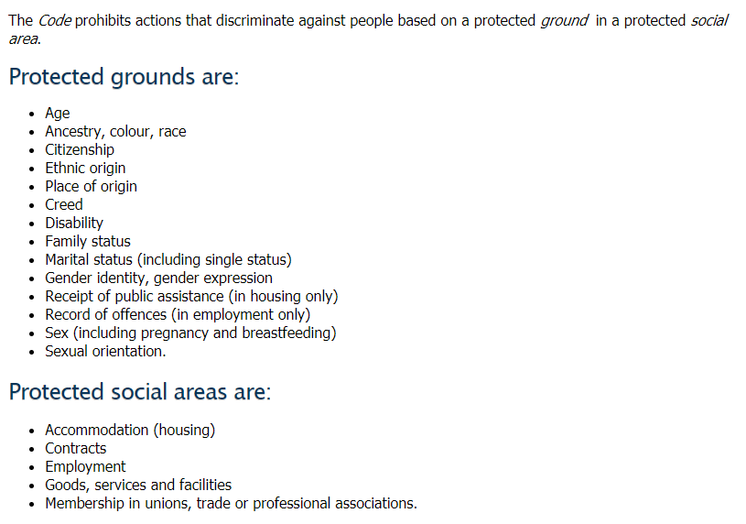

Policy on Human Rights and Rental Housing
Author: Ontario Human Rights Commission
Published: Approved by the Ontario Human rights Commission 2009
Document describing Canada’s agreement to the International Covenant on Civil and Political Rights and the International Covenant on Economic, Social and Cultural Rights (covenants that give legal force to the Universal Declaration of Human Rights. Includes multiple examples of specific cases of discriminatory planning practices, as well as statements including the following:
“Also, when planning policies or practices are directed towards, or disproportionately affect, Code-protected populations, they may be seen to violate the Code.”
“City Councils, councilors, neighbourhood associations, developers, decision-makers such as the Ontario Municipal Board, and individuals all have a responsibility to refrain from discrimination against people identified by Code grounds based on NIMBYism, and to make sure policies and practices do not give rise to differential treatment.
Even though these organizations and individuals may not provide housing directly, they still have an obligation not to contribute to indirect discrimination in the context of housing”

Planning and Human Rights: Legal Cases and Resources
Author: Ontario Human Rights Commission
Published: No date
A reading list of human rights and planning intersections, prepared by the Ontario Human Rights Commission. Includes the PPS, Municipal Councillor’s Guide, legal cases, reports, tip sheets and other material.

Zoning Out Discrimination: Working Towards Housing Equality in Ontario
Author: Jessica Simone Roher, lawyer
Published: Journal of Law and Social Policy, 2016
Describes, through the use of case law, the three levels of human rights discrimination, and how the culture of planning (systemic discrimination) applies discriminatory practices to produce and implement discriminatory zoning bylaws (indirect discrimination) which then result in direct discrimination (houselessness of people protected by the Ontario Human Rights Code). Understanding discrimination as it functions in these three levels (systemic, indirect, and direct), are critical to identify and shifting discriminatory practices.

Planning Act
Author: Government of Ontario
Published: e-laws currency date, December 8, 2020
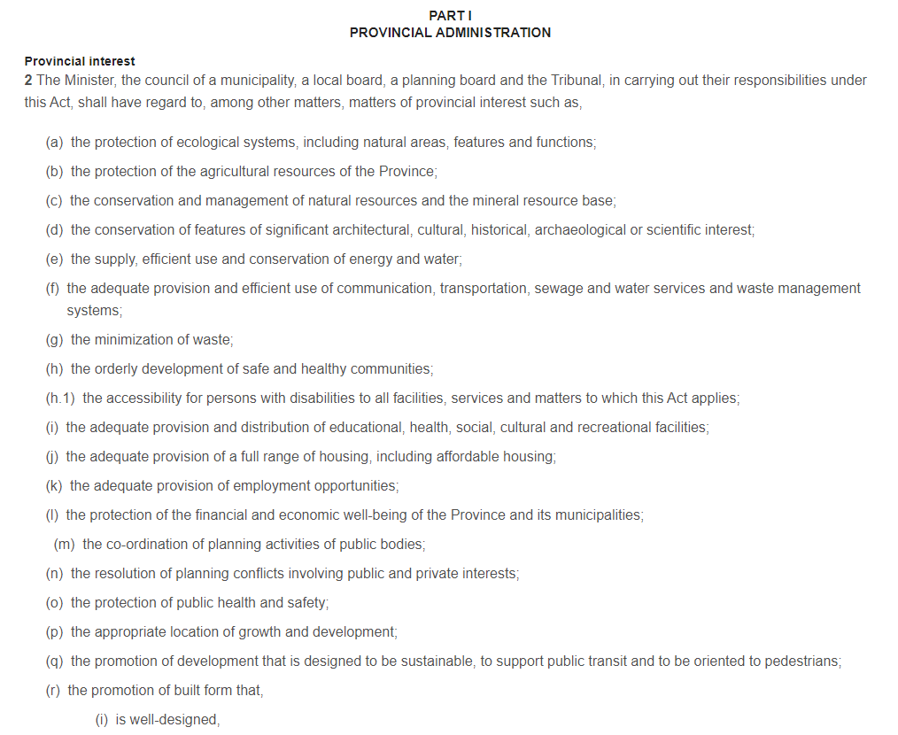
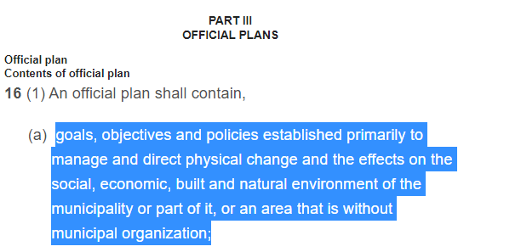 | 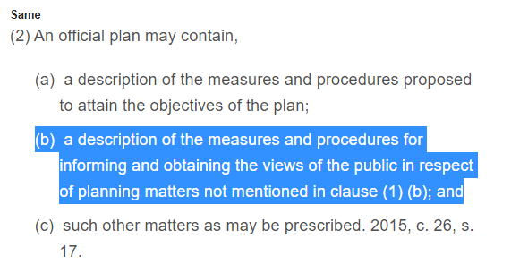

The Provincial Policy Statement
Author: Government of Ontario
Published: 2020
“The Provincial Policy Statement provides policy direction on matters of provincial interest related to land use planning and development. As a key part of Ontario’s policy-led planning system, the Provincial Policy Statement sets the policy foundation for regulating the development and use of land. It also supports the provincial goal to enhance the quality of life for all Ontarians.” emphasis added. Clipping including statement 4.4 is included below.
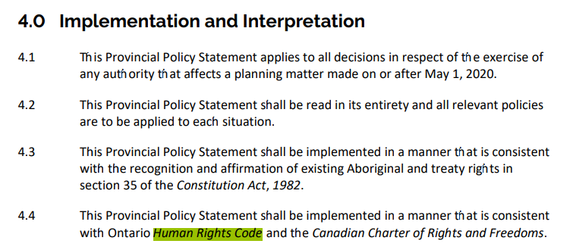

A Place to Grow: Growth Plan for the Greater Golden Horseshoe
Author: Government of Ontario
Published: 2020
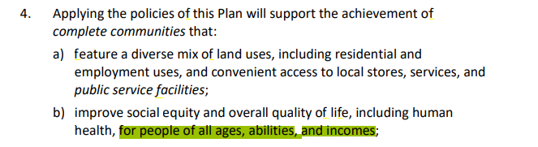

United Nations
Some key files below:
- 2019 – UN – UN System-Wide Strategy on Sustainable Urban Development – prepared by the High Level Committee on Programmes under the leadership of the UN-Habitat
- 2018 – UN – Report of the Special Rapporteur on Adequate Housing as a Component of the Right to an Adequate Standard of Living, and on the Right to Non-Discrimination in this Context - written by Leilani Farha. Leilani was the UN Rapporteur on Affordable Housing. She’s an Ottawan, the founder, and lead of The Shift, an organization coordinating with multiple levels and bodies of governments to integrate a human rights approach into the housing systems.
- 2018 – UN ESCO – Creating Inclusive and Equitable Cities – International Coalition of Inclusive and Sustainable Cities, Canadian Commission for UNESCO
- 2016 – UN – The Right to the City and Cities for All
- 2015 – UN – Social Development Goals
- 2015 – UN Decade for People of African Descent
- 2009 – UN Habitat – Fact Sheet No. 21, The Human Right to Adequate Housing
- 2007 – UN Department of Economic and Social Affairs – United Nations Declaration on the Rights of Indigenous Peoples
- 2007 – UN Habitat – V1 – Inclusive and Sustainable Urban Planning: A Guide for Municipalities: An Introduction to Urban Strategic Planning
- 2007 – UN Habitat – V2 – Inclusive and Sustainable Urban Planning: A Guide for Municipalities: Urban Situation Analysis
- 2007 – UN Habitat – V3 – Inclusive and Sustainable Urban Planning: A Guide for Municipalities: Urban Development Planning
- 2007 – UN Habitat – V4 – Inclusive and Sustainable Urban Planning: A Guide for Municipalities: Sustainable Action Planning

Ontario Provincial Planning Institute

Anti-Black Racism in Planning Task Force: Terms of Reference
Author: Government of Ontario
Published: 2020
In 2020, OPPI launched a Task Force to confront systemic* anti-Black racism within the practices of Registered Professional Planners and the planning practice in general. *Systemic, as understood through a human rights lens is the culture and practices of people that actively or unknowingly allow for the marginalization of persons protected by the Ontario Human Rights Code.
“Planners are charged with the responsibility of crafting, designing, and creating the diverse places and spaces we live in, influencing the social, physical, and economic construct of our built and natural environment. One of the core principles of our professional planning practice is to plan for “the public interest.” While planners talk about equity, diversity, and social justice in theory and practice, the reality is that the dominating colonial, Eurocentric planning system is historically structured on the preservation of privileges and entitlements for white people over Black, Indigenous, and other racialized peoples and from which unconscious biases have evolved. As a profession, planning has failed to address how discriminatory systemic actions and decisions negatively impact the Black community and marginalized groups, and how the consequences of these actions and decisions impact society as a whole”
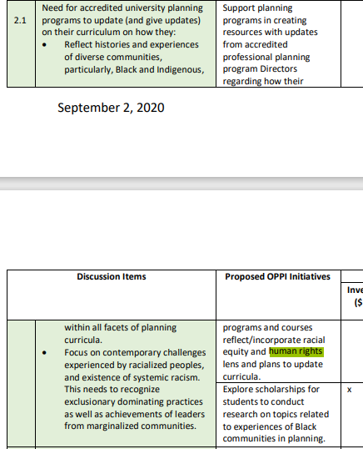 | 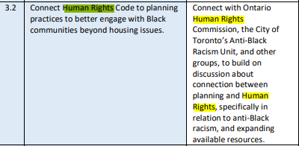  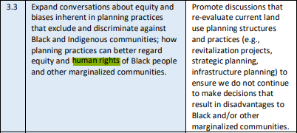

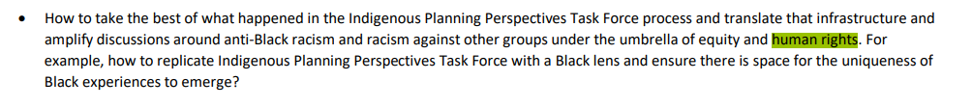

sThe Task Force mandate was approved by the OPPI Council. Members of the OPPI Council body listed below.
Justice Giancola, RPP  President  Calvin Brook, RPP  Director  Kelly Weste, RPP  Director | Paul Lowes, RPP  President Elect  Rob Dowler, RPP  Director  Beverley Hillier, RPP  Director | Claire Basinksi, RPP  Director  Eldon Theodore, RPP  Director  Colleen Sauriol, RPP  Director | Curry Clifford  Public Interest Representative  Andria Leigh, RPP  Director

Zoning for Inclusion: Human Rights and the Public Interest
Speakers: Jacquelin Pegg (inquiry analyst, Ontario Human Rights Commission), John Gladki (President, Gladki Planning Associates)
Published: 2015, by the Ontario Provincial Planning Institute
Session focused on the intersection of zoning, affordable housing, and human rights. Provided tips and tools for meeting the human rights challenges, and ensuring that planning truly serves the broader public interest.

