**ERIN RIOS CASTRO FOUNDATION 2024-25 SCHOLARSHIP APPLICATION**

**SCHOLARSHIP INSTRUCTION SHEET**

The Erin Rios Castro Foundation offers a minimum of two $500 scholarship each year to recognize a senior student and young adults who have been impacted by teen dating or domestic violence; multiple scholarships may be offered depending on funds. This scholarship(s) will be paid directly to the recipient(s) and per IRS code, must be used for tuition, fee, or books. Scholarship recipients will be notified before the end of the school year. Scholarship recipient may choose to remained anonymous.

**ELIGIBILITY**

Applicants must meet the following eligibility requirements:

➢ Applicant must be planning to enroll or currently enrolled at an accredited college, university, or technical institute within six months of graduation.

➢ Applicant must have a minimum Grade Point Average of 75 as indicated on the transcript.

➢ Complete application and all required paperwork must be turned in to Erin Rios Castro Foundation Scholarship by 11:59pm, August 28, 2023. No late submissions will be accepted. Only completed applications will be considered.

**APPLICATION AND REQUIRED INFORMATION**

➢ A seven semester official high school transcript and a cop of your SAT/ACT scores you want considered. Two sealed letters of recommendation, written on  
the provided Recommendation Form. At least one must be from a High School  
core subject teacher. The other can be from any adult, non-family member, who has been associated with the applicant.

➢ An original essay, typed, 12-font, double spaced, 250 minimum words. ***State your educational and career goals. Include how teen dating violence and/or how domestic violence has affected you personally in any way***.

➢ This guideline sheet must be signed by the applicant and a parent/ guardian and returned with the application.

STUDENT APPLICATION SIGNATURE & DATE SIGNED PARENT APPLICATION SIGNATURE & DATE SIGNED

page1image388844352page1image388844784

**APPLICANT INFORMATION**

Student ID Number: __________________________ Date of Birth (MM/DD/YYYY): __________________ Best SAT Score (CR/Math/Writing): _____________

Student Initials: ______________ GPA: ________________________ ACT Composite Score: ________

**CONTINUING EDUCATION**

What college/university/technical institute(s) are you planning to attend? ___________________________________________________________________________________

Have you been: ACCEPTED WAIT LISTED HAVE NOT APPLIED Intended Field of Study/Major: _____________________________________________

**SCHOLARSHIP APPLICATION CHECKLIST**

__ Completed application and all required paperwork must be turned in to

__Scholarship Committee by midnight, August 28,2024 addressing the prompt on the scholarship guidelines. No late submissions will be accepted.

__ An original essay, typed, 12-font, doubled space, minimum 250 words. ***State your educational and career goals. Include how teen dating violence and/or how domestic violence has affected you personally in any way***.

__ Photocopy of the applicant’s PTSA card.  
__ A seven-semester official high school transcript.  
__ The applicant and the parent/guardian must sign where needed.

**ACTIVITIES, AWARDS, COMMUNITY SERVICE & EMPLOYMENT**

Please attach a resume to your application for this section of questions. Be sure your resume addresses each area. Include your student ID #, Date of Birth, and initials.

What awards or special recognition did you receive in high school? Include year(s). *if applicable

What is your work experience? Who was your employer? What position did you hold and how long did you work there? *if applicable

**SCHOLARSHIP RULES**

Per the Erin Rios Castro Scholarship Standing Rules offers a minimum of TWO $500 scholarship each year to recognize two senior and young adults; multiple scholarships may be offered depending on funds. The scholarship(s) will be paid directly to the recipient(s) and per IRS code, must be used for tuition, fees, or books.

The Erin Rios Castro Scholarship Committee will select the scholarship recipient(s). Those selections will be final.

*Disclaimer:* Financial Aid recipients, please take note: Awards and scholarships are considered a “resource” and must be included in a student’s financial aid budget. If you are awarded a scholarship that exceeds your unmet needs, a reduction in payment of financial aid may occur.

**CERTIFICATION**

I have read the Erin Rios Castro Scholarship Foundation Guidelines. I understand the eligibility requirements and that failure to complete or include any of the required information will disqualify the applicant. I understand that it is the sole responsibility of the applicant to make sure all mandatory documents are turned in with the application by the deadline on August 28, 2024, no later than 12 midnight.

In the fairness to all applicants, only the applications that are completed in every detail and submitted on or before the deadline stated will be considered by the Scholarship Committee.

All of the information on this form is true and complete to the best of my knowledge. If asked by the Scholarship Committee, I agree to give proof of the information that I have given on this form.

STUDENT APPLICATION SIGNATURE & DATE SIGNED PARENT APPLICATION SIGNATURE & DATE SIGNED

page3image386660992page3image386661296

**SCHOLARSHIP FORM**

STUDENT ID # _____________ INITIALS __________ DOB: ____________

*To the applicant:* This section is required and must be completed in the format provided. Fill in the identifying information above and then give the form to your adult appraiser. If incomplete, your application will not be evaluated.

*To the Adult Appraiser:* You have been asked to provide information in support of this scholarship application. Please give immediate and serious attention to the following statements. When complete, please return to the applicant in a sealed envelope. While comments are optional, a written letter of recommendation does not replace this form.

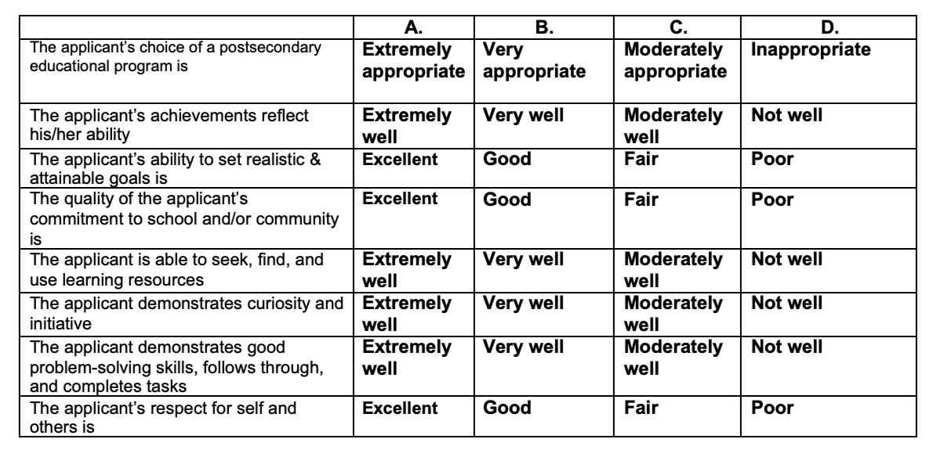

Comments: ______________________________________________________________________________ ______________________________________________________________________________ ______________________________________________________________________________ ______________________________________________________________________________ ______________________________________________________________________________ ______________________________________________________________________________

Appraiser’s Name: _________________________________Title: _____________________________ Signature: ________________________________________ Date: ____________________________

page4image454357776