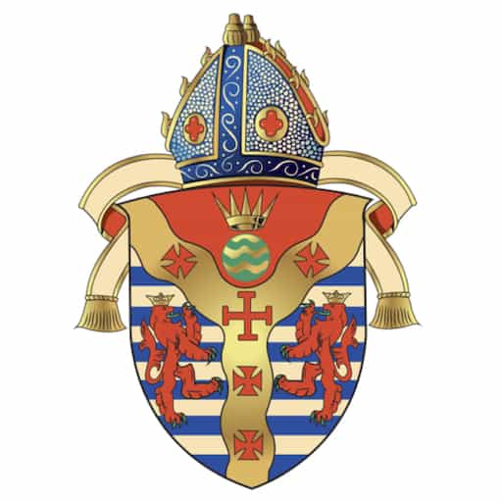

A GOOD CHURCH
St Christopher’s Cathedral, Bahrain
Diocese of Cyprus and the Gulf
St Christopher’s Cathedral, Bahrain
Anglican Riyadh Fellowship, Riyadh

Session 1: A Good Church is Born

Scripture – Acts 17:1-10
1 After Paul and Silas had passed through Amphipolis and Apollonia, they came to Thessalonica, where there was a Jewish synagogue. 2 And Paul went in, as was his custom, and on three Sabbath days argued with them from the scriptures, 3 explaining and proving that it was necessary for the Messiah to suffer and to rise from the dead and saying, “This is the Messiah, Jesus whom I am proclaiming to you.” 4 Some of them were persuaded and joined Paul and Silas, as did a great many of the devout Greeks and not a few of the leading women. 5 But the Jews became jealous, and with the help of some ruffians in the marketplaces they formed a mob and set the city in an uproar. While they were searching for Paul and Silas to bring them out to the assembly, they attacked Jason’s house. 6 When they could not find them, they dragged Jason and some brothers and sisters before the city authorities, shouting, “These people who have been turning the world upside down have come here also, 7 and Jason has entertained them as guests. They are all acting contrary to the decrees of the emperor, saying that there is another king named Jesus.” 8 The people and the city officials were disturbed when they heard this, 9 and after they had taken bail from Jason and the others, they let them go. 10 That very night the brothers and sisters sent Paul and Silas off to Beroea, and when they arrived they went to the Jewish synagogue. | 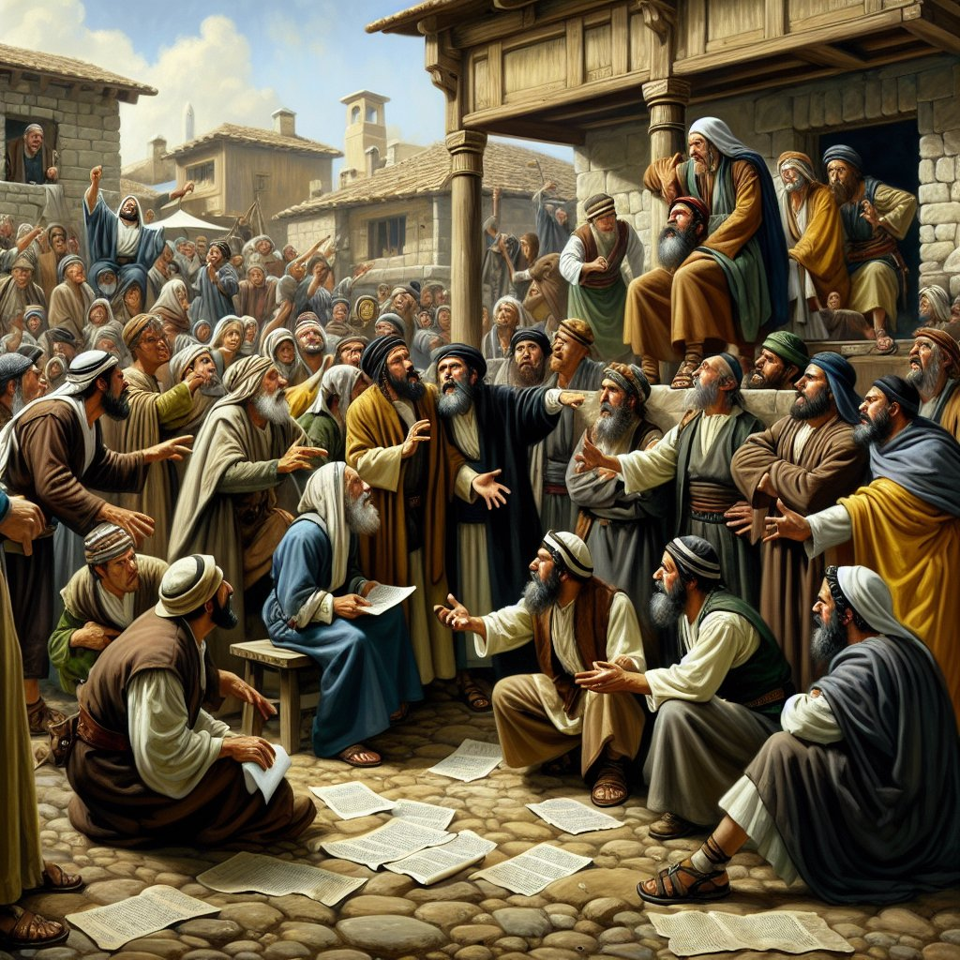

Teaching Summary
After Paul and Silas had passed through Amphipolis and Apollonia, they came to Thessalonica and scripture states that many of them therefore believed. They preached the Word of God but were eventually chased out of the town. The Church is created by the Word of God. As Paul proclaimed Scripture in Thessalonica, the Holy Spirit formed a community of faith. The Church is not a human institution but the Body of Christ, grounded in Scripture, sustained by grace, and sent into mission.

Reflection
• What does this passage teach about the foundation of the Church?
• How does Scripture shape the identity of a faithful church?
• Where do we see God's work in our own church?

Liturgy
Opening Acclamation:
Grace, mercy and peace from God our Father and the Lord Jesus Christ be with you.
And also with you.
Collect for Lent:
Almighty and everlasting God, you hate nothing that you have made and forgive the sins of all those who are penitent: create and make in us new and contrite hearts, that we, worthily lamenting our sins and acknowledging our wretchedness, may receive from you, the God of all mercy, perfect remission and forgiveness; through Jesus Christ our Lord. Amen.
Confession:
Most merciful God, we confess that we have sinned against you in thought, word and deed, by what we have done and by what we have left undone. We have not loved you with our whole heart. We have not loved our neighbours as ourselves. In your mercy forgive what we have been, help us to amend what we are, and direct what we shall be; through Jesus Christ our Lord. Amen.
Lord’s Prayer:
Our Father, who art in heaven, hallowed be thy name; thy kingdom come; thy will be done; on earth as it is in heaven. Give us this day our daily bread. And forgive us our trespasses, as we forgive those who trespass against us. And lead us not into temptation; but deliver us from evil. For thine is the kingdom, the power, and the glory, for ever and ever. Amen.
Blessing:
May the God of peace sanctify you wholly; and may your spirit and soul and body be kept sound and blameless at the coming of our Lord Jesus Christ. Amen.

Closing Prayer
Lord Jesus Christ, establish your Church in truth and grace. Strengthen us in faith and make us faithful witnesses. Amen.

Spiritual Formation
The Church is born wherever Christ is faithfully proclaimed. Read Scripture daily and trust God’s gracious Promise in Christ.

Session 2: Faith that Rings Out

Scripture – 1 Thessalonians 1:1-10
1 Paul, Silvanus, and Timothy, To the church of the Thessalonians in God the Father and the Lord Jesus Christ: Grace to you and peace. 2 We always give thanks to God for all of you and mention you in our prayers, constantly 3 remembering before our God and Father your work of faith and labor of love and steadfastness of hope in our Lord Jesus Christ. 4 For we know, brothers and sisters beloved by God, that he has chosen you, 5 because our message of the gospel came to you not in word only but also in power and in the Holy Spirit and with full conviction; just as you know what kind of persons we proved to be among you for your sake. 6 And you became imitators of us and of the Lord, for in spite of persecution you received the word with joy from the Holy Spirit, 7 so that you became an example to all the believers in Macedonia and in Achaia. 8 For the word of the Lord has sounded forth from you not only in Macedonia and Achaia but in every place your faith in God has become known, so that we have no need to speak about it. 9 For they report about us what kind of welcome we had among you and how you turned to God from idols to serve a living and true God 10 and to wait for his Son from heaven, whom he raised from the dead—Jesus, who rescues us from the coming wrath. | 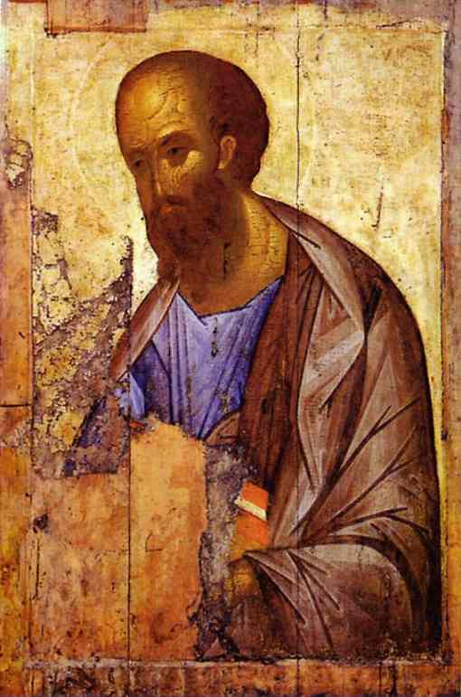

Teaching Summary
A faithful Church reflects Christ. The Church lives by faith, love, and hope. Anglican theology recognises these as the marks of Christian life, formed by grace and expressed in community and witness.

Reflection
• How does faith become visible in community?
• What does Christian hope look like in daily life?
• How is our church called to witness?

Liturgy
Opening Acclamation:
Grace, mercy and peace from God our Father and the Lord Jesus Christ be with you.
And also with you.
Collect for Lent:
Almighty and everlasting God, you hate nothing that you have made and forgive the sins of all those who are penitent: create and make in us new and contrite hearts, that we, worthily lamenting our sins and acknowledging our wretchedness, may receive from you, the God of all mercy, perfect remission and forgiveness; through Jesus Christ our Lord. Amen.
Confession:
Most merciful God, we confess that we have sinned against you in thought, word and deed, by what we have done and by what we have left undone. We have not loved you with our whole heart. We have not loved our neighbours as ourselves. In your mercy forgive what we have been, help us to amend what we are, and direct what we shall be; through Jesus Christ our Lord. Amen.
Lord’s Prayer:
Our Father, who art in heaven, hallowed be thy name; thy kingdom come; thy will be done; on earth as it is in heaven. Give us this day our daily bread. And forgive us our trespasses, as we forgive those who trespass against us. And lead us not into temptation; but deliver us from evil. For thine is the kingdom, the power, and the glory, for ever and ever. Amen.
Blessing:
May the God of peace sanctify you wholly; and may your spirit and soul and body be kept sound and blameless at the coming of our Lord Jesus Christ. Amen.

Closing Prayer
Lord, strengthen our faith, deepen our love, and renew our hope. Amen.

Spiritual Formation
Faith becomes visible through love.

Session 3: Authentic Ministry

Scripture – 1 Thessalonians 2:9-16
19 You remember our labor and toil, brothers and sisters; we worked night and day so that we might not burden any of you while we proclaimed to you the gospel of God. 10 You are witnesses, and God also, how pure, upright, and blameless our conduct was toward you believers. 11 As you know, we dealt with each one of you like a father with his children, 12 urging and encouraging you and pleading that you lead a life worthy of God, who calls you into his own kingdom and glory. 13 We also constantly give thanks to God for this, that when you received the word of God that you heard from us you accepted it not as a human word but as what it really is, God’s word, which is also at work in you believers. 14 For you, brothers and sisters, became imitators of the churches of God in Christ Jesus that are in Judea, for you suffered the same things from your own compatriots as they did from the Jews 15 who killed both the Lord Jesus and the prophets and drove us out; they displease God and oppose everyone 16 by hindering us from speaking to the gentiles so that they may be saved. Thus they have constantly been filling up the measure of their sins, but wrath[c] has overtaken them at last. | 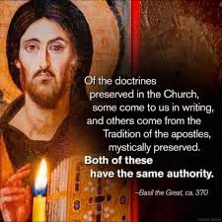

Teaching Summary
Christian ministry reflects the servant nature of Christ, rooted in humility and truth.

Reflection
• What defines authentic Christian leadership?
• How does humility shape ministry?
• How can we serve faithfully?

Liturgy
Opening Acclamation:
Grace, mercy and peace from God our Father and the Lord Jesus Christ be with you.
And also with you.
Collect for Lent:
Almighty and everlasting God, you hate nothing that you have made and forgive the sins of all those who are penitent: create and make in us new and contrite hearts, that we, worthily lamenting our sins and acknowledging our wretchedness, may receive from you, the God of all mercy, perfect remission and forgiveness; through Jesus Christ our Lord. Amen.
Confession:
Most merciful God, we confess that we have sinned against you in thought, word and deed, by what we have done and by what we have left undone. We have not loved you with our whole heart. We have not loved our neighbours as ourselves. In your mercy forgive what we have been, help us to amend what we are, and direct what we shall be; through Jesus Christ our Lord. Amen.
Lord’s Prayer:
Our Father, who art in heaven, hallowed be thy name; thy kingdom come; thy will be done; on earth as it is in heaven. Give us this day our daily bread. And forgive us our trespasses, as we forgive those who trespass against us. And lead us not into temptation; but deliver us from evil. For thine is the kingdom, the power, and the glory, for ever and ever. Amen.
Blessing:
May the God of peace sanctify you wholly; and may your spirit and soul and body be kept sound and blameless at the coming of our Lord Jesus Christ. Amen.

Closing Prayer
Lord, make us faithful servants of your Gospel. Amen.

Spiritual Formation
The ministry of the people reflects the heart of Christ.

Session 4: Strengthened in Faith

Scripture – 1 Thessalonians 3:6-13
But Timothy has just now come to us from you and has brought us the good news of your faith and love. He has told us also that you always remember us kindly and long to see us, just as we long to see you. 7 For this reason, brothers and sisters, during all our distress and persecution we have been encouraged about you through your faith. 8 For we now live, if you continue to stand firm in the Lord. 9 How can we thank God enough for you in return for all the joy that we feel before our God because of you? 10 Night and day we pray most earnestly that we may see you face to face and restore whatever is lacking in your faith. 11 Now may our God and Father himself and our Lord Jesus direct our way to you. 12 And may the Lord make you increase and abound in love for one another and for all, just as we abound in love for you. 13 And may he so strengthen your hearts in holiness that you may be blameless before our God and Father at the coming of our Lord Jesus with all his saints | 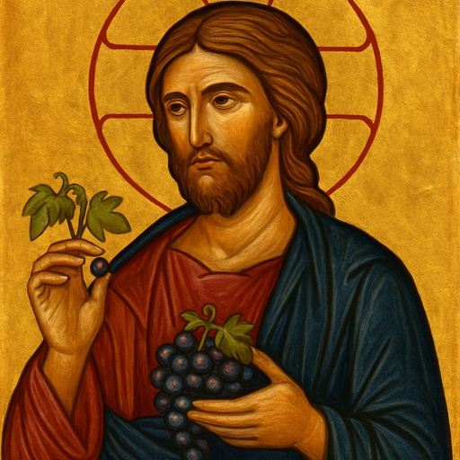

Teaching Summary
The Church grows through encouragement, prayer, and fellowship. We and strengthened in Holiness so that we may stand blameless before God.

Reflection
• Why is encouragement important?
• How does prayer strengthen the Church?
• How can we build one another up in Holiness?

Liturgy
Opening Acclamation:
Grace, mercy and peace from God our Father and the Lord Jesus Christ be with you.
And also with you.
Collect for Lent:
Almighty and everlasting God, you hate nothing that you have made and forgive the sins of all those who are penitent: create and make in us new and contrite hearts, that we, worthily lamenting our sins and acknowledging our wretchedness, may receive from you, the God of all mercy, perfect remission and forgiveness; through Jesus Christ our Lord. Amen.
Confession:
Most merciful God, we confess that we have sinned against you in thought, word and deed, by what we have done and by what we have left undone. We have not loved you with our whole heart. We have not loved our neighbours as ourselves. In your mercy forgive what we have been, help us to amend what we are, and direct what we shall be; through Jesus Christ our Lord. Amen.
Lord’s Prayer:
Our Father, who art in heaven, hallowed be thy name; thy kingdom come; thy will be done; on earth as it is in heaven. Give us this day our daily bread. And forgive us our trespasses, as we forgive those who trespass against us. And lead us not into temptation; but deliver us from evil. For thine is the kingdom, the power, and the glory, for ever and ever. Amen.
Blessing:
May the God of peace sanctify you wholly; and may your spirit and soul and body be kept sound and blameless at the coming of our Lord Jesus Christ. Amen.

Closing Prayer
Lord, strengthen your Church in faith and love. Amen.

Spiritual Formation
Encourage others. Faith grows within the family of God and the community of the Church.

Session 5: Holy Living

Scripture – 1 Thessalonians 4: 1-12
1 Finally, brothers and sisters, we ask and urge you in the Lord Jesus that, as you learned from us how you ought to live and to please God (as, in fact, you are doing), you should do so more and more. 2 For you know what instructions we gave you through the Lord Jesus. 3 For this is the will of God, your sanctification: that you abstain from sexual immorality; 4 that each one of you know how to control your own body[a] in holiness and honor, 5 not with lustful passion, like the gentiles who do not know God; 6 that no one wrong or exploit a brother or sister in this matter, because the Lord is an avenger in all these things, just as we have already told you beforehand and solemnly warned you. 7 For God did not call us to impurity but in holiness. 8 Therefore whoever rejects this rejects not human authority but God, who also gives his Holy Spirit to you. 9 Now concerning love of the brothers and sisters, you do not need to have anyone write to you, for you yourselves have been taught by God to love one another, 10 and indeed you do love all the brothers and sisters throughout Macedonia. But we urge you, brothers and sisters, to do so more and more, 11 to aspire to live quietly, to mind your own affairs, and to work with your hands, as we directed you, 12 so that you may behave properly toward outsiders and be dependent on no one. | 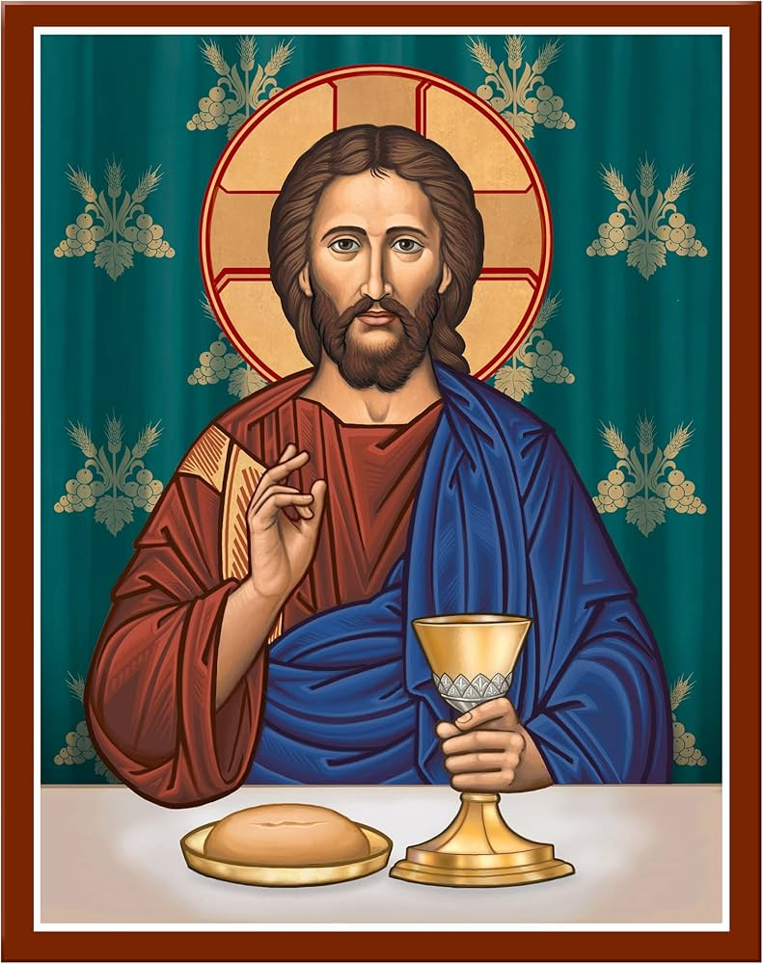

Teaching Summary
God calls the Church to holiness. The Church reflects God’s holiness through transformed lives.

Reflection
• What does holiness mean today?
• How does holiness shape community?
• How can we grow spiritually?

Liturgy
Opening Acclamation:
Grace, mercy and peace from God our Father and the Lord Jesus Christ be with you.
And also with you.
Collect for Lent:
Almighty and everlasting God, you hate nothing that you have made and forgive the sins of all those who are penitent: create and make in us new and contrite hearts, that we, worthily lamenting our sins and acknowledging our wretchedness, may receive from you, the God of all mercy, perfect remission and forgiveness; through Jesus Christ our Lord. Amen.
Confession:
Most merciful God, we confess that we have sinned against you in thought, word and deed, by what we have done and by what we have left undone. We have not loved you with our whole heart. We have not loved our neighbours as ourselves. In your mercy forgive what we have been, help us to amend what we are, and direct what we shall be; through Jesus Christ our Lord. Amen.
Lord’s Prayer:
Our Father, who art in heaven, hallowed be thy name; thy kingdom come; thy will be done; on earth as it is in heaven. Give us this day our daily bread. And forgive us our trespasses, as we forgive those who trespass against us. And lead us not into temptation; but deliver us from evil. For thine is the kingdom, the power, and the glory, for ever and ever. Amen.
Blessing:
May the God of peace sanctify you wholly; and may your spirit and soul and body be kept sound and blameless at the coming of our Lord Jesus Christ. Amen.

Closing Prayer
Holy God, sanctify us through your Spirit. Amen.

Spiritual Formation
Live intentionally in holiness. Holiness reflects God's presence.

Session 6: Ready and Faithful

Scripture – 1 Thessalonians 5: 1-11
1 Now concerning the times and the seasons, brothers and sisters, you do not need to have anything written to you. 2 For you yourselves know very well that the day of the Lord will come like a thief in the night. 3 When they say, “There is peace and security,” then sudden destruction will come upon them, as labor pains come upon a pregnant woman, and there will be no escape! 4 But you, brothers and sisters, are not in darkness, for that day to surprise you like a thief; 5 for you are all children of light and children of the day; we are not of the night or of darkness. 6 So, then, let us not fall asleep as others do, but let us keep awake and be sober, 7 for those who sleep sleep at night, and those who are drunk get drunk at night. 8 But since we belong to the day, let us be sober and put on the breastplate of faith and love and for a helmet the hope of salvation. 9 For God has destined us not for wrath but for obtaining salvation through our Lord Jesus Christ, 10 who died for us, so that whether we are awake or asleep we may live with him. 11 Therefore encourage one another and build up each other, as indeed you are doing. | 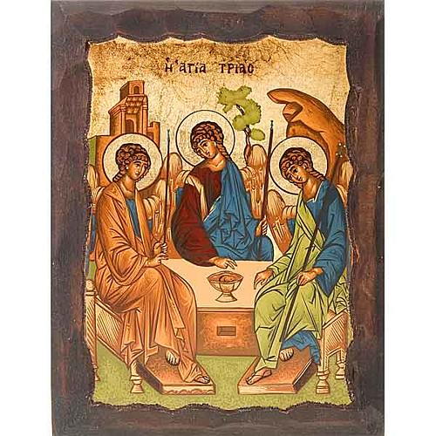

Teaching Summary
The Church lives in readiness. The Church lives in hope, awaiting Christ’s return.

Reflection
• What does faithful readiness mean?
• How does hope shape our lives?
• How can we encourage one another and those who are new to church?

Liturgy
Opening Acclamation:
Grace, mercy and peace from God our Father and the Lord Jesus Christ be with you.
And also with you.
Collect for Lent:
Almighty and everlasting God, you hate nothing that you have made and forgive the sins of all those who are penitent: create and make in us new and contrite hearts, that we, worthily lamenting our sins and acknowledging our wretchedness, may receive from you, the God of all mercy, perfect remission and forgiveness; through Jesus Christ our Lord. Amen.
Confession:
Most merciful God, we confess that we have sinned against you in thought, word and deed, by what we have done and by what we have left undone. We have not loved you with our whole heart. We have not loved our neighbours as ourselves. In your mercy forgive what we have been, help us to amend what we are, and direct what we shall be; through Jesus Christ our Lord. Amen.
Lord’s Prayer:
Our Father, who art in heaven, hallowed be thy name; thy kingdom come; thy will be done; on earth as it is in heaven. Give us this day our daily bread. And forgive us our trespasses, as we forgive those who trespass against us. And lead us not into temptation; but deliver us from evil. For thine is the kingdom, the power, and the glory, for ever and ever. Amen.
Blessing:
May the God of peace sanctify you wholly; and may your spirit and soul and body be kept sound and blameless at the coming of our Lord Jesus Christ. Amen.

Closing Prayer
Lord, keep us faithful until your coming. Amen.

Spiritual Formation
Hope sustains the Good Church. Practice daily prayer, bible reading and devotion. Encourage one another.

