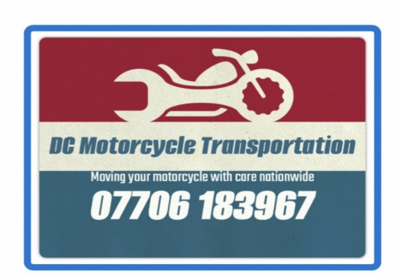Making a booking

Please fill in as much detail as possible to help us transport your motorcycle.

Your name and if applicable the Company name

Your contact details/phone numbers

Your Email address-Please make sure this is correct!

Collection address and full postal code – Include collection name/contact if different to above.

Making a booking

Please fill in as much detail as possible to help us transport your motorcycle.

Delivery Name and if applicable the company name

Delivery contact details/phone numbers

Delivery Email address

Delivery address and full postal code – Include name/contact

Making a booking

Please fill in as much detail as possible to help us transport your motorcycle.

Preferred collection date and time? This will be confirmed

Make and model of motorcycle

Registration number and value

Any other useful notes: