Executive Summary

Increasing the Competitiveness of Manitoba’s Potato Industry

Manitoba potato growers must generate an increased yield of a high-quality crop grown in a sustainable, cost effective manner to improve market competitiveness because of an upcoming expansion in processing potential within Manitoba. Competitive factors outside our influence include Manitoba’s distance to markets, global supply and demand of processed potato products, and volatility in the exchange rate between Canada and the United States. Yield increases must be achieved through regional research, development, and evaluation of crop management strategies because the long-distance importation of research results from other areas risks overlooking regionally significant yield-limiting factors. The overall goal of the research program “Increasing the Competitiveness of Manitoba’s Potato Industry” is to foster sustainable, competitive growth of the Manitoba potato industry through a research program within Manitoba. The current objective of this research program was to identify areas of variable potato yield and to characterize the variables responsible for variable yield. The future objective is to compile the most important variables responsible for variable yield and evaluate strategies to remediate each factor in-field.

The variables associated with variability in the value (in dollars), specific gravity, and tuber size profiles of <3 oz, 3-6 oz, 6-10 oz, 10-12 oz, and > 12 oz of processing tubers are covered in detail in the full report. In the case of each dependant variables, such as total yield, a model was created which listed the major contributing variables and denotes if the association was positive or negative. In this summary, the results for total yield are included:

Listed above are the top ten most influential positive and negative variables on total yield of processing fields evaluated 2015-2017. The X axis (bottom) identifies the variable recorded, whether it was from the soil or petioles, and the time of year it was collected. Nutrients were generally recorded as lbs available to the plant in soil and PPM in petioles, as determined by Agvise testing. The Y axis identifies the Variable of Importance in Projection (VIP) in the creation of the model predicting total yield. Greater positive VIP (above zero) indicates that variable has a bigger, positive association with yield. In other words, a bigger VIP indicates that greater total yield from sampling points was associated with the increasing amount of this nutrient in the soil or petiole. Lower, negative VIPs (below zero) indicates that variable has a bigger negative association with yield. As the VIP drops, the increasing amount of that nutrient is associated with the lowest yielding sampling points. The exact relationship between a negative VIP and too much or too little of nutrient must be determined by a resource such as Agvise recommendations or the Manitoba Soil Fertility guide (https://www.gov.mb.ca/agriculture/crops/soil-fertility/soil-fertility-guide/). It is important to note that 45-55 variables were associated with yield for all tuber size categories and total yield, but only the top ten were reported here for simplicity.
The same type of models were created for each of the tuber size categories as total yield. It is important to note that not all variables are consistent across total yield and each size category, meaning that some variables are important for specific size categories. These variables can be the target of remediation efforts if interest lies in improving the yield of that specific size category. Variables that show up across some or all size categories are consistently associated with greater or lesser potato yield, and the consistency is an important observation for remediation efforts to improve yield regardless of size category. The figure below lists the top ten most influential variables on 10-12 oz tubers to compare and contrast with total yield.

The most important variables contributing positively to both 10-12 oz tubers and total yield was petiole sodium at row closure. Over the course of the experiment, the percentage sodium recorded in the petiole by Agvise varied from 0.01% to 0.07%, indicating the percentage range of positive benefit was small. However, the analysis indicated that the higher percentages were associated with higher yielding sampling points. It is also important to note that the petiole sodium content became a negative yield association from mid bulking and late bulking, albeit not one of the top ten.
There were also two variables that were negatively associated with yield for both total yield and 10-12 oz yield. In these cases, too much or too little of either nutrient was associated with lower yielding sampling points. A soil test and reference are necessary to determine whether it was too much or too little – the model will not inform this result. Soil potassium at row closure from 0-15 cm was one such example, and 91 to 1150 PPM recorded as lowest to very high. The other consistent variables were petiole calcium at row closure and mid bulking. The percentage of petiole calcium at row closure ranged from 0.87-2.48%, which appeared to range from high to very high. It is possible that excessive calcium was part of the negative yield association. Field experimentation to address the relationship between calcium or potassium on negative yield associations is absolutely necessary to verify this claim, especially before major management decisions are implemented.
There are also many variables that appear on the top ten for total yield, but not 10-12 oz yield. For example, sampling points with greater petiole nitrate at row closure are associated with total yield negatively (i.e. greater petiole nitrate at row closure is associated with the lowest yielding sampling points). The PPM of nitrate in the petiole ranged from 3,892 to 24,852. Ten of the sixty sampling points were deficient at this time, and fifteen of the sixty were low. No sampling point had high petiole nitrate at this time. It is likely that the negative yield association for total yield was observed with low to deficient petiole nitrate sampling points. As with soil potassium and petiole calcium, field experimentation is necessary to demonstrate this relationship and evaluate remediation approaches.
Increasing numbers of Verticillium propagules were the largest negative contribution to 10-12 oz yield. Verticillium infection is likely preventing the tubers from sizing in the 10-12 oz category more so than the smaller categories. The fact that these variables appear in only one tuber size category is an important consideration for specific remediation strategies aimed at improving yield to just this size of tuber.
In addition to evaluating the impact of variables on yield of all the processing fields combined, individual fields from 2017 were rated for nutrient, soil, disease, and plant health status. Drone imagery was used in conjunction with scouting, nutrient status as determined by Agvise recommendations, and yield to visualize variability at each sampling point and what trends were apparent in the overall yield. The point of this individual analysis is to demonstrate the usefulness of the PLS analysis from all processing fields in identifying one or a few major yield-limiting factors from a larger list of potential problems listed for a specific site. This information begins the conversation with a local consultant and grower about priorities in remediating yield variability, and ultimately ideal practices to remediate the situation. The results are covered in detail in the following report. In summary, the results for one 2017 processing field are included:
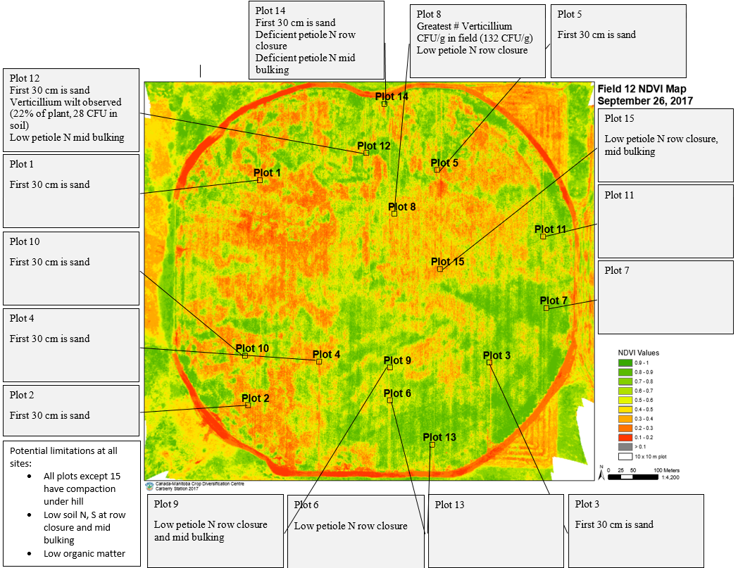
Green on above drone image indicates the living potato plants from a drone flight on September 25th, while varying degrees of yellow indicate areas of plant die-down. Red indicates bare earth. Each of the 15 sampling points is geo-referenced and were selected to represent the full variation in soil nutrient content, organic matter, texture, and topography. Possible factors for yield variability, as indicated by the Manitoba Soil Fertility guide, are highlighted for each point and on a field-wide basis.

The yield of the same field (#12), split by tuber size profile, is listed about by each sampling point. Each point (1-15) on the above image corresponds to the plot numbers in the previous image. Each color represents a specific tuber size profile. For example, yellow bars near the top indicate the 10-11.9 oz tuber size. The yield is measured in hundredweight per acre (Cwt/A) on the right side, and the harvest date was the first week in September. The green line connecting the bars is the estimated dollar value of the sampling point. The scale for the dollar value is on the left side.
In comparing the drone image of field 12 to the tuber size profile, some trends become apparent. The lowest yielding sampling point number 14 was observed to have compaction under 30 cm, low soil nitrogen and sulfur at row closure and mid bulking, low organic matter, high sand composition, and deficient petiole nitrogen at row closure and mid bulking. It is possible that the combination of some or all of these factors contributed to the yield limitation. This situation is where the partial least squares regression (PLS) analysis from earlier can provide some clarity. The sulfur concentration in the soil at mid bulking was an important, positive yield association for total yield. The low soil sulfur at mid bulking could possibly be a large contributor to this yield reduction. In addition, the noted low soil nitrogen availability is also an important variable identified in the PLS regression analysis for all processing fields. Further trends are apparent as the potential problems of an individual sampling point are cross-referenced with the PLS regression analysis for each tuber size profile further into this report. The full set of conclusions complete objective of this research program was to identify areas of variable potato yield and to characterize the factors responsible for variable yield. These conclusions are expected to influence the choices in meaningful yield variability remediation strategies and products are evaluated moving forward in the future of this project.
Fields destined for processing were not the only market consideration throughout the course of this project. Two fresh market fields were analyzed separately from processing fields in 2017. The variables associated with variability in the misshapen tubers, knobs, growth cracks, enlarged lenticels, russeting, and tuber size profiles of <2 in, 2-2.25 in, 2.25-3 in, 3-3.5 in, and > 3.5 in of fresh market tubers is also covered in detail in the full report. In summary, only the results for total yield are included:
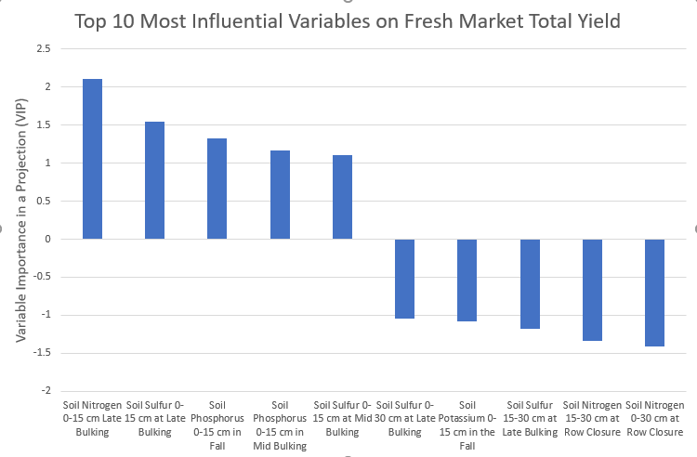
Listed above are the top ten most influential positive and negative variables on total yield of fresh market fields evaluated in 2017. As before, a bigger VIP indicates that greater total yield from sampling points was associated with the increasing amount of this nutrient in the soil or petiole. As the VIP drops, the increasing or decreasing amount of that nutrient is associated with the lowest yielding sampling points.

Sampling points with greater soil nitrogen concentration at late bulking are associated with total yield positively (i.e. greater soil nitrogen at late bulking is associated with the highest yielding sampling points). Conversely, greater soil nitrogen concentration (0-30 cm) at row closure was negative associated with yield – more soil nitrogen at row closure was associated with lower yielding points. Greater soil sulfur in the upper (0-15 cm) soil layer were associated with the highest yielding sampling points at mid and late bulking. The most pronounced benefit of soil sulfur was more strongly associated with late bulking than mid bulking. In contradiction, soil sulfur from the deeper (15-30 cm) soil layer was negatively associated with fresh market yield at late bulking.
The objective of this research program was to identify areas of variable potato yield and to characterize the factors responsible for variable yield. Lists of the top ten most important variables associated with variable yield for fresh market and processing tubers sizes have been established. Moving forward, the objective will be to revisit fields coming back into the potato rotation at the beginning of the study to observe if these same yield-limiting variables can be observed repeatedly. In addition, yield-limiting variables identified and mapped in the first objective will be used to develop and evaluate remediation strategies in-field. Improving yield of desirable tuber sizes in less-than-ideal patches of fields in the project will add to the value of the crop, thereby improving the competitiveness of the Manitoba potato farmer in the market. This is important as processing expansions in Manitoba come into effect in the near future. Once cooperators are satisfied by remediation strategies to variable yield, other Manitoba growers can judge the fit of the practice to their operation. Remediation strategies that are adopted on a larger scale provincially will amplify the desired goal to reach and improve the competitiveness of all Manitoba potato growers.

