Increasing the Competitiveness

of Manitoba’s Potato Industry

Investigators

Primary:
Dr. Zachary Frederick (principle investigator 2017-present)
Dr. Oscar Molina and Garry Sloik (principle investigators 2016)
Dr. Alison Nelson (principle investigator 2015)

Secondary:
Jane Klippenstein (Technician 2018-present)
Dr. Francis Zvomuya (statistical consultation 2016-present)
Dr. Mario Tenuta (Verticillium microsclerotia counts from soil 2016-present)
Blair Geisel (data curation and statistical consultation 2016)
Haley Lobreau, Christine McGorman and Rylee White (student assistants 2017-18)
Rylee White and Charles Kuizon (student assistants 2016-17)

Research committee

Dan Sawatzky – Keystone Potato Producers Association (KPPA)
Bryce Regan – Simplot Canada II
Jason Coates - Simplot Canada II
Dan Parynuik – Simplot Canada II
Mary LeMere - McCain Foods
Craig Linde - Diversification Specialist (MAFRD)
Tim Hore - Manitoba Agriculture
Dr. Vikram Bisht - Manitoba Agriculture
Dr. Alison Nelson - Agriculture and Agri-Food Canada
Dr. Tracy Shinners-Carnelley – Peak of the Market
Andrew Ronald – KPPA Agronomist
Dave Buhler – Chipping Potato Grower Association of Manitoba
Russell Jonk - Seed Potato Growers Association of Manitoba
Dr. Zachary Frederick (Manitoba Horticultural Productivity Enhancement Centre Inc)

Grower collaborators/consultants/agronomists

Kevin Hood, Trevor Thornton, David Baron, John Goff, Darin White, Southern Potato Co, Eric Unrau, Paul Adriaansen, Steve Saunderson, Brock McIntosh, Brian McDonald, Glen Fehr, Tim Braun, Randy Baron, Stan Wiebe, Joel Doerksen, Sheldon Wiebe, Consultant Pryor, Kroeker Farms, Gord Penner, and Earl Baron.

Canada Manitoba Crop Diversification Centre (CMCDC) staff

Dr. Alison Nelson, Craig Linde, Brian Baron, Eric Claeys, Alan Manns, Lindsey Andronak, Ryan Groves, Amanda Fisher, Seasonal students

Sources of Funding

Provincial strategic initiative and Canadian Agricultural Partnership, Ag Action Manitoba Program
Partners with MHPEC Inc (Keystone Potato Producers Association, McCain Foods, Simplot Canada II)

The following report would not be possible without the contributions of the above individuals, groups, and entities

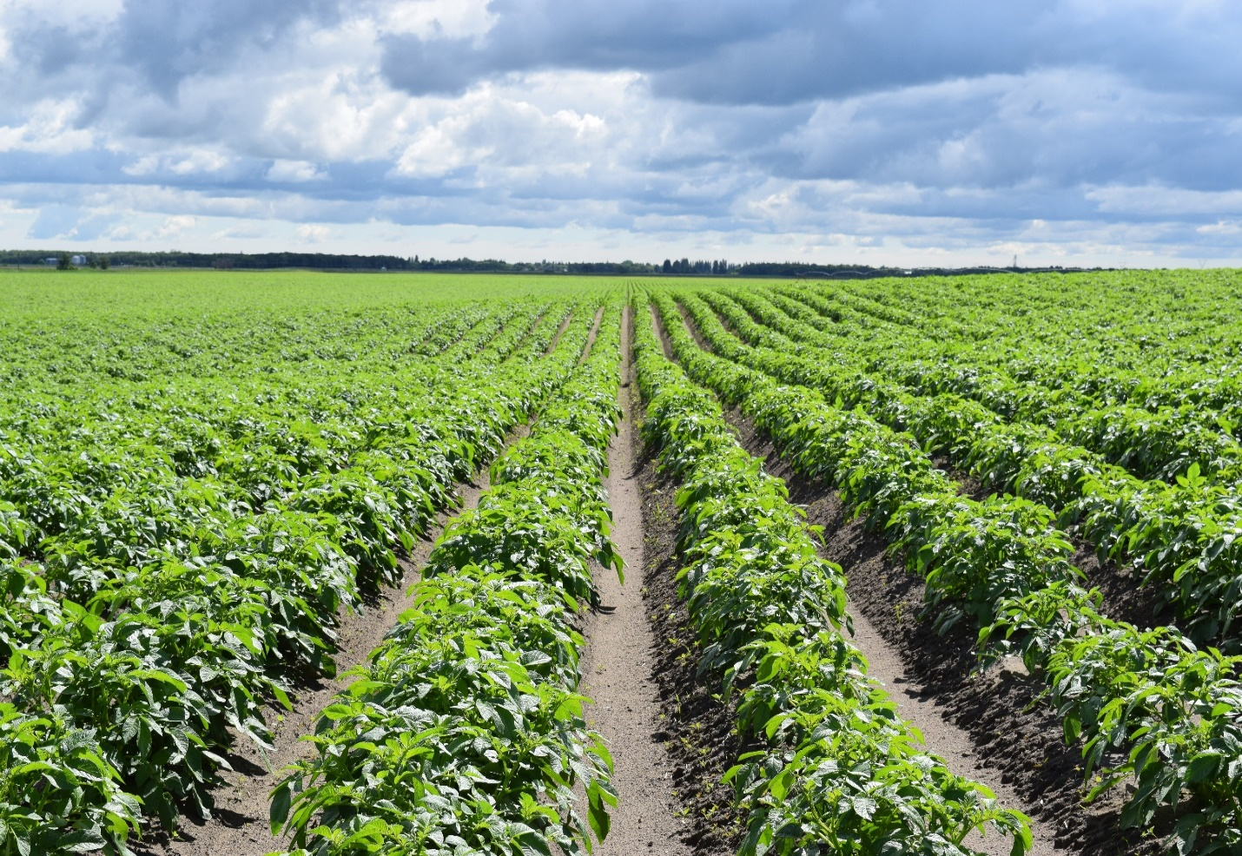

TABLE OF CONTENTS
Increasing the Competitiveness of Manitoba’s Potato Industry

Summary - Increasing the Competitiveness of Manitoba’s Potato Industry 7
Introduction 8
Works Cited: 11
Results and Brief Discussion 12
Partial Least Squares regression analysis of all processing fields 2015-2018 (pooled data set) 12
Total Yield 12
Value of the crop in dollars 14
Yield: percentage of the undersized (< 3 oz) tubers 16
Yield: percentage of the small tubers (3-6 oz) 17
Yield: percentage of the 6-10 oz tubers 18
Yield: percentage of the 10-12 oz tubers 20
Yield: percentage of the 6-12 oz combined tuber size categories 21
Yield: percentage of the > 12 oz tubers 23
Tuber specific gravity 24
Drone Image Analysis 26
2018 Processing Field Individual Analysis 27
Field 16: 27
Field 17: 31
Field 18: 35
Field 19: 38
2017 Processing Field Individual Analysis 42
Field 10: Pictured below (Fig. 12) is a drone image identifying potential limiting factors to the whole field or specific points 42_Toc3753484
Field 11: Pictured below (Fig. 15) is a drone image identifying potential limiting factors to the whole field or specific points 47
Field 12 Pictured below (Fig. 18) is a drone image identifying potential limiting factors to the whole field or specific points 53
Field 13 Pictured below (Fig. 21) is a drone image identifying potential limiting factors to the whole field or specific points 58
Fresh Market Fields 62
Total Yield Using one model for all response variables 62
2 to 2.25-inch diameter category 64
2.25 to 3.0-inch diameter category 66
3.0 to 3.5-inch diameter category 68
2017 Fresh Market Field Individual Analysis 71
Field 14 71
Field 15 75
Nitrogen Remediation Study 79
Conclusions 79
Materials and Methods 82
Field Variability Study 82
Statistical Analysis with the Partial Least Squares Regression method 90
Nitrogen Remediation Study: 93
Fertilizer calculations: References for this material are in the notes section 94
Experimental Progression 99
Notes 106
Tables 110
Table 1. The 46 of the 97 independent variables that were identified through partial least squares analysis showed that 56% of the variability in all response variables taken together for the processing total yield. 110
Table 2. The 46 of the 97 independent variables that were identified through partial least squares analysis showed that 58% of the variability in all response variables taken together for the processing value. 112
Table 3. The 42 of the 97 independent variables that were identified through partial least squares analysis showed that 53% of the variability in all response variables taken together for the percentage of processing tubers < 3 oz. 114
Table 4. The 46 of the 97 independent variables that were identified through partial least squares analysis showed that 61% of the variability in all response variables taken together for the percentage of 3-6 oz processing tubers. 116
Table 5. The 46 of the 97 independent variables that were identified through partial least squares analysis showed that 46% of the variability in all response variables taken together for the percentage of 6-10 oz processing tubers. 118
Table 6. The 50 of the 97 independent variables that were identified through partial least squares analysis showed that 52% of the variability in all response variables taken together for the percentage of 10-12 oz processing tubers. 120
Table 7. The 50 of the 97 independent variables that were identified through partial least squares analysis showed that 57% of the variability in all response variables taken together for the percentage of 6-12 oz processing tubers. 122
Table 8. The 43 of the 97 independent variables that were identified through partial least squares analysis showed that 48% of the variability in all response variables taken together for the percentage of > 12 oz processing tubers. 124
Table 9. The 48 of the 97 independent variables that were identified through partial least squares analysis showed that 60% of the variability in all response variables taken together for the specific gravity of processing tubers. 126
Table 10. A 4-component model containing 21 variables explained 96% of the variability in fresh market total yield. 128
Table 11. A 2-component model containing 19 variables explained 41% of the variability in the percentage of yield in the fresh market 2-2.25-inch diameter category. 130
Table 12. A 2-component model containing 17 variables explained 52% of the variability in the percentage of yield in the fresh market 2.25 to 3.0-inch diameter category. 132
Table 13. A 2-component model containing 22 variables explained 78% of the variability in the percentage of yield in the fresh market 3.0 to 3.5-inch diameter category. 134

Summary - Increasing the Competitiveness of Manitoba’s Potato Industry

Note: a complete version of this research is available at mbpotatoresearch.ca under the research reports tab as of March 31 2019. This is an interim report for 2018-19, project not complete yet.

Problem: Manitoba potato growers must generate an increased yield of a high-quality crop grown in a sustainable, cost effective manner to improve market competitiveness in response to changes in the local and global supply and demand of processed potato products, as well as the volatility in the exchange rate between Canada and the United States.

Why conduct this study in Manitoba? Yield increases must be achieved through regional research, development, and evaluation of crop management strategies because the long-distance importation of research results from other areas risks overlooking regionally significant yield-limiting factors.

Objectives:
- Characterize the variables responsible for variable ‘Russet Burbank’ yield in MB
- Experimentally confirm ideal range of variable that is currently yield-limiting (i.e. if low soil sulfur is a problem, what rate of sulfur is necessary to eliminate the problem)
- Evaluate treatment on field-scale for variables identified in objective 1, evaluate treatment cost-effectiveness

Methods: The independent variables (what we measured) were approximately 98 soil, plant, and environmental factors from 2015-2018 for 19 fields planted to ‘Russet Burbank’.

The dependant variables (what we are associating our independent variables to) were the total yield, value (in dollars), specific gravity, and percentage of each tuber size profile of < 3 oz, 3-6 oz, 6-10 oz, 10-12 oz, and > 12 oz.

In the case of each dependant variable, such as total yield, a model was created (partial least squares regression) which listed the major contributing variables and denotes if the association was positive or negative.

Conclusions: Approximately 50 independent variables have been associated with yield variability, and the effect of each variable has been ranked in order of significance. Consultations with growers on the project have identified three variables of the top ten that are economically feasible to manage and have the support to study improvements on their farms.

The three main takeaways
- Lower petiole nitrate at row closure are associated with total yield negatively (i.e. lower petiole nitrate at row closure is associated with the lowest yielding sampling points).
- Soil sulfur at all growth stages are associated positively with total yield and virtually all the size categories. The most benefit to sulfur was when more soil sulfur was available at row closure.
Increasing numbers of Verticillium propagules were the largest negative contribution to 10-12 oz yield

Introduction

Manitoba potato production has averaged 20.5 million hundredweight (cwt) annually from 2000 to 2013, landing the province with the #2 rank in Canadian potato production. Manitoba produces 20% of all the potatoes grown in Canada as of 2014 (Informa Economics, 2014). Manitoba has a long history of growing potatoes, which is demonstrated in part by Fig. 1.

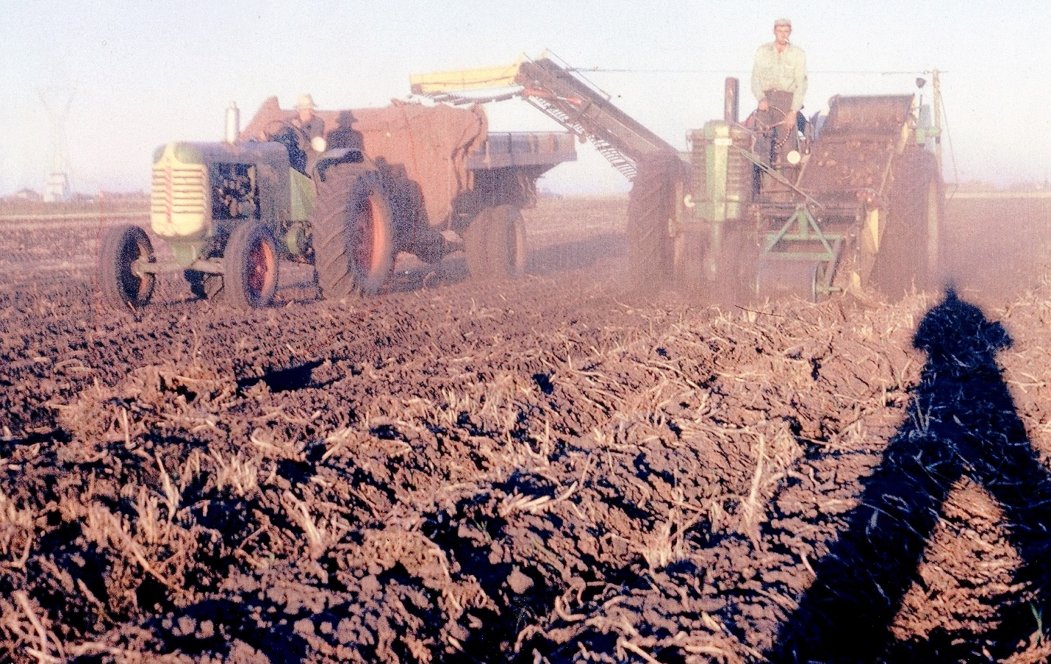
Fig 1. Potato harvest in Carberry, Manitoba in the mid-1960s. Several items are particularly interesting about this photograph. For example, the axel on the tractor with the digger (right) has been extended to allow placement of a one-row digger. The operator of the digger was the first person on the line to sort material out of the harvested potatoes. The preparation of the field for harvest is also interesting in that the majority of plant matter was shredded and removed prior to harvest, which could have potential implications on setting skins for harvest and removal of infected plant matter before propagules of organisms like Colletotrichum coccodes and Verticillium dahliae return to the soil. Photo credit: Earl Baron.

Potato yield in Manitoba has varied between approximately 16 and 25 million cwt from 2005 to 2013 (Fig. 2), with more recent advances being attributed to the implementation of sustainable best management practices (Informa Economics, 2014). These recent improvements identify that there is opportunity for continued improvement through the collaboration of research and the potato community to define and improve these best management practices.

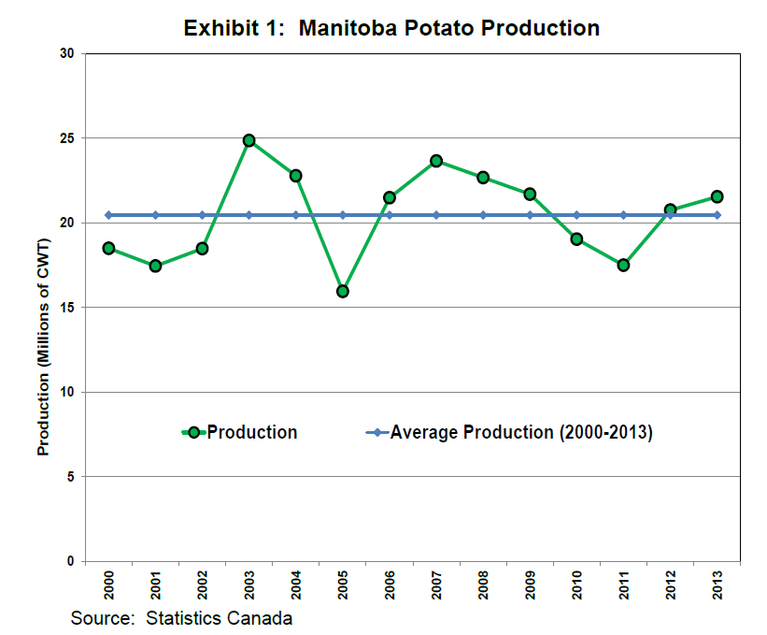
Fig 2. Line graphical display of Manitoba potato production yield by each year from 2005 to 2013. The green line links annual production (in millions cwt) by year, whereas the blue line represents the average across all year. Sourced and created by Informa Economics (2014) from Statistics Canada.

The direct application of research to engage communities to promote growers and their commodities is the hallmark of cooperative extension (CED-81-119), which will be referred to as extension from here onward. The key to extension is the exchange of information between people with different perspectives and experience is necessary in order to overcome a problem together. This exchange educates both parties to make informed choices, which in this case improves the crop and encourages other members of the community to seek what was done differently in order to achieve the same result for themselves. This report is one such attempt to supply research results that can integrate into the conversation about improving the yield and quality of potatoes grown in Manitoba. This report is only meaningful if you, the reader, provide feedback on what interests you, why, and how you think we can overcome yield limitations together.

The concept of cooperative extension is not new to North America– agricultural clubs and societies of the early 19th century encouraged farmers to report their achievements on yield and problem-solving. This practice of coming together to share knowledge to boost crop yield and quality eventually led to events sponsored by local governments and universities the United States, which eventually precipitated the formation of the land-grant college system in 1862 (CED-81-119). Attempts to overcome the current limitations of an agricultural system, potatoes in this case, are inextricably intertwined with research and communal education efforts.

The Manitoba Crop Diversification Centre (MCDC) was established in 1993 with a ten-year agreement amongst a community consisting of the Government of Canada, the Government of Manitoba, and Manitoba Horticulture Productivity Enhancement Centre Inc. (MHPEC). Applied research continues to this day under the name of the Canada-Manitoba Crop Diversification Centre (CMCDC) on a five-year (2013-2018) agreement (Anonymous, 2017). Part of the necessary information exchange for extension occurs at CMCDC through research in the areas of crop diversification, intensive crop production technology practices, such as irrigation, and facilitating development of value added processing of Manitoba-grown crops (Anonymous, 2016). Research reporting days, space for meetings for growers and industry, and individual consultation with research agronomists means CMCDC is an integral part of the conversation to exchange information to complete the purpose of extension for the Manitoba potato community. The conversation to enhance Manitoba potato growers, as well as those involved in potato processing and marketing, brings new challenges and opportunities for further research and extension going into the future.

Manitoba potato growers must generate an increased yield of a high-quality crop grown in a sustainable, cost effective manner to improve market competitiveness because of an upcoming expansion in processing potential within Manitoba. Competitive factors outside our influence include Manitoba’s distance to markets, global supply and demand of processed potato products, and volatility in the exchange rate between Canada and the United States. Yield increases must be achieved through regional research, development, and evaluation of crop management strategies because the long-distance importation of research results from other areas risks overlooking regionally significant yield-limiting factors. The overall goal of the research program “Increasing the Competitiveness of Manitoba’s Potato Industry” is to foster sustainable, competitive growth of the Manitoba potato industry through a research program within Manitoba. This research program is conducted within grower fields, but is housed at CMCDC and aligns with the centre’s objective of research into intensive crop production technology practices.

The research program consisted of two objectives, and the first objective was to identify areas of variable potato yield in specific fields and to characterize the factors responsible for variable yield. A second objective uses yield-limiting factors identified in the previous objective to select and evaluate strategies aimed at mitigating or compensating for these factors in field settings specific to Manitoba.

This research program is designed to supply information on the remediation of yield limiting factors for specific fields in Manitoba, which are generally representative of commercial processing potato acres in Manitoba. The broader impact of this research is that remediation strategies can be employed elsewhere in Manitoba to improve the yield or cost-effectiveness of the potato crop. For example, the opposite of practices that are identified as selecting for larger processing tubers could be considered by a seed grower for smaller seed potatoes. This goal can only be achieved through the combined experience and research capacity of the Manitoba potato growers, Manitoba Agriculture, Agriculture and Agri-Food Canada, the University of Manitoba, the Keystone Potato Producers Association (KPPA), McCain Foods (Canada), Simplot Canada II, the Chipping Potato Grower Association of Manitoba (CPGAM), and the Seed Potato Growers Association of Manitoba (SPGAM).

Works Cited:

Anonymous. 2016. Canada-Manitoba Crop Diversification Centre Objectives. Published by the Agriculture and Agri-Food Canada, retrieved from < http://www.agr.gc.ca/eng/about-us/offices-and-locations/canada-manitoba-crop-diversification-centre/canada-manitoba-crop-diversification-centre-objectives/?id=1185212178964? >

Anonymous. 2017. Canada-Manitoba Crop Diversification Centre. Published by the Agriculture and Agri-Food Canada, retrieved from < http://www.agr.gc.ca/eng/about-us/offices-and-locations/canada-manitoba-crop-diversification-centre/?id=1185205367529>

CED-81-119. 1981. Cooperative Extension Service's Mission and Federal Role Need Congressional Clarification. United States General Accounting Office, Document Handling and Information Services Facility. Retrieved from <https://www.gao.gov/products/CED-81-119>

Informa Economics. 2014. Manitoba Potato Industry Generates Over 1.4 Billion Dollars to the Canadian Economy. Published by the Keystone Potato Producers Association, Chipping Potato Growers of Manitoba, Seed Potato Growers of Manitoba, McCain Foods Canada, and Simplot Canada II.

Results and Brief Discussion

Partial Least Squares regression analysis of all processing fields 2015-2018 (pooled data set)

Total Yield
Partial least squares analysis showed that 56% of the variability in all response variables taken together was explained by a model containing 46 of the 97 independent variables tested (Table 1). The seven most influential variables with negative contributions to the model, greatest to least influential, were petiole calcium concentration at row closure, soil nitrogen concentration at row closure from depths of 15-30 cm, petiole concentration of calcium at mid bulking, soil nitrogen 0-30 cm at row closure, nitrate concentration in the petiole at row closure, boron concentration in the petiole at late bulking, and soil potassium availability in the soil at row closure from depths 0-15 cm (Fig. 3).
Among the top ten most important explanatory variables was the available sodium in petioles at row closure, which was positively associated with yield. The two other positive yield associations were soil sulfur at mid bulking (from depths of 0-15 cm) and soil phosphorus at late bulking (from depths of 0-15 cm, Fig. 3).

Fig. 3. Listed above are the top ten most influential positive and negative variables on total yield of processing fields evaluated 2015-2017. The X axis (bottom) identifies the variable recorded, whether it was from the soil or petioles, and the time of year it was collected. Nutrients were generally recorded as lbs available to the plant in soil and PPM in petioles, as determined by Agvise testing. The Y axis identifies the Variable of Importance in Projection (VIP) in the creation of the model predicting total yield. Greater positive VIP (above zero) indicates that variable has a bigger, positive association with yield. In other words, a bigger VIP indicates that greater total yield from sampling points was associated with the increasing amount of this nutrient in the soil or petiole. Lower, negative VIPs (below zero) indicates that variable has a bigger negative association with yield. As the VIP drops, the increasing or decreasing amount of that nutrient is associated with the lowest yielding sampling points. The exact relationship between a negative VIP and too much or too little of nutrient must be determined by a resource such as Agvise recommendations or the Manitoba Soil Fertility guide (https://www.gov.mb.ca/agriculture/crops/soil-fertility/soil-fertility-guide/). It is important to note that 45-55 variables were associated with yield for all tuber size categories and total yield, but only the top ten were reported here for simplicity.
The interpretation of these results is that variables with greater VIPs have greater significance to the model (Table 1), and therefore have greater variance between the sampling points with greater and lesser total yield. For example, sampling points with greater petiole nitrogen at row closure are associated with total yield negatively and could be translated as less petiole nitrate at row closure is associated with our lowest yielding sampling points. Over the course of the experiment, petiole nitrate results varied from 3892 to 32668. The association with decreasing total yield would focus on the upper range of 32668, but the exact cut off of when the benefit of available nitrogen turns to detriment cannot be determined by this form of analysis. Recommendations from Agvise suggest that the cut off is around 25000, but experimental validation with a remediation strategy (objective 2) aimed at identifying nitrogen practices prior to row closure and their effect on the ideal petiole range are needed before experimentally-validated recommendations can be issued.
Variables such as available sodium in the petiole are positively associated with total yield, indicating the best-yielding sampling points were associated with more petiole sodium than the lower yielding points. Over the course of the experiment, the percentage sodium recorded in the petiole by Agvise varied from 0.01% to 0.07%, indicating the percentage range of positive benefit was small. However, the analysis indicated that the higher percentages were associated with higher yielding sampling points. It is also important to note that the petiole sodium content became a negative yield association from mid bulking and late bulking, albeit not one of the top ten.
Similarly, increased sulfur concentration in the upper (0-15 cm) horizon of the soil at mid bulking was associated with our highest yielding sampling points. However, the benefit to total yield associated with greater petiole sodium is larger than the benefit from increased soil sulfur, as indicated by an increased VIP in the model (i.e. the higher the bar is on the positive side, the greater the benefit, and the lower the bar on the negative side indicates incrementally larger negative effect).
The results on petiole calcium are also interesting in that sampling points with greater petiole calcium had lower total yield. In this case, too much or too little of calcium was associated with lower yielding sampling points. A soil test and reference are necessary to determine whether it was too much or too little – the model will not inform this result. The percentage of petiole calcium at row closure ranged from 0.87-2.48%, which appeared to range from high to very high. It is possible that excessive calcium was part of the negative yield association. Field experimentation to address the relationship with calcium on negative yield associations is absolutely necessary to verify this claim, especially before major management decisions are implemented.
It is very to get lost in the morass of results and interpretation of the following results for each size category. Repetition is key to the integrity of any result from any scientific study. The conclusions section will list the consistent results across all size categories and total yield for the processing and fresh sections of this report.

Value of the crop in dollars
When the total dollar value of the crop was tested individually, a two-component model containing 46 variables explained 58% of the variability was generated with strong predictive power (Table 2). The seven most influential variables with negative contributions to the model, greatest to least influential, were calcium concentration in the petiole at row closure, nitrogen concentration in the 15-30 cm soil layer at row closure, soil nitrogen concentration from 0-30 cm at row closure, calcium concentration in the petiole at mid bulking, sulfur concentration in the 15-30 cm soil layer at row closure, calcium concentration in the petiole at late bulking, and sodium concentration in the petiole at late bulking (Fig. 4).
The three most influential variables with a significant, positive contributions to the model, greatest to least influential, were the sodium concentration in the petiole at row closure, soil nitrogen 0-15 cm at row closure, and soil potassium 0-15 cm at row closure (Fig. 4).

Fig. 4. The top 10 most influential positive and negative variables on the value of processing fields evaluated 2015-2017. The X axis (bottom) identifies the variable recorded, whether it was from the soil or petioles, and the time of year it was collected. Nutrients were generally recorded as lbs available to the plant in soil as determined by Agvise testing and nutrient recommendations. The Y axis identifies the Variable of Importance in Projection (VIP) in the creation of the model for this yield category. Greater positive VIP (above zero) indicates that variable has a bigger positive association with yield. Lesser negative VIP (below zero) indicates that variable has a bigger negative association with yield.
The interpretation of these results is that variables with greater VIPs have greater significance to the model (Table 2), and therefore have greater variance between the sampling points with greater and lesser value in dollars. More valuable sampling points were associated with higher petiole sodium at row closure than less valuable sampling points. More valuable sampling points were associated with lower calcium concentrations in the petiole at row closure or lower nitrogen concentration in the 0-15 cm soil layer at row closure than less valuable sampling points, for example. The negative association with petiole calcium at row closure was greater than soil nitrogen at row closure (VIP greater for petiole calcium).
The pounds of nitrogen available in the soil varied at row closure from 5 to 160 lbs, which can explain the anomalous result that increasing soil nitrogen can be a positive value association, but too much or too little is a negative value association. Five pounds of available soil nitrogen is too little by row closure – limiting growth and eventual bulking, and ultimately reducing value. The consultants that took part in the 2017 year of the project seem to aim for 130-180 lbs of nitrogen in the soil by row closure, which includes the upper range of 160 lbs nitrogen in the soil observed in the experiment. This could explain the result where increasing soil nitrogen (up to the 160 lbs max observed) at the 0-15 cm is a positive yield association. However, too much or too little decrease value. Field experimentation is necessary to place the association in the context of an actual on-farm practice.

Yield: percentage of the undersized (< 3 oz) tubers
A two-component model containing 42 variables explained 53% of the variability was generated with strong predictive power for variables associated with the yield of undersize tubers (Table 3). The eight most influential variables with negative contributions to the model, greatest to least influential, were the sodium concentration in the petiole at row closure, sulfur concentration in the 0-15 cm soil layer at mid bulking, petiole sulfur concentration at mid bulking, petiole magnesium concentration at mid bulking, soil sulfur concentrations from 0-30 cm (especially the 15-30 cm layer) at late bulking, petiole concentration of sulfur at row closure, and soil concentration of sulfur at 15-30 cm at mid bulking (Fig. 5).
The two most influential variables with a significant, positive contributions to the model, greatest to least influential, were the potassium concentration in the petioles at late bulking and calcium concentration in the petiole at row closure (Fig. 5).

Fig. 5. The top 10 most influential positive and negative variables on the yield <3 oz tubers for processing fields evaluated 2015-2017. The X axis (bottom) identifies the variable recorded, whether it was from the soil or petioles, and the time of year it was collected. Nutrients were generally recorded as lbs available to the plant in soil as determined by Agvise testing and nutrient recommendations. The Y axis identifies the Variable of Importance in Projection (VIP) in the creation of the model for this yield category. Greater positive VIP (above zero) indicates that variable has a bigger positive association with yield. Lesser negative VIP (below zero) indicates that variable has a bigger negative association with yield.
The interpretation of these results is that variables with greater VIPs have greater significance to the model (Table 3), and therefore have greater variance between the sampling points with greater and lesser yield of undersize tubers. For example, sampling points with more calcium and potassium in the petioles at row closure had more undersize tubers than sampling points with less of either nutrient. Sulfur was consistently negatively associated with undersize tubers and therefore the sampling points with more available sulfur in the soil and petioles at mid and late bulking were associated with fewer undersize tubers. The association between more sulfur in petiole and soil and fewer undersize tubers is more pronounced at mid bulking than at row closure.

Yield: percentage of the small tubers (3-6 oz)
A two-component model containing 46 variables explained 46% of the variability was generated with strong predictive power for variables associated with the yield of undersize tubers (Table 4). The eight most influential variables with negative contributions to the model, greatest to least influential, were the soil sulfur concentration from 0-15 cm at mid bulking and petiole sodium concentration at row closure (Fig. 6).
The two most influential variables with a significant, positive contributions to the model, greatest to least influential, were the petiole calcium concentration at row closure, soil nitrogen concentration at 0-30 cm at row closure, soil nitrogen concentration at 15-30 cm at row closure, soil nitrogen concentration at 0-15 cm at row closure, petiole concentration of calcium at late bulking, soil potassium concentration at 0-15 cm at row closure, EC soil reading from 0-15 cm, and soil sulfur concentration at 0-15 cm at row closure (Fig. 6).

Fig. 6. The top 10 most influential positive and negative variables on the yield 3-6 oz tubers for processing fields evaluated 2015-2017. The X axis (bottom) identifies the variable recorded, whether it was from the soil or petioles, and the time of year it was collected. Nutrients were generally recorded as lbs available to the plant in soil as determined by Agvise testing and nutrient recommendations. The Y axis identifies the Variable of Importance in Projection (VIP) in the creation of the model for this yield category. Greater positive VIP (above zero) indicates that variable has a bigger positive association with yield. Lesser negative VIP (below zero) indicates that variable has a bigger negative association with yield.
The interpretation of these results is that variables with greater VIPs have greater significance to the model (Table 4), and therefore have greater variance between the sampling points with greater and lesser yield of 3-6 oz tubers. For example, sampling points with fewer 3-6 oz tubers were associated with less petiole sodium at row closure and less soil sulfur at mid bulking. The effect of petiole sodium concentration was greater than soil sulfur at mid bulking in terms of association of fewer 3-6 oz tubers. Sampling points with greater 3-6 oz yield were associated with increased petiole calcium concentration at row closure and soil nitrogen concentration at row closure. The effect of increased petiole concentration of calcium on increased 3-6 oz yield was greater than the effect of soil nitrogen.

Yield: percentage of the 6-10 oz tubers
A two-component model containing 46 variables explained 46% of the variability was generated with strong predictive power for variables associated with the yield of 6-10 oz tubers (Table 5). The five most influential variables with negative contributions to the model, greatest to least influential, were nitrogen concentration in the soil at both depths of 0-15 and 0-30 cm at late bulking, the boron concentration in the petiole at late bulking, calcium concentration in the petiole at row closure, soil sulfur concentration in the soil from 0-15cm at mid bulking.
The five most influential variables with a significant, positive contributions to the model, greatest to least influential, were the sodium concentration in the petiole at row closure, nitrate concentration in the petioles at late bulking, sulfur concentration in the petiole at row closure, soil nitrogen concentration in the soil from 0-15 cm at mid bulking, and sulfur concentration in the petiole at mid bulking (Fig. 7).

Fig. 7. The top 10 most influential positive and negative variables on the yield 6-10 oz tubers for processing fields evaluated 2015-2017. The X axis (bottom) identifies the variable recorded, whether it was from the soil or petioles, and the time of year it was collected. Nutrients were generally recorded as lbs available to the plant in soil as determined by Agvise testing and nutrient recommendations. The Y axis identifies the Variable of Importance in Projection (VIP) in the creation of the model for this yield category. Greater positive VIP (above zero) indicates that variable has a bigger positive association with yield. Lesser negative VIP (below zero) indicates that variable has a bigger negative association with yield.
The interpretation of these results is that variables with greater VIPs have greater significance to the model (Table 5), and therefore have greater variance between the sampling points with greater and lesser yield of 6-10 oz tubers. For example, sampling points with more sodium and nitrate in the petioles at row closure had more 6-10 oz tubers than sampling points with less of either nutrient. Sulfur was also positively associated with 6-10 oz tubers and therefore the sampling points with more available sulfur in the petioles at mid and late bulking were associated with more of this desirable tuber range. The association between more sulfur in petiole and more 6-10 oz tubers is more pronounced at row closure than mid bulking. However, sampling points with more petiole boron and soil nitrogen at late bulking were associated with fewer 6-10 oz tubers.

Yield: percentage of the 10-12 oz tubers
A two-component model containing 50 variables explained 52% of the variability was generated with strong predictive power for variables associated with the yield of 10-12 oz tubers (Table 6). The nine most influential variables with negative contributions to the model, greatest to least influential, were the number of Verticillium dahliae propagules (as evaluated by the PCR test), calcium concentration in the petioles at late bulking, potassium concentration in the petiole at late bulking, EC soil reading from 0-15cm, calcium concentration in the petiole at row closure, petiole potassium concentration at row closure, soil potassium concentration from 0-15 cm at row closure, percentage sand 0-15 cm, and the calcium concentration in the petiole at mid bulking (Fig. 8).
The only influential variable (of the top 10 total) with a significant, positive contribution to the model was the petiole sodium concentration by row closure (Fig. 8).

Fig. 8. The top 10 most influential positive and negative variables on the yield 10-12 oz tubers for processing fields evaluated 2015-2017. The X axis (bottom) identifies the variable recorded, whether it was from the soil or petioles, and the time of year it was collected. Nutrients were generally recorded as lbs available to the plant in soil as determined by Agvise testing and nutrient recommendations. The Y axis identifies the Variable of Importance in Projection (VIP) in the creation of the model for this yield category. Greater positive VIP (above zero) indicates that variable has a bigger positive association with yield. Lesser negative VIP (below zero) indicates that variable has a bigger negative association with yield.
The interpretation of these results is that variables with greater VIPs have greater significance to the model (Table 6), and therefore have greater variance between the sampling points with greater and lesser yield of 10-12 oz tubers. There was only one variable observed, sodium concentration in the petiole at row closure, where sampling points with more 10-12 oz tubers had more sodium than sampling points with lower 10-12 oz yield. Over the course of the experiment, the percentage sodium recorded in the petiole by Agvise varied from 0.01% to 0.07%, indicating the percentage range of positive benefit was small. However, the analysis indicated that the higher percentages were associated with higher yielding sampling points. It is also important to note that the petiole sodium content became a negative yield association from mid bulking and late bulking, albeit not one of the top ten.
Interestingly, sampling points with more Verticillium propagules had fewer 10-12 oz tubers. This is the only observation in the whole experiment where Verticillium was a variable of greater significance than most of the nutrients tested on impacting the yield of a specific tuber size profile. In the case of Verticillium, greater numbers of propagules per gram of soil were associated with the sampling points with the lowest percentages of 10-12 oz tubers. It is generally accepted that 5 to 30 CFUs per gram of soil are necessary to infect a potato plant (Colony Forming Units – a form of propagule observed under a microscope while growing on a petri plate). In the case of the experiment, CFU counts in excess of 100 in sampling points is where 10-12 oz yield begins to drop. More discussion on Verticillium counts in specific fields can be found in the “2017 Processing Field Individual Analysis” section.
The results on petiole calcium are also interesting in that sampling points with greater petiole calcium had fewer 10-12 oz tubers at any of the sampling dates, but our earliest sampling at row closure had the most pronounced effect of the three sampling dates. The final result to note is that more available sulfur in the petioles and soil at mid and late bulking improved 6-10 oz yield, but more soil sulfur at mid bulking decreased 10-12 oz yield. In these cases, too much or too little of either nutrient was associated with lower yielding sampling points. A soil test and reference are necessary to determine whether it was too much or too little – the model will not inform this result. Soil potassium at row closure from 0-15 cm was one such example, and 91 to 1150 PPM recorded as lowest to very high. The other consistent variables were petiole calcium at row closure and mid bulking. The percentage of petiole calcium at row closure ranged from 0.87-2.48%, which appeared to range from high to very high. It is possible that excessive calcium was part of the negative yield association. Field experimentation to address the relationship between calcium or potassium on negative yield associations is absolutely necessary to verify this claim, especially before major management decisions are implemented.

Yield: percentage of the 6-12 oz combined tuber size categories
A two-component model containing 44 variables explained 57% of the variability was generated with strong predictive power for variables associated with the yield of 6-12 oz tubers (Table 7). The seven most influential variables with negative contributions to the model, greatest to least influential, were the calcium concentration in the petiole at row closure, nitrogen concentration in the soil at both depths of 0-15 and 0-30 cm, boron concentration in the petiole at late bulking, EC reading for 0-15 cm, soil nitrogen from depths of 15-30 cm, and calcium concentration in the petiole at late bulking (Fig. 9)
The three most influential variables with a significant, positive contributions to the model, greatest to least influential, were the sodium concentration in the petiole at row closure, sulfur concentration in the petiole at row closure and mid bulking (Fig. 9).

Fig. 9. The top 10 most influential positive and negative variables on the yield 6-12 oz tubers for processing fields evaluated 2015-2017. The X axis (bottom) identifies the variable recorded, whether it was from the soil or petioles, and the time of year it was collected. Nutrients were generally recorded as lbs available to the plant in soil as determined by Agvise testing and nutrient recommendations. The Y axis identifies the Variable of Importance in Projection (VIP) in the creation of the model for this yield category. Greater positive VIP (above zero) indicates that variable has a bigger positive association with yield. Lesser negative VIP (below zero) indicates that variable has a bigger negative association with yield.
The interpretation of these results is that variables with greater VIPs have greater significance to the model (Table 7), and therefore have greater variance between the sampling points with greater and lesser yield of 6-12 oz tubers. When the 6-10 and 10-12 oz data sets are combined, the positive associations of sulfur in the petioles on 6-12 oz tubers outweighs the drawback of sulfur in the soil at mid bulking on 10-12 oz tubers. Calcium concentration in the petioles at row closure and late bulking remains negatively associated with 6-12 oz yield, and more so at row closure than at late bulking. Nitrogen in the soil remains negatively associated with 6-12 oz yield, but less so than the other nutrients previously listed. The Verticillium propagules are notably absent from the top 10 list of negative associations of 6-12 oz tubers, meaning Verticillium still negatively impacts yield, but the nutrients listed previously are more deleterious to yield than Verticillium in the fields we have sampled at this time. It is important to note that, as a biological system, areas where Verticillium dahliae infections become a prominent potato problem tend to grow in size and increase in severity with time, necessitating long-term management strategies even if it currently isn’t the most important yield limiting factor.

Yield: percentage of the > 12 oz tubers
A two-component model containing 43 variables explained 48% of the variability was generated with strong predictive power for variables associated with the yield of >12 oz tubers (Table 8). The seven most influential variables with negative contributions to the model, greatest to least influential, were the soil nitrogen availability at row closure for both depths of 0-15 and 15-30 cm, organic matter at depths of 0-15 cm, percentage of soil silt 0-15 cm, soil sulfur concentration at mid bulking, and gravimetric water content 0-12 cm (Fig. 10).
The three most influential variables with a significant, positive contributions to the model, greatest to least influential, were the sodium concentration in the petiole at row closure, sulfur concentration in the soil from depths of 0-15 and 0-30 cm at row closure (Fig. 10).

Fig. 10. The top 10 most influential positive and negative variables on the yield > 12 oz tubers for processing fields evaluated 2015-2017. The X axis (bottom) identifies the variable recorded, whether it was from the soil or petioles, and the time of year it was collected. Nutrients were generally recorded as lbs available to the plant in soil as determined by Agvise testing and nutrient recommendations. The Y axis identifies the Variable of Importance in Projection (VIP) in the creation of the model for this yield category. Greater positive VIP (above zero) indicates that variable has a bigger positive association with yield. Lesser negative VIP (below zero) indicates that variable has a bigger negative association with yield.
The interpretation of these results is that variables with greater VIPs have greater significance to the model (Table 9), and therefore have greater variance between the sampling points with greater and lesser yield of > 12 oz tubers. Increased soil nitrogen at row closure, regardless of depth, is associated with decreased yield of tubers > 12 oz and 6-10 oz. This stands in contrast to increased soil nitrogen at row closure associating with more >3 oz tubers. The > 12 oz size category is unique in that organic matter, silt percentage, and moisture content are in the top ten most influential variables that are negatively associated with yield. The positive association of soil sulfur at row closure with >12 oz yield aligns with the general positive yield associations with sulfur on 6-10 oz and 6-12 oz tubers.

Tuber specific gravity
A two-component model containing 48 variables explained 60% of the variability was generated with strong predictive power for variables associated with tuber specific gravity (Table 9). The seven most influential variables with negative contributions to the model, greatest to least influential, were the potassium concentration from petioles at late bulking, sodium concentration from petioles at mid bulking, potassium concentration at row closure from soils at depths of 0-15 cm, soil nitrogen concentration at row closure from depths of 15-30cm, soil nitrogen concentration at late bulking from depths 0-30 cm, soil potassium concentrations at late bulking from depths of 0-15cm, and soil potassium concentration at row closure from depths of 15-30cm (Fig. 11).
The three most influential variables with a significant, positive contributions to the model, greatest to least influential, were the pH of soil from the depth of 15-30 cm, boron concentration in the petiole at late bulking, and soil compaction from the depth of 15-30 cm (Fig. 11).

Fig. 11. The top 10 most influential positive and negative variables on specific gravity of processing tubers evaluated 2015-2017. The X axis (bottom) identifies the variable recorded, whether it was from the soil or petioles, and the time of year it was collected. Nutrients were generally recorded as lbs available to the plant in soil as determined by Agvise testing and nutrient recommendations. The Y axis identifies the Variable of Importance in Projection (VIP) in the creation of the model for this yield category. Greater positive VIP (above zero) indicates that variable has a bigger positive association with yield. Lesser negative VIP (below zero) indicates that variable has a bigger negative association with yield.
The interpretation of these results is that variables with greater VIPs have greater significance to the model (Table 10), and therefore have greater variance between the sampling points with greater and lesser specific gravity of tubers. Boron concentration of the petiole was higher in sampling points with higher specific gravity at late bulking. Petiole boron varied from 22 to 39 PPM over the course of the experiment, although this analysis doesn’t exactly identify the relationship at which too much petiole boron pushes for too high of a specific gravity.
Tuber specific gravity was otherwise observed as increasing as soil compaction and pH increased at depths of 15-30 cm.
Too much or too little soil potassium and nitrogen was associated with decreased specific gravity. The soil nitrogen values have been identified previously, but the late bulking soil potassium values varied from 87 to 1032 lbs. It is possible that both too much and too little soil potassium could present problems, but further field experimentation is necessary to link exact soil potassium values with specific gravity variability.

Drone Image Analysis
Drone images from 2017 processing fields had the NDVI values (scale 0-1 vegetative index) were extracted and pooled for all processing fields for regression analysis independent of the partial least squares regression discussed previously. This data was analyzed separately because there was only data for only one year, which doesn’t represent the entire project. The limitation of this analysis is that factors outside of those listed could influence the result, but could not be part of the analysis. More years of data are necessary to solidify the following results, and results that interest the committee merit the creation of their own, independent experiment to fully validate results before recommendations can be issued.
In summary, only significant results will be presented.
- Drone flights taken in June were positively associated with total yield (i.e. the greener spots identified by the drone correlated well with the highest yielding points (P = 0.0031).
- Drone flights taken in June (P = 0.0051) and August 18-21 (P = 0.0265) were negatively associated with 3-6 oz yield. Drone images at these dates could become part of a predictive tool using the drone to associate certain parts of the field with less 3-6 oz tubers.
- Drone flights taken in June were positively associated with 6-12 oz yield (i.e. the greener spots identified by the drone correlated well with the highest yielding points (P = 0.0467).
The June flight results are interesting when combined with individual field analysis drone images to follow in that there is a possibility of using the June flight as a predictive tool for problem places in certain fields.

2018 Processing Field Individual Analysis

Field 16:
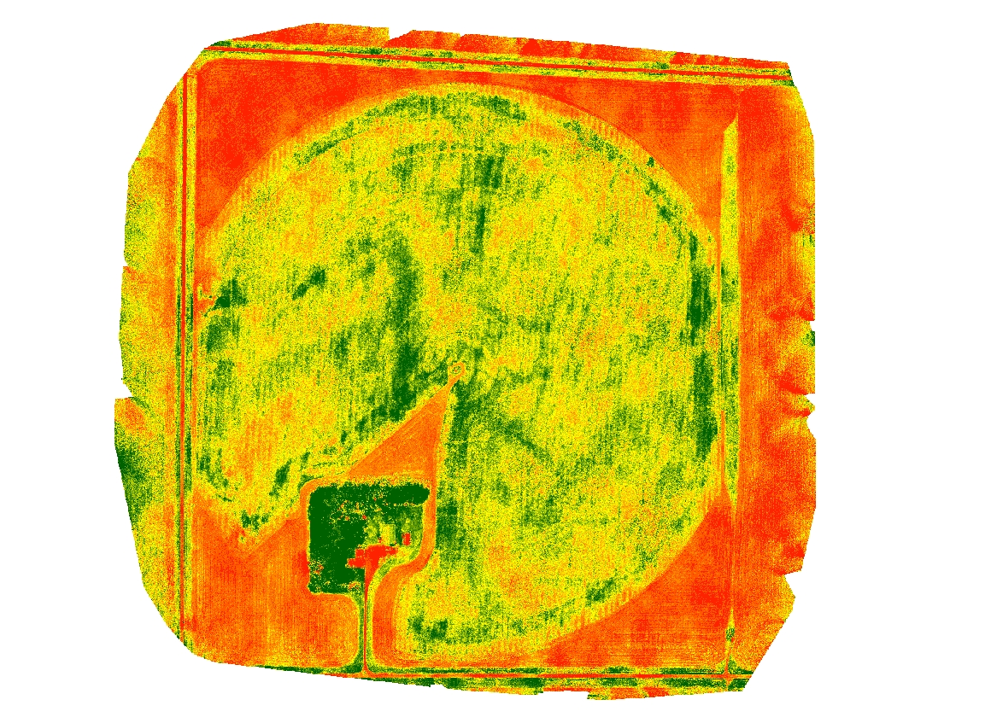
Site 4
Low soil N mid bulking
Low petiole N row closure
Exceptional OM
Low petiole S row closure, mid bulking

Site 1
Interestingly, not the wettest sensor the field (despite proximity to water)
Site 9
Low soil N row closure Exceptional OM
Deficient petiole N row closure
Exceptional weed pressure
Deficient petiole S mid bulking
Wetter part of field

Site 10
Exceptional OM
High weed pressure
Low petiole S row closure, mid bulking

Site 11
Exceptional OM
High weed pressure
Low petiole S row closure, mid bulking
Wetter part of field (6cm), dryer 15cm

Site 12
Very high soil N late bulking
Low petiole N row closure
Deficient petiole S mid bulking

Site 13
Low soil N mid bulking
Low petiole N row closure
Low petiole S mid bulking
Dryer part of field (<1 VWC)

Site 8
Very high Verticillium risk (42 CFU/g, plants showing wilt)
Low soil N row closure, mid bulking
Deficient petiole N row closure
Deficient petiole S mid bulking

Site 6
Low soil N mid bulking
Low petiole S mid bulking
Dryer part of field (<1 VWC)

Site 14
Low soil N mid bulking
Low petiole N row closure
Deficient petiole S mid bulking

Site 7
Site 15
Low soil N mid bulking
Low petiole N row closure
Exceptional OM
Low petiole S mid bulking

Site 5
Very high soil N late bulking
Exceptional OM
Low petiole S row closure
Wetter part of field

Site 2
Low soil N row closure, mid bulking, Low petiole N row closure
Low OM
Site 3
Very high soil N late bulking
Low OM
Low petiole S mid bulking

Field 16

- General Notes:
  - Field generally loamy (8/15 points), remainder is sandy loam
  - Verticillium risk: All points over the 30 CFU threshold, 12/15 points over 100 CFU. High counts and low incidence of wilt likely indicates other species of Verticillium present
  - Most points (6/15) with Very high soil nitrogen at row closure, 3 high
  - High soil phos and potassium and sulfur throughout season
  - Some points had depleted nitrogen by fall (like point 8 being down to 16 lbs), some have very high nitrogen residual (like point 3 having 171 lbs). Thoughts on persistence of nitrogen through the season, how to equalize by the next

- General Notes:
  - Field generally loamy (8/15 points), remainder is sandy loam
  - Verticillium risk: All points over the 30 CFU threshold, 12/15 points over 100 CFU. High counts and low incidence of wilt likely indicates other species of Verticillium present
  - Most points (6/15) with Very high soil nitrogen at row closure, 3 high
  - High soil phos and potassium and sulfur throughout season
  - Some points had depleted nitrogen by fall (like point 8 being down to 16 lbs), some have very high nitrogen residual (like point 3 having 171 lbs). Thoughts on persistence of nitrogen through the season, how to equalize by the next potato rotation?
  - Low salinity in all points
  - In general, compared to others in 2018, this field has less Verticillium, more soil nitrogen, more soil sulfur, more organic matter, higher petiole N, lower petiole sulfur at end of season – making it hard to put together a picture of what this field lacks

- High sulfur is not really considered a problem, but this field had the largest amount of soil sulfur at row closure that we have recorded in Manitoba – points 1 and 3. Any reason why this could be? Thoughts on positive or negative effect?
  - Why would soil sulfur be high but then petiole sulfur was low (such as point 5), why would low petiole sulfur start at mid bulking and not row closure?

- Talk about nitrogen program – hard to keep fuel in the tank with low points becoming more frequent as time went on (granted, end of season want low N)

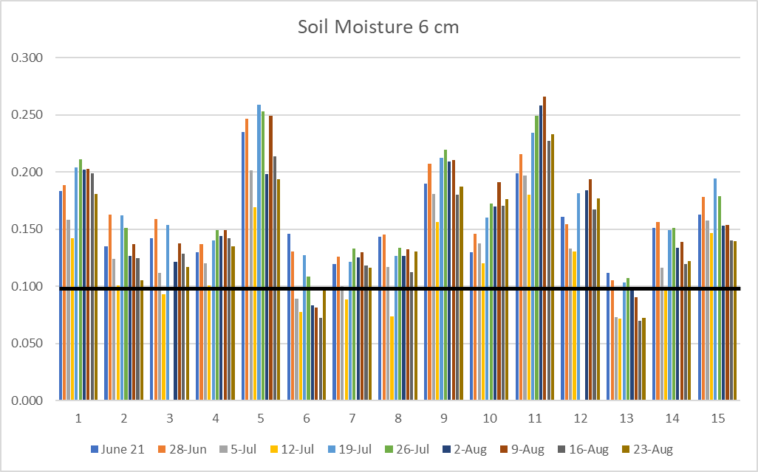

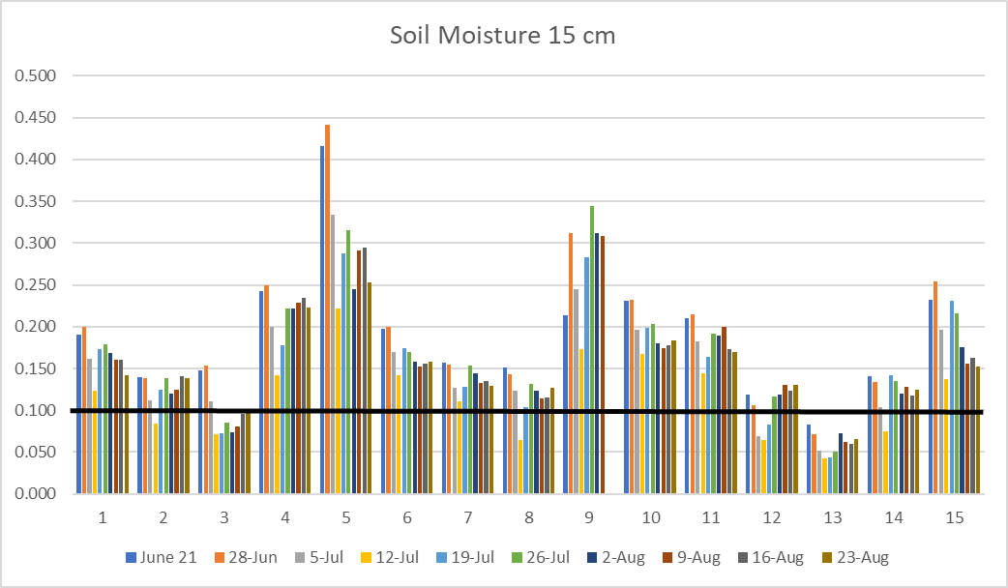

Field 17:
Site 14
Very high Verticillium risk (112 CFU/g)
Low soil N row closure, mid bulking
Low petiole sulfur mid bulking

Field 17
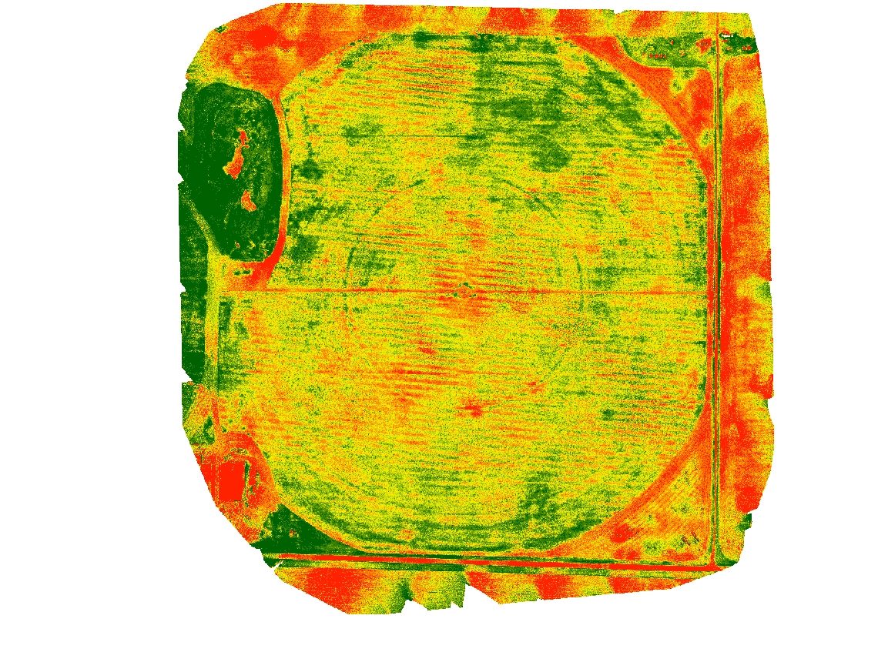
Site 13 – Low OM
Very high Verticillium risk (120 CFU/g, plants showing wilt)
Many plants with black dot
Low soil N row closure, mid bulking
Low petiole S row closure, deficient mid bulking

Site 1 –
Exceedingly high Vert count (262 CFU/g), no wilt, possibility of other Vert spp
Low petiole sulfur mid bulking
Site 7
Very high Verticillium risk (168 CFU/g, plants showing wilt)
Low soil N row closure

Site 9
Low soil N mid bulking
Low petiole S row closure, mid bulking

Site 8
Low soil N row closure, mid bulking
Low petiole S row closure

Site 11
Low soil N row closure, mid bulking
Low petiole sulfur mid bulking

Site 12 – Low OM
Many plants with black dot
Low soil N row closure, mid bulking
Low petiole S row closure, deficient mid bulking

Site 3
Site 6
Burn symptoms in one point of season, pattern artificial
Low soil N mid bulking

Site 4
Very high Verticillium risk (158 CFU/g, plants showing wilt)
Site 2

Site 15
Very high Verticillium risk (138 CFU/g)
Low soil N mid bulking

Site 5
Wettest part of field
Site 10
Low soil N mid bulking
Low petiole sulfur mid bulking

- General Notes:
  - Field generally loamy (10/15 points), remainder is sandy loam, point 9 is sandy clay loam
  - Notes have considerable black dot in field, discuss management
  - Verticillium: All points over the 30 CFU/g threshold, 10/15 over 100 CFU/g
  - Coinfection of black dot and Verticillium presents greater risk for early die problems
  - Nitrogen generally low at row closure
  - High soil phos and potassium and sulfur throughout season, not all points had high petiole phos
  - Not really any excess nitrogen in late season (some fields have problem with too much residual nitrogen at season’s end – prolongs vegetative growth and shortens bulking)
  - Some points had depleted nitrogen by fall (like point 8 being down to 24 lbs), some have very high nitrogen residual (like point 8 having 125 lbs). Thoughts on persistence of nitrogen through the season, how to equalize by the next potato rotation?
  - Field has exceptional levels of organic matter. This is something I have been toying around with improving in some of our sandy fields. What practices/explanations could explain the organic matter in this field?
  - Point 6 is unique in our study for all Manitoba: greater % base saturation (more fertile, buffered from acids) (high pH)
  - Low salinity in all points
  - Petiole Nitrogen low to deficient in all points except 4, 14, 15 – discuss reasons why petioles generally low, why the three exceptions were not low
  - Why would soil sulfur be high but then petiole sulfur was low (such as point 1), why would low petiole sulfur start at mid bulking and not row closure?
  - Low variability in recorded soil moisture (VWC)

- We should cover black dot disease control programs – short term you are getting a crop. What is the long-term plan? Is this an area we could move forward together? If we make long term plan, do we want to see control in 3, 6, or 9 years?

Field 18:
Site 8
Low soil nitrogen at row closure (31 lbs at 0-30 cm)
Low soil OM (2.4%)

Site 1
Low soil nitrogen at row closure (18 lbs at 0-30 cm)
Low soil sulfur at row closure (18 lbs at 0-30 cm), recovers at mid and late bulk
Low pH (6.3)

Field 18
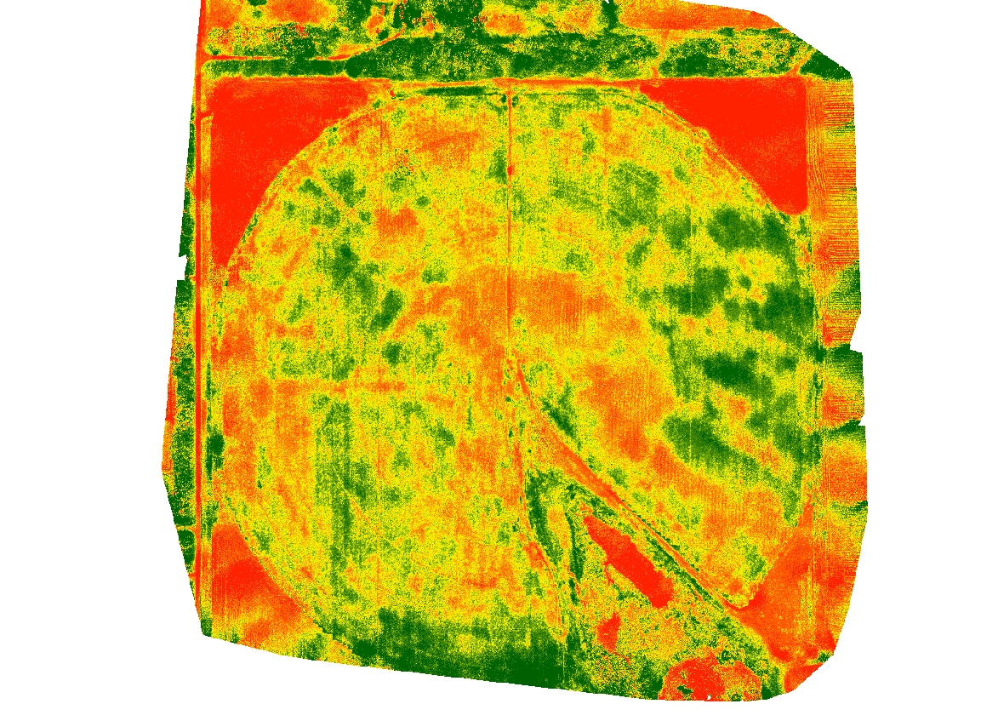
Site 13
Vert 64 CFU/g, plant show wilt symptoms
Low soil nitrogen at row closure (23 lbs at 0-30 cm)
Low soil OM (2.8%)

5
6
4
8
3
2
1
Site 3

Site 4
Low soil nitrogen at row closure (23 lbs at 0-30 cm)

Site 5

Site 11
Vert 176 CFU/g, plant show wilt symptoms
Low soil nitrogen at row closure (22 lbs at 0-30 cm)
Low soil OM (3.2%)

Site 2
Vert 240 CFU/g, plant show wilt symptoms
Low soil nitrogen at row closure (20 lbs at 0-30 cm)
Low OM (1.8%)

Site 7

Site 6
Site 9
Low soil nitrogen at row closure (27 lbs at 0-30 cm)
Low soil OM (2.2%)
Site 10
Vert 252 CFU/g, plant show wilt symptoms

Site 15
Low soil nitrogen at row closure (24 lbs at 0-30 cm)
Site 14
Low soil nitrogen at row closure (27 lbs at 0-30 cm)

Site 12

- General Notes:
  - Field generally sandy (9/15 points sandy loam), odd points out (5, 14) loam
  - Verticillium wilt
    - Exceedingly high CFU count at pts 2, 10, 11
    - 12/15 points over the 30 CFU threshold, 5/15 over 100 CFU
    - Highly variable amount of CFU throughout field, talk about soil moving
    - Risk of verticillium wilt high at pt 1, 10-11, 13
  - Nitrogen strategy – nitrogen program in this field must be reduced compared to others. What are the benchmarks for determining if soil has sufficient nitrogen or not?
    - Plan for spoon-feeding nitrogen throughout the season – benchmarks for mid and late bulk
    - You must have amazing N control because soil is consistently low by provincial benchmarks, but never deficient. Most growers cannot keep soil nitrogen within 4 lbs throughout an entire field, unlike what we observe here
    - Benchmarks for petiole N – field runs low to deficient in all points by Agvise standards. What are your thoughts on these benchmarks?
  - Soil sulfur generally sufficient throughout season
    - Site 1 is only exception
  - Most growers dealing with spots of low organic matter
    - Long-term plans to build organic matter? Interest in research?
  - pH in field runs from 6.3 to 8.4. Is this a cause for concern on-farm?

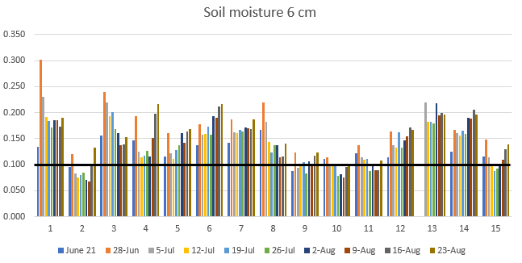

Field 19:
Site 7
Low OM (1.7%)
Deficient petiole N row closure (9097)

Field 19

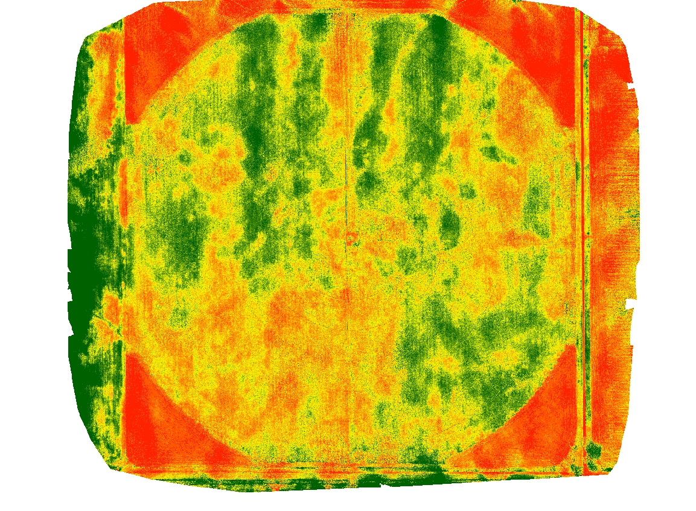
Site 8

Site 13
Vert CFU/g: 150, plants showed wilt symptoms
Deficient petiole N row closure (7257)
Low petiole sulfur (0.16) at row closure

Site 12
Vert CFU/g: 410, plants showed wilt symptoms
Low OM (2.7%)
Deficient petiole N row closure (9156)
Low petiole sulfur (0.15) at row closure

Site 1
0-15cm sand, 15-30 loamy sand
Low OM (2%)
Deficient petiole N row closure (9334)
Low petiole sulfur (0.19) at row closure

15
14
Site 14
Only site that is not over basic threshold of 8 (tests pH 7.9)
Low petiole N row closure (13632)

Site 15
0-30cm sand
Only site under Vert threshold (8 CFU/g)
Low soil N at row closure (34 lbs 0-30cm) – only one in field
Low OM (1.8%)
Deficient petiole N row closure (8147)

9
7
Site 9
Vert CFU/g: 180, plants showed wilt symptoms
Low OM (1.9%)
Low petiole N row closure (10335)

Site 6
Vert CFU/g: 334, plants showed wilt symptoms
Only site with high soil at mid bulking (74 lbs) and late bulking (75 lbs)
Low OM (2.5%)
Low petiole N row closure (12399)
Low petiole sulfur (0.19) at row closure

10
Site 10
Low petiole N row closure (11475)

Site 5
Vert CFU/g: 316, plants showed wilt symptoms
Low petiole N row closure (13169)

Site 4
0-15cm sand, 15-30 loamy sand
Low OM (2.7%)
Low petiole N row closure (12214)
Low petiole sulfur (0.19) at row closure

Site 2
0-15cm sand, 15-30 loamy sand
Low OM (2.5%)

Site 3
Low OM (2%)
Low petiole N row closure (11906)
Site 11
Low OM (2%)
Deficient petiole N row closure (5982)
Low petiole sulfur (0.15) at row closure

- General Notes:
  - Stripes in the northern part of the field – were there once tree lines through field?
    - Southwest – reasons for burning up?
  - Field generally sandy (11/15 points sandy loam), odd points out (2, 15) sand
  - 14/15 points over the 30 CFU threshold, 11/15 over 100 CFU
    - Highly variable amount of CFU throughout field, talk about soil moving
    - High levels of Vert in field, treatment options
  - Row closure nitrogen in soil is normally low, but this field had good nitrogen levels
    - Nitrogen practices on sandy areas – anything special?
    - Drop in soil nitrogen by mid bulking with 9-29 lbs in soil tests
  - Disconnect in soil nitrogen availability and petiole tests
    - Most petiole tests run low side
    - Begins at row closure, continues through bulking with all points low to deficient
  - Soil sulfur test generally always high
    - Petiole sulfur low only in sites with low organic matter (the two are correlated)
    - Thoughts on building organic matter (very long term)
  - pH in this field runs basic, fairly unique in this study. No treatment, soil is naturally basic?
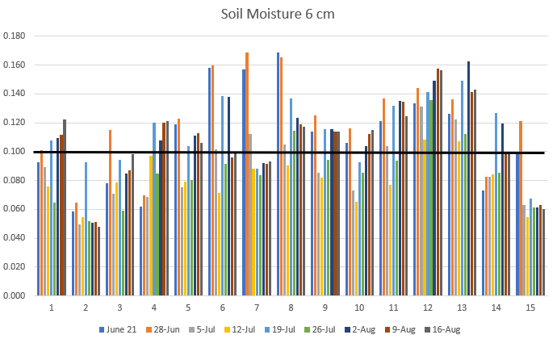

2017 Processing Field Individual Analysis

Field 10: Pictured below (Fig. 12) is a drone image identifying potential limiting factors to the whole field or specific points

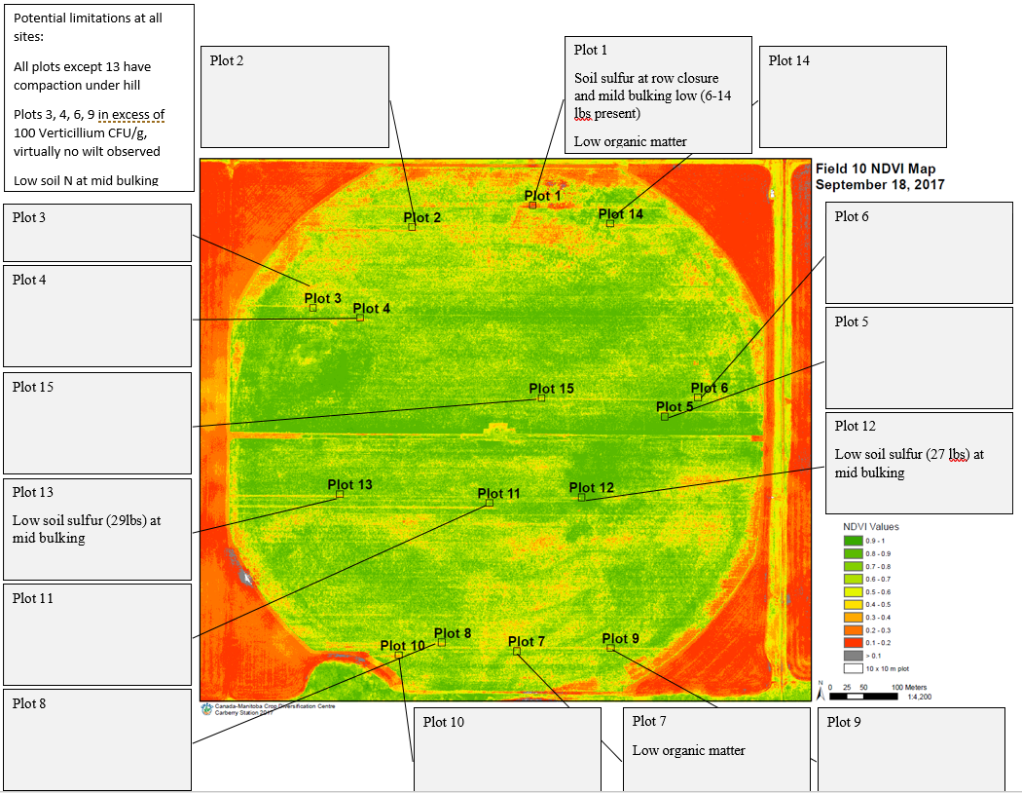

In addition to evaluating the impact of variables on yield of fresh and processing fields together, individual fields from 2017 were rated for nutrient, soil, disease, and plant health status. Drone imagery was used in conjunction with scouting, nutrient status as determined by Agvise recommendations, and yield to visualize variability at each sampling point and what trends were apparent in the overall yield. The point of this individual analysis is to demonstrate the usefulness of the Partial Least Square (PLS) analysis from all processing fields in identifying one or a few major yield-limiting factors from a larger list of potential problems listed for a specific site. This information begins the conversation with a local consultant and grower about priorities in remediating yield variability, and ultimately develop practices to remediate the situation.

Plot numbers in the drone images refer to the 15 sampling points in each field. The top of each image is north in each field, and the color scale refers to the NDVI values recorded by the drone. NDVI was recorded on a scale of 0-1, zero being red and refers to bare earth, 1 refers to green tissue, and varying shades of green to yellow indicate senescencing plant matter. It is important to note that weed canopy color will be recorded as well as potato, although no significant weed pressure was recorded in the sampling points in field 10.

For each individual field, certain variables were identified as potential problems for the whole field or individual collection points that could contribute to variable yield. Field 10 was observed to have compaction under the hill (beneath 30 cm/11.8 in from top of hill) with an excess of 300 PSI. The only sampling point that was not compacted at this layer was plot 13, on the southwestern side of the field. Compaction was not among the top ten most influential variables listed in the complete processing analysis, indicating that it could be a problem on an individual field basis, but not among the worse problems across all processing fields.

Very little Verticillium wilt was recorded in the field, but Verticillium species counts exceeded 100 CFU /g in plots 3, 4, 6, and 9. It is generally accepted that 5-30 CFU/g of V. dahliae are necessary for infection. This plate count will encompass all Verticillium species, which doesn’t accurately rely the number of V. dahliae CFU. Verticillium will likely need to be monitored in the field, but the disease is unlikely to be the cause of variable yield observed this year. The combined processing analysis indicated that the 10-12oz yield category is the size range most negatively impacted by high Vertcillium counts, as severely infected plants are killed or debilitated during late bulking when tubers are sizing in this range. Concern about any drops in 10-12 oz yield should consider the Verticillium counts in future years based on this information.

The main indicators of variable yield, among the variables recorded for the study, in this field are low soil nitrogen and sulfur at mid bulking. Low soil nitrogen was recorded across all collection points at mid bulking, whereas low soil sulfur was a more sporadic problem with no obvious trend. Both sulfur and nitrogen were important nutrients involved in variable yield across all processing fields, with low soil sulfur at mid bulking and soil nitrogen at row closure being associated with lower yielding sampling points. Throughout the study, the lowest yielding points often had multiple potential limiting factors listed in the drone image like Fig. 12. Some of these limiting factors are inter-related, such as sand texture and nitrogen leaching. In the case of field 10, only point one had four potential factors. It is extremely likely that the combined effects of multiple problems contribute to yield limitation greater when combined than each factor individually.

Fig 13. (Above) is another method of viewing the drone image from three drone flights at once. Each line represents an individual flight, and each flight date is on the bottom. The 1-15 on the bottom (X-axis) refers to each of the 15 sampling points. The scale on the Y-axis on the left refers to the same 0-1 NDVI scale as in Fig. 13 where zero is a dead plant and one is a perfectly green plant. The flights selected only show the beginning and end of the season. The scale is lower in June as some places have yet to close, and by July (not shown) the scale is at one across all points. As the line moves across the collection points, some trends in the greener (higher NDVI) points are apparent as opposed to the browner (lower NDVI) points. In June (blue line), the lowest points are 2, 6, and 14. Points 8 and 10 were noticeably greener than most other points as of June. By September points 1 and 10 are becoming browner, while points 5 and 12 are the greenest. Point 1 where there were five potential yield limiting factors, which was the greatest number of potential problems recorded in the field. Point 1 is also the numerically greatest decrease in the NVDI value (greenness) between the start and end of September. It is possible that drone images can identify problem areas after the season is over if viewed in the manner. This ability is only of limited use to a grower or consultant who wants to identify a problem while corrective action can still be taken. In the case of this field, no clear trend was apparent in June or July to identify which point would see the greatest decrease in NDVI as September progressed. This wasn’t the case for other fields in the study, where collection points with many factors associated with yield limitations were present and the point had noticeably lower NDVI as of June. In these fields, the NDVI recovered to 1 as of July, but the same pattern of decreased NDVI returned in August and became more pronounced throughout September. In these cases, a drone flight in June may identify areas where the canopy will die prematurely in August with a NDVI value that is already low in June, but the level of greenness is not discernable to the human eye on the ground. The fact that this June prescription would not have been accurate with field 10 indicates that this advice must be taken on an individual field basis based on the understanding the grower and consultant have of the situation. This interesting observation will absolutely be the subject of more study in the variability project.

Fig. 14 (above) shows the total yield (after rot and green tubers removed) by size category. Each color represents a specific tuber size profile. For example, yellow bars near the top indicate the 10-11.9 oz tuber size. The yield is measured in hundredweight per acre (Cwt/A) on the right side, and the harvest date was the first week in September.
The lowest yielding sampling point numerically was point 12. In Fig. 12, this place in the field was noted as having compaction, low soil sulfur and nitrogen at mid bulking. In Fig. 13, this point didn’t have much of a numerical drop in NDVI value throughout September. It is possible that the underlying causes of this low yield didn’t kill the plant or enhance early die based on the drone results. In examining figure 14, it appears that the 3-6 oz and 6-10 oz are notably less than most other collection points. In the combined analysis for all processing fields, high soil sulfur at mid bulking was associated with yield limitation for 3-6 oz and 6-10 oz. It is quite possible that low soil sulfur also has a pronounced effect on these size categories based on observations from this field, although not tested by the analysis. Soil nitrogen was also important negative yield impact in the 6-10 oz size category, although it was excess soil nitrogen at row closure associated with less 6-10 oz tubers. In this field, it appears that less soil nitrogen at bulking also contributed to lower yield. The exact effects of sulfur and nitrogen individually on yield are not able to be separated based on observation or association with the partial least squares regression employed for all processing fields.

A final observation of note in field 10 is the high yielding sampling point was number seven, which was located in the south-central part of the field. This collection point had one of the largest yields with numerically greater 10-12 oz tubers and >12 oz tubers. What is notable aside from yield is that this point was not the greenest point in the drone flights and was limited by soil nitrogen at mid bulking, compaction, and low organic matter. This point was not limited by sulfur. It is possible that a factor outside of the study was part of the final yield, but the combination of nutrient limitations is interesting in terms of studying the effect of sulfur availability on yield remediation as a practice that can be altered by grower practice to increase 10-12 oz yield.

Field 11: Pictured below (Fig. 15) is a drone image identifying potential limiting factors to the whole field or specific points
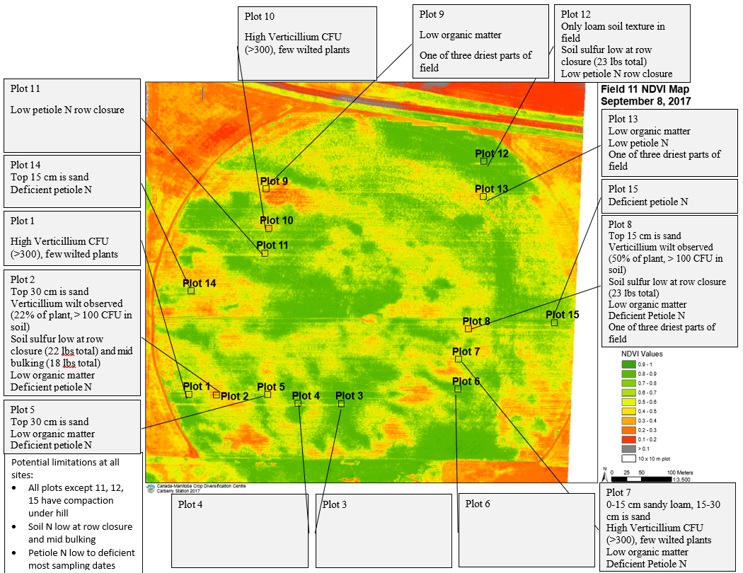
In addition to evaluating the impact of variables on yield of fresh and processing fields together, individual fields from 2017 were rated for nutrient, soil, disease, and plant health status. Drone imagery was used in conjunction with scouting, nutrient status as determined by Agvise recommendations, and yield to visualize variability at each sampling point and what trends were apparent in the overall yield. The point of this individual analysis is to demonstrate the usefulness of the Partial Least Square (PLS) analysis from all processing fields in identifying one or a few major yield-limiting factors from a larger list of potential problems listed for a specific site. This information begins the conversation with a local consultant and grower about priorities in remediating yield variability, and ultimately develop practices to remediate the situation.

Plot numbers in the drone images refer to the 15 sampling points in each field. The top of each image is north in each field, and the color scale refers to the NDVI values recorded by the drone. NDVI was recorded on a scale of 0-1, zero being red and refers to bare earth, 1 refers to green tissue, and varying shades of green to yellow indicate senescencing plant matter. It is important to note that weed canopy color will be recorded as well as potato, although no significant weed pressure was recorded in the sampling points in field 11.

For each individual field, certain variables were identified as potential problems for the whole field or individual collection points that could contribute to variable yield. Field 11 was observed to have compaction under the hill (beneath 30 cm/11.8 in from top of hill) with an excess of 300 PSI. Compaction was not among the top ten most influential variables listed in the complete processing analysis, indicating that it could be a problem on an individual field basis, but not among the worse problems across all processing fields.

Very little Verticillium wilt was recorded in the field, with the most disease observed on the south side of the field in points 1, 2, 7, and 8. Verticillium species counts exceeded 100 CFU /g in most points and >300 in points 1, 2, 7, and 10. It is generally accepted that 5-30 CFU/g of V. dahliae are necessary for infection. This plate count will encompass all Verticillium species, which doesn’t accurately rely the number of V. dahliae CFU. Verticillium wilt will need to be monitored in the field and it could be a factor in variable yield. The combined processing analysis indicated that the 10-12oz yield category is the size range most negatively impacted by high Vertcillium counts, as severely infected plants are killed or debilitated during late bulking when tubers are sizing in this range. Concern about any drops in 10-12 oz yield should consider the Verticillium counts in future years based on this information.

The main indicators of variable yield, among the variables recorded for the study, in this field are low soil nitrogen and sulfur in petioles and soil throughout the production season. Low soil nitrogen was recorded across all collection points at row closure and mid bulking, whereas low soil sulfur was a more sporadic problem with no obvious trend. Both sulfur and nitrogen were important nutrients involved in variable yield across all processing fields, and lower yield was associated with lower nitrogen or sulfur. In this case, the deficiency of petiole nitrate stands out as one of the largest issues. Petiole nitrate was low at row closure, while soil nitrogen was depleted. Petiole nitrate moved into deficiency at mid bulking.

Throughout the study, the lowest yielding points often had multiple potential limiting factors listed in the drone image like Fig. 12. Some of these limiting factors are inter-related, such as sand texture and nitrogen leaching. In the case of field 11, some sampling points like plot 15 had ten potential yield-limiting factors. It is extremely likely that the combined effects of multiple problems contribute to yield limitation greater when combined than each factor individually.

Fig 16. (Above) is another method of viewing the drone image from three drone flights at once. Each line represents an individual flight, and each flight date is on the bottom. The 1-15 on the bottom (X-axis) refers to each of the 15 sampling points. The scale on the Y-axis on the left refers to the same 0-1 NDVI scale as in Fig. 15 where zero is a dead plant and one is a perfectly green plant. The flights selected only show the beginning and end of the season. The scale is lower in June as some places have yet to close, and by July (not shown) the scale is at one across all points. As the line moves across the collection points, some trends in the greener (higher NDVI) points are apparent as opposed to the browner (lower NDVI) points. In June (blue line), the lowest points are 2, 5, 7, and 15. Points 3 and 10 were noticeably greener than most other points as of June. By September points 2, 8-10, and 13 are becoming browner, while points 3, 6, and 12 are the greenest. In the case of this field, no clear trend was apparent in June or July to identify which point would see the greatest decrease in NDVI as September progressed. Sampling points 2, 5, 7, 8, 12, and 13 had multiple yield-limiting factors observed throughout the production season in Fig. 15. These sampling points with many factors associated with yield limitations were present and the point had noticeably lower NDVI as of June. In these fields, the NDVI recovered to 1 as of July, but the same pattern of decreased NDVI returned in August and became more pronounced into September. In these cases, a drone flight in June may identify areas where the canopy will die prematurely in August with a NDVI value that is already low in June, but the level of greenness is not necessarily discernable to the human eye on the ground. This interesting observation will absolutely be the subject of more study in the variability project.

Fig. 17 (above) shows the total yield (after rot and green tubers removed) by size category. Each color represents a specific tuber size profile. For example, yellow bars near the top indicate the 10-11.9 oz tuber size. The yield is measured in hundredweight per acre (Cwt/A) on the right side, and the harvest date was the first week in September.

Despite the number of yield-limiting problems identified in previous sections, as well as the die down on drone images, it is not easy to numerically identify the lowest yielding sampling points in the field. The composition of 10-12 oz and >12 oz fluctuates point to point. The combined analysis of all processing fields identified Verticillium as the number one negative yield association for 10-12 oz tubers. More plainly, as soil Verticillium counts rise, the number of 10-12 oz tubers generally decreases. Points 1, 2, 7, and 10 had the greatest Verticillium counts, and fewer 10-12 and > 12 oz tubers. Points 8 and 9 also had fewer 10-12 and > 12 oz tubers, indicating more than Verticillium needs to be considered. Points 8 and 9 also had low organic matter and soil moisture throughout the season, in addition to the nitrogen problems outlined earlier. These factors could contribute to the fewer 10-12 and > 12 oz tubers.
It is relatively easier to look at Fig. 14 and identify point 15 as the numerically greatest yield. It appears that there were many > 12 oz tubers in this point in the far east of the field. The list of potential problems is also shorter at point 15, and only includes the nitrogen problems previously mentioned. The combined analysis of all processing fields associates more >12 oz yield with less soil nitrogen at row closure and more soil sulfur at row closure. The nitrogen problems at this point could have been of benefit in not providing excess nitrogen, and the availability of sulfur could have improved the >12 oz yield in this point. However, field notes indicate the entire field was recently extended eastward. This sampling point is likely to have a different cropping history than the remainder of the field that was not included in this study that could contribute to the >12 oz yield.

Field 12 Pictured below (Fig. 18) is a drone image identifying potential limiting factors to the whole field or specific points
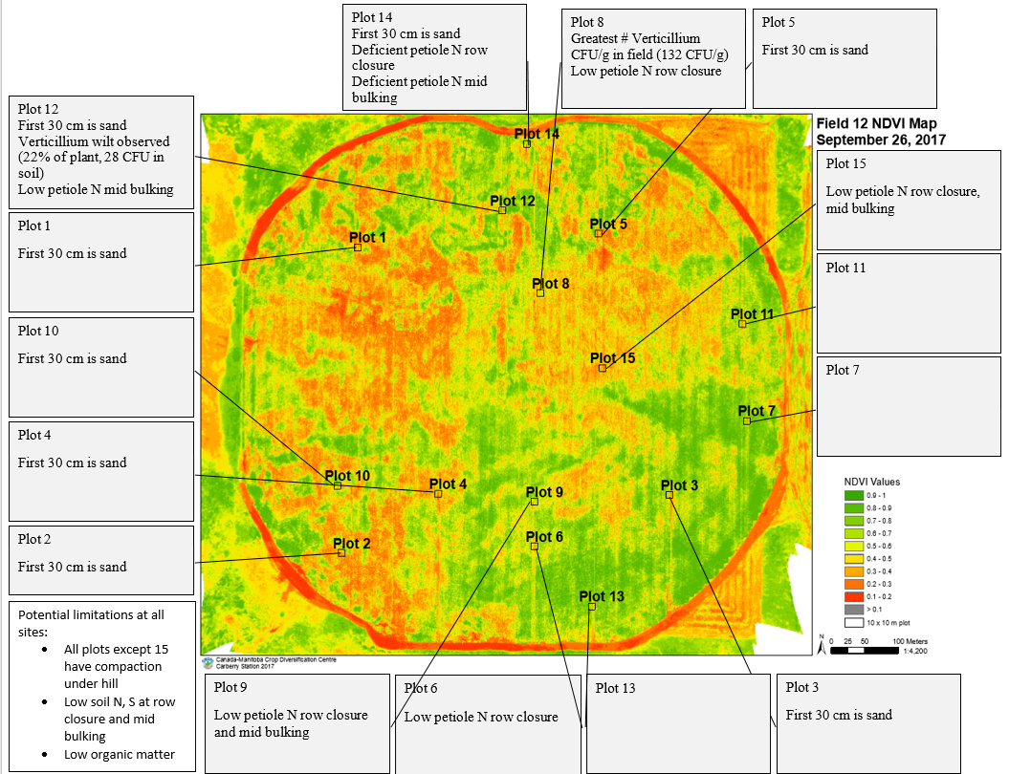
In addition to evaluating the impact of variables on yield of fresh and processing fields together, individual fields from 2017 were rated for nutrient, soil, disease, and plant health status. Drone imagery was used in conjunction with scouting, nutrient status as determined by Agvise recommendations, and yield to visualize variability at each sampling point and what trends were apparent in the overall yield. The point of this individual analysis is to demonstrate the usefulness of the Partial Least Square (PLS) analysis from all processing fields in identifying one or a few major yield-limiting factors from a larger list of potential problems listed for a specific site. This information begins the conversation with a local consultant and grower about priorities in remediating yield variability, and ultimately develop practices to remediate the situation.

Plot numbers in the drone images refer to the 15 sampling points in each field. The top of each image is north in each field, and the color scale refers to the NDVI values recorded by the drone. NDVI was recorded on a scale of 0-1, zero being red and refers to bare earth, 1 refers to green tissue, and varying shades of green to yellow indicate senescencing plant matter. It is important to note that weed canopy color will be recorded as well as potato, and all points in the northern half of the field were noted to have eastern black nightshade.

For each individual field, certain variables were identified as potential problems for the whole field or individual collection points that could contribute to variable yield. Field 12 was observed to have compaction under the hill (beneath 30 cm/11.8 in from top of hill) with an excess of 300 PSI. Compaction was not among the top ten most influential variables listed in the complete processing analysis, indicating that it could be a problem on an individual field basis, but not among the worse problems across all processing fields.

Very little Verticillium wilt was recorded in the field, with the most disease observed on the south side of the field in point 8. Verticillium species counts exceeded 100 CFU /g in plot 8. Wilt was only observed in plot 12, which had a low (28 CFU) count. It is generally accepted that 5-30 CFU/g of V. dahliae are necessary for infection. This plate count will encompass all Verticillium species, which doesn’t accurately rely the number of V. dahliae CFU. Verticillium wilt will need to be monitored in the field and it could be a factor in variable yield. The combined processing analysis indicated that the 10-12 oz yield category is the size range most negatively impacted by high Verticillium counts, as severely infected plants are killed or debilitated during late bulking when tubers are sizing in this range. Concern about any drops in 10-12 oz yield should consider the Verticillium counts in future years based on this information. Eastern black nightshade was noted as a problem in most collection points on the north side of the field. There is a known interaction with Verticillium and nightshade where nightshade is not only a host, but also trains the Verticillium to be aggressive on potato. As the Verticillium becomes aggressive to potato, lower counts are necessary to induce higher levels of disease. Nightshade control then becomes another factor to keep in mind for this specific field but will be overlooked by the total analysis of combined processing fields because nightshade wasn’t present in all fields.

The main indicators of variable yield, among the variables recorded for the study, in this field are low soil nitrogen and sulfur in petioles and soil at row closure and mid bulking. Both sulfur and nitrogen were important nutrients involved in variable yield across all processing fields, and lower yield was associated with lower nitrogen or sulfur.

Throughout the study, the lowest yielding points often had multiple potential limiting factors listed in the drone image. Some of these limiting factors are inter-related, such as sand texture and nitrogen leaching. In the case of field 12, some sampling points like plot 14 had ten potential yield-limiting factors. It is extremely likely that the combined effects of multiple problems contribute to yield limitation greater when combined than each factor individually.

Fig 19. (Above) is another method of viewing the drone image from three drone flights at once. Each line represents an individual flight, and each flight date is on the bottom. The 1-15 on the bottom (X-axis) refers to each of the 15 sampling points. The scale on the Y-axis on the left refers to the same 0-1 NDVI scale as in Fig. 15 where zero is a dead plant and one is a perfectly green plant. The flights selected only show the beginning and end of the season. As the line moves across the collection points, some trends in the greener (higher NDVI) points are apparent as opposed to the browner (lower NDVI) points. In some fields in 2017, the line between collection points was similar in June as it was in September, indicating we can see the weaker sampling points via drone flight months before early die sets in. Your field is a counter example where the lowest (less green) sampling point in June (plot 2) was not the lowest point in September. Additionally, plot 14 had numerous yield-limiting factors associated with it and yet was one of the greenest points. More research would be necessary to develop the June drone image as a predictive tool for early die.

Fig. 20 (above) shows the total yield (after rot and green tubers removed) by size category. Each color represents a specific tuber size profile. For example, yellow bars near the top indicate the 10-11.9 oz tuber size. The yield is measured in hundredweight per acre (Cwt/A) on the right side, and the harvest date was the first week in September.

Despite the number of yield-limiting problems identified in previous sections, as well as the die down on drone images, it is not easy to numerically identify the lowest yielding sampling points in the field. Without statistics, it appears that point 14 is has the lowest total yield and all size categories are less than the remaining points. Plot 14 had six possible yield-limiting factors identified though soil and petiole samples for the project. Plot 14 also had many Eastern Black Nightshade plants that could reduce yield. The highest yielding points (numerically) were sites 10 and 13, which had few to no potential yield-limiting factors identified.

Field 13 Pictured below (Fig. 21) is a drone image identifying potential limiting factors to the whole field or specific points
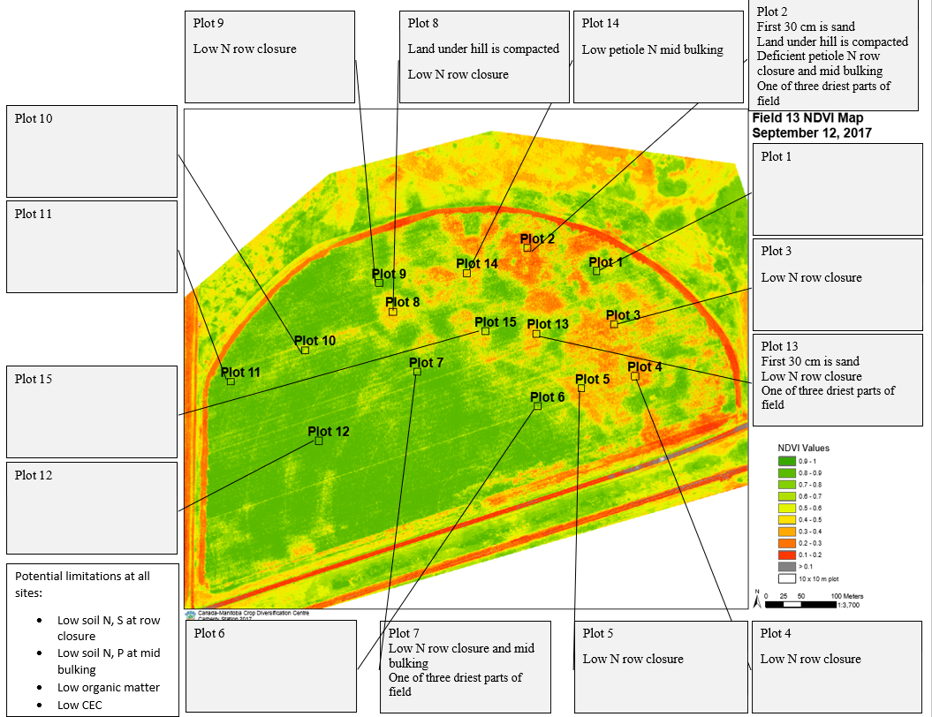

In addition to evaluating the impact of variables on yield of fresh and processing fields together, individual fields from 2017 were rated for nutrient, soil, disease, and plant health status. Drone imagery was used in conjunction with scouting, nutrient status as determined by Agvise recommendations, and yield to visualize variability at each sampling point and what trends were apparent in the overall yield. The point of this individual analysis is to demonstrate the usefulness of the Partial Least Square (PLS) analysis from all processing fields in identifying one or a few major yield-limiting factors from a larger list of potential problems listed for a specific site. This information begins the conversation with a local consultant and grower about priorities in remediating yield variability, and ultimately develop practices to remediate the situation.

Plot numbers in the drone images refer to the 15 sampling points in each field. The top of each image is north in each field, and the color scale refers to the NDVI values recorded by the drone. NDVI was recorded on a scale of 0-1, zero being red and refers to bare earth, 1 refers to green tissue, and varying shades of green to yellow indicate senescencing plant matter. It is important to note that weed canopy color will be recorded as well as potato, and all points in the northern half of the field were noted to have eastern black nightshade.

For each individual field, certain variables were identified as potential problems for the whole field or individual collection points that could contribute to variable yield. Field 13 was generally sandy loam, but only two points of 2 and 13 had sand texture. Sand points were generally the driest points in the field. Little Verticillium and few points of compaction were observed, which is unusual for this experiment. Chlorosis unlikely to be Verticillium wilt as most points were under 30 CFU/g, which is theoretically capable of causing disease but not often observed in the field.

The main indicators of variable yield, among the variables recorded for the study, in this field are low soil nitrogen and sulfur in petioles and soil at row closure and mid bulking. Both sulfur and nitrogen were important nutrients involved in variable yield across all processing fields, and lower yield was associated with lower nitrogen or sulfur.

Throughout the study, the lowest yielding points often had multiple potential limiting factors listed in the drone image. Some of these limiting factors are inter-related, such as sand texture and nitrogen leaching. In the case of field 13, some sampling points like plot 2 had six potential yield-limiting factors. It is extremely likely that the combined effects of multiple problems contribute to yield limitation greater when combined than each factor individually.

Fig 22. (Above) is another method of viewing the drone image from three drone flights at once. Each line represents an individual flight, and each flight date is on the bottom. The 1-15 on the bottom (X-axis) refers to each of the 15 sampling points. The scale on the Y-axis on the left refers to the same 0-1 NDVI scale as in Fig. 15 where zero is a dead plant and one is a perfectly green plant. The flights selected only show the beginning and end of the season. The scale is lower in June as some places have yet to close, and by July (not shown) the scale is at one across all points. As the line moves across the collection points, some trends in the greener (higher NDVI) points are apparent as opposed to the browner (lower NDVI) points. In some fields in the experiment, the line and trends are similar between June (blue) and September (orange and grey).

Fig. 22 (above) shows the total yield (after rot and green tubers removed) by size category. Each color represents a specific tuber size profile. For example, yellow bars near the top indicate the 10-11.9 oz tuber size. The yield is measured in hundredweight per acre (Cwt/A) on the right side, and the harvest date was the first week in September.

Despite the number of yield-limiting problems identified in previous sections, as well as the die down on drone images, it is not easy to statistically identify the lowest yielding sampling points in the field. Without statistics, it appears that point 13 is the lowest total yield and all size categories are less than the remaining points. Plot 13 had seven possible yield-limiting factors identified though soil and petiole samples for the project. The highest yielding points (numerically) were sites 9 and 12, which had few to no potential yield-limiting factors identified.

Fresh Market Fields

Total Yield Using one model for all response variables
A 4-component model containing 21 variables explained 96% of the variability in fresh market total yield (Table 10).

Listed above (Fig. 23) are the top ten most influential positive and negative variables on total yield of two ‘Red Norland’ fresh market fields evaluated in 2017. The X axis (bottom) identifies the variable recorded, whether it was from the soil or petioles, and the time of year it was collected. Nutrients were generally recorded as lbs available to the plant in soil and PPM in petioles, as determined by Agvise testing. The Y axis identifies the Variable of Importance in Projection (VIP) in the creation of the model predicting total yield. Greater positive VIP (above zero) indicates that variable has a bigger, positive association with yield. In other words, a bigger VIP indicates that greater total yield from sampling points was associated with the increasing amount of this nutrient in the soil or petiole. Lower, negative VIPs (below zero) indicates that variable has a bigger negative association with yield. As the VIP drops, the increasing or decreasing amount of that nutrient is associated with the lowest yielding sampling points. The exact relationship between a negative VIP and too much or too little of nutrient must be determined by a resource such as Agvise recommendations or the Manitoba Soil Fertility guide (https://www.gov.mb.ca/agriculture/crops/soil-fertility/soil-fertility-guide/), which is designed for ‘Russet Burbank’. It is important to note that 15-25 variables were associated with yield for all tuber size categories and total yield, but only the top ten were reported here for simplicity.
Soil nitrogen, sulfur, and phosphorus at several growth stages are associated positively with total yield. Translated plainly, the higher ranges of those three nutrients were associated with our highest-yielding points. Soil nitrogen at late bulking varied from 3.5 – 25.0 lbs available at late bulking. Soil sulfur at late bulking ranged from 0-88 lbs. Soil phosphorus varied in the fall from 12-46 PPM and 10-49 PPM at mid bulking. As the VIP increases, the positive effect on yield also increases. For example, the positive effect of more soil nitrogen at late bulking is greater than soil sulfur at late bulking. Each of these results is an association based on field conditions, which is worthy of note, but requires field validation before experimentally-validated recommendations to remediate nutrient deficiencies can be reliably issued.
On the negative side of the equation, soil nitrogen at row closure was a negative yield association. Soil nitrogen at row closure ranged from 10.5 to 117.5 lbs N available, with more sampling points being low-to-deficient rather than in excess of the needed nitrogen. It is possible that too little nitrogen at row closure is what is responsible for the negative yield association. The same situation is observed with soil potassium and sulfur negative yield associations – too little of that nutrient is likely the root cause of the negative yield association.

2 to 2.25-inch diameter category
The 2-component model containing 19 variables explained 41% of the variability in the percentage of yield in the fresh market 2-2.25-inch diameter category (Table 11).

Listed above (Fig. 24) are the top ten most influential positive and negative variables on total yield of two ‘Red Norland’ fresh market fields evaluated in 2017. The X axis (bottom) identifies the variable recorded, whether it was from the soil or petioles, and the time of year it was collected. Nutrients were generally recorded as lbs available to the plant in soil and PPM in petioles, as determined by Agvise testing. The Y axis identifies the Variable of Importance in Projection (VIP) in the creation of the model predicting total yield. Greater positive VIP (above zero) indicates that variable has a bigger, positive association with yield. In other words, a bigger VIP indicates that greater total yield from sampling points was associated with the increasing amount of this nutrient in the soil or petiole. Lower, negative VIPs (below zero) indicates that variable has a bigger negative association with yield.
Soil nitrogen and sulfur at several growth stages are associated positively with total yield. Translated plainly, the higher ranges of those nutrients were associated with our highest-yielding points. Soil nitrogen at row closure ranged from 10.5 to 117.5 lbs N available, with more sampling points being low-to-deficient rather than in excess of the needed nitrogen. Soil sulfur varied from 0-120 lbs available in the soil throughout the sampling date from row closure to fall soil sampling (postharvest), which would range from deficient to very high for ‘Russet Burbanks’. The positive yield association points to the higher ranges (40-60 lbs were common high observations in the experiment) as the likely yield-benefitting range, but field experimentation is needed to identify this exact range and the best practices to get there. This is especially important given our range of quality was determined for another cultivar other than ‘Red Norland’. The negative yield associations for sulfur and potassium likely originate from soil samples deficient in these nutrients.

2.25 to 3.0-inch diameter category
The 2-component model containing 17 variables explained 52% of the variability in the percentage of yield in the fresh market 2.25 to 3.0-inch diameter category (Table 12).

Listed above (Fig. 25) are the top ten most influential positive and negative variables on total yield of two ‘Red Norland’ fresh market fields evaluated in 2017. The X axis (bottom) identifies the variable recorded, whether it was from the soil or petioles, and the time of year it was collected. Nutrients were generally recorded as lbs available to the plant in soil and PPM in petioles, as determined by Agvise testing. The Y axis identifies the Variable of Importance in Projection (VIP) in the creation of the model predicting total yield. Greater positive VIP (above zero) indicates that variable has a bigger, positive association with yield. In other words, a bigger VIP indicates that greater total yield from sampling points was associated with the increasing amount of this nutrient in the soil or petiole. Lower, negative VIPs (below zero) indicates that variable has a bigger negative association with yield.
These results are unusual in that this is the only size category in the whole experiment, fresh market or processing, where the top 10 most influential variables were all negative. Based on previous results with nitrogen, potassium, and sulfur in the soil, low to deficient soil status is a likely culprit for the negative yield association.

3.0 to 3.5-inch diameter category
The 2-component model containing 22 variables explained 78% of the variability in the percentage of yield in the fresh market 3.0 to 3.5-inch diameter category.

Listed above (Fig. 26) are the top ten most influential positive and negative variables on total yield of two ‘Red Norland’ fresh market fields evaluated in 2017. The X axis (bottom) identifies the variable recorded, whether it was from the soil or petioles, and the time of year it was collected. Nutrients were generally recorded as lbs available to the plant in soil and PPM in petioles, as determined by Agvise testing. The Y axis identifies the Variable of Importance in Projection (VIP) in the creation of the model predicting total yield. Greater positive VIP (above zero) indicates that variable has a bigger, positive association with yield. In other words, a bigger VIP indicates that greater total yield from sampling points was associated with the increasing amount of this nutrient in the soil or petiole. Lower, negative VIPs (below zero) indicates that variable has a bigger negative association with yield.

The interpretation of these results is that higher ranges of soil sulfur and nitrogen at several growth stages have positive yield associations with these larger tubers. Interestingly, the soil sulfur at mid bulking has the strongest, positive yield association of all the growth stages. This is very consistent with previous results for smaller diameter tubers and even total yield. Consistency is important in evaluating the quality of the results of any study, this one included. Based on previous results with potassium in the soil, low to deficient soil status is a likely culprit for the negative yield association.

2017 Fresh Market Field Individual Analysis

Field 14
The total yield for field 14 (Fig. 27, below) is shown. Offhand, there appears to be more variability in total yield for these fresh market fields planted to ‘Red Norland’, but less variability within the tuber size profiles on the lower end (2.25 inches and under). However, this comparison is not one that can be subject to statistics due to differences in market class, location, and cultivar differences between the fresh market and processing fields included in the experiment. It is important to note that sampling points 2, 6, and 10 had numerically higher numbers of misshapen tubers than the other points (all over 1 lb of the harvested potatoes). Sampling points 9, 12 and 15 had the only russeting recorded in the experiment with 0.3, 1.78, and 0.64 lbs, respectively. Most of the yield variability came from 2.25-3.0 in. diameter tubers and 3.0-3.5 in tubers. No tubers were harvested that were in excess of 3.5 inches.

Fig. 27 Total yield of field 14 (‘Red Norland’) in lbs for each of the 15 sampling points. The colors denote the lbs of each size category recorded in the one 10-meter harvest row of each sampling point.
The following page will have a bare earth drone image from the start of the season of field 14 (Fig. 28). The image identifies where the 15 sampling points were placed in the field and list potential yield-limiting variables. It is important to note that the recommendations were for ‘Russet Burbank’, and differences will exist between the needs of different cultivars destined for different market classes.
The Verticillium counts are particularly noteworthy for this field in that points 8, 10, 11, and 13 had counts in excess of 100 CFU/g soil (CFU colony forming units – a measure determined by growth on a petri plate. This is important because dead or growth-inhibited colony forming units are of no threat). This result is peculiar in that these sampling points because they were also some of the highest yielding (Fig. 27). Verticillium wilt generally reduced the larger (10-12 oz) tubers from ‘Russet Burbank’, thereby reducing the total yield and value of a sampling point. There is no obvious answer why that did not happen here. It is generally accepted that 5-30 CFU of Verticillium dahliae are necessary to infect most Verticillium wilt-susceptible russet varieties. The counts provided on this analysis do not reliably differentiate between Verticillium species, implying that high counts are likely a mixture of species. However, the probability of exceeding the 5-30 CFU of V. dahliae is greater when the total Verticillium species count is in excess of 100 or 200. While the effect of Verticillium wilt may not be discernable for subsequent potato rotations, these areas of the field with high counts risk Verticillium wilt-related economic loss in the long term if no form of management is ever enacted. Verticillium is the kind of problem that builds with time, especially on the scale of decades. As the problem can take a long time to build, it may be possible to enact small management changes that also work over the long scale at which Verticillium is operating on.
The lowest yielding sampling points in this field, such as points 5, 7, 9, 12, and 15, were recorded as low to deficient petiole N at mid bulking. Granted, the scale of low to deficient was set for ‘Russet Burbank’, not ‘Red Norland’. However, Burbank yield of larger (10-12 oz tubers) and total yield decreased when nitrogen deficiencies were noted in the petiole or soil. It is possible that the shortage of N contributed to the lack of yield. It is also not impossible that another factor outside of the variables recorded in the experiment also contributed to the lack of yield at these sampling points. This information would have to be combined with the grower and consultants experience with this specific field in order to clarify if other explanations could exist for this specific field, but not both fresh market fields included in this experiment.
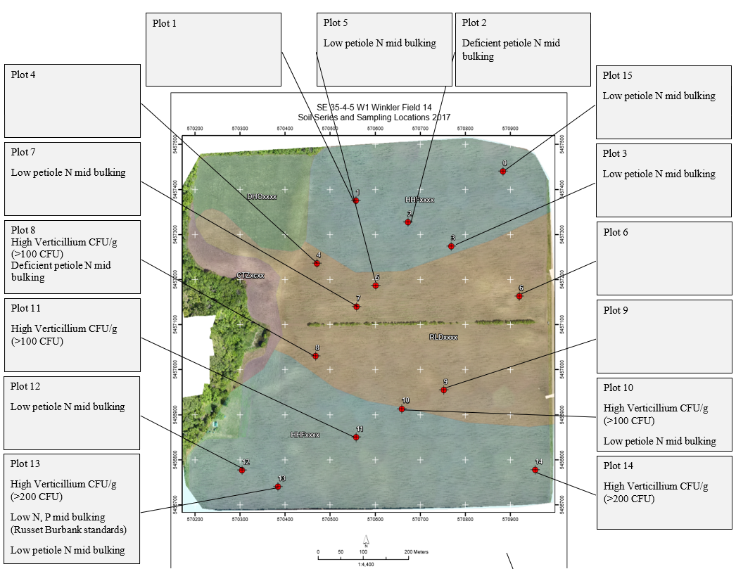
Fig. 24

Field 15
The total yield for field 14 (Fig. 29, below) is shown. Offhand, there appears to be more variability in total yield for these fresh market fields planted to ‘Red Norland’, but less variability within the tuber size profiles on the lower end (2.25 inches and under). Most of the yield variability came from the 2.25-3.0 in size category. However, this comparison is not one that can be subject to statistics due to differences in market class, location, and cultivar differences between the fresh market and processing fields included in the experiment. It is important to note that every sampling point had between 1-3 lbs of misshapen tubers and 12-33 lbs of tubers with enlarged lenticels. Only sampling point 2 had >1 lb of tubers with cracks.

Fig. 29 Total yield of field 14 (‘Red Norland’) in lbs for each of the 15 sampling points. The colors denote the lbs of each size category recorded in the one 10-meter harvest row of each sampling point.
The following page will have a drone image from the start of the season of field 15 (Fig. 30). This image shows the location of the 15 sampling points used in the experiment. The box leading to each sampling point shows the potential yield-limiting variables at each site.
The Verticillium counts are particularly noteworthy for this field in that most sampling points had counts in excess of 100 CFU/g soil (CFU colony forming units – a measure determined by growth on a petri plate. This is important because dead or growth-inhibited colony forming units are of no threat). Verticillium wilt generally reduced the larger (10-12 oz) tubers from ‘Russet Burbank’, thereby reducing the total yield and value of a sampling point. It is possible that one explanation for the lack of 3.0 in or greater diameter tubers is the prevalence of Verticllium in the field. It is generally accepted that 5-30 CFU of Verticillium dahliae are necessary to infect most Verticillium wilt-susceptible russet varieties. The counts provided on this analysis do not reliably differentiate between Verticillium species, implying that high counts are likely a mixture of species. However, the probability of exceeding the 5-30 CFU of V. dahliae is greater when the total Verticillium species count is in excess of 100 or 200. A second piece of information that is critical in identifying the areas at risk for Verticillium wilt are when the soil counts are high and disease is observed, like in sampling point 2. In the case of point 2, it is likely that Verticillium count of > 200 CFU/g soil exceeds the threshold of V. dahliae in the soil necessary to cause disease. While the effect of Verticillium wilt may not be discernable for subsequent potato rotations, these areas of the field with high counts risk Verticillium wilt-related economic loss in the long term if no form of management is ever enacted. Verticillium is the kind of problem that builds with time, especially on the scale of decades. As the problem can take a long time to build, it may be possible to enact small management changes that also work over the long scale at which Verticillium is operating on.
The lowest yielding sampling points in this field, such as points 3,8 and 12, were also noted to have low soil sulfur. Granted, the scale of low to deficient was set for ‘Russet Burbank’, not ‘Red Norland’. However, a lack of soil sulfur was negative yield association for ‘Russet Burbank’. It is possible that the shortage of sulfur contributed to the lack of yield. It is also not impossible that another factor outside of the variables recorded in the experiment also contributed to the lack of yield at these sampling points. This information would have to be combined with the grower and consultants experience with this specific field in order to clarify if other explanations could exist for this specific field, but not both fresh market fields included in this experiment.

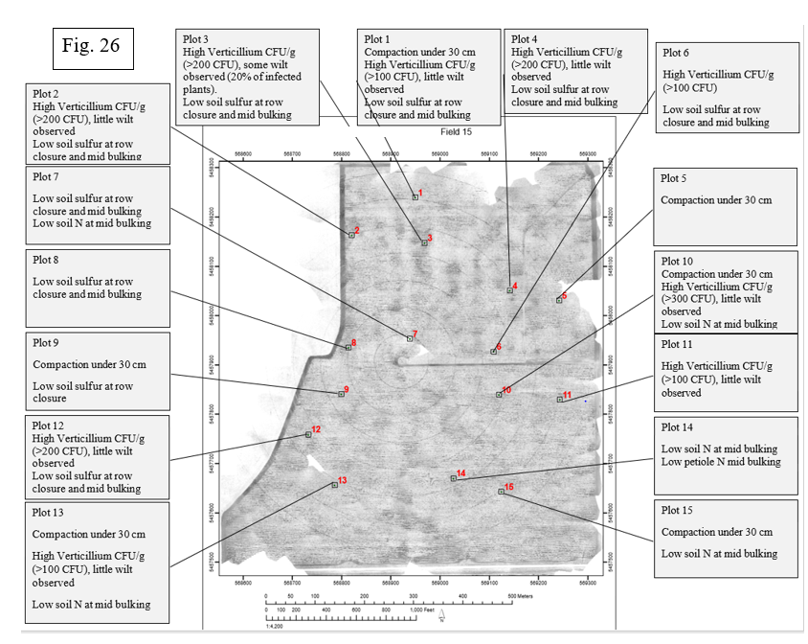

Nitrogen Remediation Study

No significant results can be reported in the first year. The first limitation is that at least two years of study are required to refute the possibility of spurious results. The second is that analysis indicated the global treatment effect was not significant for the total yield, dollar value, or any size category. Notably, there was a nearly significant effect (P = 0.07) for tubers in the 10-12 oz tuber size profile. This is important because a treatment effect is not anticipated for total yield, but for differences in the tuber size profile, especially for 10-12 oz tubers. This nearly significant result is a likely indicator that another year of study will have conclusive results on the effect of nitrogen program by row closure and changing the percentage of the total yield that is comprised of 10-12 oz tubers. The goal is to ultimately recommend programs that improve 10-12 oz yield to improve profits with this lucrative size category.

Conclusions

This analysis shows that key soil and plant parameters measured at different potato growth stages can adequately explain the variability in potato yield categories and tuber specific gravity when implemented via PLS regression. The predictive power of the model improved as more years and fields are incorporated into the study, but only the top ten most influential variables encompass many of the main, repeatedly observed variables that are important to many size categories.
There are also many variables that appear on the top ten for processing total yield, but not in certain size categories. For example, sampling points with lower petiole nitrate at row closure are associated with total yield negatively (i.e. lower petiole nitrate at row closure is associated with the lowest yielding sampling points). The PPM of nitrate in the petiole ranged from 3,892 to 24,852. Ten of the sixty sampling points were deficient at this time, and fifteen of the sixty were low. No sampling point had high petiole nitrate at this time. It is likely that the negative yield association for total yield was observed with low to deficient petiole nitrate sampling points. As with soil potassium and petiole calcium, field experimentation is necessary to demonstrate this relationship and evaluate remediation approaches.
Verticillium wilt, while an important disease to potato production, was only on the top ten list of important variables for only one size category – 10 to 12 oz. Increasing numbers of Verticillium propagules were the largest negative contribution to 10-12 oz yield. Verticillium infection is likely preventing the tubers from sizing in the 10-12 oz category more so than the smaller categories. The fact that these variables appear in only one tuber size category is an important consideration for specific remediation strategies aimed at improving yield to just this size of tuber.
Several key results were repeated across the processing total yield and one or more of the size categories. One example involves the availability of nitrogen in the soil. The pounds of nitrogen available in the soil varied at row closure from 5 to 160 lbs, which can explain the anomalous result that increasing soil nitrogen can be a positive value association, but too much or too little is a negative value association. Five pounds of available soil nitrogen is too little by row closure – limiting growth and eventual bulking, and ultimately reducing value. The consultants that took part in the 2017 year of the project seem to aim for 130-180 lbs of nitrogen in the soil by row closure, which includes the upper range of 160 lbs nitrogen in the soil observed in the experiment. This could explain the result where increasing soil nitrogen (up to the 160 lbs max observed) at the 0-15 cm is a positive yield association.
Sampling points with greater petiole nitrogen at row closure are associated with the processing total yield negatively and could be translated as greater petiole nitrate at row closure is associated with our lowest yielding sampling points. Over the course of the experiment, petiole nitrate results varied from 3892 to 32668. The association with decreasing total yield would focus on the upper range of 32668, but the exact cut off of when the benefit of available nitrogen turns to detriment cannot be determined by this form of analysis. Recommendations from Agvise suggest that the cut off is around 25000, but experimental validation with a remediation strategy (objective 2) aimed at identifying nitrogen practices prior to row closure and their effect on the ideal petiole range are needed before experimentally-validated recommendations can be issued.
Variables such as available sodium in the petiole are positively associated with the processing total yield, indicating the best-yielding sampling points were associated with more petiole sodium than the lower yielding points. The most unusual part of this observation was that petiole sodium was often the greatest positive effect on yield or certain size categories. Over the course of the experiment, the percentage sodium recorded in the petiole by Agvise varied from 0.01% to 0.07%, indicating the percentage range of positive benefit was small. However, the analysis indicated that the higher percentages were associated with higher yielding sampling points. It is also important to note that the petiole sodium content became a negative yield association from mid bulking and late bulking, albeit not one of the top ten.
The results on petiole calcium are also interesting in that sampling points with greater petiole calcium had lower total yield. In this case, too much or too little of calcium was associated with lower yielding sampling points. A soil test and reference are necessary to determine whether it was too much or too little – the model will not inform this result. The percentage of petiole calcium at row closure ranged from 0.87-2.48%, which appeared to range from high to very high. It is possible that excessive calcium was part of the negative yield association. As with the nitrogen result, field experimentation is necessary to move this result from association to concrete result that can influence recommendations.
In addition to evaluating the impact of variables on yield of all the processing fields combined, individual fields from 2017 were rated for nutrient, soil, disease, and plant health status. Drone imagery was used in conjunction with scouting, nutrient status as determined by Agvise recommendations, and yield to visualize variability at each sampling point and what trends were apparent in the overall yield. The point of this individual analysis is to demonstrate the usefulness of the PLS analysis from all processing fields in identifying one or a few major yield-limiting factors from a larger list of potential problems listed for a specific site. This information begins the conversation with a local consultant and grower about priorities in remediating yield variability, and ultimately ideal practices to remediate the situation.
Individual field analysis also highlights an interesting interaction between the June drone flight and points of premature die down of the potato canopy. There is a possibility of using the June flight as a predictive tool for problem places in certain fields because some spots of unhealthy canopy already manifest by June.
On the fresh market fields, soil nitrogen and sulfur at several growth stages are associated positively with total yield and virtually all of the size categories. Translated plainly, the higher ranges of those nutrients were associated with our highest-yielding points. Soil nitrogen at row closure ranged from 10.5 to 117.5 lbs N available, with more sampling points being low-to-deficient rather than in excess of the needed nitrogen. Soil sulfur varied from 0-120 lbs available in the soil throughout the sampling date from row closure to fall soil sampling (postharvest), which would range from deficient to very high for ‘Russet Burbanks’. The positive yield association points to the higher ranges (40-60 lbs were common high observations in the experiment) as the likely yield-benefitting range, but field experimentation is needed to identify this exact range and the best practices to get there. This is especially important given our range of quality was determined for another cultivar other than ‘Red Norland’. The negative yield associations for sulfur and potassium likely originate from soil samples deficient in these nutrients.
There are several major limitations to these results that are necessary to keep in mind when reading this report. Curious, interesting, or unexpected results are not necessarily biased, wrong, or statistically inflated. These associations are based on observations across the fields included in the experiment, and associations need a field study to further characterize the link. It is after that characterization that scientists and consultants can try to influence that variable to full benefit on yield. Field experimentation is especially important to address the relationship between calcium or potassium on negative yield associations, especially before major management decisions are implemented. Field experimentation for remediation strategies within in-field settings is a key part of the study moving forward in order to realize these results within a potato system in an economically feasible manner.
Most studies examining one of the factors in the experiment, such as a nutrient, analyze said factor in isolation as part of integrity the scientific method. While this regimented, narrowed focus is imperative for results of ideal scientific integrity, the possibility exists that several factors are inter-related. Strategies with the intent to mitigate one factor may require additional adjustment to other areas to achieve the desired association observed in the results of this document. Experience has taught the author that understand the complete range of interactions of these 97 variables is very difficult for a singular individual entity to keep in mind, yet these interactions remain important. The route to limiting this problem is the combined, group efforts of the research committee, as well as growers and consultants. Only in working together can the true objective of increasing the competitiveness of Manitoba’s potato industry be realized.

Materials and Methods

Field Variability Study
Field selection. Potato fields were deliberately chosen for exhibiting yield or quality limitations due to soil type, topography, limited water holding capacity, compaction, or for unknown reasons. Fields destined for French fry processing were planted with potato cultivar ‘Russet Burbank’, and fields destined for the fresh market (that were included for analysis in 2017) were planted to potato cultivar ‘Red Norland’. The cultivar was kept constant within the same market class to eliminate a potential variable from analysis, and the market classes were kept separate for analysis due to differences in cultivar growth and nutrient requirements, spatial distance between fields, as well as the demands of each market.
Ideal fields for selection would have some or all the following features: range in variable yield and quality of previous potato crops, representative of growing conditions and soils of potatoes in Manitoba, availability of yield maps and variability information previous to project initiation, and grower cooperator, consultant, and processor approval of in-field equipment use (1-row harvester, small tractor, quad, etc).
Observing a range of yield or quality of potatoes varies within each field is important in order to select fields that exhibit limitations severe enough to observe repeatedly and for the producer to consider mitigation strategies to be economically feasible. Fields selected for the project needed to represent the range of conditions and practices found in Manitoba (soil types, management practices, and environmental conditions) because the conclusions of the study need to be applicable to the entire province, not just one growing area and crops destined for one market. In practice, fields were selected for different soil types: sandy, clay, and silt with varying types in-between, such as sandy-loam. Varying management practices were also taken in to consideration, such as crop rotations, planting date, row width, irrigation type and frequency, plant spacing, tillage practices, as well as the herbicides, fungicides, and fertilizers employed. In essence, each grower that participated in the project was Encompassing Manitoba growing parameters also included environmental conditions: prevailing weather onsite from wind speed/direction, hours of sunlight, temperature of air and soil, and precipitation. Information and maps on previous crops in the same fields was important for informing site selection in order to represent the maximum variability in the field. Specifically, this included yield maps from rotational crops, other variability maps, elevation maps where available (soils maps, soil EM maps), and aerial images from previous crops. Finally, the growers, along with associated consultants and agronomists, are willing to consider having treatment strips (or plots) applied in the field as well as machinery, such as quads and a tractor with 1-row digger attached for harvest.
Sampling point selection within fields. Fifteen sampling points were established in each study field by each May of the study year. Sampling points were determined in consultation with each grower and their consultants using all available information: aerial imagery, variability and yield maps, as well as producer and agronomist knowledge of the field. The sampling points will be chosen to represent the range of field conditions and capture the areas of historical potato yield and/or quality variability. The GPS coordinates of each sampling point would be captured by the mapping software that each consultant used and recorded. Sampling points were manually entered and tracked with a Garmin GPSmap 78S from 2015-2018.
Sampling points were marked with 6-foot, fiberglass-pole flags in May to June, depending on when the grower had completed hilling and remaining tillage operations. Sampling points consisted of seven 10-meter row lengths with one guard row, followed by 3 adjacent rows flagged for destructive sampling and observations (soil sampling, petiole sampling, etc.). A fourth row will be flagged as a guard row. The fifth row will be designated as the harvest row and remain undisturbed through the season, avoiding heavy foot traffic, for final yield determination. The seventh and final row will be a guard row. Each sampling point was surrounded by the field crop, e.g. there was no unplanted space around each sampling point.
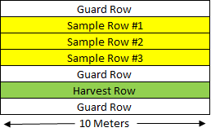
Arrangement of rows in a sampling point
Determining Verticillium propagule levels. Soil samples were collected in the spring at full crop emergence for each of the sampling points within the study fields. Full emergence was anticipated by late May to early June 2017. Sampling at each collection date for all fields in the project did not vary by more than two weeks. Composite soil samples (Seven cores per sampling point) were taken from 0-15 cm depths from each collection point. Soil samples in the project were generally taken a ‘V’ pattern from sampling rows 1-3, and Verticillium samples were taken from within 4 inches of the young potato plant (other soil samples in the project were taken from within 6 inches of the plant). Approximately 200 grams of sieved soil (to remove solid mass) would be stored at 4°C until processed. Soil samples were not dried, nor were stored for more than three weeks. Soil samples were transported on ice to the University of Manitoba to Dr. Mario Tenuta for Verticillium propagule enumeration via a plate counting method for Verticillium species and PCR amplification of Verticillium dahliae.
Determining soil penetration and soil density (bulk density). Soil bulk density was evaluated in the spring at full crop emergence at each of the sampling points within the study fields. The collection date coincided with the Verticillium soil collection dates.
Bulk density evaluation required the following materials: 30 Bulk Density rings, hammer, block of wood, ruler, trowel, and Ziploc bags for soil collection. The procedure was as follows:
- Determine which numbered ring corresponds to which of the two depths recorded at each collection point.
- Push or hammer ring into soil (use block of wood to protect ring) to depths of 0-12 and 12-24 cm.
- Excavate soil around ring to expose and remove ring without disturbing soil in ring
- Place caps on ring to contain soil and place into labeled Ziploc bag.
- Place bulk density rings into cooler until processing.
- Weigh each tin can and record the weight and the number on the tin under proper sampling point on the Bulk Density Weigh sheet before placing soil in tin.
- Remove caps and scrape all soil out of ring into tin cans in the lab.
- Weigh the soil and can together and write combined weight onto Bulk Density Weigh Sheet.
- Place uncovered tins in oven at 106°C for three days.
- Weigh the tins and soil combined again and then subtract the weight of the tin for final dry weight and record on sheet
- Input data from Bulk Density Weight sheet into excel spreadsheet with following formulas:
- Calculate volume of ring – V=πr²h
- Bulk density (g/cm³) = Dry soil weight (g)/soil volume (cm³)
- Water content = ((wet weight – dry weight) / dry weight) * 100
Bulk density can be impacted by soil type, compaction, and tillage. Taking one bulk density reading in a season was expected to be sufficient unless any of those three factors change after we take our reading.
Subsurface soil compaction will be evaluated using the Manometer penetrometer from Eijekelkamps available at CMCDC at mid-bulking, which was late July in most fields. Recommended penetrometer use was 24 hours after rain or heavy irrigation, when the soil is at or near field capacity. Moisture must be constant for comparisons across sites as reading can vary as soil moisture varies. A Delta-T HH2 moisture meter with WET-2 sensor was used to determine that soil penetrometer readings are within reasonable surface soil moisture content between sites and fields. The WET-2 sensor of the Detlta-T HH2 was used to collect three moisture readings from different locations within the sampling point from depths of 4-5 cm using the following protocol (borrowed liberally from the operating manual):
1. Press Esc to wake the Moisture Meter if it is asleep.
2. Connect the sensor. The HH2 initially will assume it is an ML2 ThetaProbe in
mineral soil unless you tell it otherwise using the Options, Device menu.
3. Press Read to read and display a result.
4. Press Store to store it (or Esc to not store it).
Averaging can be done after each reading (whether or not you stored it)
5. Press the hash # key once to display the previous cumulative average.
(Initially “No Average” is displayed).
6. Press # again to update the cumulative average with the current reading (or
Esc to back out).
7. Write down the final cumulative average if you wish to retain it.
8. To erase the cumulative average press Esc until you return to “Delta-T
Devices”.
9. Output data was manually recorded on a Penetrometer Data Sheet and then data was entered into excel sheet to calculate cone resistance with the following formula:
Cone Resistance = ((Manometer Reading)/(Base Area of Cone))/100 Mpa
Soil texture and water holding capacity. Composite soil samples (Seven cores per sampling point) were taken from 0-15 cm depths from each collection point to determine percentage of sand, silt and clay. In addition, a subsample will be used to determine water holding capacity. A second set of soil samples (five cores) be collected at a depth of 15-30 cm, which will also be testing for water holding capacity and soil texture. Samples will be collected early in the season along with Verticillium testing and Bulk Density testing (close to full crop emergence). Soil samples were dried for three days after collection. Samples will be sent to Agvise for texture and water holding capacity determination.
Soil moisture and temperature. Decagon EC50 soil data loggers with three sets of soil moisture and temperature sensors for each logger (1 5TM 3-pronged red sensor and 2 Ec-5 2-pronged blue sensors) have been acquired for the study to be placed in each of the 15 collection points in two fields. The loggers were placed in June, which generally coincided with soil sampling and bulk density.
Cellular EM50G Decagon logger and sensor protocol
Materials:
- Sensors (3/logger)
- One 5TM sensor
- Two EC-5 sensors
- Decagon Logger
- Tall Stake
- Auger
- Ruler
- Flags
- Zip ties (2/logger)
- Batteries (5/logger)
- Desiccant Pack
- Antenna
- Computer and USB cord to connect manually to logger
- Burlap sack
Preparation:
- Go to http://www.ech2o.com/accounts/login/?next=/ and enter each unique Device ID and password that comes with each individual EM50G logger. Also add this information into DataTrac3 to get live feeds of data being collected.
- Connect every EM50G logger to Ech2o Utility or DataTrac3 program to configure EM50G logger. Set measurement interval to one hour on each logger, under Device Identity and Name, enter logger name that is on the front of the logger. Under Data Storage and Port Sensor 1, 2, 3, choose which sensors you are using. Under Device Location and Site Name, enter the point at which the logger is being installed.
- Preform communication test by connecting logger with antenna attached to Ech2o or DataTrac3 program and clicking on “Actions” pull down menu and then selecting “Communications Test,” then click “Test.” If the logger does not have a good connection quality, try moving to a different location or outside of the building, or change the batteries. You can also select “List Cellular Carries” under the “Actions” pull down menu to see if the logger is picking up any signal from any cellular carrier.
- Label each sensor at the non-probe end corresponding to which port it will be inserted in to. The 5TM sensor (3-pronged red sensor) should be labelled “1” and the two EC-5 (2-pronged blue sensors) should be labelled “2” and the other “3.” If the sensor cables are of different lengths, reserve the longer one for the deeper depth. On the inside of the logger, there will be a paper slip in the sleeve called “Em50 Port Configuration.” On this sheet, indicate which depths the sensors will be installed at. “1” should be the 5TM sensor installed at depth of 6 cm, “2” is the EC-5 sensor installed at 15 cm, “3” the last EC-5 sensor installed at 30 cm.
Installation:
- Dig a hole in the hill with the auger to desired depth (30 cm). As you dig, place the soil onto the burlap sack so that each horizon can approximately be placed back in the same order after completion of sensor installation.
- Place the ruler on the flat edge of the hole made by the auger and make pilot holes with a pin flag at depths of 6 cm, 15 cm, and 30 cm. Then, insert the prongs of the sensors from the bottom depth up into the pilot holes with the EC-5 sensor labelled “3” at 30 cm, the EC-5 sensor labelled “2” at 15 cm, and the 5TM sensor labelled “1” at 6 cm. Make sure that the prongs have sufficient soil contact for an accurate reading, later in season, potatoes may grow and dislodge the prongs or may grow into the prongs themselves and give an inaccurate moisture reading that is too high. If this happens, re-installation of the affected sensors will be required.
- Unravel the appropriate amount of chord needed for the sensor to reach to the logger at the top of the stake (make sure the stake is tall enough so that the antenna on the logger will be above the canopy for a good cellular signal). Group the male input ends of the cable together, so that once the hole is filled, all wires will come up out of the ground at the same site. Bundle the unneeded amount of cable back up with the twist tie and then bury the cables with soil that was laid to the side on the burlap sack. Attempt to replace the soil back at the correct horizons.
- Attach the logger to the top of the stake with the two provided zip ties. Insert the batteries and the male input into the correct ports labelled “1,” “2,” and “3.” Attach the antenna to the top of the logger, place desiccant pack inside and close the logger.
- Manually connect the logger to the laptop with the USB chord and open Ech2o utility. Once connected, select scan to ensure that the sensors were installed correctly and are producing moisture readings.
- Mark the location of the wires with pin flags and ensure that the stake is marked with bright colour so that it is clearly visible to field workers.

Soil nutrient evaluation. Soil and Petiole samples were collected at row closure, mid bulking, and late bulking to determine in-season nutrient availability. Soils were collected from each of the 15 sampling points in each field, and each point had been previously marked out with flags that were not removed between sampling dates, implying that GPS confirmation of location was not necessary between collection dates. Row closure was anticipated in early July, mid bulking in late July, and late bulking in late August.

Soils were sampled five times with a probe at 0-15 cm and 15-30 cm, and composite soil samples from both depths at each sampling point were tested through Agvise for NO₃, P-Olsen, K, and S. Soil samples in the project were generally taken a ‘V’ pattern from sampling rows 1-3, and soil samples in the project were taken from within 6 inches of the plant, but never where the consultant had banded fertilizer (if fertilizer was not broadcast or fertigated). Soils were kept at 4⁰C between field sampling and shipment for testing. These samples were not dried before submission.

Soil samples will also be collected in the fall following crop harvest, which is anticipated to be complete by October. Flags denoting sampling points were removed before harvest, necessitating the following protocol for fall soil sampling:
Procedure:
- Use GPS to re-locate points after harvest
- Samples from two depths will be taken, 0-15 cm and 15-60 cm. Take three full length cores (0-60 cm) with the hydraulic-probe and take an additional three 0-15 cm cores with the hand-probe.
- Twist both bags for each depth together and tie. Store for processing later
- Lay soil out in chem shed or Bernie’s shed on butcher paper, place labelled field soil collection bag underneath butcher paper with corresponding sample ontop
- Allow soil to dry for three days
- Sieve soil and place into labelled Agvise bags and place into Agvise box along with proper spreadsheet containing the information of each sampling point
- Ship to Portage
Analysis by Agvise was completed for fall soil samples. Specifically, nitrogen (two depths), phosphorus, potassium, pH, soluble salts, sulfur, zinc, calcium, magnesium, sodium, CEC, and percentage organic matter were evaluated.

Plant assessment. Plant counts will be collected on the 10-meter row lengths of the harvest row for each study point after crop emergence, but before row closure.

Counts on sampling row lengths are collected to determine the number of plants being assessed at later visits. Comparable numbers of plants between sampling points is important when comparing factors such as yield, which can be influenced by the number of plants. Plant counts therefore served as a quality control check for the initial health of the stand and crop before that collection point is used for continued experimentation.

Plant disease assessments. Field visits assessed crop growth and health following emergence at each sampling point in each field. Field visits varied in frequency from once a week to once every two weeks. The notes from these visits were to be used with data and imagery interpretation at a later date. If crop issues arise during the growing season within study fields, regular visits and notes may point to additional sampling or data collection. Field notes to be taken included: crop growth stage, visual crop stress symptoms, visual crop disease symptoms, and crop pests and weeds notes.
The only consistent disease rating across two years of study (2016-17) was a Verticillium rating, in which one of the established 10 m sampling rows was chosen to evaluate vascular discoloration in potato stems and wilt symptoms for the whole plant using published disease charts (below). These charts were provided by Dr. Vikram Bisht. In 2017, direct estimation of total plant chlorosis (0-100% instead of a sale) was conducted by Dr. Zachary Frederick in mid-August and late August, rating the same rows as were subject to rating using Dr. Bisht’s scale.
Verticillium wilt rating scale:

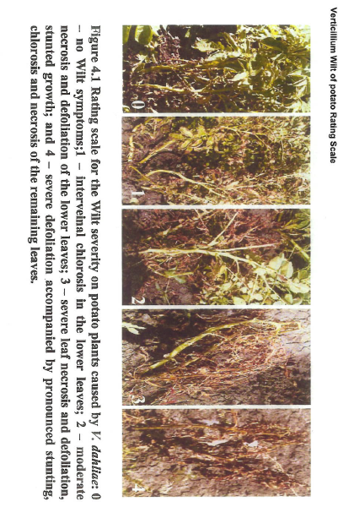
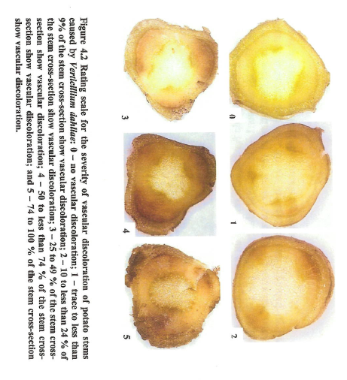
Direct estimation of Verticillium wily severity was assessed from 0 to 100% wilt symptoms (chlorosis mainly in practice) in the plant and 0-100% vascular discoloration or necrosis as determined by field observation. Both direct estimation and charts will be used at the same time for two sampling dates to ensure quality data is recorded and analyzed.
Petiole sampling. Potato petiole samples were collected three times during the growing season during row closure, mid-bulk, and late bulk for analysis of N, P, K and S levels in plants. The data were used to assess the nutrient status of the plants at the various field sampling points through the season. Thirty petioles were collected from sampling rows 1-3 in each collection site of each field. Given the sensitivity of petiole sampling to human-inducer (user) error, training was conducted by John Lee from Agvise for correctly identifying the second, third, and fourth leaflet in Russet Burbanks in June 2017. Petiole collection was done through the following method:
Fields should not have been sprayed with pesticides or foliar nutrients for 3-5 days
- Sample from all 15 sites, use rows 1 and 2 and 3, 30 petioles per site, go in zig zag down the rows.
- Select plants without an inflorescence if possible.
- Attempt to maintain similar sizes of petiole throughout sample, attempt to maintain petiole length of a minimum of three inches after stripping leaves
- Do no include snapped, torn, crushed, or otherwise damaged petioles
- Select 4th petiole from the top of the meristem, samples should not come in contact with dirt.
- Samples must be maintained in as cool temperatures as possible and not be exposed to sunlight.
- Samples should be delivered for processing immediately.
Tuber yield and quality. The selected 10m harvest row will be harvested in Late August or September and will be ahead of the producer’s harvest but be as close as possible. Total harvest weight and quality grading will be done separately on each of the 15 samples taken from the study fields and based on crop sector (fresh or processing). Processing yield and quality will be determined by Agworld at the McCain Foods (Canada) plant in Carberry. Fresh market field yield and quality will be determined by a consultant, Kurt Ginter, in Winkler.
Weather data. Weather information from available weather stations near to the fields were used to better understand the interactions between the factors associated to field variability and the crop performance. Mean temperature, daily minimums and maximums, relative humidity, rain events and wind will be recorded in an excel spreadsheet. One field in each year of study will also have a Hobo weather station temporarily installed onsite, with sensors for Mean temperature, daily minimums and maximums, relative humidity, rain events, solar radiation, and wind.
Drone Imagery. Drone images will be collected from the beginning of the season on bare soil to capture elevation, moisture and any other observable variability factors within the field. Drone images will also be collected three times throughout the season: At row closure, late bulking, and at senescence.

NIR and true color images will be collected at each of the three in-crop image dates. Four ground-control points be established in each 2017 processing field (4 fields total) prior to the collection of the drone imagery to assist with proper geo-referencing of the images. The fixed-wing drone used a parrot sequoia camera that records green, red, red edge, near IR. It has a 70 degree field of view and catches one image per second that was stitched together using ArcGIS. We get about 13 cm per pixel at 120m. The 15 collection points per field were identified in 2017 based on GPS coordinates recorded on the ground, the average Normalized Difference Vegetation Index (NDVI) value for the collection point was extracted into a table using ArcGIS and Microsoft Excel. These tables were then used for statistical analysis in SAS and graphical display in Microsoft Excel.

Statistical Analysis with the Partial Least Squares Regression method
The relationships between potato yield and quality parameters as dependent variables and 97 independent variables were explored with Partial Least Squares regression analysis with the primary goal to identify the key ten to twenty variables explaining the yield and quality variability in the response variables for potatoes destined for processing or fresh markets. The market classifications were analyzed separately for the same reasons outlined previously, but essentially summarized as the markets have different quality parameters and cultivar differences. The approach employed in the analysis involved developing a separate model for each of the response variables of interest after initially conducting an analysis of all response variables taken together.
Since many of the soil variables are inherently correlated, standard (ordinary least squares) regression approaches present challenges because they are designed for explanatory variables that are not correlated. Furthermore, the sheer size of the subject data set relative to the number of explanatory variables is not suitable for ordinary least squares regression. Therefore, a technique that works well for this type of data – Partial Least Squares regression – was employed in the analysis, using the PLS procedure of the SAS statistical package. The approach has some similarity with Principal Component Analysis but differs in that it is also a regression technique that can be used to predict outcomes given a set of measurements of suitable independent variables.
Using this approach, all explanatory variables that contributed significantly to explaining the variability in each dependent variable (i.e., yield in the different tuber size categories, specific gravity) individually and combined were initially explored and identified based on their influence, or variable importance in the projection (VIP). Variables with VIP > 0.8 were considered significant predictors in the model. Subsequently, the effect of sequentially removing variables that appeared less influential was determined. If there was a measurable loss in the predictive power of the model or the percent of variability accounted for, the variable was retained in the model; otherwise, it was excluded so that a simpler model was developed. The best model was deemed to be the one that used a minimum of the available explanatory variables to give a reasonable prediction of the yield and tuber quality. Generally speaking, PLS regression in this scenario highlights which factors vary between high and low-yielding points in all fields of a particular market class. Specifically, explanatory variables that score high VIPs are the variables that vary between high and low yielding sampling points. Factors that do not score very high VIPs do not vary between high and low yielding sampling points.
The number of PLS factors (latent variables) was selected using a cross validation method in which the original data set was divided into two groups: a training or calibration set and a test or validation set. The number of extracted factors with the minimum predictive residual sum of squares (PRESS) statistic was chosen as the optimum. Using the CVTEST option of the PLS procedure, the optimum or minimizing number of factors was compared to the PRESS for fewer factors to test whether there was a significant difference. In the absence of a significant difference, the model with fewer factors was chosen.
A comparison of model predictive power was also performed to determine whether fewer predictors selected based on VIP > 1.5 could be included in the model without significantly reducing the predictive power. Response variables that were modeled better using the VIP > 0.8 criterion were yield in the size categories 6-10 oz (1-factor model) and 3-6 oz (2-factor model), and tuber specific gravity (2-factor model). By comparison, yield in the categories 10-12 oz (2-factor model), > 12 oz (1-factor model), and < 3 oz (1-factor model), and all response variables analyzed together (3-factor model) were adequately modelled using fewer factors selected using the VIP > 1.5 threshold. Additionally, attempts were made to create the same models with 97 dependent variables and 10, 20, or 30 of the most influential dependent variables. Decreasing the number of dependant variables decreased predictive power and the quality of the resulting model, therefore all 97 dependant variables were used. The top 10 dependant variables could still be reported, but it is important to consider that the model requires as many inputs from dependant variables as possible to achieve the “best” predictive model (best defined as the model greatest predictive power, least scatter).

Nitrogen Remediation Study:
Observation from FVS: Higher nitrate in petiole at row closure is positivity associated with smaller tubers (>3 oz) and negatively associated with 6-12 oz yield, specific gravity, and dollar value of the crop.
Goal: Conduct a study on a plot scale to compare urea fertilizer programs to evaluate the rate and timing of urea or ESN on petiole nitrate is available at row closure.
  - Objectives:
    - Determine the appropriate rate of N at planting and hilling for optimal yield with Russet Burbank
      - How much N is too much before row closure N buildup in petiole occurs?

Three phases to experiment:
- Observation of association of petiole nitrate availability at row closure and tuber size profile
- [Current phase of project] Onsite study to determine how much N is too much before row closure N buildup in petiole occurs?
  - Need to do offsite to get control over nitrogen program, find out what provides biggest yield boosts to desirable tuber sizes, demonstrate what has negative yield trends
  - Don’t conduct in grower field because cannot justify hurting the crop
- In-field experiment to demonstrate nitrogen programs with most promise to increase desirable tuber size profiles
  - Get as large section of field as grower will allow (up to 1 acre?)
  - Replicate across several soil types

Equipment and Materials Needed (part 2 at CMCDC offsite)
Tractor with custom-built fertigation unit
Nitrogen source (Urea and ESN)
Nitrogen broadcasting equipment (CMCDC should own variable-rate output unit)
Russet Burbank Seed
Offsite space to plant
Offsite irrigation for watering
Spray equipment and pesticides for routine pest and disease program

Site Selection and Considerations
Desired site: CMCDC offsite
- Difficult to control nitrogen program used by a grower in-field, offsite offers that control and allows us to create spatially discrete programs (no potential overlap).
- Changes to nitrogen program could have negative yield impact. Trial on offsite doesn’t hurt grower if negative yield impact
- Lighter soil at offsite preferred to heavier soil because lighter soils are prevalent in regional potato production fields.

Experimental Design:
- Plots 24m in length, plots are 4 rows wide, 2 middle rows for tractor to drive on
  - No gaps between plots, plant straight through
  - 36 inches between rows, 13 inches within row, 6-7 inches deep(from top of hill)
- 1 level for potato cultivar: ‘Russet Burbank’
- Two N sources (urea, ESN), target yield 400 cwt/A, spring broadcast (100% N use efficiency)
  - 9 treatments (see below)
  - Two application dates before row closure: at plant (40 lbs N/A max), and at hilling (remainder of N for treatment)
- Three years (2018, 2019, 2020)
- Randomized complete block design
- 5 replicates (blocks)

See attachment for Map

Assuming 4 rows at 36-in spacing is about 144 inches (3.6m or 12ft) wide. 24 m is 78.7402 ft
- Total area of each plot is 78.7402 ft X 12 ft = 944.904 ft²
  - Total area for each treatment is 944.904 ft² per plot * 5 reps = 4724.52 ft² (0.109 Acres)
  - Total area of all plot space 944.904 ft² * 9 treatments * 5 reps = 42520.68 ft² (0.976 Acres)
- Drive row area
  - 2-lane drive row
    - (2 rows * 0.9144 m (36 in) row spacing each row) * (24 meters * 5 plot lengths) = 219.456 m² (2362.205 ft²)
  - Drive row space
    - 6 two-lane drive rows, (2362.205 ft² *6) = 14,173.23 ft²

Total size of experiment = 1.33 Acres

All plot space (42520.68 ft²) + drive row space (14,173.23 ft²) + red row space (1175.42 ft²) = 57869.28 ft² (1.33 Acres)

Math double check:

Experiment is 50 rows wide on 36-inch row spacing. That’s 1800 inches wide or 45.72 m
The experiment is 5 replicates/blocks long, each block is 24 m in length, total length is 120 m

Area of experiment is 45.72 m * 120 m = 5486.4 m² (1.36 acres)

Fertilizer calculations: References for this material are in the notes section
  - Conversion PPM to lbs/A http://edis.ifas.ufl.edu/hs1229
  - Nutrient lbs/A needed referenced from MB soil fertility guide
  - Current soil nutrient ppm at offsite referenced from Alison fall soil sampling
    - Alison says offsite N is depleted at CMCDC offsite – I should expect to replace it all

To determine the fertilizer rate for a particular nutrient, multiply the rate of the desired nutrient by 100 and divide by the percentage of the nutrient in the fertilizer (Agvise recommendations).

- Urea 46-0-0. N needed is 251 lbs/A. (251 X 100) / 46 = 546 lbs Urea/A
  - Theoretical use if all season of N is applied up front in this form only. The experiment will use less (see below).

- ESN (Polymer Coated Urea, Environmentally Smart Nitrogen) 44-0-0. N needed is 251 lbs/A. (251 X 100) / 44 = 570 lbs ESN/A

- Triple Super Phosphate 0-45-0 (soil at 33 ppm or 137 p205 lbs/A) – 73 lbs/A required

- K fertilizer not needed. Soil at 223 PPM (481 lbs K20/A) right now, max needed 327 lbs/A

- Sulfur not needed. Soil sulfur at 20 lbs/A, 20lbs/A is what is needed

- Ca not needed. Soil has 1015 PPM Ca (2000 lbs/A), 48 lbs/A needed.

- Mg not needed. Soil Mg at 161 PPM Mg (320 lbs/A), 36 lbs needed.

Need to figure out the split percentage and then rates -these will be treatments:
- Research shows that about 150 to 180 pounds N/acre from soil and fertilizer N is required by the time the rows begin to close to provide for optimum canopy development and yield.
  - Consultant says he shots for 130 on by row closure. This will be the new “low” end of the acceptable spectrum to test.

Treatments:
Pre-row closure N (note Triple super phosphate also applied pre-row closure)
- N at fertigation only (No N prior to row closure)
  - Purpose – demonstrate that residual N is indeed insufficient for potato growth, which is an underlying assumption for the remaining treatments since we’re putting on all the N we expect the potato to need. This treatment should have less petiole nitrate than any other treatment throughout the whole season, and could show deficiency symptoms, and have less yield than all other treatments. This treatment will receive fertigation because we wish for fertigation to not be a factor for experimentation.

- Urea, 280 lbs/A N by row closure. This treatment is anticipated to be way too much N because we are putting a whole season’s worth on N on before row closure. 40 lbs N will be applied at plant and 240 lbs applied at hilling.
- Urea, 180 lbs/A N by row closure. This treatment is the upper end of what is anticipated to be sufficient N. 40 lbs N will be applied at plant, and 140 lbs N applied at hilling.
- Urea, 130 lbs/A N by row closure. This treatment is the lower end of what is anticipated to be sufficient N. 40 lbs N will be applied at plant and 90 lbs N applied at hilling.
- Urea, 40 lbs/A N by row closure. This treatment is anticipated to be too little N. The 40 lbs will be applied at planting, and no additional N will be applied at hilling.

- ESN, 280 lbs/A N by row closure. ESN justification for treatments, rates for season, and rates split for plant and hilling are the same as urea.
- ESN, 180 lbs/A N by row closure. This treatment is the upper end of what is anticipated to be sufficient N.
- ESN, 130 lbs/A N by row closure. This treatment is the lower end of what is anticipated to be sufficient N.
- ESN, 40 lbs/A N by row closure. This treatment is anticipated to be too little N.

Amount each fertilizer needed before row closure:
- Urea, 280 lbs/A N by row closure. Urea 46-0-0.
((280 lbs N * 100) / 46) * 0.109 Acres = 66.35 lbs Urea needed
- Urea, 180 lbs/A N by row closure.
((180 lbs N * 100) / 46) * 0.109 Acres = 42.65 lbs Urea needed
- Urea, 130 lbs/A N 1by row closure.
((130 lbs N * 100) / 46) * 0.109 Acres = 30.8 lbs Urea needed
- Urea, 40 lbs/A N by row closure.
((40 lbs N * 100) / 46) * 0.109 Acres = 9.48 lbs Urea needed

149.28 lbs Urea needed total

- ESN, 280 lbs/A N by row closure. ESN 44-0-0
((280 lbs N * 100) / 44) * 0.109 Acres = 69.37 lbs ESN needed
- ESN, 180 lbs/A N by row closure.
((180 lbs N * 100) / 44) * 0.109 Acres = 44.59 lbs ESN needed
- ESN, 130 lbs/A N by row closure.
((130 lbs N * 100) / 44) * 0.109 Acres = 32.20 lbs ESN needed
- ESN, 40 lbs/A N by row closure.
((40 lbs N * 100) / 44) * 0.109 Acres = 9.91 lbs ESN needed

156.07 lbs ESN needed total

Post Row closure N
All treatments will receive N via fertigation in the summer. Fertigation will be a constant across all treatments as it comes after row closure and is not a factor for experimentation. UAN 28% is more common for fertigation according to our consultants.
- Fertigation calculation reference: http://irrigation.wsu.edu/Content/Fact-Sheets/Calculating-Chemigation-Injection-Rates.pdf
- Fertigation will begin when the tubers are set and are about the size of pea. This is expected to be starting in July and ending the first week of August (From Consultant Pryor)
- A calendar schedule will be enacted, but adjusted for soil and petiole results (schedule may need to speed up or slow down depending on conditions).
  - Consultant expects to have 60 lbs N in soil at this time, petiole values of 10,000+
  - WA recommended 15 lbs N or less and the same petiole
    - We will go with fertigation once below 15 lbs N in soil or petiole of under 10,000.
  - Fertigation even triggered when values fall below expected soil or petiole values
  - Fertigation in Washington and Minnesota is done every 7 to 14 days at 20-40 lbs N/A per application. We will fertigation at 20 lbs N/A (6.67 gals UAN 28/A) at 7 day intervals in the month of July, anticipating applying every Wednesday before irrigation of 1/3 inch. http://www.extension.umn.edu/agriculture/nutrient-management/nutrient-lime-guidelines/potato-fertilization-on-irrigated-soils/

Fertigation will supply 80 lbs N/A for each treatment, including treatment getting no N prior to row closure. Brian and Dan think 5-fold dilution for treatment. Consultant runs 28 straight into irrigation and adds 0.15 to 0.25 inches of water. Consultant runs 7500-8000 gals of water (3/10 in) for 10 gals of UAN 28.

- UAN (Urea Ammonium Nitrate) 28-0-0. N needed is 80 lbs/A. (80 X 100) / 28 = 285.72 lbs UAN/A
  - Total area of all plot space 944.88 ft² * 9 treatments * 5 reps = 42520 ft² (0.976 Acres)
  - 253.57 lbs UAN/A * 0.976 A = 247.48 lbs UAN needed for experiment. Assuming 3 lbs N are in a gallon of UAN 28, 246.48 lbs N is 82.16 gallons of UAN 28.
  - UAN per plot = total UAN per application*plot size – 20 lbs N/A per app (6.67 gals UAN 28/A)* 0.02169 A (944.904 ft² ) = 0.4338 lbs N (0.15 gals/A or 0.56 L/A or 568 ml/A) / plot
  - Nozzle pressure: 80 PSI, shape of spray should be triangular cones and the cones should be raised over the canopy so that the edges touch. Vehicle speed will need to be 4-5 mph to have correct deposition.

Burning situation required recalculation of UAN application

Calibration: Second to right 1200 mos. Second to right 1300. Center right 1300. Center left 1350. Fifth left 1300. Second left 1200. 1700 rpm and 1 minute

Total volume needed: 36 gallons (verified by running water over experiment)
Nozzle: minidrift 03-blue
~41 PSI
Speed: 2-4 mph
Turn off nozzles that run over drive row, turn off end nozzles on each boom to ensure no overlap. Final height – just above inflorescence

Dilution factor:
Desired conc (6.7 gallons UAN for 1 acre experiment), 36 gallons water are needed to cover the experiment (field-tested)
- 36/6.7 almost equals 5.5 gallons of UAN in the tank with 36 gallons of water

MAKE SURE BOOM HIGH ENOUGH OR BURN HAPPENS, apply in morning, dilute with linear very quickly (rotate experiment so that linear approaches broad side)

35 imperial gallons water, add 29.59 L of UAN 28

V = volume of N solution needed in gallons per acre (20 lbs of N from UAN 28 / 3 lbs N per gallon UAN = 6.7 gallons per acre UAN-28)

Convert lbs of UAN I need to gallons:

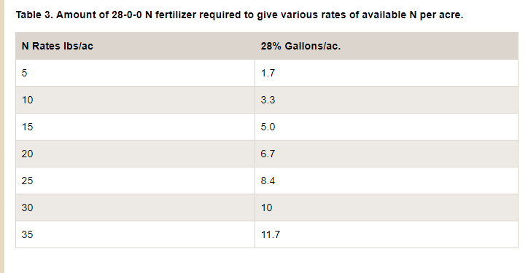

MAP and Kmag

Mono-ammonium phosphate (MAP, 11-52-0-0) was applied at rate of 115 lbs/ A before at offsite

- 115 lbs/A for experiment size of 0.976 acres is about 113 lbs of MAP needed

Kmag put on as mixture of 32% 0-0-60-0 and 68% 0-0-22-22 at 132 lbs/ A. I presume I would need that amount (132 lbs) for the whole experiment

Experimental Progression

Sampling points
Experiment will be situated at the CMCDC offsite. Blocks will be established to encompass maximum variability in organic content, nutrient availability, previous trials, soil texture between the blocks and not within the blocks. The information necessary to the establish blocks will be made in consultation with Alison Nelson and Brian Baron.
- Anticipate planting and hilling at the time when 50% of the industry has accomplished each task. Anticipate Late April for planting.
- Anticipate flagging after hilling in late May or early June, record plot information on flags
- Blocks will be recorded quad-mounted GPS
- Large MHPEC flags will be placed on the corners of each sampling point based on handheld GPS directions. These flags have fiberglass poles and should be handled with gloves- preferably nitrile or latex gloves. Small flags will be used to mark the harvest row, as well as the entrance and exit to the field.

Prior to Season’s start (March and April)
- Prices negotiated for services with Agvise and Agworld. With Agvise, we do not seek research discount on all samples because I need petioles back in time to make fertigation call.
  - Budget established and approved, requires the above companies to quote
- Labels and spreadsheets constructed for samples, especially Agvise samples
  - Label as many bags before season as possible
- Confirm equipment operational, supply of disposables like bags and flags sufficient
- Obtain high quality Burbank seed, fertilizers
  - Alison usually purchases fertilizers before season’s start, may change in 2018.
- Stakes readied for experiments – large 2x2 stakes of 18 inches in length on the corner of blocks (28 needed total)
  - Lesser stakes (<12 in) on the corner of the treatments
    - 9 sets of colors needed to match the map, grey, black, orange, yellow, purple, dark green, salmon, sky blue, very light green
    - 9 sets of colors of 20 each, total of 180 stakes
- Corners of trial are flagged and located on GPS – in April
  - Experiment squared up using Pythagorean theorem (square of the hypotenuse (the side opposite the right angle) is equal to the sum of the squares of the other two sides)
  - Tech services out of Winnipeg marks 4 corners of experiments, arranged by Brian and Lindsey
- Spring sampling for soil samples
  - Composite sample 5 cores/sample, probes taken at least 3 feet apart and not in straight line
  - Sample soil NPKS and get 2 samples per block (one from top, one from bottom), get 10 samples total
  - Visually confirm variation (if exists), exists between block and not within blocks
- Calibrate fertilizer applicators (terra meter and fertigation sprayer) – Do sometime in April allow 1 month for repairs. No repairs expected terra meter, fertigation unit may require work. Brian and Eric know how calibrate equipment, Zack will learn from them.
  - Brian already working on getting Tarometer and cup-planter already being serviced for other research.
- Fertigation unit in Portage, make arrangements to get it to CMCDC Carberry in spring, remove antifreeze and test/calibrate at end of seeding.

Planting (Anticipated end of April or Early May)
- Seed is donated– 25 bags max for experiment
- Seed is russet burbank treated with ‎Titan Emesto
  - In-row spacing: 13 inches within row (calibrate 3rd sprocket, Z3 driving Z7)
  - Between-row spacing: 36 inches (3 feet) between rows
  - Seed piece size: 2.5 oz
  - Potato trial planted at 4c as soon as we can drive in
  - Z3 diving z7 potato seeded calibration
43,560 ft²/A ÷ 3 ft = 14,520 row-ft/A
14,520 ft * 12 in/ft = 174,240 row-in/A
174,240 in/A ÷ 13 in/seed piece = 13,404 seed pieces an acre
13,404 seed pieces/A * 2.5 oz average per seed piece = 33,510 oz/acre
33510 oz/acre ÷ 1600 oz/cwt = 20.94 cwt

- Hand graded on tables (5 people needed when Alison does it) in mid to late April
- 3 oz seed pieces
- Planting occurs when 50% of planting done for the industry, anticipate between late April to early May
40 lbs N applied to all treatments except “N at fertigation only” in the form of ESN or urea. Baseline rates of MAP and kmag also applied, as is customarily done by Alison and Brian. Application will be done by terra meter and overseen by Zack

Four person crew recommended. Coutler (or skilled tractor driver), student on back of terra meter to ensure kmag/postash mixture doesn’t clog up pipe, student on one flank hitting pipe to ensure kmag dispersal, myself on other flank to ensure kmag dispersal. When fertilizing with N, mark end or rows with number so I don’t get lost halfway through the field. Have one student stand at starting point, one student stand at end. Have tractor drive with terra meter up to starting point, lower terra meter, run to stopping point. Calibrate fertilizer for only one set of hoppers (front, mid, back) so that we don’t have to clean out. Have rototerra ready after fertilizing for immediate fertilizer incorporation.

Hilling (Anticipated late May)
- GRANULAR FERTILIZER ON JUST BEFORE HILLING, HILL RIGHT AFTER FERTILIZING
- Hilling operation will be done when the plant is peeping (just emerging, no real rosettes) because we’re using a closed hiller (power hiller). Anticipate timing to be 3-4 weeks after planting.
  - CHECK FREQUENTLY (2x per week) for sprouts
- Remainder of nitrogen to be applied before row closure will be applied at hilling and incorporated into the hill as outlined in the rates section above.
Fertigation (Anticipated July)
Fertigation will likely coincide with irrigation events at the CMCDC offsite, which are typically on Mondays Wednesday and Friday. Spray day is Thursday
Liquid urea-ammonium nitrate (28%)

Nitrogen use at bulking could be 2.5-3.5 lbs N/ac/day

Critical petiole <10,000 PPM – low, 10,000-15,000 ppm-medium, >15,000 PM = sufficient

Fertigation unit in Portage, make arrangements to get it to CMCDC Carberry in spring, remove antifreeze and test/calibrate at end of seeding.

In-season pesticide applications
Pest and disease programs will be executed by CMCDC staff at the same time, products, and rates as the other trials on the offsite. This will generally occur weekly on Thursdays, but is subject to change based on local conditions. The express goal of these programs is to eliminate sporadic and routine pests and pathogens before yield loss can occur, thereby eliminating these organisms as possible causal agents to consider for the analysis of factors linked to yield loss.

Soil texture
Previously determined by CMCDC staff. Information will have to be procured, catalogued, and the parties responsible thanked.

Soil moisture and temperature.
Three aquaspy moisture and EC loggers with three sets of have been acquired for the study. 15 decagon data loggers for soil and moisture are also available for use in field.
- Determine data loggers are functional, programmed, and labeled before placement in the field
  - Read interval at 1 hour minimums
- Aqua spy will be used to record soil moisture, observe rate of percolation in soil and observe change in EC with fertilizer applications.
- Wait until after emergence and confirm no additional work will be done in the field, such as hilling or dammer-diking. This is to prevent damage to loggers after placing them.
- If loggers placed in June, placement will coincide with soil sampling and bulk density.
- While downloading data off of logger, DO NOT CLEAR LOGGER AFTER DOWNLOADING. This will allow us to have a complete record at end of season that won’t be patched up
- Each week get logger data and add to spreadsheet – spreadsheet made by logger but add means for temperature column after first read and excel charts for visualizing

Soil nutrients
Soil samples will be collected at row closure, mid bulking, and late bulking to determine in-season nutrient availability. Soil samples will also be collected in the fall following crop harvest to avoid swings in nutrient values due to applied fertilizers. Composite soil samples will be taken to characterize the soil properties at each sampling point in the fall at two depths.
- 10 cores per sampling point are to be composited, thoroughly mixed, and sub-sampled.
- IN-SEASON: 0-15 cm, 15-30 cm.
- Samples collected will be transported in a cooler on ice in the field until it can be stored at 4°C. Samples will be laid out to air-dry at room temperature (temperatures not to go above 30°C), sieved to 2mm and sent to Agvise for analysis.
- Soils measured at Preplant, row closure, and late bulking
  - Sampling row will be separated into four sections for sampling and marked with flags (entire row is 24 m, each section is 4.8 meters in length)

Plant assessment
Plant counts will be collected on harvest established at each sampling point after crop emergence, but before row closure. The number of stems per plant will also be recorded at the same time. The first soil collection section of the sampling row will be the section that is evaluated.

Stems counted from 15 plants per 10 m section of harvest row.

Counts on sampling row lengths are collected to determine the number of plants being assessed at later visits. Comparable numbers of plants between sampling points is important when comparing factors such as yield, which can be influenced by the number of plants. Plant counts therefore serve as a quality control check for the initial health of the stand and crop before that collection point is used for continued experimentation.

Vine length – Every stem (2-3 stems per plant expected) for 5 plants per 4.8 meter section of the sampling row will be measured for total length crown to apical tip This will occur after every soil sampling (4 per treatment).

Number of tubers per plant – 5 plants from sections of the sample row (4.8 m long) that was subject to soil and petiole collection already will be uprooted, tubers counted and lengths measured.

Plant disease assessments
Weekly field visits will be used to assess crop growth and health following emergence at each sampling point. These notes will assist with data and imagery interpretation at a later date. If crop issues arise during the growing season within study fields, regular visits and notes may point to additional sampling or data collection. Field notes to be taken include:
o Crop growth stage
o Visual crop stress symptoms
o Visual crop disease symptoms
o Crop pests and weeds notes

Verticillium rating: The sampling row (24m) will be used to evaluate vascular discoloration in potato stems and wilt symptoms for the whole plant direct estimation in mid-August and late August IF VERTICILIUM WILT IS OBSERVED. Wilt symptoms anticipated to begin in early August.

Direct estimation: severity will be assessed from 0 to 100% wilt symptoms in the plant and 0-100% vascular discoloration or necrosis as determined by field observation.

Direct estimation of severity of other disease symptoms will occur when pathogens or symptoms are observed.
- Sclerotinia mycelium will be monitored post-row closure
- Black dot root sloughing will be monitored late July onward (during plant sampling), sclerotia will be monitored late August onward.
- Early blight will be monitored in foliage July onward
- Late blight will be monitored in accordance with announcements from Dr. Vikram Bisht and Dr. Tracy Shinners-Carnelley about first occurrence and spread.

AUDPC can be calculated if an epidemic of any given disease occurs. Take audpc weekly, calc relative audpc (raudpc). If same start date, can compare raudpc across years.

Borrowed from: http://www.apsnet.org/EDCENTER/ADVANCED/TOPICS/ECOLOGYANDEPIDEMIOLOGYINR/DISEASEPROGRESS/Pages/AUDPC.aspx

Petiole sampling
Potato petiole samples and corresponding soil samples will be collected four times during the growing season for analysis of N, P, K and S levels in plants and soils. Sampling dates will target: row closure, mid-bulking and late bulking. The data will be used to assess the nutrient status of the plants at the various field sampling points through the season. 20 petioles will be collected from sampling rows in each plot
Petiole
Sites should not have been sprayed with pesticides or foliar nutrients for 3-5 days
Sample from all treatments, use sample row
Select petiole 4th from the top of the plant, sample should not come in contact with dirt
Strip all individual leaflets
Place into labeled bag, place bag in cooler. Keep in the dark and chilled
Drop off samples to Agvise shed by Delta Ag in Portage

Petioles will be taken at row closure, 3-4 times in July (late bulking at the end of July?). Petioles only taken from 1 treatment, randomly across blocks, but from the same plot every week. Plots chosen were 37, 21, 26, 30, 17, 36, 8, 9 24

Tuber yield and quality

Mid August totes cleaned, trailer readied, harvest plans and crew drafted

Harvest 10m row from 24m – most representative 10m, least damaged by foot traffic, well inside buffer zone around plots.

Tuber yield and quality grading samples will be collected from harvest rows (left undisturbed all season). Grading will be done by Agworld to produce the following dependent variables: total yield (t/ha), total value ($/ha), <3 oz (t/ha), 3-5.9 oz (t/ha), 6-9.9 oz (t/ha), 10-11.9 oz (t/ha), >12 oz (t/ha), and specific gravity.

Weather information
Weather information from available weather stations near to the fields will be used to better understand the interactions between the factors associated to field variability and the crop performance. Mean temperature, daily minimums and maximums, relative humidity, rain events and wind will be recorded in an excel spreadsheet.

Drone Imagery
Drone images will be collected from the beginning of the season on bare soil to capture elevation, moisture and any other observable variability factors within the field. Drone images will also be collected 3 times throughout the season: At row closure, late bulking, and at senescence.

Craig and Charles like at least one week’s notice, one week for flights, one week for processing. Send reminder on end of processing week and beginning of notification week.

NIR and true color images will be collected at each of the 3 in-crop image dates. It is preferable that ground-control points be established prior to the collection of the drone imagery to assist with proper geo-referencing of the images. Drone imagery will be set up using a MAFRD drone.

STATISTICAL ANALYSES (Approved by Francis – Statistical Consultant)

Assumptions:
- All 9 treatments randomized in each block, which is a requirement for the RCBD
  - One way layout, 2 x 4 factorial + one control
  - Equal replication for each of the two factors (fertilizer and rate)
- Continuous variables are recorded (no scales) for ANOVA, provided other ANOVA assumptions met by data

Analysis:
- One-way ANOVA with
  - contrasts to assess interaction effects
  - ls means to assess mean differences
  - the MIXED and GLIMMIX procedures allow you to analyze data with unequal replication. The standard error of the mean will be different for the treatment with 4 replicates, and all pairwise comparisons and contrasts will account for this.

Notes

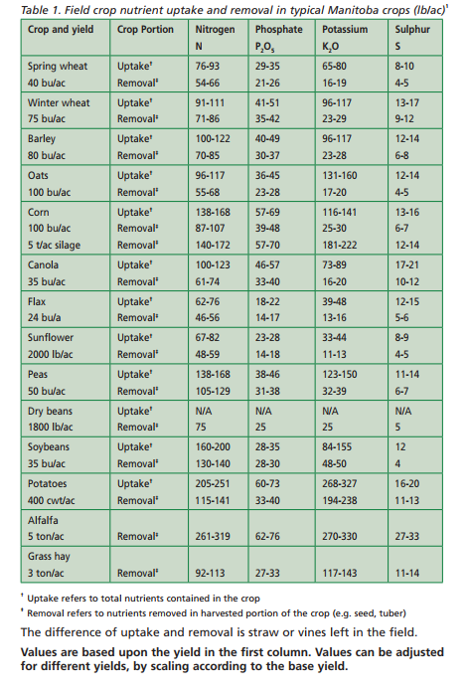
Source for above: https://www.gov.mb.ca/agriculture/crops/soil-fertility/soil-fertility-guide/pubs/soil_fertility_guide.pdf

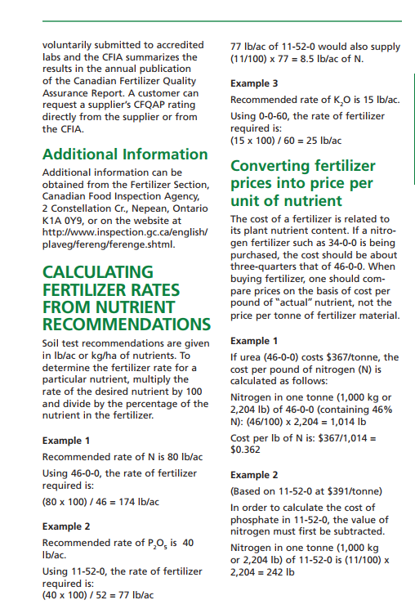
Consultants often shoot for 350 cwt/A min, but 400 is their ideal that they are interest in seeing research shoot for. With this yield we’re in the market for
- 251 lbs/A N
- 73 lbs/A phosphate (P203)
- 327 lbs/A potassium (K20)
- 20 lbs/A Sulfur

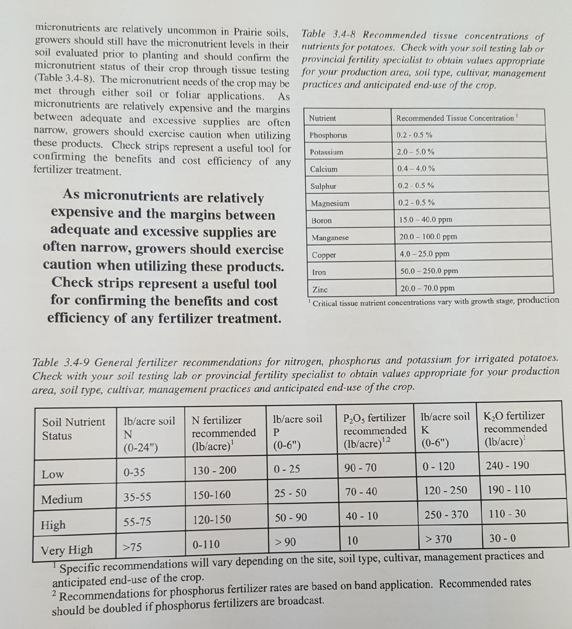
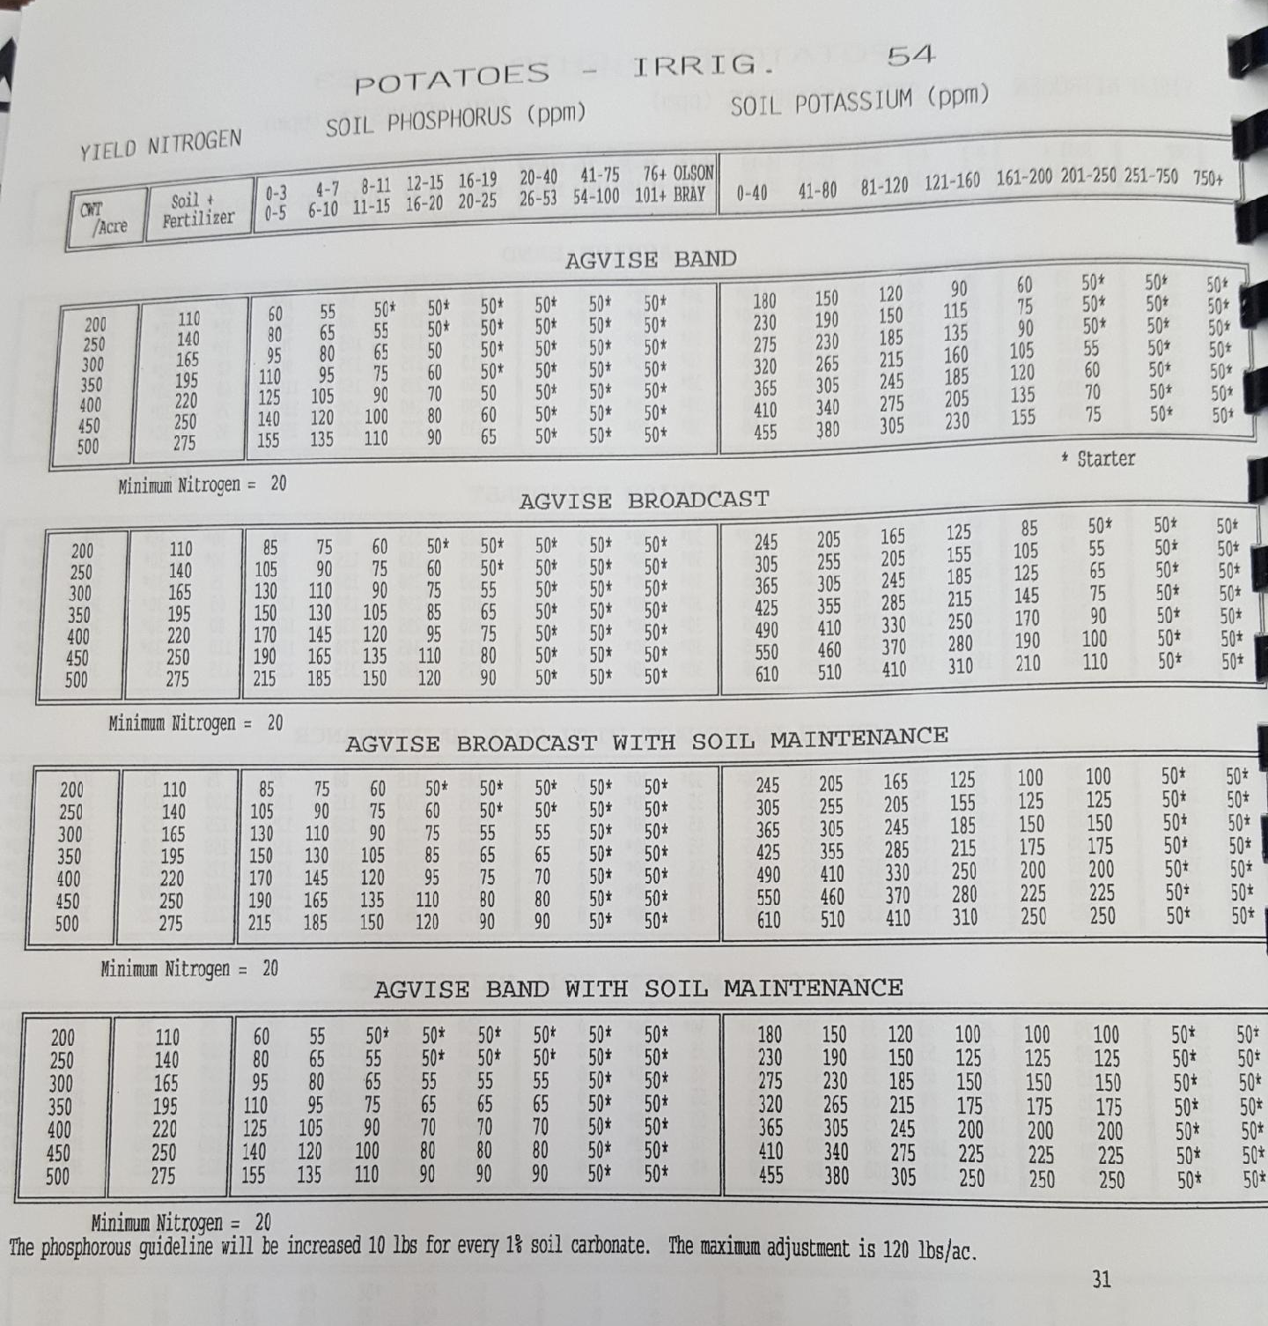

Tables

Table 1. The 46 of the 97 independent variables that were identified through partial least squares analysis showed that 56% of the variability in all response variables taken together for the processing total yield.
Obs | Label | VIP†
1 | Napetrc | 2.0026
2 | Capetrc | 1.80988
3 | Nrc624 | 1.61129
4 | Capetmb | 1.48229
5 | Nrc024 | 1.4743
6 | NO3petrc | 1.41181
7 | Bpetlb | 1.34772
8 | Smb06 | 1.29528
9 | Krc06 | 1.28069
10 | Capetlb | 1.24301
11 | pHf06 | 1.21799
12 | Nrc06 | 1.18379
13 | OMf624 | 1.17585
14 | Plb06 | 1.16401
15 | Spetrc | 1.14619
16 | NO3petmb | 1.14344
17 | Klb06 | 1.12154
18 | Kmb06 | 1.12083
19 | Smb624 | 1.11924
20 | Kpetmb | 1.11382
21 | mc1224 | 1.11024
22 | Napetlb | 1.10085
23 | OMf06 | 1.0864
24 | sa1530 | 1.08607
25 | si1530 | 1.0788
26 | si015 | 1.07253
27 | sa015 | 1.06566
28 | vertcopies | 1.06107
29 | Ppetlb | 1.04159
30 | pHf624 | 1.04055
31 | mc012 | 1.02729
32 | penf030 | 1.0195
33 | cl1530 | 1.00754
34 | Slb06 | 0.9956
35 | penf3060 | 0.98307
36 | ECf06 | 0.98001
37 | cl015 | 0.96815
38 | penh3060 | 0.95447
39 | Ppetrc | 0.94666
40 | bd012 | 0.94248
41 | Slb024 | 0.90615
42 | Slb624 | 0.87738
43 | Pmb06 | 0.86759
44 | Bpetmb | 0.83645
45 | Mgpetrc | 0.82972
46 | Mgpetlb | 0.79698
† Variable importance in the projection.

Table 2. The 46 of the 97 independent variables that were identified through partial least squares analysis showed that 58% of the variability in all response variables taken together for the processing value.
Obs | Label | VIP †
1 | Napetrc | 2.11621
2 | Capetrc | 1.93348
3 | Nrc624 | 1.55998
4 | Nrc024 | 1.50282
5 | Capetmb | 1.48782
6 | Smb06 | 1.42632
7 | Capetlb | 1.31038
8 | Nrc06 | 1.29746
9 | Napetlb | 1.28349
10 | Krc06 | 1.26368
11 | NO3petrc | 1.2524
12 | Bpetlb | 1.17175
13 | Plb06 | 1.16575
14 | OMf624 | 1.1594
15 | vertcopies | 1.13335
16 | Kpetmb | 1.13124
17 | Spetrc | 1.1191
18 | ECf06 | 1.11586
19 | mc1224 | 1.10633
20 | NO3petmb | 1.09028
21 | si1530 | 1.08177
22 | penf030 | 1.07939
23 | OMf06 | 1.07078
24 | Klb06 | 1.07038
25 | sa1530 | 1.0693
26 | Slb06 | 1.06399
27 | Kmb06 | 1.05606
28 | si015 | 1.05419
29 | pHf06 | 1.05159
30 | sa015 | 1.04887
31 | Ppetlb | 1.04552
32 | mc012 | 1.04519
33 | Slb024 | 1.01048
34 | penf3060 | 1.00388
35 | penh3060 | 0.97919
36 | cl015 | 0.95998
37 | cl1530 | 0.95994
38 | Slb624 | 0.95615
39 | bd012 | 0.95314
40 | Counts | 0.91475
41 | Ppetrc | 0.9024
42 | Smb624 | 0.88195
43 | Kpetlb | 0.87733
44 | Src024 | 0.86087
45 | Src06 | 0.8361
46 | Smb024 | 0.82821
† Variable importance in the projection.

Table 3. The 42 of the 97 independent variables that were identified through partial least squares analysis showed that 53% of the variability in all response variables taken together for the percentage of processing tubers < 3 oz.
Obs | Label | VIP †
1 | Napetrc | 2.33517
2 | Smb06 | 1.82333
3 | Spetmb | 1.66885
4 | Mgpetlb | 1.55429
5 | Kpetlb | 1.47288
6 | Capetrc | 1.41899
7 | Slb024 | 1.3979
8 | Slb624 | 1.39502
9 | Spetrc | 1.36668
10 | Smb024 | 1.3563
11 | Nrc624 | 1.34666
12 | Kpetmb | 1.29612
13 | Nrc024 | 1.26591
14 | Ppetlb | 1.25934
15 | Src06 | 1.25287
16 | NO3petlb | 1.25262
17 | sa015 | 1.19658
18 | mc012 | 1.16833
19 | si015 | 1.16397
20 | OMf624 | 1.1621
21 | ECf624 | 1.14585
22 | si1530 | 1.14497
23 | cl015 | 1.142
24 | Spetlb | 1.12973
25 | sa1530 | 1.1229
26 | OMf06 | 1.09355
27 | Nrc06 | 1.06498
28 | cl1530 | 1.04347
29 | Mgpetmb | 1.03079
30 | ECf06 | 1.0282
31 | Slb06 | 1.01257
32 | Src024 | 1.01168
33 | Bpetlb | 0.99534
34 | Ppetmb | 0.96861
35 | Kmb06 | 0.91097
36 | penf3060 | 0.88523
37 | Krc06 | 0.88117
38 | penh3060 | 0.88054
39 | bd012 | 0.87423
40 | Nlb06 | 0.85891
41 | Smb624 | 0.84683
42 | Klb06 | 0.82722
† Variable importance in the projection

Table 4. The 46 of the 97 independent variables that were identified through partial least squares analysis showed that 61% of the variability in all response variables taken together for the percentage of 3-6 oz processing tubers.
Obs | Label | VIP †
1 | Napetrc | 2.31904
2 | Capetrc | 1.70787
3 | Nrc024 | 1.58526
4 | Nrc624 | 1.52515
5 | Nrc06 | 1.50554
6 | Capetlb | 1.45137
7 | Smb06 | 1.39233
8 | Krc06 | 1.37347
9 | ECf06 | 1.3095
10 | Src06 | 1.30299
11 | OMf06 | 1.29627
12 | Bpetlb | 1.2742
13 | Spetrc | 1.26497
14 | si1530 | 1.20922
15 | sa1530 | 1.19932
16 | mc012 | 1.1989
17 | Kmb06 | 1.19191
18 | sa015 | 1.17462
19 | Capetmb | 1.16742
20 | si015 | 1.16164
21 | OMf624 | 1.16101
22 | Spetmb | 1.13846
23 | Slb024 | 1.13097
24 | Napetlb | 1.12677
25 | Klb06 | 1.11183
26 | cl1530 | 1.11171
27 | cl015 | 1.09116
28 | penh3060 | 1.0892
29 | Slb624 | 1.08403
30 | penf3060 | 1.0834
31 | NO3petmb | 1.01849
32 | vertcopies | 1.01358
33 | Slb06 | 1.00587
34 | Src024 | 0.96671
35 | bd012 | 0.96547
36 | penf030 | 0.96373
37 | Smb024 | 0.90537
38 | Kpetlb | 0.89841
39 | Counts | 0.84933
40 | NO3petrc | 0.84799
41 | Nlb06 | 0.83971
42 | Smb624 | 0.83455
43 | Bpetrc | 0.82373
44 | NO3petlb | 0.82027
45 | Mgpetlb | 0.80826
46 | ECf624 | 0.80794
† Variable importance in the projection.

Table 5. The 46 of the 97 independent variables that were identified through partial least squares analysis showed that 46% of the variability in all response variables taken together for the percentage of 6-10 oz processing tubers.
Obs | Label | VIP †
1 | Napetrc | 1.87159
2 | NO3petlb | 1.75929
3 | Spetrc | 1.68456
4 | Nrc06 | 1.60333
5 | Nrc024 | 1.56449
6 | Bpetlb | 1.5389
7 | Capetrc | 1.50346
8 | Nrc624 | 1.39974
9 | Spetmb | 1.3878
10 | Smb06 | 1.34013
11 | OMf624 | 1.2688
12 | cl1530 | 1.23204
13 | cl015 | 1.22936
14 | Bpetrc | 1.22593
15 | sa015 | 1.19163
16 | Kmb06 | 1.18195
17 | Krc06 | 1.16299
18 | Nlb024 | 1.15628
19 | Nlb06 | 1.15039
20 | penf030 | 1.11293
21 | Nmb06 | 1.10159
22 | si015 | 1.09521
23 | mc012 | 1.07732
24 | Slb024 | 1.0737
25 | Nlb624 | 1.06405
26 | Klb06 | 1.05889
27 | Slb624 | 1.02609
28 | Capetlb | 1.02104
29 | bd012 | 1.01594
30 | Bpetmb | 1.01312
31 | Capetmb | 1.01217
32 | Ppetmb | 1.00991
33 | Src624 | 0.98694
34 | Slb06 | 0.98418
35 | sa1530 | 0.97911
36 | si1530 | 0.97199
37 | Spetlb | 0.97011
38 | Smb024 | 0.96723
39 | OMf06 | 0.9412
40 | penh030 | 0.93167
41 | ECf06 | 0.91897
42 | Napetmb | 0.90827
43 | Src024 | 0.90343
44 | penh3060 | 0.86532
45 | penf3060 | 0.85096
46 | NO3petmb | 0.81521
† Variable importance in the projection.

Table 6. The 50 of the 97 independent variables that were identified through partial least squares analysis showed that 52% of the variability in all response variables taken together for the percentage of 10-12 oz processing tubers.
Obs | Label | VIP †
1 | Napetrc | 1.77281
2 | vertcopies | 1.65872
3 | Capetlb | 1.60297
4 | Kpetlb | 1.58411
5 | ECf06 | 1.54282
6 | Capetrc | 1.47907
7 | Kpetmb | 1.41185
8 | Krc06 | 1.28551
9 | sa015 | 1.25384
10 | Capetmb | 1.25353
11 | mc012 | 1.24535
12 | Smb624 | 1.23504
13 | OMf06 | 1.23149
14 | sa1530 | 1.22217
15 | si1530 | 1.2195
16 | cl015 | 1.21577
17 | Bpetlb | 1.21306
18 | Kmb06 | 1.21277
19 | penf3060 | 1.2121
20 | si015 | 1.2098
21 | cl1530 | 1.15886
22 | OMf624 | 1.15386
23 | NO3petmb | 1.14681
24 | Src06 | 1.13202
25 | Napetlb | 1.11318
26 | Klb06 | 1.09529
27 | Smb06 | 1.09068
28 | penh3060 | 1.05467
29 | Slb024 | 1.02883
30 | Src024 | 1.02689
31 | Nlb624 | 1.00225
32 | bd012 | 1.00224
33 | Slb624 | 0.9933
34 | Mgpetlb | 0.95901
35 | pHf06 | 0.94037
36 | Smb024 | 0.92422
37 | penf030 | 0.91802
38 | NO3petrc | 0.9161
39 | Spetrc | 0.90672
40 | Slb06 | 0.90531
41 | Ppetlb | 0.90027
42 | Nlb024 | 0.86592
43 | ECf624 | 0.86044
44 | Nrc024 | 0.85544
45 | Spetmb | 0.84456
46 | Nrc624 | 0.83334
47 | Counts | 0.82633
48 | Mgpetmb | 0.8212
49 | penh030 | 0.81982
50 | Nrc06 | 0.8066
† Variable importance in the projection.

Table 7. The 50 of the 97 independent variables that were identified through partial least squares analysis showed that 57% of the variability in all response variables taken together for the percentage of 6-12 oz processing tubers.
Obs | Label | VIP †
1 | Napetrc | 2.14939
2 | Capetrc | 1.76201
3 | Nrc06 | 1.5534
4 | Nrc024 | 1.54132
5 | Bpetlb | 1.53551
6 | Spetrc | 1.44346
7 | ECf06 | 1.43153
8 | Nrc624 | 1.40466
9 | Capetlb | 1.4041
10 | Spetmb | 1.39256
11 | Krc06 | 1.34764
12 | Smb06 | 1.32659
13 | Kmb06 | 1.23722
14 | OMf624 | 1.20433
15 | OMf06 | 1.18574
16 | sa015 | 1.16058
17 | Bpetrc | 1.15251
18 | cl1530 | 1.14903
19 | sa1530 | 1.1485
20 | Capetmb | 1.14679
21 | mc012 | 1.14527
22 | si1530 | 1.14398
23 | si015 | 1.1334
24 | penf3060 | 1.10311
25 | Klb06 | 1.09879
26 | cl015 | 1.09648
27 | Slb024 | 1.05855
28 | penf030 | 1.03406
29 | Slb624 | 1.00952
30 | NO3petlb | 1.00514
31 | NO3petmb | 0.99918
32 | bd012 | 0.99849
33 | Slb06 | 0.99271
34 | penh3060 | 0.98582
35 | vertcopies | 0.90706
36 | Mgpetlb | 0.90496
37 | Src624 | 0.89824
38 | Napetlb | 0.88469
39 | Src024 | 0.87833
40 | Src06 | 0.86273
41 | Smb024 | 0.85542
42 | Smb624 | 0.82847
43 | pHf06 | 0.81454
44 | Kpetlb | 0.81345
45 | NO3petrc | 0.78793
46 | Kpetmb | 0.77594
47 | ECf624 | 0.76113
48 | Bpetmb | 0.73878
49 | pHf624 | 0.71009
50 | mc1224 | 0.67876
† Variable importance in the projection.

Table 8. The 43 of the 97 independent variables that were identified through partial least squares analysis showed that 48% of the variability in all response variables taken together for the percentage of > 12 oz processing tubers.
Obs | Label | VIP †
1 | Napetrc | 2.41186
2 | Src06 | 1.85284
3 | Nrc024 | 1.62971
4 | Nrc624 | 1.61612
5 | Nrc06 | 1.4933
6 | OMf06 | 1.30749
7 | Src024 | 1.30103
8 | si1530 | 1.23523
9 | Smb06 | 1.23233
10 | mc012 | 1.22936
11 | Capetrc | 1.22625
12 | sa1530 | 1.22174
13 | sa015 | 1.21622
14 | si015 | 1.20476
15 | Slb024 | 1.18934
16 | OMf624 | 1.18556
17 | Napetlb | 1.17703
18 | Slb624 | 1.17069
19 | Spetmb | 1.16565
20 | ECf06 | 1.14082
21 | Krc06 | 1.13818
22 | Kmb06 | 1.1265
23 | cl015 | 1.1255
24 | Klb06 | 1.10892
25 | cl1530 | 1.10694
26 | penf3060 | 1.08945
27 | Nlb06 | 1.04871
28 | Capetlb | 1.04618
29 | Spetrc | 1.0414
30 | penh3060 | 1.03008
31 | NO3petrc | 1.02217
32 | bd012 | 1.00114
33 | Smb024 | 0.98928
34 | Bpetlb | 0.98144
35 | Capetmb | 0.9608
36 | Mgpetlb | 0.95784
37 | Slb06 | 0.94082
38 | ECf624 | 0.92528
39 | penf030 | 0.88401
40 | NO3petlb | 0.88237
41 | Kpetlb | 0.88011
42 | Nlb024 | 0.8683
43 | NO3petmb | 0.83142
† Variable importance in the projection.

Table 9. The 48 of the 97 independent variables that were identified through partial least squares analysis showed that 60% of the variability in all response variables taken together for the specific gravity of processing tubers.
Obs | Label | VIP †
1 | Kpetlb | 1.78478
2 | Napetmb | 1.76281
3 | pHf624 | 1.65996
4 | Bpetlb | 1.59166
5 | Krc06 | 1.49081
6 | penf030 | 1.44048
7 | Nlb624 | 1.3842
8 | Nrc06 | 1.36883
9 | Nlb024 | 1.29916
10 | Klb06 | 1.29745
11 | Nrc024 | 1.28148
12 | Kmb06 | 1.27232
13 | Counts | 1.24828
14 | pHf06 | 1.23367
15 | Nmb06 | 1.23282
16 | NO3petlb | 1.21707
17 | Mgpetmb | 1.19928
18 | CFUgsoil | 1.14798
19 | Smb624 | 1.12092
20 | Napetlb | 1.12011
21 | Nrc624 | 1.10835
22 | Kpetrc | 1.09921
23 | ECf624 | 1.09301
24 | Spetrc | 1.09134
25 | Capetmb | 1.07351
26 | Slb624 | 1.05964
27 | Kpetmb | 1.05153
28 | NO3petmb | 1.05046
29 | Bpetmb | 1.03406
30 | Mgpetlb | 1.03024
31 | Slb024 | 1.02283
32 | mc012 | 1.01947
33 | Smb024 | 1.01147
34 | Nlb06 | 1.00215
35 | Capetlb | 0.98487
36 | Nmb024 | 0.96497
37 | OMf624 | 0.95744
38 | sa015 | 0.88815
39 | ECf06 | 0.88487
40 | cl015 | 0.87916
41 | bd012 | 0.85497
42 | OMf06 | 0.85287
43 | penf3060 | 0.84611
44 | sa1530 | 0.84484
45 | si015 | 0.84053
46 | cl1530 | 0.83498
47 | NO3petrc | 0.8221
48 | si1530 | 0.81742
† Variable importance in the projection.

Table 10. A 4-component model containing 21 variables explained 96% of the variability in fresh market total yield.
Obs | Label | VIP †
1 | Nlb06 | 2.1064
2 | Slb06 | 1.54193
3 | Nrc024 | 1.40725
4 | Nrc624 | 1.33334
5 | Pf06 | 1.32418
6 | Slb624 | 1.18478
7 | Pmb06 | 1.17267
8 | Smb06 | 1.10193
9 | Kf06 | 1.07792
10 | Slb024 | 1.04854
11 | Kmb06 | 0.98969
12 | Src06 | 0.97613
13 | Sf06 | 0.97512
14 | Nrc06 | 0.94587
15 | Krc06 | 0.93541
16 | Src624 | 0.92026
17 | Src024 | 0.90982
18 | Plb06 | 0.88626
19 | Klb06 | 0.88208
20 | Nmb624 | 0.86022
21 | Nmb024 | 0.80683
22 | Nf624 | 0.79373
23 | Prc06 | 0.76329
24 | Smb624 | 0.68605
25 | Smb024 | 0.66732
26 | Nf024 | 0.63827
27 | Nlb624 | 0.6154
28 | Sf024 | 0.60916
29 | Nlb024 | 0.57677
30 | Sf624 | 0.48484
31 | Nf06 | 0.4344
32 | Nmb06 | 0.30858
† Variable importance in the projection.

Table 11. A 2-component model containing 19 variables explained 41% of the variability in the percentage of yield in the fresh market 2-2.25-inch diameter category.
Obs | Label | VIP †
1 | Nrc06 | 1.64245
2 | Sf06 | 1.53348
3 | Smb06 | 1.49209
4 | Kf06 | 1.44525
5 | Sf024 | 1.31407
6 | Smb024 | 1.25916
7 | Kmb06 | 1.22948
8 | Slb06 | 1.22776
9 | Src624 | 1.19172
10 | Smb624 | 1.19015
11 | Src024 | 1.17743
12 | Sf624 | 1.12652
13 | Klb06 | 1.11036
14 | Krc06 | 1.10205
15 | Slb624 | 1.09071
16 | Slb024 | 0.98989
17 | Src06 | 0.98205
18 | Nlb024 | 0.88786
19 | Pf06 | 0.84085
20 | Nlb624 | 0.79781
21 | Nrc024 | 0.77767
22 | Nlb06 | 0.72016
23 | Nf06 | 0.66697
24 | Plb06 | 0.59926
25 | Nf024 | 0.5672
26 | Nf624 | 0.48648
27 | Nmb624 | 0.41712
28 | Nmb024 | 0.41101
29 | Nrc624 | 0.352
30 | Prc06 | 0.23954
31 | Nmb06 | 0.21868
32 | Pmb06 | 0.20353
† Variable importance in the projection.

Table 12. A 2-component model containing 17 variables explained 52% of the variability in the percentage of yield in the fresh market 2.25 to 3.0-inch diameter category.
Obs | Label | VIP †
1 | Smb06 | 1.86031
2 | Nrc06 | 1.65166
3 | Smb024 | 1.41118
4 | Sf06 | 1.37166
5 | Kf06 | 1.30696
6 | Sf024 | 1.28875
7 | Smb624 | 1.28632
8 | Src624 | 1.26438
9 | Kmb06 | 1.25066
10 | Src024 | 1.23864
11 | Klb06 | 1.19088
12 | Sf624 | 1.19055
13 | Krc06 | 1.11581
14 | Slb624 | 1.10322
15 | Slb024 | 1.04242
16 | Src06 | 0.93008
17 | Nf06 | 0.91616
18 | Nrc024 | 0.77504
19 | Nf024 | 0.74318
20 | Slb06 | 0.737
21 | Pf06 | 0.63511
22 | Nf624 | 0.55272
23 | Nmb024 | 0.52433
24 | Nmb624 | 0.50932
25 | Pmb06 | 0.49097
26 | Prc06 | 0.47319
27 | Nlb624 | 0.44465
28 | Nlb024 | 0.41362
29 | Nmb06 | 0.36672
30 | Nrc624 | 0.31101
31 | Plb06 | 0.26122
32 | Nlb06 | 0.23745
† Variable importance in the projection.

Table 13. A 2-component model containing 22 variables explained 78% of the variability in the percentage of yield in the fresh market 3.0 to 3.5-inch diameter category.
Obs | Label | VIP †
1 | Smb06 | 2.01853
2 | Plb06 | 1.42494
3 | Smb024 | 1.34518
4 | Nlb06 | 1.31923
5 | Src024 | 1.21066
6 | Smb624 | 1.19106
7 | Src624 | 1.18386
8 | Sf624 | 1.09904
9 | Nmb06 | 1.06481
10 | Nf06 | 1.06142
11 | Slb024 | 1.06086
12 | Klb06 | 1.05775
13 | Sf024 | 1.03577
14 | Kmb06 | 1.01485
15 | Slb624 | 0.98895
16 | Slb06 | 0.97556
17 | Src06 | 0.96702
18 | Nrc06 | 0.95823
19 | Nf024 | 0.92219
20 | Krc06 | 0.91932
21 | Nf624 | 0.85109
22 | Kf06 | 0.80749
23 | Nmb024 | 0.79711
24 | Pmb06 | 0.75952
25 | Nlb024 | 0.72393
26 | Sf06 | 0.70738
27 | Nmb624 | 0.66425
28 | Prc06 | 0.60669
29 | Nrc024 | 0.3561
30 | Nlb624 | 0.33077
31 | Pf06 | 0.28076
32 | Nrc624 | 0.16717
† Variable importance in the projection

