*31/03/2024*

*Business Continuity Plan*

|  |  |  |  |
| --- | --- | --- | --- |
| Date Written | *30/03/24* |  | *Hexgreave Hall* |
| Author(s) | Maria Principe |  | *Farnsfield, Newark* |
| Version | *1* |  | *NG22 8LS* |
| Date Signed Off | *06/01/2024* |  | *info@aneleclinic.co.uk* |
| Reviewed by | *Elena Caraman* |  | *01623 575017* |

The aim of this local business continuity plan is to ensure Anele Health and Beauty Clinic is able to continue to deliver essential patient care and associated services in the face of a disruptive incident.

The key objectives of the plan are to: -

1. Provide basic information about the clinic, including staff and core supplier contact information
2. Provide an overview and prioritisation of essential services delivered by the practice to patients and associated supporting functions
3. Outline and analyse known risks to delivery of these services, including reduction of risks where possible
4. Provide a framework for responding to any disruptive incident the clinic faces
5. Identify some of the key actions staff can take in a disruptive incident

**1.2 Overview of the Clinic and Service Delivered**

Location Include details of location of services Key services provided Detail key services provided e.g. GP services, nursing, dispensary, reception, administration, management

Anele Health and Beauty Clinic offers the following key services:

Finch Lodge, Hexgreave, Nottinghamshire, NG22 8LS, 01623 575017

1. **Aesthetic Services**: Anele Health and Beauty Clinic likely provides a range of aesthetic treatments and services aimed at enhancing one's physical appearance and overall well-being. These services may include procedures such as facials, skin treatments, dermal fillers, botox injections, and more.
2. **Hormone Support**: The clinic specializes in providing hormone support services, which may involve hormone replacement therapy (HRT) or other treatments designed to help individuals achieve hormonal balance. Hormone support can be beneficial for various health and wellness goals.

**1.3.Notification**

In the event of an incident Elena Caraman or Hannah Walker will ensure all staff are notified using the contact directory in the back of this plan.

**1.4.Communications**

In the event of an incident, the clinic will ensure that any patients, stakeholders and staff are notified of any service changes. Thought will be given to the nature of the impact and the knock of effects this will have. Where services are affected, it is critical to ensure patients are notified of changes using a number of means. These may include a notice on the clinic door, utilising our internet and social media pages, calling patients who have appointments during the incident, changing voicemail message. Our Receptionist will play a key role in ensuring these actions are undertaken.

**1.5 Risk Assessment**

The following risk assessment has been undertaken and likelihood considered.

|  |  |  |  |  |  |
| --- | --- | --- | --- | --- | --- |
| Risk | Impact (1-5) | Likelihood (1-5) | Scope  Impact x Likelihood | Mitigating Actions | Owner |
| Data Breach | 2 | 2 | 4 | Implement robust cybersecurity measures, including firewalls and encryption.  Regularly update and patch software to address vulnerabilities.  Train staff on data security best practices. | Hannah Walker |
| Cybersecurity Threats | 1 | 1 | 2 | Conduct regular cybersecurity assessments and penetration testing.  Back up critical data regularly and store it securely.  Invest in cybersecurity insurance. | Hannah Walker |
| Infection Control | 3 | 3 | 9 | Adhere strictly to infection control protocols.  Provide staff with appropriate personal protective equipment (PPE).  Conduct regular audits of cleanliness and hygiene. | Elena Caraman |
| Equipment Failure | 3 | 3 | 9 | Implement a routine equipment maintenance program.  Maintain a backup plan for essential equipment.  Train staff in recognizing equipment malfunctions. | Hannah Walker/Elena Caraman |
| Staff Shortage | 3 | 3 | 9 | Cross-train staff to perform essential functions.  Develop a contingency plan for temporary staffing shortages.  Offer competitive compensation and benefits to reduce turnover. | Elena Caraman |
| Supply Chain Disruption | 2 | 1 | 2 | Maintain a diverse supplier base to reduce reliance on a single source.  Develop a supply chain continuity plan for emergencies.  Monitor suppliers' financial health. | Hannah Walker/Elena Caraman |
| Natural Disaster | 1 | 1 | 1 | Conduct regular safety drills and develop an emergency response plan.  - Ensure the clinic's infrastructure is designed to withstand local risks.  - Have backup power sources in place. | Hannah Walker |
| Fire Hazard | 4 | 1 | 4 | Conduct regular fire safety inspections and maintain fire extinguishers.  - Educate staff on fire safety procedures.  - Install smoke detectors and sprinkler systems. | Elena Caraman |
| Financial Risk | 3 | 3 | 9 | Conduct regular financial audits to identify and rectify errors.  - Establish a financial risk management strategy.  - Diversify revenue streams if possible. | Elena Caraman/Accountant |
| Flood | 1 | 1 | 1 | Ensure building and water supply are safe, (not within a flooding area) | Hannah Walker |

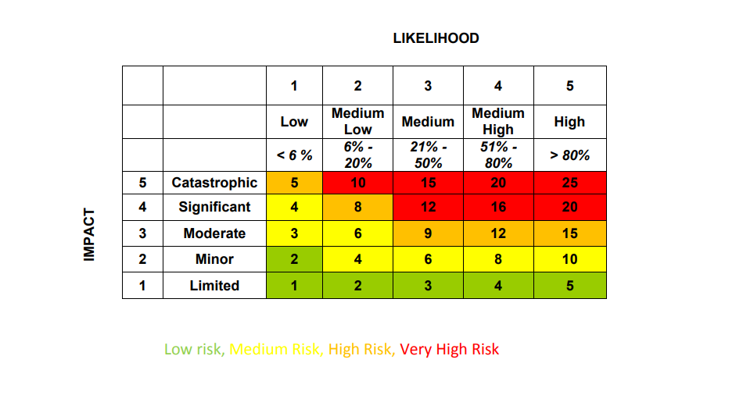

**1.6. Identification of Vulnerable Patients**

An incident, whether internal to the clinic or affecting the local area, has the potential to impact patients who may be deemed as vulnerable. There is a requirement on the clinic to make an assessment of vulnerable patients and consider relevant actions to mitigate the risk to them. How the vulnerability is defined will vary depending on the incident and should be a dynamic decision considering the impacts of the incident and how it will affect those considered vulnerable. Once patients are identified specific actions need to be considered to support, in conjunction with partners, those affected by an incident.

**1.7. Major Incidents/System Escalation**

If a major incident has been declared support may be required from the clinic to the NHS. Anele Clinic will respond accordingly. As Anele Clinic does not delivery life impacting care, the impact to the clinic and its patients will be low risk.

**1.8. Surge and Escalation**

The clinic will if required, be prepared to deal with incidents which may cause a surge in patient attendance/registration. Examples may include local infectious disease outbreak or a loss of services.

**1.9.Staff Roles in an Incident**

|  |  |
| --- | --- |
| Position | Role in Incident |
| Elena Caraman | **(Incident Coordinator):** Responsible for overseeing the implementation of the BCP, coordinating responses to incidents, and ensuring the plan's execution. |
| Hannah Walker | **(Resource Coordinator)**: Responsible for ensuring that necessary resources and supplies are available, coordinating resource allocation, and managing inventory. |
| Hannah Walker | **(Communication Officer)**: Responsible for managing internal and external communication during an incident, including communicating with clients, staff, and external authorities. |

**2.0 Keeping Essential Services Functioning**

This plan is designed to ensure essential services continue to function in an incident. These are time critical services which must continue to ensure the delivery of patient care and other associated functions. Priority for restoration of these services is designated by the maximum acceptable period of disruption. A key part of this is identifying essential activities, the impact of a disruption and the resources required to maintain/restore them. Below are listed the essential activities undertaken by a practice, focused on patient services, and the maximum period these cannot function for. The tables on the following page list what resources are required to ensure these continue to function.

|  |  |  |  |  |
| --- | --- | --- | --- | --- |
| Number | Essential Activities Undertaken | Maximum acceptable  service disruption  Red = up to 24 hour  Amber = up to 72 hours  Green = up to 5 days | Responsible lead | Minimum number of staffing required |
|  | Medical Aesthetics |  | E Caraman | 1 |
|  | Hormone Clinics |  | E Caraman | 1 |
|  | Salon Services |  | E Caraman | 1 |
|  | IV Wellness |  | E Caraman | 1 |
|  | Back Pain (LPG) |  | E Caraman | 1 |
|  | Counselling/Support |  | C Coxson | 1 |

**2.1 Essential Services Functioning**

|  |  |
| --- | --- |
| **1** | **Minimum Premises Requirements**  A room, to hold consultations. |
| **2** | **Minimum Information Requirements**  Access to Nurse Aesthetics Software |
| **3** | **Minimum Technology Requirements**  Access to Nurse Aesthetics Software  Wifi and internet access |
| **4** | **Minimum Clinical Equipment Required**  **PC or laptop** |
| **5** | **Minimum Supplies required to maintain/restore the service**  Nurse Aesthetic Software  Orchard Medical Practice |
| **6** | **Stakeholders required to maintain/restore the service**  Elena Caraman  Maria Principe  Hannah Walker |
| **7** | **Staff required to maintain/restore service**  Elena Caraman  Maria Principe |

**3.0 Contact Details**

|  |  |
| --- | --- |
| **Position** | **Contact Details** |
| Elena Caraman | 07830 222744 |
| Hannah Walker | **07368 818284** |
| Hexgreave Hall  (utilities, Internet and burglar alarm). | **01623 884340** |
| Nurse Aesthetics Software | **07399 864626** |

**4.0 Initial Actions to take in the event of an incident**

When an incident occurs there are a number of key initial actions which should be taken to assess the incident, its impact on essential services and ensure the correct stakeholders are notified. The diagram should be followed in the event of an incident which could potentially impact on essential services and patient care.

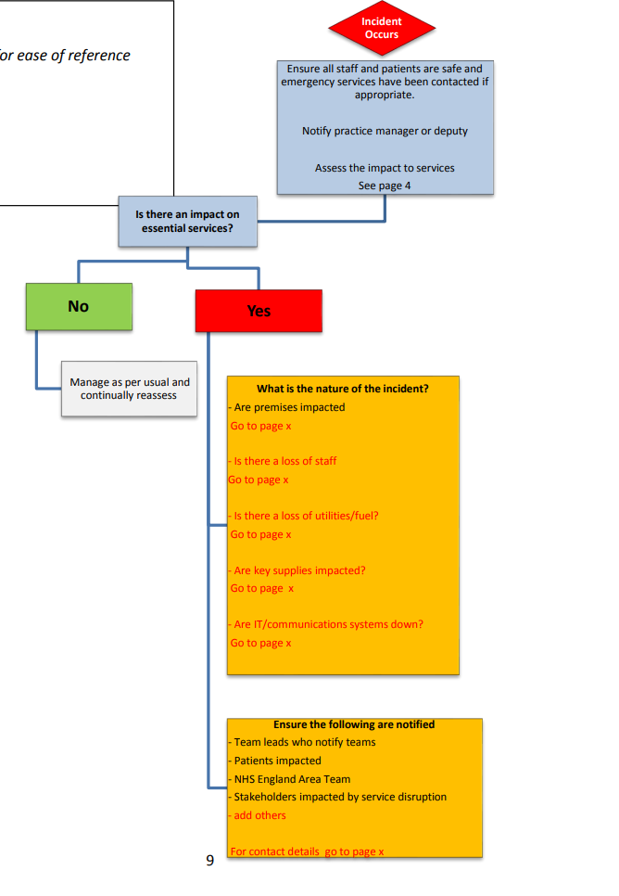

**5.0 Key Premises Details**

|  |  |  |
| --- | --- | --- |
| Type of Information | Location | Comments |
| Key Holder | Elena Caraman  Hannah Walker |  |
| Building Alarm | Directly as adjacent to front door | Hexgreave, also have Burglar alarm details |
| Gas Shut off | Outside door, near Garage | Hexgreave facilities manager has access and available 24/7 |
| Water Stop Cock | Hexgreave facilities manager has access and available 24/7 |  |
| Fuse Box | Downstairs Kitchen, near Boiler | Hexgreave facilities manager has access and available 24/7 |
| Fire Fighting equipment | Located in each room | Hexgreave facilities manager has access and available 24/7 |

**6.0 Moving to Alternative Premises**

Statement on Business Continuity

Anele Health and Beauty Clinic recognizes the importance of business continuity planning to ensure the well-being and safety of our clients, staff, and stakeholders. In the event of a major incident or disruption, we want to clarify our approach:

As a wellness clinic offering aesthetic and hormone support services, our operations are not classified as critical in the context of emergency response. Therefore, in the event of a major incident or disruption, our primary focus will be on the well-being of our clients and staff while maintaining continuity of service to the best of our ability within our existing premises.

We understand the significance of our services to our clients, and we are committed to minimizing any potential impact on their well-being. Our dedicated team will follow established business continuity plans and protocols to address incidents and ensure the safety of all individuals on our premises.

While we do not have plans to relocate to alternative premises in the event of a major incident, we have implemented comprehensive risk management and mitigation strategies to address potential risks specific to our services and location. These strategies include measures to safeguard data, protect against cyber threats, ensure infection control, and maintain the safety of our premises.

It is our priority to provide our clients with safe and high-quality services, and we will continue to work diligently to achieve this goal while remaining committed to the well-being of all those associated with Anele Health and Beauty Clinic.

This statement serves as a commitment to transparency in our approach to business continuity planning and response.

**7.0 Utilities Management and Leasing Agreement**

At Anele Health and Beauty Clinic, we place great emphasis on the seamless management of utilities to ensure the uninterrupted provision of our services. Our leasing agreement with Hexgreave Hall acknowledges the integral role that utilities play in our daily operations.

As part of our commitment to maintaining continuous services, it is essential that utilities such as electricity, water, and heating remain operational. In the event of a loss of utility supply that affects our clinic's ability to operate, we have established a clear protocol.

In such situations, either Elena Caraman or Maria Principe, key coordinators responsible for various aspects of our clinic's operations, will initiate immediate contact with Hexgreave Hall. This communication will serve to alert them to the utility issue and facilitate a swift resolution. Our collaboration with Hexgreave Hall underscores our shared commitment to ensuring that utility-related disruptions are addressed promptly and efficiently. We recognize the importance of utilities management in upholding the high standards of care and service that our clients expect from Anele Health and Beauty Clinic.

This statement affirms our dedication to maintaining a strong partnership with Hexgreave Hall and our commitment to managing utilities effectively to safeguard the well-being and satisfaction of our clients.

**8.0 Loss of Staff**

At Anele Health and Beauty Clinic, we recognise that our dedicated staff members are an invaluable part of our team, contributing significantly to the high-quality services we provide. We are committed to ensuring the continued smooth operation of our clinic in the event of staff turnover or departures.

In cases where staff members are no longer available to fulfil their roles, we have a structured workforce planning approach to address these situations effectively. It is important to note that none of our clinic's functions are life-threatening; therefore, our approach prioritises facilitating appropriate replacements while maintaining the quality of care and service we offer.

Clinical Staff: In the event of the loss of clinical staff members, including advanced nurse practitioners, our approach involves collaborating with clinical banks and relevant healthcare organisations to source skilled and qualified replacements. This ensures that our clients continue to receive the highest level of care and expertise, even in the absence of specific team members.

Beauty Team: For our beauty services, we have established adequate backfill resources within our team to provide support during periods of staff absence. This proactive approach allows us to maintain service continuity and uphold the high standards of our beauty treatments.

Our commitment to workforce planning and the recruitment of appropriate replacements underscores our dedication to our clients' well-being and satisfaction. We understand the importance of seamless service delivery and are prepared to take the necessary steps to ensure that any staff transitions do not disrupt the quality and availability of our services.

**Monitoring and Review**

The Managing Director will check this policy is working properly, and they will review it at least once a year. We will make improvements to the policy wherever we can.

Employees are invited to suggest any ways the policy can be improved.

**Authorisation and Signature**

This Policy is the authorised version agreed by the Directors of Anele Health & Beauty Clinic*.* All employees are expected to follow this policy and failure to do so could result in disciplinary action.

SIGNATURE

Elena Caraman

**Director**

March 2025