

T1X CUSTOM ORDER FORM

Follow the steps below to build your T1X Custom golf putter. Upon completion of this form, please submit the form with any additional documentation to Bowden 3D. Please submit multiple forms if multiple putter configurations are being ordered.

|  |  |
| --- | --- |
| First Name: | Click or tap here to enter text. |
| Last Name: | Click or tap here to enter text. |
| Shipping Address: | Click or tap here to enter text. |
| Valid Email: | Click or tap here to enter text. |
| Phone (Optional): | Click or tap here to enter text. |
| Putter Quantity: | Click or tap here to enter text. |

1. CLUB HEAD COLOR

The first step is choosing your Club Head color. The Club Head color is the main color of the club. Select a color and type the Color ID in the Club Head Color ID field below. Additional colors are available upon request.

 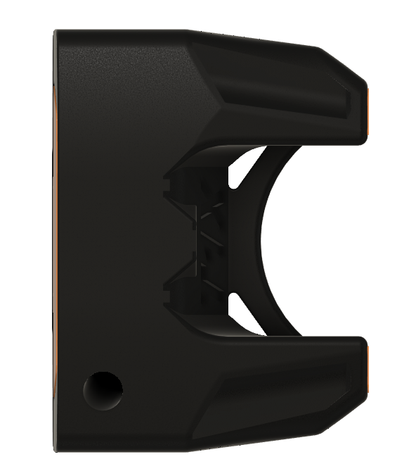

|  |  |
| --- | --- |
| Club Head Color ID: | Enter Color ID Here |

1. PRIMARY COLOR

The second step is choosing your Primary color. The Primary color is the color of the club face, rear bumpers, and the aim line. Select a color and type the Color ID in the Primary Color ID field below. Additional colors are available upon request.

 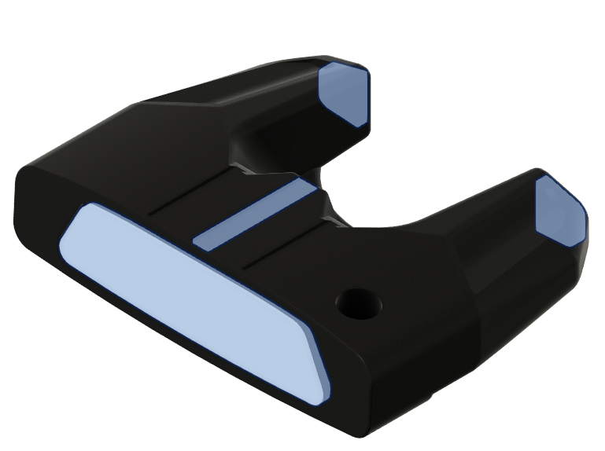

|  |  |
| --- | --- |
| Primary Color ID: | Enter Color ID Here |

1. SECONDARY COLOR

The third step is choosing your Secondary color. The Secondary color is color of the small aim lines along with the T1X logo. Select a color and type the Color ID in the Secondary Color ID field below. Additional colors are available upon request.

 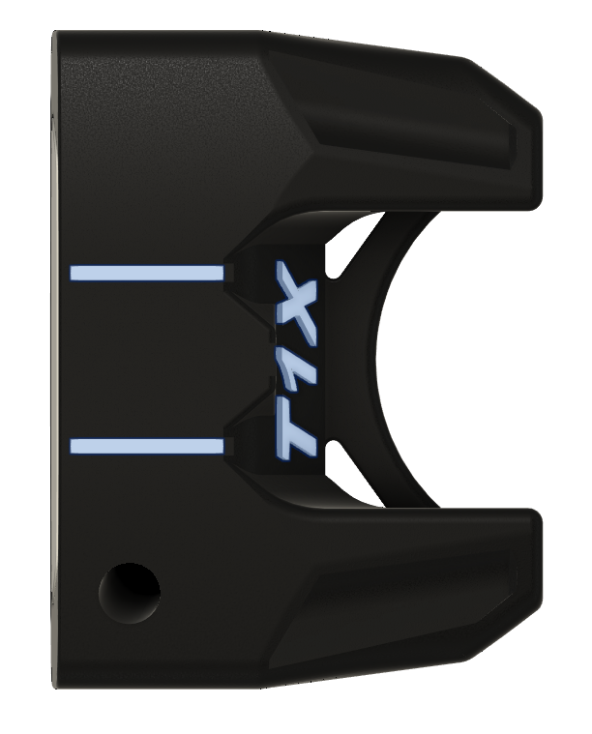

|  |  |
| --- | --- |
| Secondary Color ID: | Enter Color ID Here |

1. CUSTOM ENGRAVING

Bowden 3D can engrave nearly any request.

For text only, please specify the text below. Example of text only engraving is shown below.

For logos, please upload photo (JPEG preferred) below.

|  |
| --- |
| Click or tap here to enter text. |

Custom Engraving: (14 Character Maximum)

|  |
| --- |
|  |

Custom Logo:

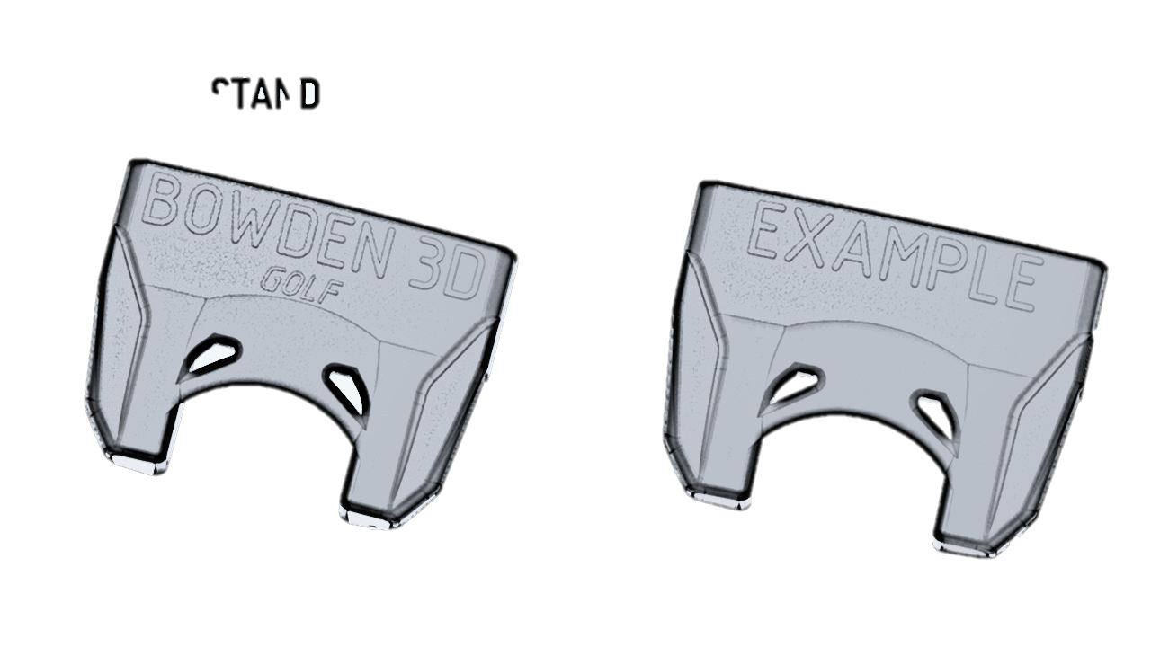

*STANDARD ENGRAVING TEXT ONLY EXAMPLE*

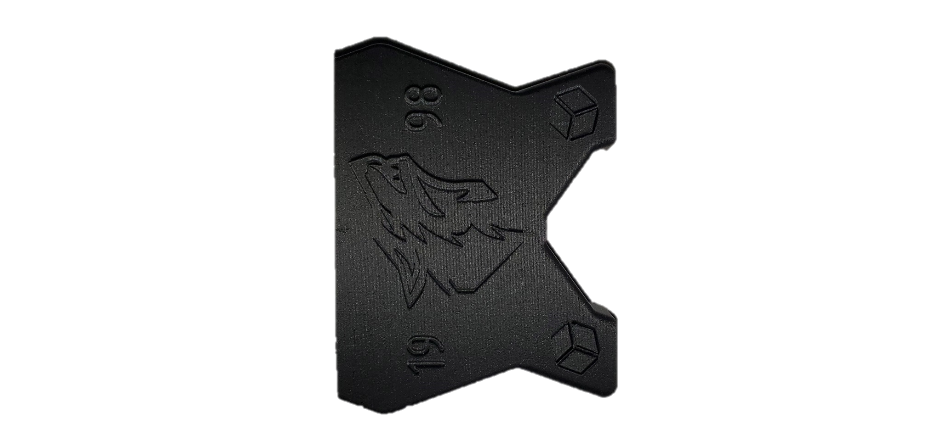

*EXAMPLE LOGO SHOWN*

1. SHAFT LENGTH

Next please specify the shaft length. This is the overall shaft length of the putter. Please check the desired golf club shaft length.

|  |  |
| --- | --- |
| Shaft Length | Select Option |
| 32" |  |
| 33" - Standard |  |
| 34" - Standard |  |
| 35" - Standard |  |
| 36" |  |

1. GRIP

A Mid-Size Royal Pistol Grip is included with every T1X Custom putter.

Have a specific grip in mind?

For a custom grip, please copy and paste a link to the grip in the field below.

|  |
| --- |
| Enter URL Here |

Custom Grip URL:

1. Pricing and Payment

Upon completion, submit this form to the “Attach Files” link in the Custom Putters tab on our website.

Within 48 hours, Bowden 3D will send a quote and payment options. Once payment has been received, Bowden 3D will send a digital prototype photo of your putter. Once you approve, the putter will be manufactured and shipped! Generally custom orders ship within 1-2 weeks.

General pricing is below:

|  |  |
| --- | --- |
| T1X Custom | $179.99 |
| Any Additional Colors Not Listed (Optional) | Varies (Approx $20-$30) |
| Logos (Optional) | Varies (Approx $5-$25) |
| Non-Standard Grip (Optional) | Price of Grip |

*Pricing is pre-tax and shipping*

T1X specifications:

- Rigid steel and resin reinforced 3D printed club head

- Shaft balancing counterweight

- 70° lie angle

- 3° of loft

- Horizontal putting face groove lines

- Light putter head weight, 315g

- Odyssey double bend True Temper putting shaft

- Mid-Size pistol grip

- Ball scoop

- Included protective club head cover