HAPPY THANKSGIVING 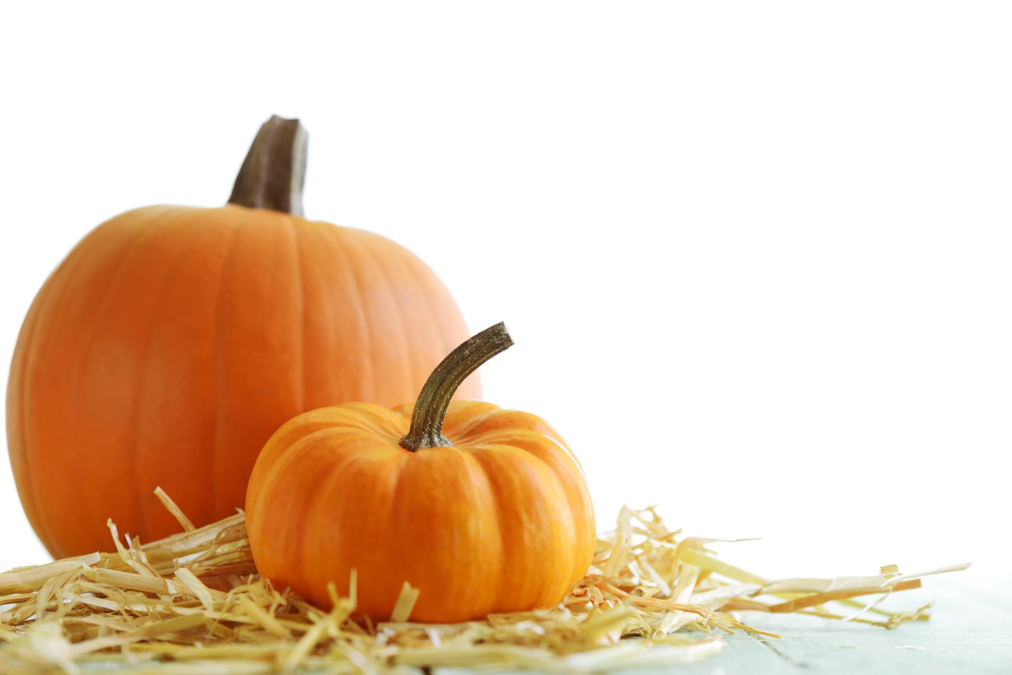
Hope all are continuing to be safe and healthy, we are all good here….Once again, “THANKS” to all who gave me a heads-up for the weekends off in November. Below you will find the schedule for Christmas and New Year’s Masses. Please check your calendar to see if you will be available to help out for these Masses and let me know…..There will be 3 Ad Orientum Masses in December: December 4, 11, and 18 so please let me know if you can help out with these Saturday morning Masses as well as your requests for weekends off in December.

Friday, December 24 - Christmas Eve Mass Schedule
4:00 pm – SJA – Children’s Mass – No Lectors Needed
6:30 pm – OLPH – Confirmation Students as Lectors
8:30 pm – Spanish - OLPH
12:00 pm – OLPH – Midnight Mass – Need 2 Lectors

Saturday, December 25 - Christmas Day Mass Schedule
5:00 pm – SJA – Need 2 Lectors

Sunday, December 26 – Regular Mass Schedule
+ + + + + + + + + + + + + + + + + + + + + + + + + + + + + + + + + + + + + + +
Friday, December 31 – New Year’s Eve Mass Schedule
8:30 am – OLPH – Need 2 Lectors
5:00 pm – SJA – Need 2 Lectors

Saturday, January 1 – New Year’s Day Mass Schedule
5:00 pm – SJA – Need 2 Lectors

Sunday, January 2 – Regular Mass Schedule

Thank You so very much to every one for volunteering for this Ministry. Please feel free to call (979-236-3978) or e-mail (lmiska@yahoo.com) if you have any questions or if there is a problem of any kind.

Linda Miska

