* **HAPPY THANKSGIVING**  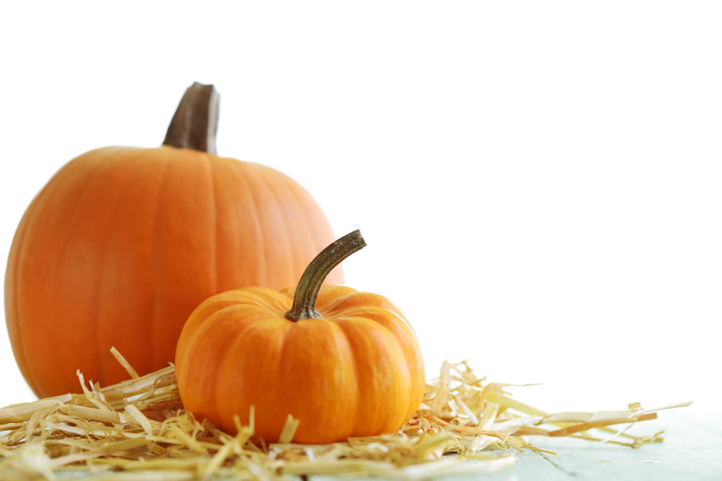

Hope all are continuing to be safe and healthy, we are all good here….Once again,“THANKS” to all who gave me a heads-up for the weekends off in November. Below you will find the schedules for the Immaculate Conception, Christmas and New Year’s Masses. Please check your calendar to see if you will be available to help out for these Masses and let me know…..There will be an Ad Orientem Mass on Saturday, December 3, so please let me know if you can help out with the this Mass as well as your requests for weekends off in December.

**Wednesday, December 7 - Vigil Mass for the**

**Immaculate Conception**

* **6:00 pm at SJA - Need 2 Lectors, Rosary Leader**

**& Sacristan**

**Thursday, December 8 – Immaculate Conception**

* **8:30 am at SJA - Need 2 Lectors, Rosary Leader**

**& Sacristan**

* **6:00 pm at OLPH - Need 2 Lectors, Rosary Leader**

**& Sacristan**

+ + + + + + + + + + + + + + + + + + + + + + + + + + + + + + + + + + + + + + +

**Saturday, December 24 - Christmas Eve Mass Schedule**

* **4:00 pm – SJA – Children’s Mass - Need 2 Lectors, Rosary Leader & Sacristan possibly**
* **7:00 pm – OLPH - Spanish**
* **11:55 pm – OLPH – Midnight Vigil Mass – Need 2 Lectors, Rosary Leader & Sacristan**

**Sunday, December 25 - Christmas Day Mass Schedule**

* **9:30 am – SJA – Need 2 Lectors,** **Rosary Leader & Sacristan**

+ + + + + + + + + + + + + + + + + + + + + + + + + + + + + + + + + + + + + + +



**Saturday, December 31 – New Year’s Eve Mass Schedule**

* **5:00 pm – SJA – Need 2 Lectors, Rosary Leader & Sacristan**

**Sunday, January 1 – New Year’s Day Mass Schedule**

* **Normal Mass Schedule - Need 2 Lectors, Rosary Leader & Sacristan at 8:30 am and 10:30 am Masses**

**Thank You so very much to every one for volunteering for this Ministry. Please feel free to call (979-236-3978) or e-mail (**[**lmiska@yahoo.com**](http://us.f518.mail.yahoo.com/ym/Compose?To=lmiska@yahoo.com)**) if you have any questions or if there is a problem of any kind.**

***