神学导论 (Introduction to Theology)
- 《神学》介绍 Introduction to THEOLOGY
- 纯正教义的重要性 The Importance of Sound Doctrine
- 提前1:3; 4:16; 提后4:3; 提多书1:9; 2:1
- 1 Tim.1:3; 4:16; 2 Tim. 4:3; Titus 1:9; 2:1
- 十大得到错误答案的原因 Top 10 Reasons we get Wrong Doctrine
  - __________________________ 6) __________________________
  - __________________________ 7) __________________________
  - __________________________ 8) __________________________
  - __________________________ 9) __________________________
  - __________________________ 10) __________________________
- 十大获得正确答案的原因 Top 10 Reasons we get Right Doctrine
  - __________________________ 6) __________________________
  - __________________________ 7) __________________________
  - __________________________ 8) __________________________
  - __________________________ 9) __________________________
  - __________________________ 10) __________________________
- 基督信仰的基本信条 Essential Beliefs of the Christian Faith
  - __________________________ 9) __________________________
  - __________________________ 10) __________________________
  - __________________________ 11) __________________________
  - __________________________ 12) __________________________
  - __________________________ 13) __________________________
  - __________________________ 14) __________________________
  - __________________________ 15) __________________________
  - __________________________ 16) __________________________
- 正统性的基要教义 Essential to Orthodoxy
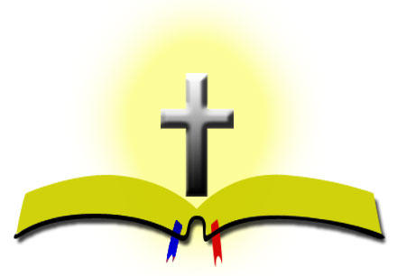
- 重要但并非基要 Important, not Essential
- 观点 Opinions
- 假教导 False Teachings
- 异端 Heresy
“在基要里合一,在非基要里宽容,在一切事上以爱相待.” –Rupertus Meldenius “In essentials unity, in non-essentials liberty, in all things charity.”
有关“三位一体”的二十个问题 (20 Questions on the TRINITY)

  - 为何我要学习 “三位一体”的教义? (Why should I study the Trinity?)
  - “三位一体”这词出现在《圣经》了吗? ( Is the word in the Bible?)
  - “三位一体”这个词是什么意思？(What does the word mean?)
  - 《圣经》教导只有一位神吗? (Does the Bible teach only ONE GOD?)
  - 《圣经》有无教导圣父是神? (Does the Bible teach the Father is God?)
  - 《圣经》 有无教导耶稣是神？(Does the Bible teach JESUS IS GOD?)
  - 《圣经》有无 教导圣灵是神? (Does the Bible teach the SPIRIT IS GOD?)
  - “三个分别不同的位格”是什么意思? (What do we mean by 3 PERSONS?)
  - 三个位格是否声称他们有所分别? (Do they claim to be separate people?)
  - “三位一体”的神看上去是什么样子? (What is this Trinitarian God like?)
  - 古犹太拉比教导 “三位一体”吗? (Did ancient Rabbis teach the Trinity?)
  - 旧约中能否找到 “三位一体”? (Is the Trinity found in the O.T.?)
  - 新约中能否找到 “三位一体”？(Is the Trinity found in the N.T.?)
  - 早期教会教导 “三位一体”的教义吗？(Did early church teach the trinity?)
  - 哪些有关 “三位一体”的教导被认为是异端言论？(What would be heresy?
  - 有无什么方法可以教导孩子明白 “三位一体”？(Ways to teach children?)
  - 若我的教 会不相信 这教义,我 该怎么办? (if my church rejects Trinity?)
  - “三位一体”的教义会如何影响我的生活? (How should this affect my life?)
  - 我应向 谁祷告? (Which One do I pray to?)
  - 基督徒在这个问题上的认识难道不可以不一致吗? (Can we disagree?)

