**Marquis Who’s Who Lauds Jason D. Fletcher for Expertise in Financial Planning**

*Jason D. Fletcher, certified financial planner and senior financial consultant with Level Four Advisory Services, LLC dba DF Consultants, has 25 years of experience in financial planning and consulting*

FINCASTLE, VA, November 22, 2024, Jason D. Fletcher has been selected for inclusion in Marquis Who's Who. As in all Marquis Who's Who biographical volumes, individuals profiled are selected on the basis of current reference value. Factors such as position, noteworthy accomplishments, visibility, and prominence in a field are all taken into account during the selection process.

A seasoned professional in the field of financial planning and consulting, Mr. Fletcher brings 25 years of experience to his role as a certified financial planner and senior financial consultant at Level Four Advisory Services, LLC dba DF Consultants, a provider of wealth management and advising services. Since joining the firm in 2014, he has worked closely with individuals and businesses to build and execute strategies for health, life, and long-term care insurance, investment and portfolio management, and business planning.

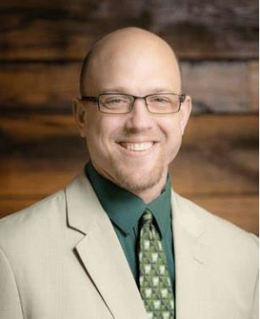

Prior to his current position, Mr. Fletcher worked from 2003 to 2014 as a banking center manager and senior personal banker at the Bank of America Corporation, where he honed his skills in personal banking and management and laid the foundation for his subsequent achievements in financial consulting. His earlier career included a role as an investment advisor at John Hancock from 1999 to 2003, where he received several internal awards recognizing his contributions.

Mr. Fletcher's educational background has been pivotal to his success. He earned a master's degree in project management with honors from Capella University in 2012. Additionally, he holds a bachelor's degree in economics with honors from the Virginia Military Institute, completed in 1999.

In addition to his formal education, Mr. Fletcher has obtained several certifications that underscore his commitment to professional excellence. Furthermore, he completed a Green Belt Six Sigma certification from Villanova University in 2012, enhancing his proficiency in process improvement methodologies. In recognition of his professional accomplishments, he received the Financial Planner Certification from the CFP Board in 2021 and was part of the Employee Advisory Panel at Bank of America Corporation in 2013.

Mr. Fletcher attributes much of his success to the values instilled by his parents, especially strength, authenticity, resilience, and accountability. His faith and partnership with his own financial partner and spiritual adviser have also played significant roles in shaping his career trajectory. Looking ahead, Mr. Fletcher aims to acquire the Chartered Financial Analyst certification next year and eventually pursue a Certified Kingdom Advisor designation.

Beyond his professional endeavors, Mr. Fletcher is actively involved in civic activities as a volunteer at Orchard Hills Church. His dedication to community service reflects his commitment to giving back and making a positive impact beyond the financial sector.

In his personal life, Mr. Fletcher finds relaxation and enjoyment outside of his demanding career by spending time by the pool. As he continues to advance professionally and personally, he remains focused on maintaining good health and exploring new opportunities for growth and development within the financial industry.

**About Marquis Who’s Who®:**

Since 1899, when A. N. Marquis printed the First Edition of Who’s Who in America®, Marquis Who’s Who® has chronicled the lives of the most accomplished individuals and innovators from every significant field of endeavor, including politics, business, medicine, law, education, art, religion and entertainment. Who’s Who in America® remains an essential biographical source for thousands of researchers, journalists, librarians and executive search firms around the world. The suite of Marquis® publications can be viewed at the official Marquis Who’s Who® website, [www.marquiswhoswho.com](http://www.marquiswhoswho.com).