2018 Deltana Fair
Demolition Derby

Registration Information:
Name:______________________________ Contact:_______________
Address:___________________________________________________
City:_______________ State:_____________ Zip Code:____________
E-Mail:________________________________ Phone:______________

Waiver of Liability:
By signing, I agree to Release/Waiver of Liability: In condition of your accepting this entry, I intend to be legally bound, hereby for myself, my heirs, executors, and administators, waive and release any and all rights and claims for the damage I may have against the Deltana Fair Association or their agents, successors, sponsors and assigns for any and all injuries suffered by myself or my guests in this event. Further, I hereby grant full permission to the Deltana Fair Association and any other agents authorized by this event’s organizers to use any photographs, videotapes, motion pictures, recordings or any other record of this event for any legitimate purpose.

Name:__________________________________________

Date:_______________________

Please do not forget, your registration is NOT complete until your registration fee is received

Please sign to acknowledge that you have read all of the information, rules and regulations and agree to be bound by this contract.

Signed:_______________________________________________ Date:_________________________

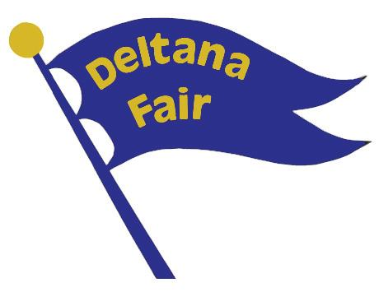
Cost to participate is a non-refundable $125 fee if registered by July 15th.
$150 on Derby Day

PAYMENT MADE PAYABLE TO AND MAILED TO:
Deltana Fair Association
PO Box 408
Delta Junction, AK 99737

