Hernando Band Flag Project

The students of the Hernando Band program invite you to participate in their Flag Project benefitting the award-winning Hernando Band. For a modest contribution, Hernando Band students will place a 3ft x 5ft U.S. flag on an aluminum flag pole in front of your business or home six times each year. Each annual subscription includes six holidays. The cost for one subscription is $50 per year. A five-dollar discount will be given for a purchase of more than five yearly subscriptions. Flags will not be displayed if it is raining on the holiday in question.

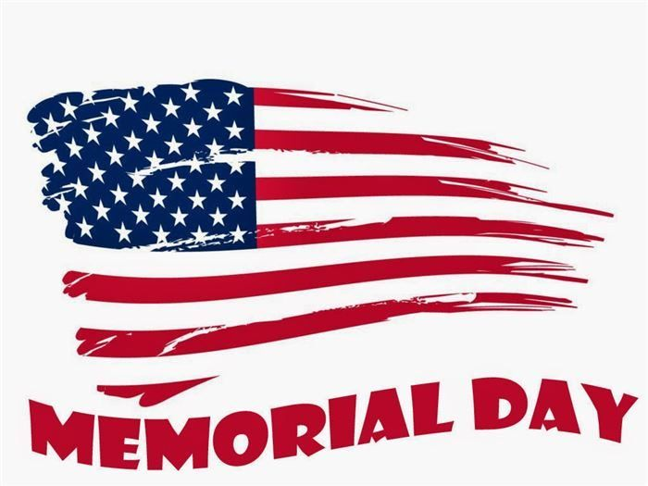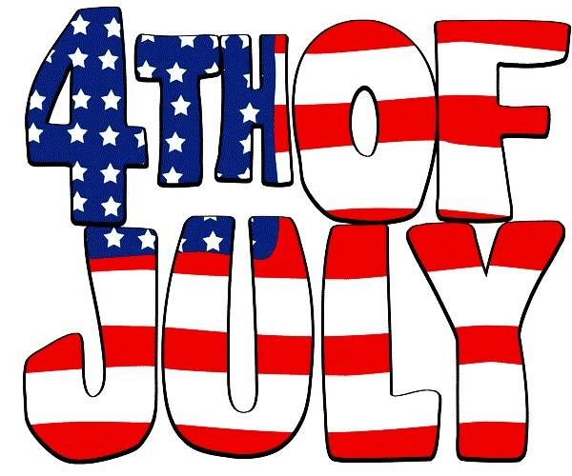
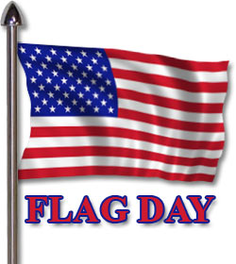
-----------------------------------------------------------------------------------------------

Name: _______________________________________________ Date:____________________
Address:_______________________________________________________________________
City:_______________________ State:______ Zip:_________ Phone #:____________________
Email:_________________________________________________________________________
Subdivision (If Applicable):________________________________________________________
Business Name (If Applicable):_____________________________________________________
Number of Yearly Subscriptions:_______
Student Name:__________________________________________________________________
Tear on the dotted line and return the completed order form with your cash, check, or money order to the Hernando Band Boosters. Forms and money can be returned in person or mailed to Hernando Band Boosters, PO Box 917, Hernando, MS, 38632. For questions please contact Joseph Quinnelly at joseph.quinnelly@dcsms.org.

