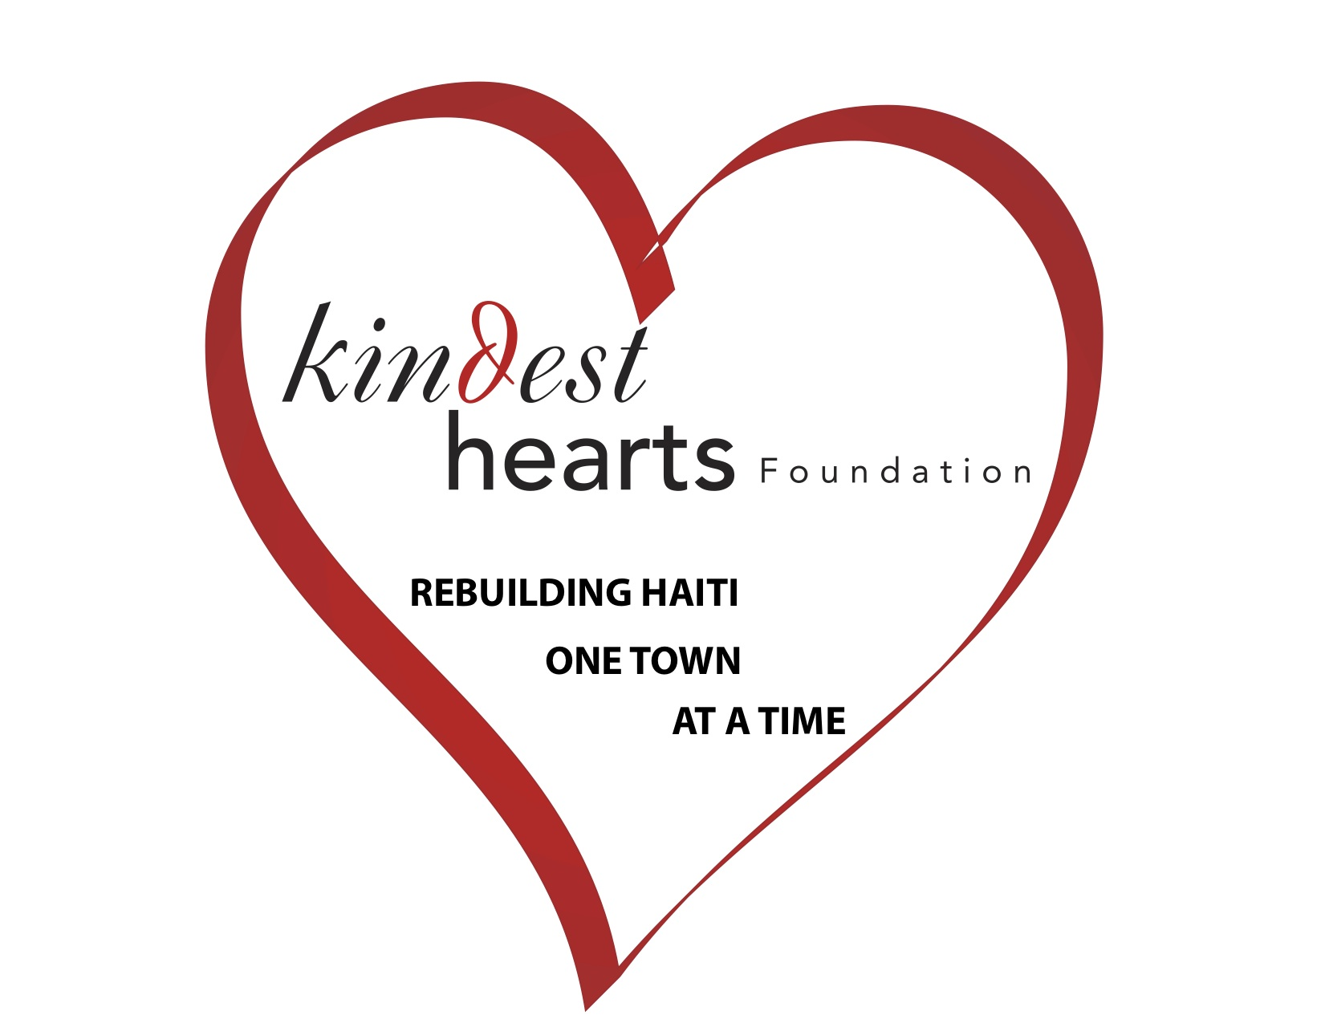
Volunteer Heath Form
All trip participants are required to supply health information. First aid and basic medical supplies will be available on-site. Please remember that Kindest Hearts' projects are held in remote areas with limited access to medical care. Expect your trip to be physically and emotionally demanding both as a result of activities and living conditions. Please let us know of any physical limitations or medical conditions which may for any reason interfere with your ability to fully participate in the program or require medical attention.
1) General Information:
Volunteer Name: _________________________________________________________
Dates You'll Be Travelling: ________________________________________________
NOTE At a minimum, you should consult with your personal physician about the recommended immunizations as well as any particular aspect of your health that may be impacted by this trip or be a potential cause for concern.
2) Medical Conditions: Please list any potentially serious or significant medical conditions for which you've seen a doctor and/or received medical care within the last five years: None

3) Medications: Please list any medications you are currently taking and/or will be taking while in Haiti: None _____

4) Dietary Restrictions:
NOTE: An important part of Kindest Hearts experience is to eat with and like the people of the community where you'll be staying. It is our hope that you will approach eating in Haiti as another part of the learning and growing experience that we offer and that you will respect both the food your hosts offer and also what it means for them to offer it. We do our best to see that you have a variety to choose from within the boundaries of what's available. Please indicate any significant restrictions beyond this below.
Please list any strict and/or necessary dietary restrictions you have: None _______
5) Allergies:
Please list any serious and/or potentially severe allergies you have (to food items, medicine, insect bites, etc.): None
6) Signatures:
By completing these fields and submitting this form, I affirm that all the above information is true and accurate to the best of my knowledge. I understand the health risks involved in traveling to a developing country. I consider myself in good mental and physical shape.
Name: ______________________________________________________________
Date: _______________________________________________________________

Complete and Return this Form to:
Kindest Hearts Foundation P.O. Box 2101 Miller Place, NY 11764

