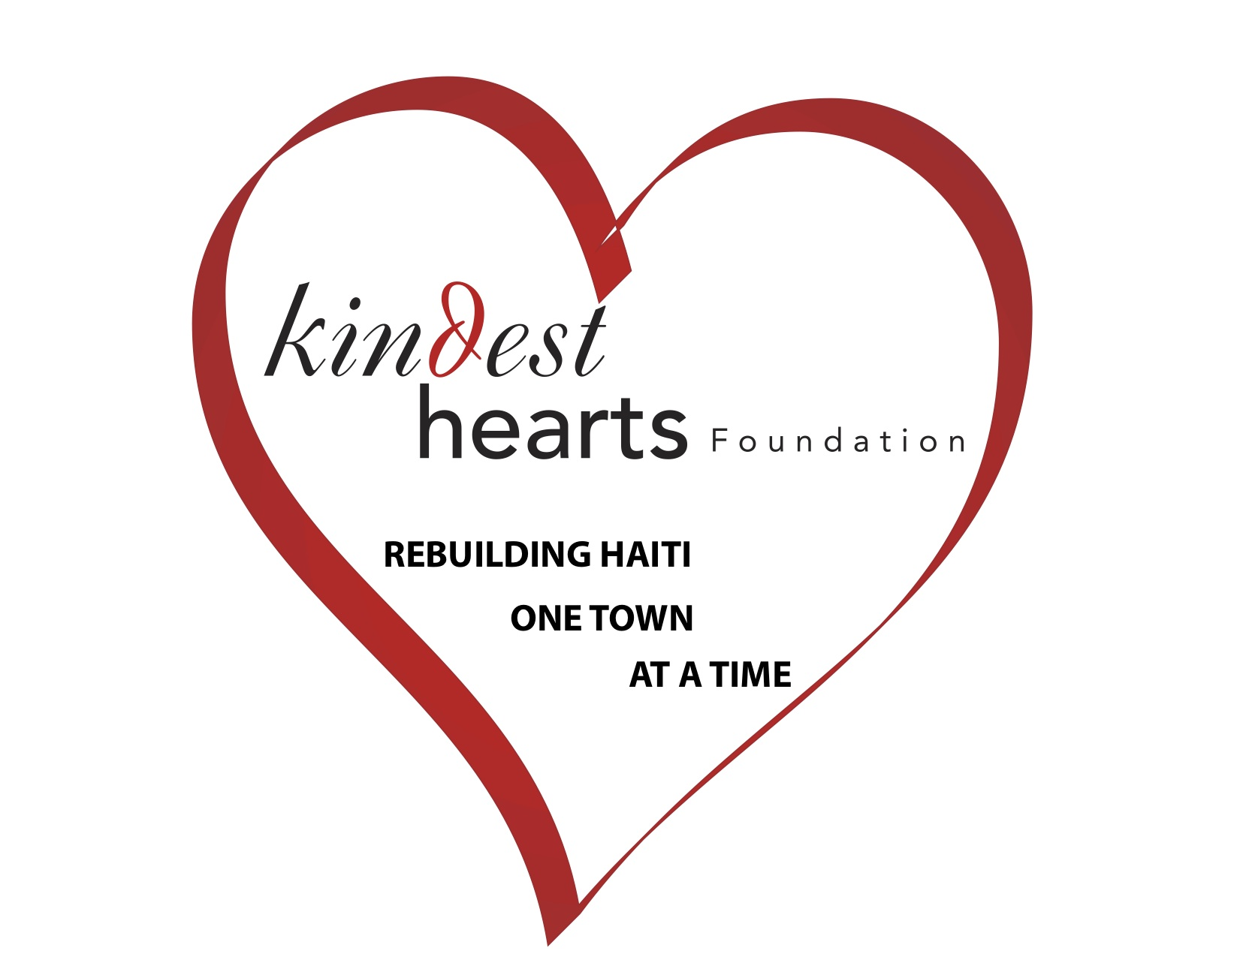Agreement and Release
NOTE: This document is a legally binding release, which, in certain situations, will reduce or eliminate Applicant's legal rights and legal recourse. Please read it carefully before signing.
THIS AGREEMENT AND RELEASE is between (Applicant’sName ) _____________
_________________________________________and Kindest Hearts Foundation (“KHF”). This Agreement and Release is entered into in connection with the program offered by KHF under which KHF provides the opportunity for Applicant to participate in volunteer service and cultural exchange. Applicant enters into this Agreement and Release in consideration of the opportunity to participate in the Program and for other good and valuable consideration, the sufficiency of which the parties acknowledge.
To indicate agreement with the stated policies, initial at the bottom of each page and provide a full signature on the final page of this document.
1) Payment Policy
The total trip fee is $800 per person. To hold your place in the Program, a $400 non-refundable deposit must be submitted no later than sixty (60) days prior to the start of your trip to secure your spot. The completed Program Application, Health Information form, copy of the first page of your passport must be submitted with the initial donation. The balance of $400 is due no later than thirty(30) days prior to the departure date. Applicant is responsible for its own airfare.
We accept checks made payable to Kindest Hearts Foundation. You can make payment online at www.kindesthearts.org. All payments must indicate the name(s) of the volunteer(s) for whom they are intended, as well as the dates of the Program.
2) Refunds for Cancellation or Withdrawal
A) Cancellation by KHF
At any time prior to the Program start date, KHF may, at its sole discretion, cancel an Applicant's registration, or cancel the Program in which Applicant is scheduled to participate. KHF will not be responsible to Applicant for any refund, costs, interest, liability, losses, or damages of any kind
B) Withdrawal by Applicant
If Applicant withdraws for any reason, Applicant must notify KHF in writing. Such withdrawal will not be effective until received in writing by KHF at its offices at the address set forth below. KHF incurs substantial administrative and planning costs with respect to each Program. Therefore, if Applicant voluntarily withdraws from the Program, funds donated by Applicant to KHF will be applied to a subsequent trip only as set forth below:
Initials: Applicant: Parent / Guardian Page 1 of 5

Agreement and Release
* The deposit will not be refunded. Applicant may, however, apply the deposit to another KHF program scheduled to take place within twelve (12) months of the original Program start date, subject to space availability.
* If the withdrawal is effective thirty (30) days or more prior to the Program start date, the balance of the program fee paid, will be refunded to Applicant. .
* No portion of any Program Fee paid shall be refunded if the withdrawal is received 15 days before, on or after the Program start date. Furthermore, no refunds will be made for unused portions of the Program or because of Applicant's withdrawal or removal from the Program for any reason after the Program start date.
Applicant is solely responsible for any airfare or other travel fees, charges, expenses or penalties that might result from any cancellation of or withdrawal from the Program.
3) Alterations to Program
KHF reserves the right to change the Program due to severe weather, acts of war or terrorism, or other causes beyond our control. In such cases we will make our best effort to offer alternate dates for travel KHF will not be responsible for any additional costs associated with such circumstances. If Applicant withdraws from the Program due to such causes, the same withdrawal policy as above will remain in effect.
4) Applicant's Responsibility for Costs, Third Party Suppliers
The Program fee covers all airfare food, water, lodging, in-country ground transportation, administrative expenses, and program costs. Applicant is responsible for 1) travel to and from the start location, 2) any additional costs incurred during free time, personal time, or on activities which are outside the Program, and 4) any costs incurred should applicant withdraw early from or remain past the time scheduled for the program.
KHF is not responsible for the acts or failures to act of anyone who provides goods or services in connection with the program. In addition, KHF is not responsible for any costs, losses, damages, interest, or penalties that Applicant may incur because of delays or losses caused by any airline, other transportation or car rental company, travel agent, hotel, restaurant, medical facility or other individual or organization providing goods or services, regardless of who arranged or paid for such goods or services, or because of any act or failure to act by any governmental entity, including any delay or change of travel plans caused by any action by any governmental entity.
5) Dismissal from the Program
KHF has the authority at any time and in its sole discretion to dismiss Applicant from the Program. Causes for dismissal may include, but are not limited to:
*Behavior that is destructive, abusive, violent, or involves harassment, theft, vandalism, or chronic defiance of policies.
* Refusal to abide by the laws and regulations of the local country and community and of the United States of America and /or the State of New York, or to behave in a manner that is appropriate in the local community, all as determined by KHF in its sole discretion.
Initials: Applicant: Parent / Guardian Page 2 of 5
Agreement and Release
* Engaging in inappropriate sexual activity, unauthorized absence from the group, or failure to abide by curfews and/or other set policies or expectations.
* Possession or use of any weapons, non-prescribed drugs, or narcotics.
* Deterioration of Applicant's physical health or mental condition.
KHF personnel may discuss Applicant's situation, including Applicant's health, physical, or mental condition, with any person, including family members or medical personnel, and release any information concerning Applicant to such person. If Applicant is required to leave the Program, KHF will provide transport to the appropriate airport. Applicant will be responsible for all costs incurred as a result of being required to leave the Program, and there will be no refund of all or any portion of the Program Fee.
6) Donations Restricted to Benefit Applicant
All donations made by third parties to underwrite the costs of an Applicant's Program fee are non-refundable.
7) Personal Property Loss
KHF takes all reasonable measures to ensure the security of Applicant's personal belongings. However, petty theft occurs worldwide. KHF will not be held responsible for the loss of, theft of, or damage to, personal property or equipment. KHF strongly advises Applicant not to bring expensive or irreplaceable items including but not limited to cameras, computers, portable music players, cell phones, other electronic equipment, and/or jewelry on the Program.
8) Medical Insurance and Emergency Treatment
Applicant acknowledges that all information that Applicant has supplied to KHF concerning his or her medical condition and physical and mental health is accurate and complete. Applicant will make arrangements for such additional or supplemental insurance as Applicant, in his or her sole discretion, may require. KHF strongly recommends that all airline tickets are purchased with insurance which covers medical emergencies.
Should any medical emergency arise which precludes Applicant's ability to consent to emergency treatment, KHF will endeavor to communicate with the person designated by Applicant to request permission for any necessary treatment. If KHF personnel believe, in their sole discretion, that time or circumstances do not permit such communication, Applicant authorizes KHF to consent on his or her behalf to any medical treatment, including all types of medical examinations, diagnosis, medication, or physician or hospital care, that is deemed advisable by, and is to be rendered under the general or special supervision of any hospital, medical clinic or physician. Applicant agrees not to hold KHF responsible for actions or consequences relating to any such medical or emergency treatments or the failure to provide such medical treatment.
9) Use of Applicant's Likeness
Applicant consents to the use of Applicant's likeness (whether photographed, filmed or videotaped) and/or oral or written comments or any portion thereof, in any manner now or in the future, including, without limitation, in fund-raising and promotional materials, advertising for television, radio, print or other media, and any other KHF presentations or publications. Applicant agrees that, in connection with such use, KHF, and persons acting for or on behalf of KHF, may identify Applicant by name, age, city and/or state or country of residence.
Initials: Applicant: Parent / Guardian Page 3 of 5
Agreement and Release
10) Acknowledgement and Release
Applicant acknowledges that the Program involves travel to a third world country with a possibly unstable political system and differing cultural expectations and practices. Applicant acknowledges that there are risks inherent in such trips, including, but not limited to, forces of nature, accident or illness in remote places without immediate access to adequate medical facilities, a lower standard of sanitation, job site injury, and travel by air, automobile, truck, on foot or by other conveyance. Applicant assumes all the risks of the Program, including health and personal safety risks, and waives all claims for loss or injury to person or property while participating in any of the activities contemplated thereby, whether such damage, loss, or injury results from the negligence of KHF or its officers, directors, representatives, employees, liability insurance carriers or agents, or from any other cause.
Therefore, in consideration of the right to participate in the Program, and of the services, food and transportation arranged by KHF, and its agents and associates, the undersigned Applicant, intending to be legally bound, consents to the assumption of such risks, and agrees to forever waive, discharge and release for Applicant and Applicant's heirs, executors, and administrators, all rights and claims for injuries, damages, illness, losses, demands and other actions of every kind and nature whatsoever, which Applicant may have against KHF or its officers, directors, employees, liability insurance carriers and agents and all of those entities' representatives, successors and assigns, resulting from or in connection with the Program or any other activities arranged for Applicant by KHF and/or its agents and associates.
Applicant Signature
For Applicants under 18 years old, a parent or legal guardian must accompany and also sign below: Parent/Guardian

Date_______________________Signature_____________________________________

Complete and Return this Form to:
Kindest Hearts Foundation P.O. Box 2107 Miller Place, NY 11764

Page 4 of 5

