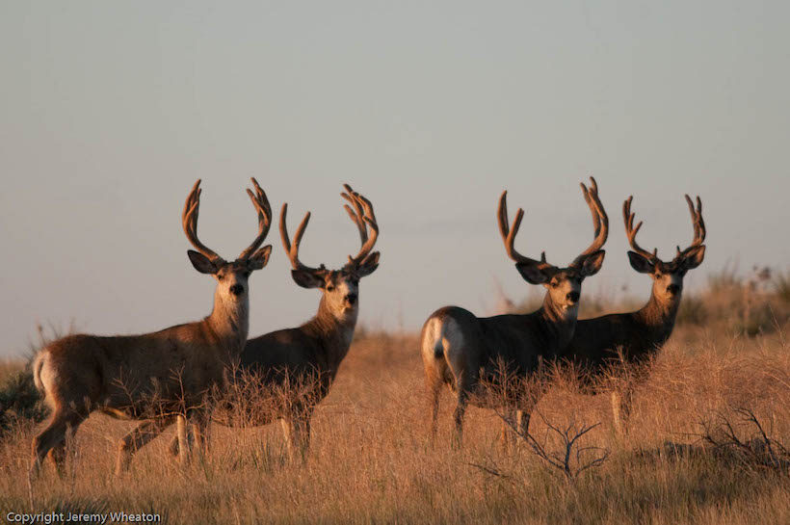  Processing  Cut and Wrapped  Charge is based on the hanging/drop-off weight or the minimum fee, whichever is greater:  *EXAMPLES: Deer weight 55 LB - Price $100. Deer with Bone weight 95 LB. (Price 95x$1.45=$$137.75). Field Bone weight 95LB. (Price is 95x$1.70=$161.50).  Additional Services
  Animal | Min Fee | Field Boned (No Bones) $1.70 lb | Hanging (Bone-in) $1.45
  Deer/Antelope | $100 | 60+ LB | 69+ LB
  Sheep/Goat | $100 | 60+ LB | 69+ LB
  Bear | $100 | 60+ LB | 69+ LB
  Elk/Moose | $300 | 178+ LB | 208+ LB
  Buffalo | $350 | 206+ LB | 242+ LB
  Animal | Skinning NO CAPING | Antler Capped | Teeth  Ivory
  Elk | $50 - Whole  $60 – ½ or ¼ | $20.00 | $10.00
  Deer | $30.00 | $10.00 | NA
  Antelope | $30.00 | $10.00 | NA
  Moose | $55 – Whole  $65 – ½ or ¼ | $20.00 | NA
  Sheep/ Goat | $45.00 | NA | NA
  Bear | $65.00 | NA | NA
  Buffalo | $75.00 | NA | NA
  Important Information
  - “Full cut and wrap” includes:
  - Loin steak
  - Round steak
  - Cube steak
  - Roast upon request
  - Burger usually 10%
  - Suet at or over 20% additional fee
  - All hides belong to Tizer Meats unless buy
  back is arranged.
    - Buffalo …………………… $20.00
    - Elk/Moose ……………….. $15.00
    - Deer ……………………… $10.00
    - Antelope …………………... $7.00
  - Antlers/Horns You Want Back
    - Taken horns or head with you at the time
  of drop-off
  - Beetle cleaned orders must be pre-paid and
  skull must be tagged and identified
  - All meat vacuum sealed
  - Must pay 50% of processing fees at time of
  drop off
  - No stew meat, liver, or heart
  - Thawing fee …………………….. $25.00
  - Excessively dirty ……………..… $20.00
  - Rush Fee:
    - 1-2 days …. …………… double fee
    - Big Game 3 days + .……… $150.00
    - Small Game 3 days + ……... $75.00
  Effective 9/28/2026
  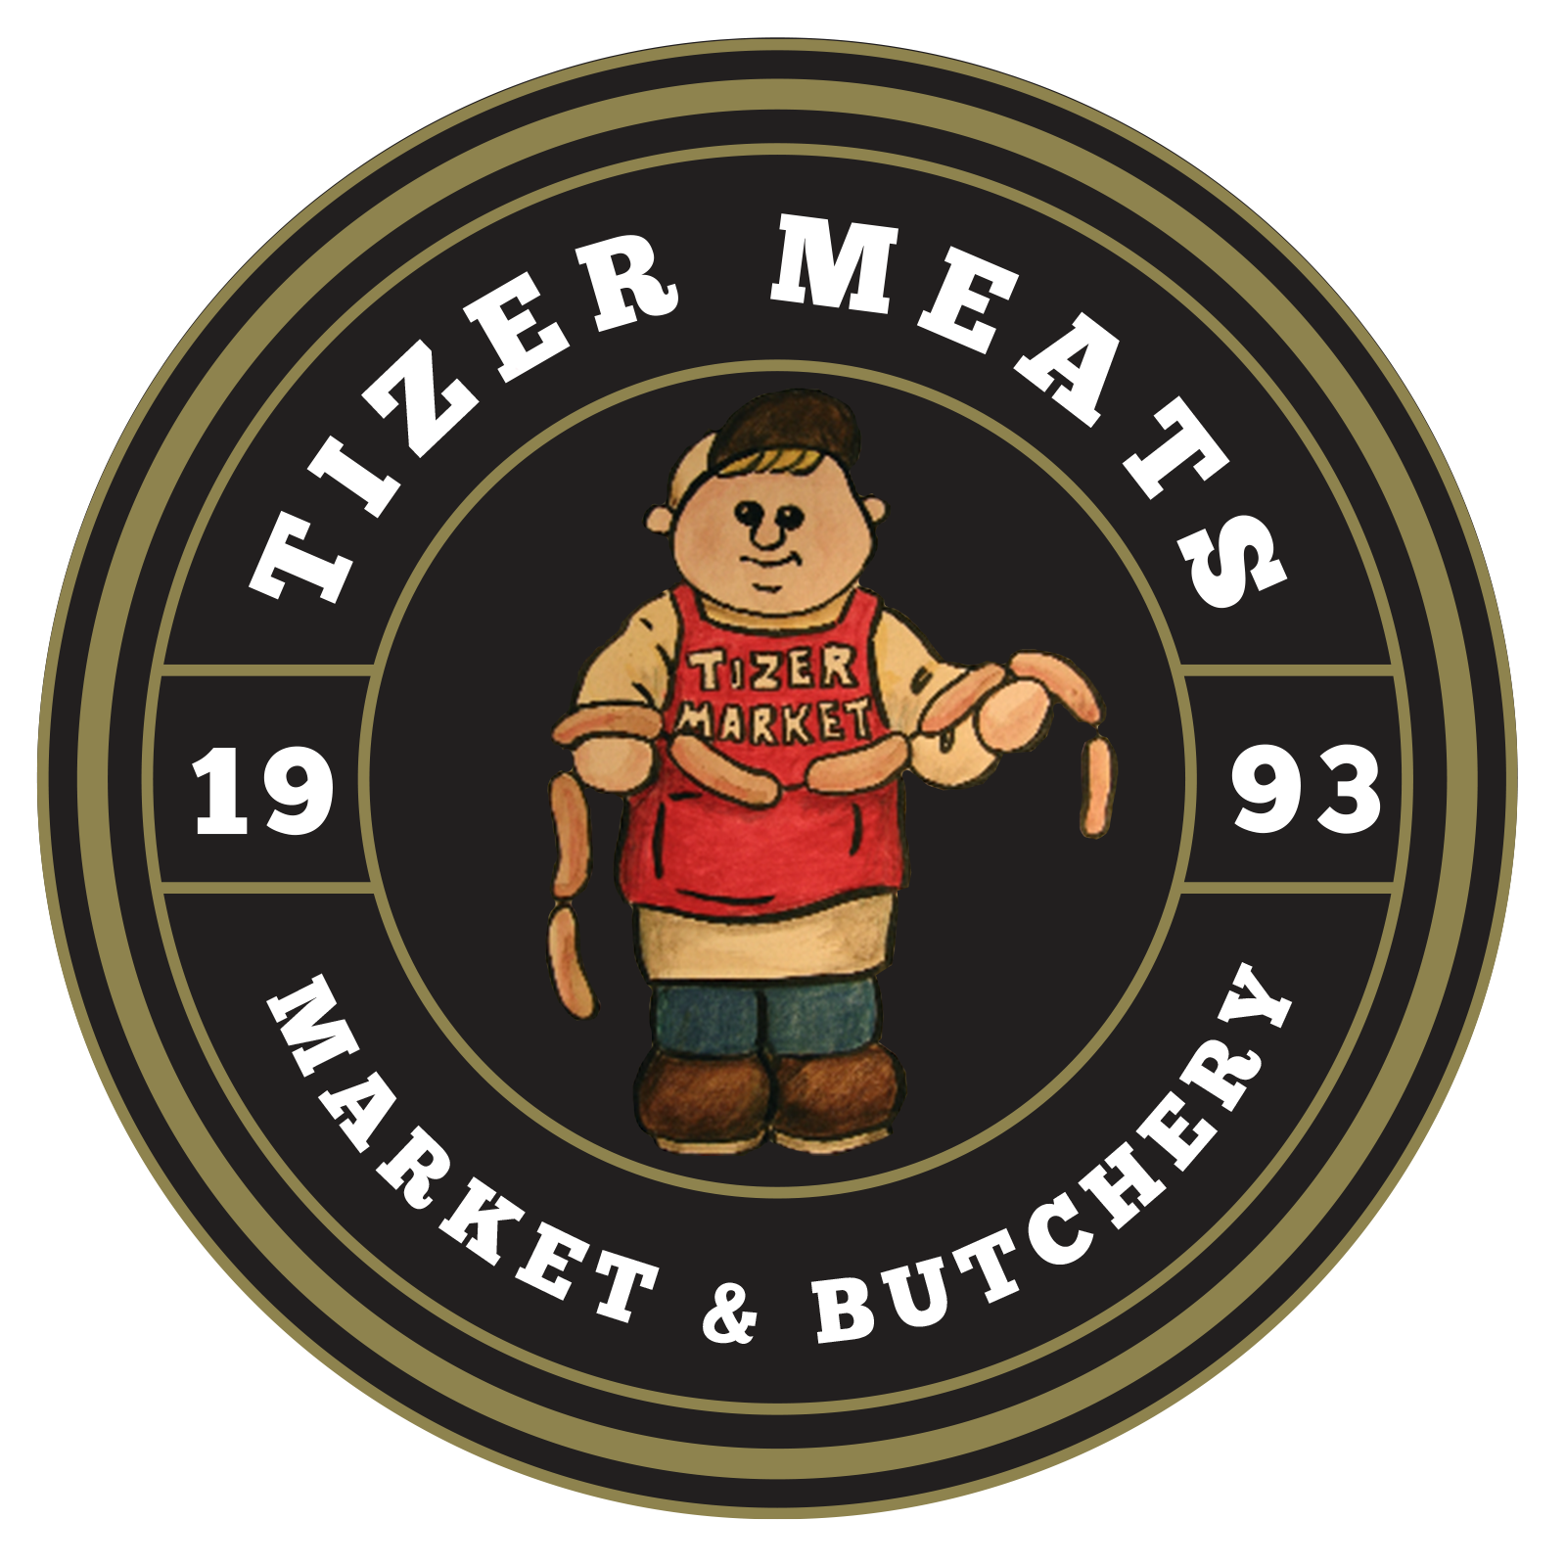 |  | Tizer Meats - Wild Game Processing  3558 Tizer Rd  Helena, MT 59602  406-442-3096  www.tizermeats.com
  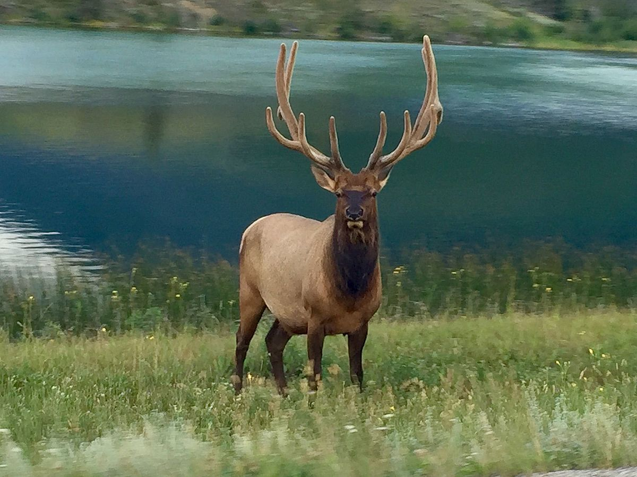
  Effective 9/28/2026
  Tizer Meats - Wild Game Processing
    - 3558 Tizer Rd. Helena,
    - MT 59602
    - 406-442-3096
    - www.tizermeats.com

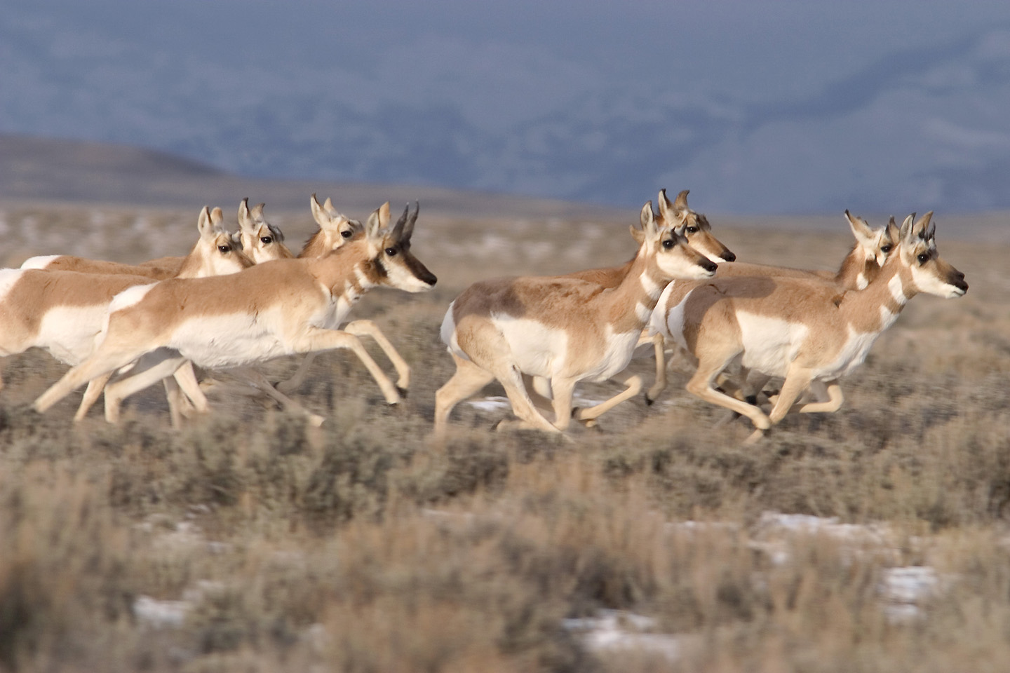  Additional Processing  Bulk Meat (Packaged)  (Clean and ready to process. (Min. Fee $20.00)  - Burger …………………………… $2.50 LB  - Cube Steaks …………………….. $2.00 LB  - Cut Steaks ………………………. $2.00 LB  - Clean up fee ……………………. $2.50 LB  - Custom Smoking  - Smoking …………………… $1.00 LB  - Brining …………….……….. $2.00 LB  - Sliced ……………..………… $1.00 LB  - Packaged …………..………. $1.00 LB  Sausage Making Supplies  - 2.5” Casing …………………………... $1.75  (Holds approx. 3.5 LB)  - Hog Casing ………………………… $10.00  (Holds Approx. 25 LB)  - Bulk Seasoning Available  (Does 25 LB batch) |  |  | SAUSAGE  (Requires 20 LB Raw Meat)  LOGS Batch …………………. $135.00  LINKS Batch  Smoked …………………… $130.00  Fresh ……………………..…. $95.00  Breakfast Links ………….. $105.00  FRESH BULK Batch …………... $80.00  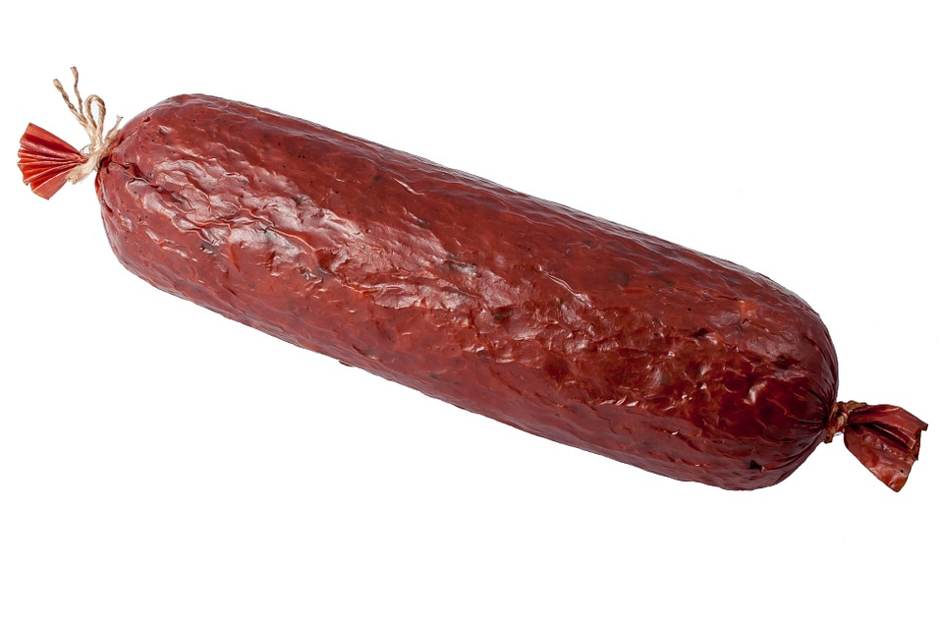 |  |  | 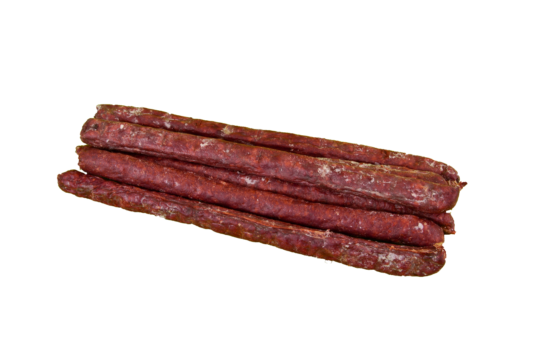  JERKY STICKS  (Requires 25 LB Raw Meat)  Round ………..…………… $145.00  Flat ………..………………. $150.00  (Round is the default shape. You must ask for flat sticks)  Additional Sausage Ingredients  Cheddar Cheese …………… $25.00  Pepper Jack Cheese .………. $30.00  Jalapeno Peppers …………… $5.00  (Cost per Batch)
  Pastrami | Salami
  Summer | Thuringer
  Bratwurst | Cheddar Dog
  Chili Cheese Dog | Hot Beer
  Sweet Italian | Hot Italian
  Honey Maple | Pepperoni
  Mild German | Spicy German
  Breakfast Links | Polish
  Breakfast | Spicy Breakfast
  Cajun | Chorizo
  Honey Maple | Hot Italian
  Sweet Italian | Mild German
  Spicy German
  Snack | Peppered
  Cajun | Pepperoni

