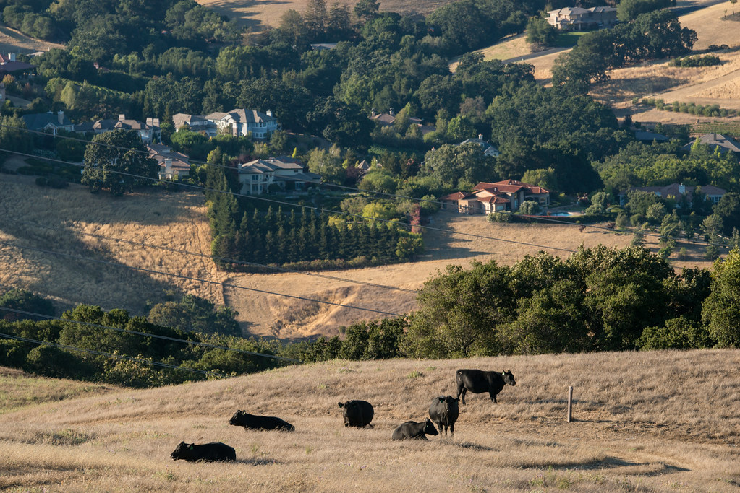
Processing
Congue nihil imperdiet doming id quod mazim placerat facer minim veni am ut wisi enim ad minimeniam, quis erat nostr uexe
rci tation ullamcorper nostru exerci tation ullam corper et iusto odio dig nissim qui blandit praesent lupta. Tummer delenit
augue duis dolore te feugait nulla facilisi. Con erattis sectetuer adip iscing elit, sed erat diam nonummy nibh magna erat.

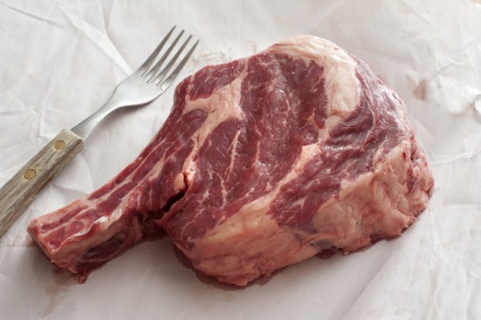
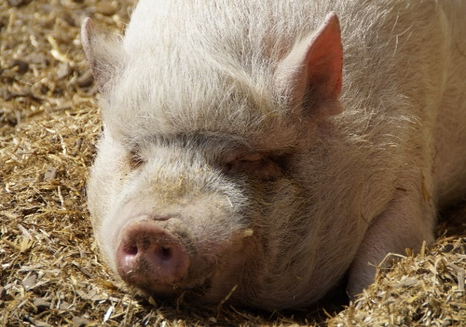
Domestic Processing
3558 Tizer Dr
Effective 09/01/2026

Helena, Mt 59602

Contact us at
(406) 422-4822
or on the web at www.tizermeats.com
Effective 09/01/2026
Self-Drop Off at Slaughter Facility (3831 Wylie Dr):
- Drive straight to the second gate.
- Place animals in an open pen.
- On the whiteboard, write:
  - First and Last Name
  - Phone number
  - Other important Information
- Bring paperwork: Beef Brand Inspections and/or Travel Permits to the store at 3558 Tizer Dr.

Beef Standard Hanging time is 14 Days.
Additional time can be requested for an additional fee.

Product Pick-up policy:
Please pick up the completed product within three (3) business days from the date of notification.

A $5 fee will be charged every day after 3 days until the product is picked up or other arrangements are made.
Beef
- $1.15/lb. carcass weight processing

Pork
- $300 flat-rate processing
- Includes all smoking/curing.
- $2//lb. link sausage
- Includes bulk sausage.

Sows (Over 226 lbs.)
- $0.95/lb. carcass weight
- Includes all smoking/curing.
- $2//lb. link sausage
- Includes bulk sausage.

Lamb / Goat
- $80 Flat Rate Processing

Your Hometown Butcher Shop
Tizer Meats
3558 Tizer Dr
Helena MT 59602
406-422-4822
Slaughter and processing by appointment only.
Call to reserve a place on the slaughter calendar.
All meat is vacuum sealed.
Important Information!
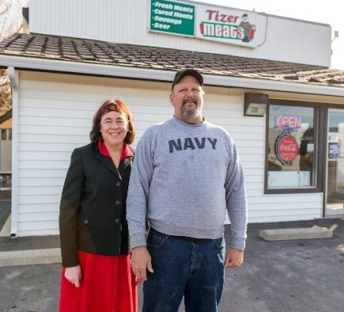
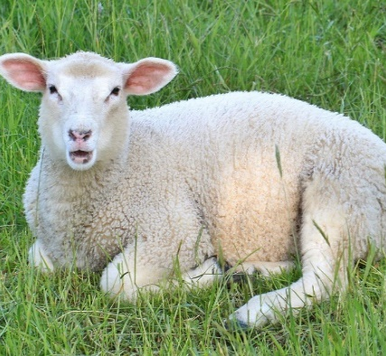
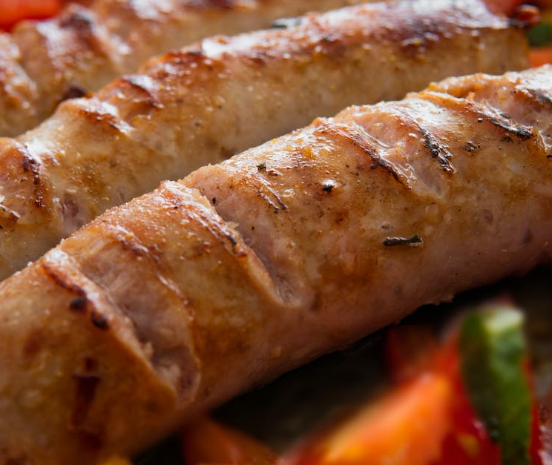
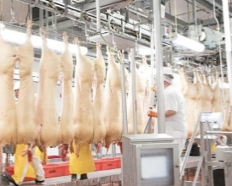
Bring your animals to us and tell your friends.
You will be glad you did!

Tizer Meats started out over 20 years ago, as a one-man operation. We have grown into one of the premier meat processors in Montana. We're experienced and we continue to produce quality products that keep our customers coming back. Tizer Meats is the Helena Valley, hometown butcher, and we're here for you!
​ ​ Co-founders Matt & Anita Elvbakken had a passion for serving people in the community. They opened their doors in 1993, and as the business grew, Mat and Anita realized how hard it was to get their hands on quality, local meat from sources they could trust, so they decided to take matters into their own hands and started their own butchery inside their market.

Thank you for using Tizer Meats for Your Processing Needs >>>
PORK OPTIONS
Bacon Options >>>
$10 per pork belly
- Hot Italian
- Sweet Italian
- Peppered
- Rob’s hand rubbed.
- Cajun
- Crushed Red Pepper
- Dill Pickle
- Cranberry Orange
- Apple Cinnamon
Bulk Sausage Options >>>
- Breakfast Links - $2 per lb.
- Bulk Sausage flavors - $5 fee for each flavor
- Ask about options.
- If you do a 25 lb. batch or a smoked sausage, see other sausage options.

Smoked Log >>>
$135 per batch
Pastrami Summer
Salami Thuringer

Links >>>
$130 Smoked; $95 Fresh Large; $105 Fresh small; with cheddar cheese see additional ingredients.
Bratwurst Cheddar Dog
Hot Beer Chili Cheese
Sweet Italian Hot Italian
Honey Maple Pepperoni
Mild German Spicy German
Polish Breakfast

Fresh Bulk >>>
$80 per batch
Spicy Breakfast Breakfast
Cajun Honey Maple
Chorizo Hot Italian
Sweet Italian

Jerky Sticks >>>
$145 Round Stick default option
$150 Flat Sticks must be requested.
Snack Pepper
Pepperoni Cajun

Additional Ingredients >>>
- Cheddar Cheese …… $25.
- Pepper Jack Cheese ... $30
- Jalapeno’s …………… $5

Specialty Items Processing Fees
Have enough ground beef and traditional bulk sausage, or bacon? We have tasty options for you. For specialty products, each type is made with 25 Lb. of raw meat!
KILL FLOOR SLAUGHTER FEES – 3831 Wylie Dr
- Beef …………………. $185 ($225 over 1000Lb carcass)
- Pork …………………………... $85.00 (Skin or BBQ Prep)
- Lamb/Goat ………………………………………… $40.00
- Buffalo …………………………………………… $125.00
- Same fee if Tizer Meats Skins and guts an animal brought in dead.

MOBILE SLAUGHTER FEES - $2 Per mile both ways
- Beef ………………………………………………. $350.00
- Pork ………………………………………………. $160.00
- Lamb/Goat ………………………………………… $80.00
- Disposal Free: $30 Per animal (To haul guts away)
SLAUGHTER FEES

Tizer Meats has pride!
>>>
MEATS THAT ARE RAISED BETTER TASTE BETTER.

